FREDERICTON YOUTH RINGETTE ASSOCIATION SPONSORSHIP PACKAGE
2021-22 RINGETTE SEASON
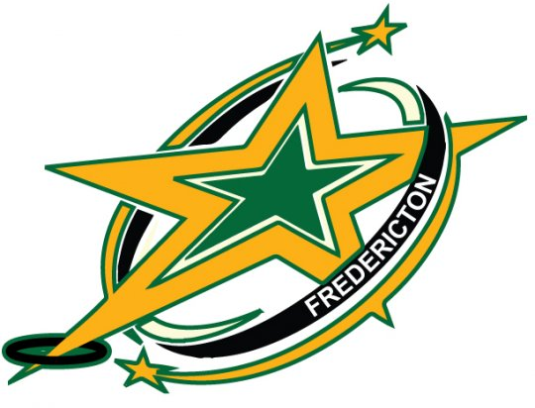

For more information, please contact the FYRA Director of Promotions at
FYRAringette@gmail.com
Sponsorship Package Summary
Level of Sponsorship | Platinum | Gold | Silver | Friend of Ringette
Commitment Level | $1,500+ | $1,000 - $1,500 | $501 - $999 | $100- $500
Tier 1 - Team title sponsor | EXCLUSIVE | n/a | n/a | n/a
Tier 1 – Game jersey sponsor name bar | EXCLUSIVE | n/a | n/a | n/a
Official Division Sponsor – shared name | n/a | Shared | n/a | n/a
Sponsor listed on www.Fredericton-Ringette.ca | ✔️ | ✔️ | ✔️ | ✔️
Sponsor logo advertised on www.Fredericton-Ringette.ca | ✔️ | ✔️ | ✔️ | n/a
Sponsor advertised in Early Bird Tournament program | Full page | Half page | ¼ page | Listed
Sponsor level advertised on tournament banner | ✔️ | ✔️ | ✔️ | ✔️
Appreciation letter and team photo | ✔️ | ✔️ | ✔️ | n/a
Sponsor recognition on social media | ✔️ | ✔️ | ✔️ | n/a

*Platinum Sponsor (1 opportunity available)
Your generous support of $1,500 or more as a Platinum Sponsor entitles you to:
- Official title sponsor of a Tier 1 team (i.e. U14 Sodrox Stars)
- Sponsor name bars on back of game jerseys for team sponsored (sponsor will be responsible to cover the initial cost of name bars)
- Your corporate logo displayed on the FYRA website (www.Fredericton-Ringette.ca) with a link to your website.
- Prominent display on a Sponsor’s banner which will be displayed at the Fredericton Youth Ringette Early Bird Tournament (November).
- A full page ad in the annual Fredericton Youth Ringette Early Bird Tournament program. (sponsor responsible to provide ad graphic)
- Sponsor recognition on FYRA social media
- Appreciation letter from the FYRA and copy of team photo in form of a plaque for team sponsors.
*NOTE: Platinum sponsors must commit to 2 years ($1,500 or more per year) and will receive the first right of refusal for years 3 & 4 (2 year increments).

Gold Sponsor (6 opportunities available)

Your generous support of $1,000 - $1,500 as a Gold Sponsor entitles you to:
- Official title sponsor of community division (i.e. U9 Sodrox Division)
- Your corporate logo displayed on the FYRA website (www.Fredericton-Ringette.ca) with a link to your website.
- Prominent display on a Sponsor’s banner which will be displayed at the Fredericton Youth Ringette Early Bird Tournament (November).
- ½ page ad in the annual Fredericton Youth Ringette Early Bird Tournament program. (sponsor responsible to provide ad graphic)
- Sponsor recognition on FYRA social media
Additional opportunity (if you commit the full $1,500), in addition to the items above, you would also receive the following benefits at the Fredericton Youth Ringette Early Bird Tournament:
- Official title sponsor of the division at the Early Bird Tournament (i.e. U9 Sodrox Division)
  - This will be represented in the following ways throughout the tournament:
    - Tournament Program
    - Tournament website (including company logo and link to your website)
    - All communications related to your division (i.e. MC notes, social media posts etc..)
- Appreciation letter from the FYRA and copy of the division’s winning team photo in the form of a plaque for team sponsors.

Silver Sponsor

Your generous support of $501 - $999 as a Silver Sponsor entitles you to:
- Your company logo listed on the FYRA website (www.Fredericton-Ringette.ca) with a link to your website.
- Prominent display on a Sponsor’s banner which will be displayed at the Fredericton Youth Ringette Early Bird Tournament (November).
- ¼ page ad in the annual Fredericton Youth Ringette Early Bird Tournament program. (sponsor responsible to provide ad graphic)
- Sponsor recognition on FYRA social media

Friends of Ringette Sponsor

Your generous support of $100 - $500 as a Friends of Ringette Sponsor entitles you to:
- Your company name listed on the FYRA website (www.Fredericton-Ringette.ca) with a link to your website.
- Prominent display on a Sponsor’s banner which will be displayed at the Fredericton Youth Ringette Early Bird Tournament (November).
- Company name listed in the annual Fredericton Youth Ringette Early Bird Tournament program.

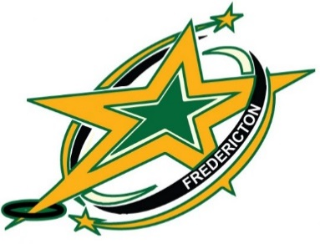

2021 / 22 Sponsorship Commitment

If you are ready to commit to sponsorship please complete and return this letter to: Fredericton Youth Ringette Association - 1261 Station A - Fredericton, New Brunswick E3B 5C8 or email to FYRAringette@gmail.com
Name of Business:
Contact Person Name and Number:
Contact Email:
Check boxes for type of sponsorship:
- Platinum Sponsor ($1,500 +)
- Gold Sponsor ($1,000 - $1,499)
  - Gold Sponsor with additional Early Bird Tournament options ($1,500)
- Silver Sponsor ($501 - $999)
- Friend of Ringette ($100 - $500)
Select one (make cheque payable to Fredericton Youth Ringette Association)
- Payment attached
- Send invoice to contact
Select one regarding ad for the Fredericton Youth Ringette Early Bird Tournament program:
- Ad information attached
- Please contact to discuss ad
Select one (for Platinum & Gold Sponsors):
- Would like to receive plaque of team picture
- Do not wish to receive plaque of team picture
Questions? Please email the Director of Promotions at FYRAringette@gmail.com
Fredericton Youth Ringette Association
PO Box 1261 Station A - Fredericton, New Brunswick E3B 5C8

