U11 DRILL LIBRARY
(Blue underlined text signifies Video link to supplemental material)

- Below are examples of drills that can be used and suggestions for what age group they are appropriate to use with. Drills listed in U11 category are easily usable and applicable for U13 and U14 levels as well with proper loads and relevant points of emphasis
- Suggested loads are also included that could be used to modify to fit your age level. Adding constraints to any of these drills will help reinforce your desired points of emphasis
- Most Drills can be adapted to incorporate transition by transitioning on the change of possession to play live for the desired number of transition trips
- Any drill with a Blue Highlighted title has a video demonstration
- Click Here to go to the BNB YouTube Drill Library to see a complete list
- You can also Click Here to access the drills from a word document that you can then copy and paste into your own Practice Plan

Suggested Age Group: U11+
Drill | Possible Loads
Ball Handling Drills
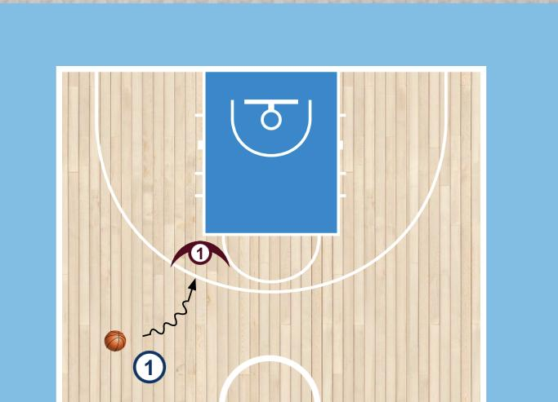  Guided Attack Moves  - Offense starts in space and attacks the defense with a dribble move  - Guided Reads  - Don't react to first move  - React to first move to force a counter  - Give space for a pullup | - Dribble limit  - Make it live 1v1  - Script type of dribble move being used  - Add second guided defende at the rim to guide finish
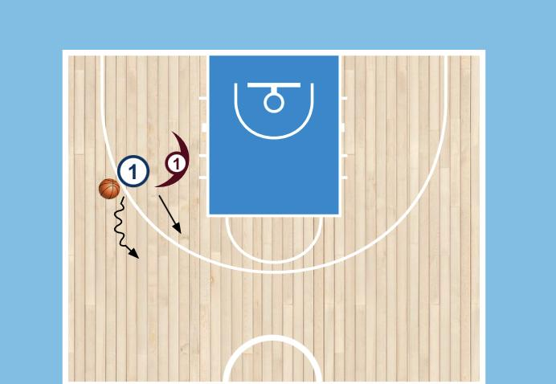  Shadow Game  - Offense and defensive pair  - Offense can move anywhere in the gym and defender must stay within arms length  - Anytime offense gets more than arms length from the dense they get a point | - Place constraint on moves offense can make  - Change the size of the playing area  - Have offense and defense both have a ball  - Have the defender become a follower and have to mirror the offensive player
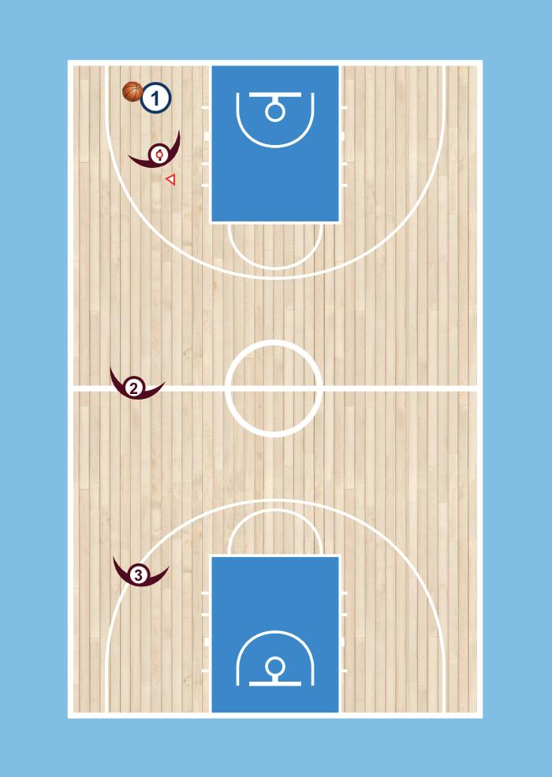  Gauntlet  - Offensive player starts close to the baseline, with 3 defenders staggered up the court  - Use whatever boundaries you can to limit the size of court(badminton lines work well)  - Offensive player has to make a dribble move to get past first defensive player, as soon as they get past one defender the next defender engages  - Offense has to get through all defenders and then rotate positions | - Place constraint on moves offense can make  - Change the size of the playing area  - Allow double teams(U13+)
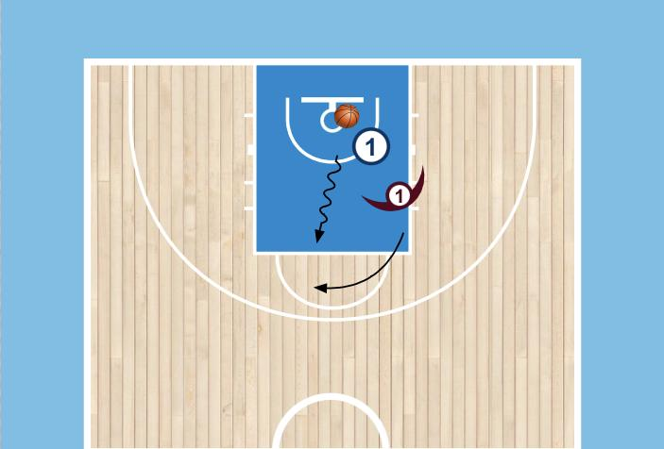  Full Court 1v1  - Offense starts with the ball in the backcourt  - As opposed to zig zag, just play full court 1v1 instead  - Offense is trying to score at opposite basket | - Change the boundaries (one side of the court)  - Change starting point (check ball, off a defensive rebound, off an inbounds pass, etc…)
Dribble Attack / FInishing Drills
Footwork Progression  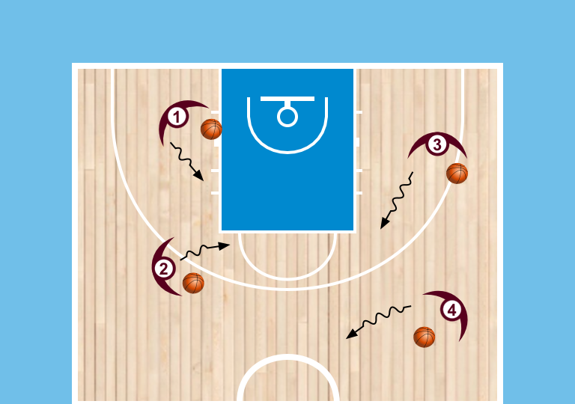  - Players spread out with a ball  - Self toss to catch  - Dribble freely around gym  - On the coaches whistle comes a two foot jump stop. Repeat  - Load: start dribble with a crossover step  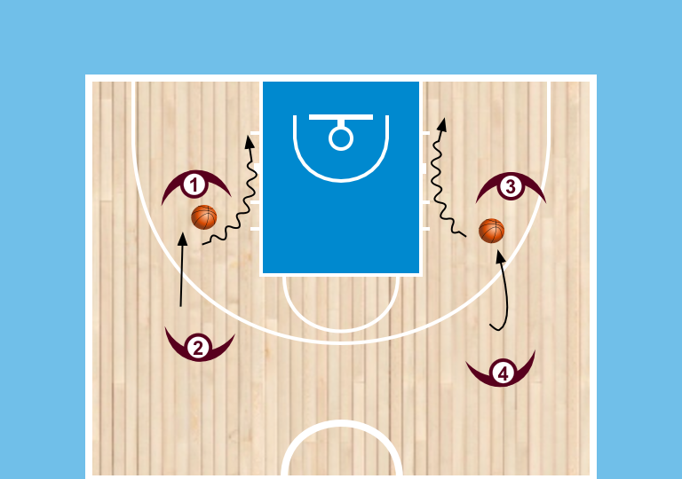  - Partner and 1 ball  - Start with a pass to the partner, then the partner will hold the ball out in front to one side or the other.  - Player will go to receive the ball landing on two and then execute a dribble start  - Repeat 3 times and then switch roles | - use different footwork  - Incorporate attacking and finishing at a basket
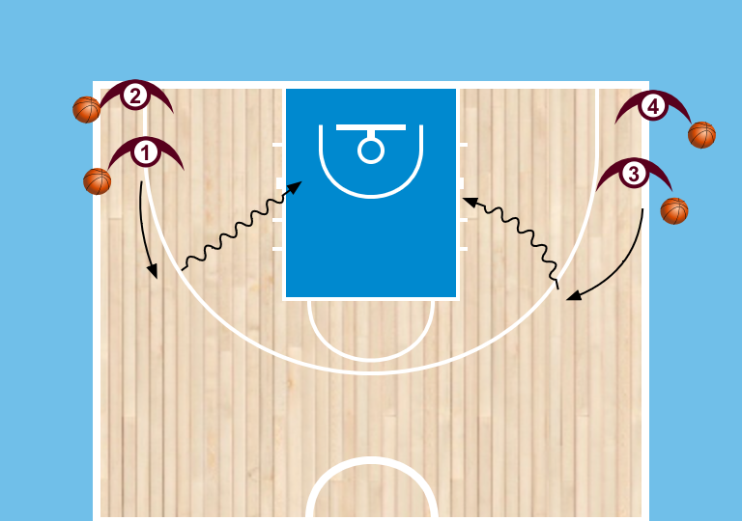  Attack Moves  - Lines in each baseline with a ball  - First line self tosses to the wing making sure to circle the catch and catch on two feet  - Player will attack using a crossover step and finish with the designated finish  - Alternate sides, switching lines after each finish | - mix up attack footwork or finishes being used  - Coach will now be at the rim to guide decisions of what layup to use. Open rim(speed) Contested/shoulders of the D(Power)  - Add more players to make it 2v1, 2v2, etc..
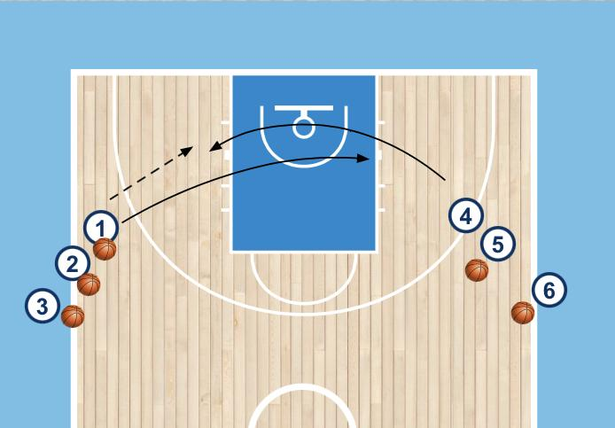  Two Lines - Post up  - Lines on each wing with ball at everyone except first person in one of the lines  - Player without the ball will cut to the opposite block for a post catch and will make a scoring move  - Passer will cut to opposite block for the same thing to make it continuous | - Change the move in which the players are using  - Add a guided defender on the catch (could be coach or player)
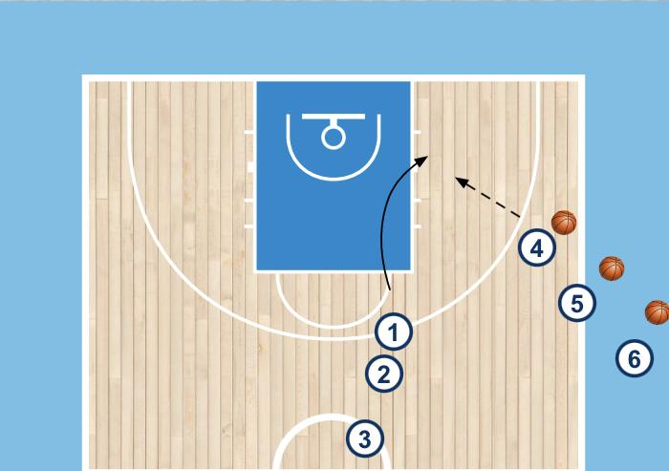  Cut to Post Up  - Two lines, one in the swing and one on the wing with basketball  - First player from the swing cuts to the block for a catch  - Make a interior move to score on the catch | - Mix up finish (wedge or face up, etc…)  - Add guided defender on post catch  - Change location of te cut to the post  - Add live defender  - Add Offense and defense pairs to make it (2v2, 3v3, etc…)
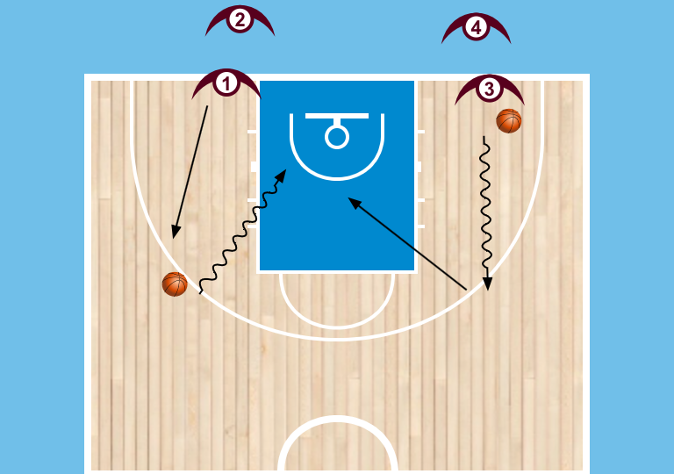  Two Line 1v1  - Two lines on each side of the key. ONe line has a ball at front, the opposite line has a ball sitting at 3 pt line.  - Player will start to dribble out (other player starts to run) Line with Ball is on D, line without is on O  - Player runs out and as soon as they pick up the ball they are live. D dribbles out and sets ball down and then plays defense, live 1v1 from there where attacker has to read the defense | - add a offensive teammate to make it 2v1  - Script how and what type of finish the offensive player can use  - Place a constraint on the offense (dribble limit, etc..)  - Change the location of where O and D are coming from
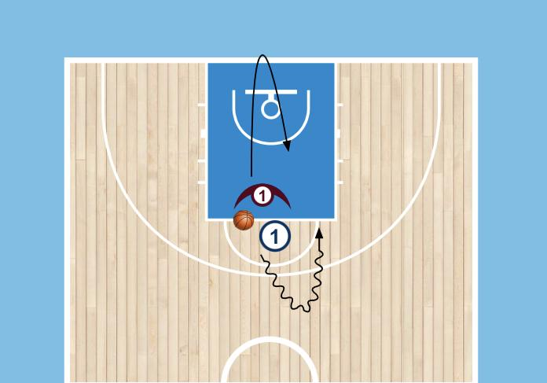  1v1 off the Dribble  - Offense dribbles to 3pt line while D touches baseline into live 1v1 | - Change the location and angle of both the attack and te recovery of the defender  - Dribble limit  - Scripted finish(off two feet, weak hand only, etc…)
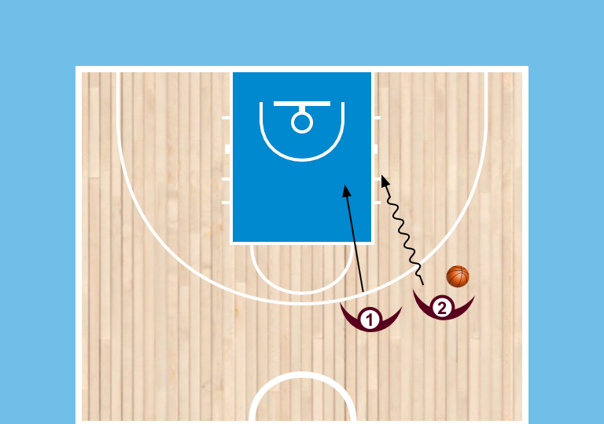  Shoulder 1v1  - Lines at half  - Player on outside with a ball is on offense and player on inside on defense  - Players start shoulder to shoulder  - Live 1v1 on dribble | - add constraint of how to finish  - Dribble maximum  - Add guided help defender to cue drive and kick  - Add O and D pairs to make it 2v2, 3v3, etc…  - Change where offense is attacking from
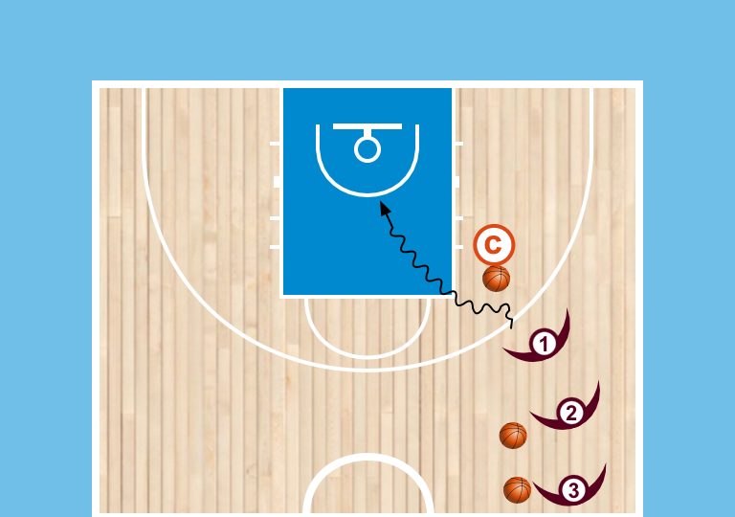  Coach Toss Progression  - Line on wing, each with ball, coach in front of line  - Coach will toss ball to one side or other, player will go recieve it with two foot  - Attack the basket using attack move and finish | - mix up attack footwork  - Mix up finish  - Add guided defender to guide finish  - Add O and D pairs to make it 2v1, 3v2, etc….
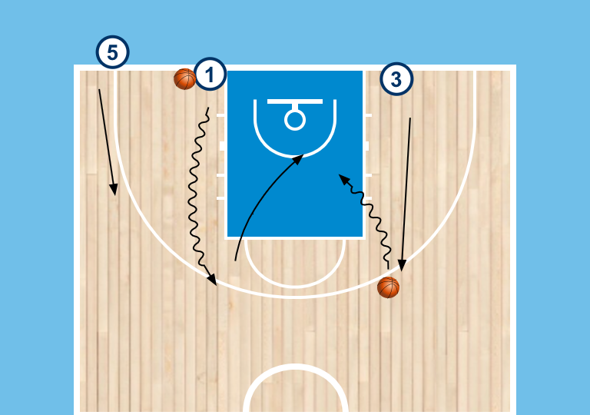  Read the Help 2v1  - 3 lines on baseline, same setup from session 2 except adding 3rd line in the corner  - Player with ball will be D, lines without are on Offense  - D line will initiate by dribbling ball out and setting ball down on 3pt line, Offense will run out to receive ball and 3rd player spaces to the wing  Live when offense attacks, defender is sprinting to stop ball and 3rd offense player spaces to make it 2v1 | - Change location of the drive or the teammate  - Load to 2v2, 3v2, etc..
Passing Drills
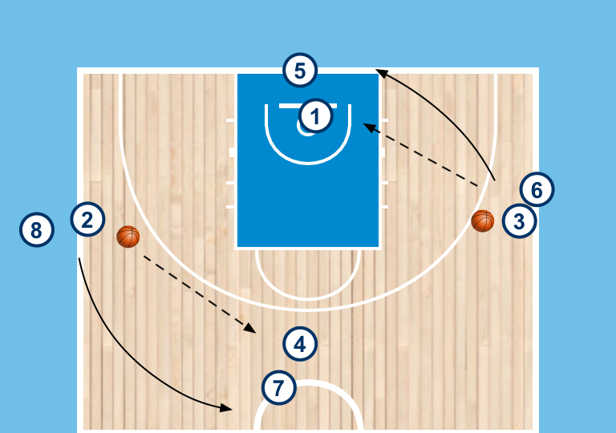  Diamond Passing  - Groups of at least 8, ball in front of two lines  - Players will pass to line one pass away and then follow to the end of that line | - Add pressure on the passers  - Change the type of pass being thrown
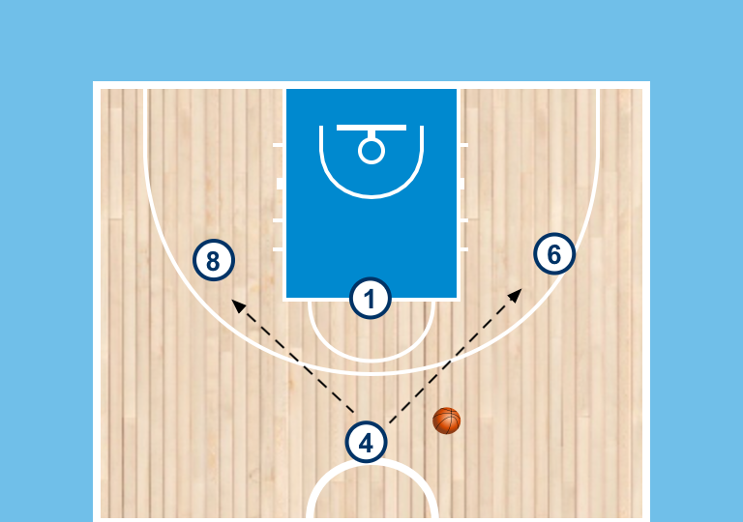  Monkey in the middle  - Groups of 4 with 1 ball  - Start in same diamond shape except leave 1 spot open and that person becomes it  - Players pass the ball around trying not to have “monkey” intercept the ball  - Players can’t dribble, can only cut without the ball, pivot and pass  - Switch who’s it on an interception or after certain length of time | - add second defender, 1 person guards the ball the other tries to intercept  - Change the playing area  - Constraint type of passes to be thrown  - Allow dribbles  - Change number of players, could be anything
5 Pass Game  Great time to reinforce principles of basketball Agility: stance, pivoting, start/stop, change of direction, etc..  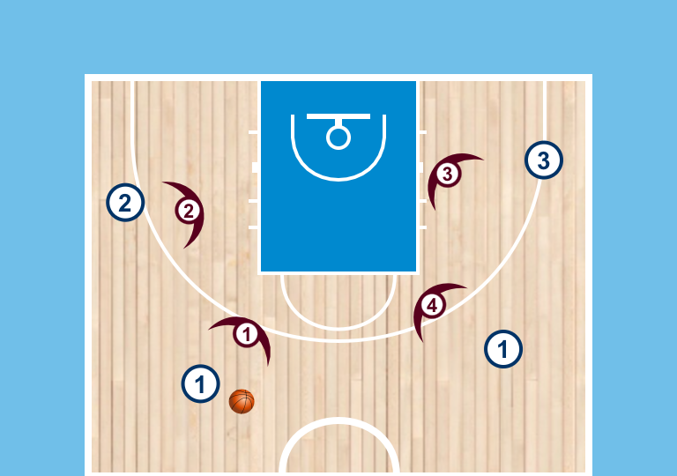  - Can play 3v3 or 4v4 depending on numbers  - Object of the game to complete 5 passes in a row without committing a violation(travel) or defense stealing the ball  - No dribbling - only passing, cutting and pivoting  Players are free to move without the ball | - After passing need to touch sideline/boundary before receiving another pass  - After passing need to cut to the smile(basket) before receiving another pass  - Change how you score (get a catch in the paint, score a basket, etc…)  - Change size of playing area  - Change number of players (could be even or advantage for O or D)  - Change number of passes required
Dynamic 1v1 Drills
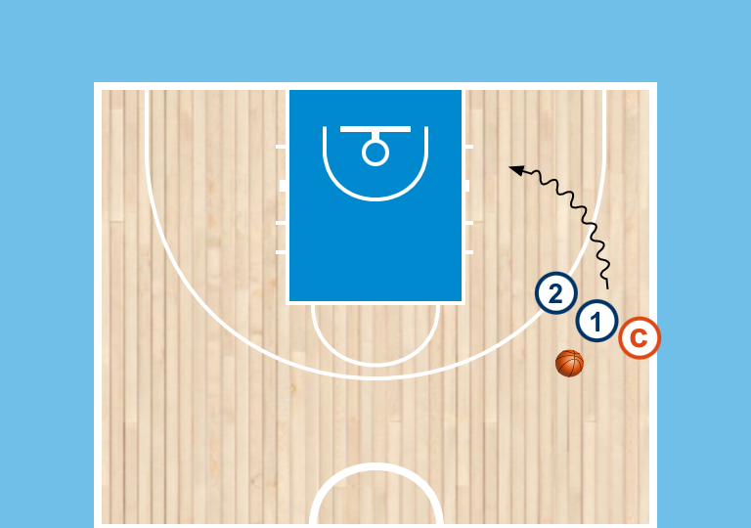  Coach Tag 1v1  - drill starts with offense/defense with a ball in the attack spot  - coach stands behind the offense  - coach will show a hand on one side or the other, d has to tag before they can defend, offense should attack the advantage  - live 1on1 once coach shows a hand | - Change location of the attack spot  - Constraint placed on how offense can finish  - Add offense and defense pairs to create a dominoes situation (2v1, 2v2, 3v2, etc…)
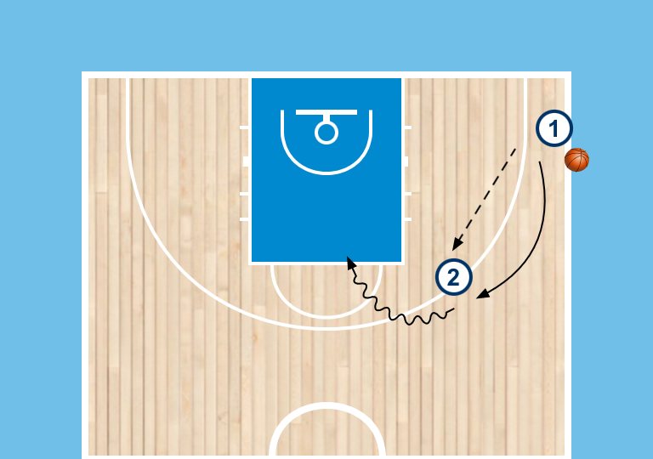  Player Holds 1v1  - Line in the corner with the ball, line on the wing with back to basket without the ball  - Pass goes to the player on the wing.  - Player from corner cuts to receive the ball, player on wing will hold the ball to one side or the other to cue where the offensive advantage is  - Play live 1v1 as soon as offense has the ball | - Play from a different spot on the floor (Swing, etc..)  - Have the defender be guided to start and restrict what reads they can give  - Put a constraint on how the offense can finish  - Add offense and defense to make it a small sided game(2v2, 3v2, 3v3, etc…)
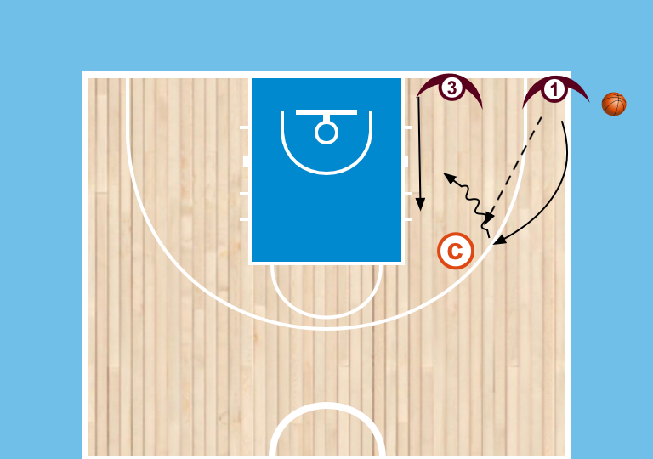  Coach Holds  - Players now start in corner, coach starts on wing  - Players will pass to coach and then come receive pass  - Coach will hold ball to one side or the other for players to receive and then attack basket to score  Load  - Offense and defense line  - Same as above except now defender will have to tag coaches hand before they can play 1v1 | - mix up attack footwork  - Mix up finish  - Add guided defender to guide finish  - Add O and D pairs to make it 2v2, 3v3, etc…  - Change read options for the players (incorporate back door, etc…)
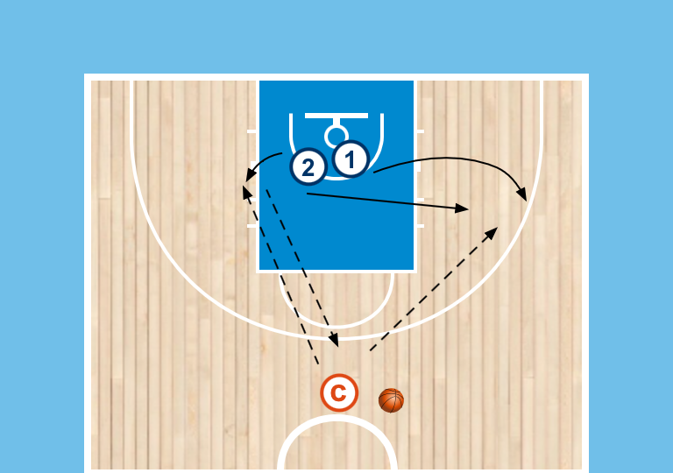  Roll Out 1v1  - Two players start shoulder to shoulder underneath the rim  - Coach rolls ball to one side for that player retrieve, the opposite player will sprint out to the open side  - Player with the player will throw a return pass to coach and then closeout to make it 1v1 | - Play out of an interior catch instead of a perimeter one  - Roll the ball further or closer to adjust the advantage for the offense
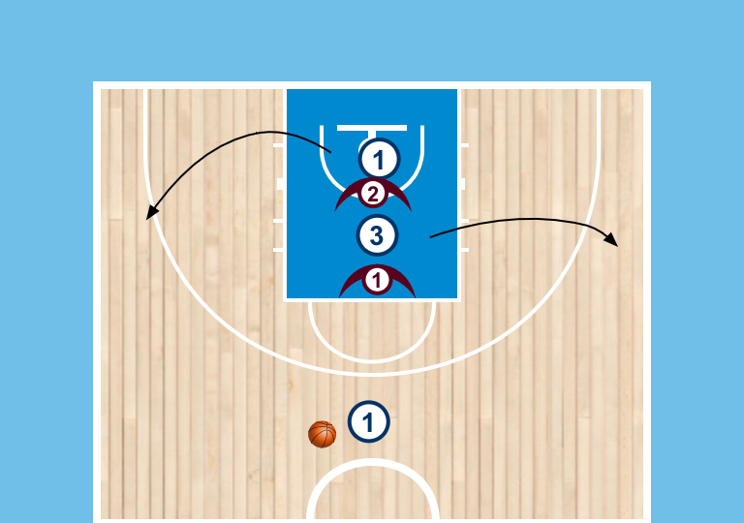  2v2 Double Exit  - Players line up alternating offense and defense in a straight line facing out from the basket  - Passer (should be a player) at the top who is out after making first pass  - First Offensive player cuts out to either wing, triggering teammate to cut to open wing  - Play live 2v2 on a pass to the wing  - Play until either offense scores or defense gets the ball | - Add pressure on the passer up top, make that pair live and 3v3 on pass  - Allow players to cut to any position on floor  - Constraint the offense as to how they can score or what actions can be used (U13+)
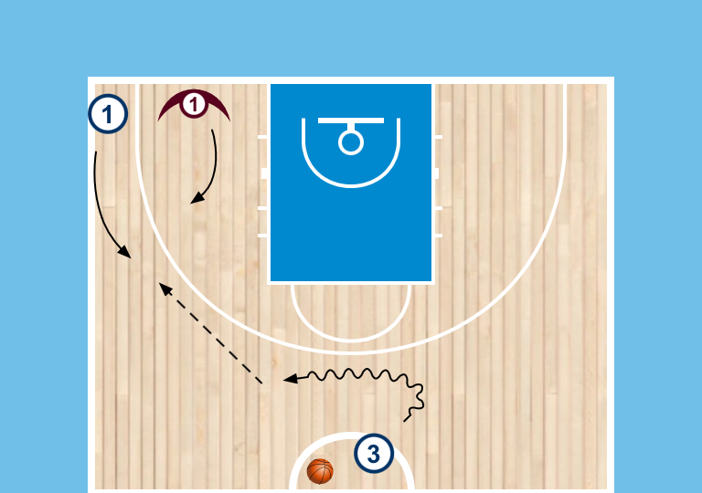  Blast Cut 1v1 to wing  - O and D pair in corner, passer at the top  - on change of direction Offense will cut  - Live 1v1 on pass to the wing  D will give 1 of 3 reads  - Overplay  - give space  - trail or curl  - Play live on pass | - Put guided defender on the wing to start  - Load or deload the options for how the D can guard to simplify at first for the offense or add complexity  - Change the location on the court of the Blast Cut  - Add pressure on the passer  - Add other O and D pairs to make it 2v2, 3v3, 4v4, etc...
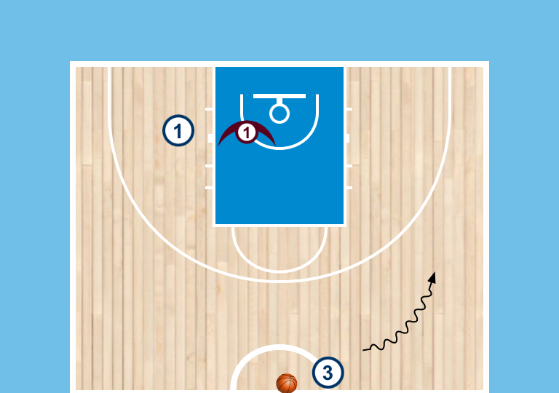
Blast Cut guided 1v1 (Lift Catch)
- same Rules except O and D pair in waiting area
- passer will dribble to the 45 and O will cut to the top

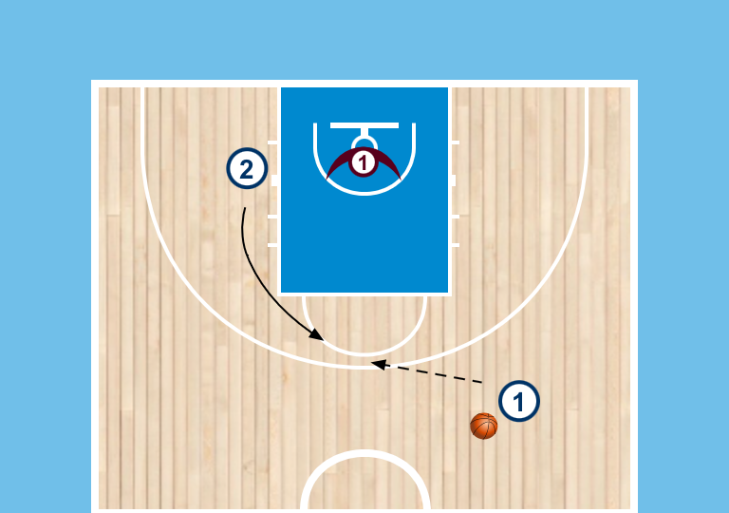
1v1 Blast Cut (from lift)
- Offense and defense pair in the waiting area
- passer dribbles to the 45
- play live 1v1 on the pass to the lift
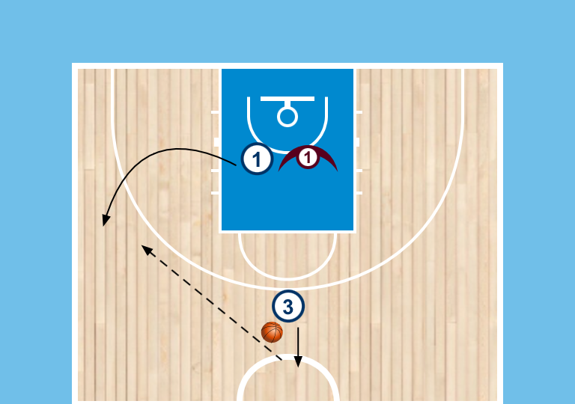  Circle 1v1  - Two players start in the Paint, Passer at the top  - passer will self toss either to the top or to the 45 and call the name of who is going to be on offense  - If you name is called you are on offense  - Toss to the top will signal a cut to the wing, toss to the 45 will signal a cut to the lift(top)  - Play live 1v1 on the catch  - Passer stays involved and can be a relay point if neutralized  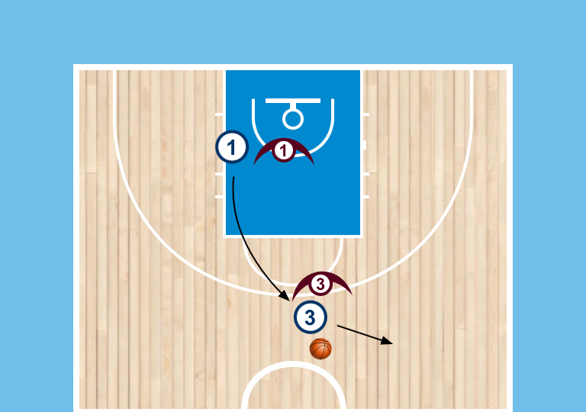  Load to 2v2  - Same setup except add a defender on the passer  - this time colour up so O and D are pre-determined  - Play live 2v2 on cut to the wing or lift | - Change location of where the offense can fill out too  - Add O and D pairs to make it 3v3, etc...
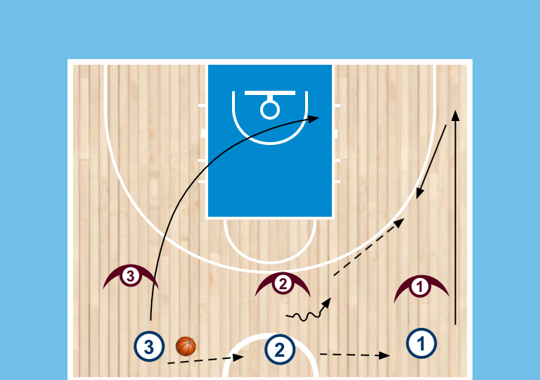  3v3 Post Entry (from Flow Start)  - 3 pairs of Offense and defense line up across half matched up with each other  - Ball starts in far lane and is passed to the middle player, everyone moves on first pass  - Passer becomes rim runner, weakside player runs wing, receiver of the pass becomes ball handler  - Play live 3v3 on the wing entry looking to play out of post entry | - Change number of players involved  - Change the trigger being used
Shooting Drills
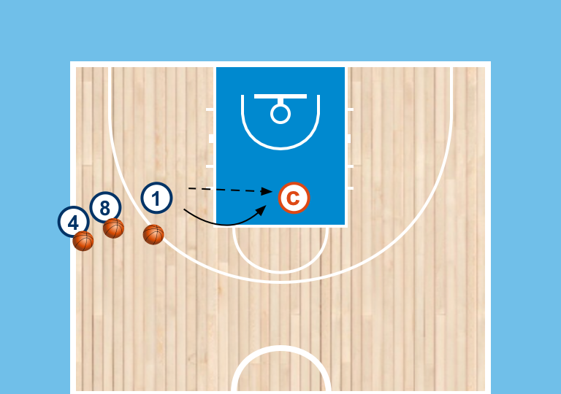  Spot Shooting  - Line on wing, each with ball, coach on foul line  - Player will pass to coach and then cut to receive the ball back  - Coach will hold ball out front for player to catch  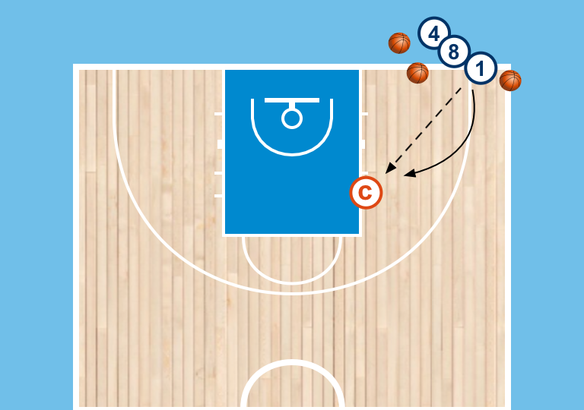  Player will catch and shoot, get own rebound and go to the end of the line  Load  - Same as above except player line in corner  - Coach starts on the wing for players to cut and receive shot from the wing  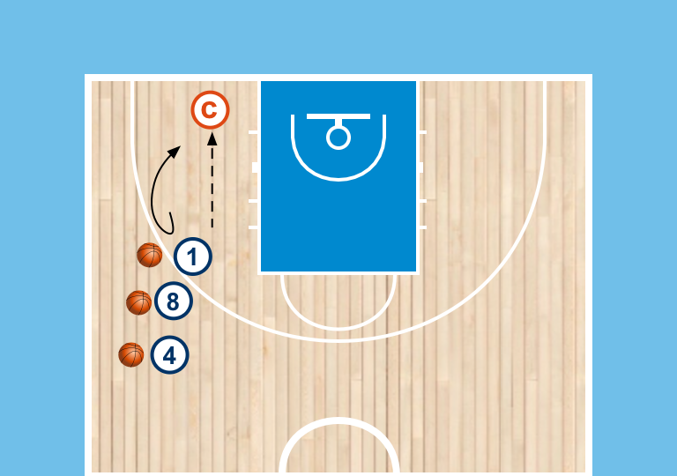  Load  - Same as above except player line on wing  - Coach starts in the short corner for players to cut and receive shot from the corner | - Shoot from different spots on the floor  - Change to player cutting to a different spot amd coach passing to the shooter instead of holding it for them
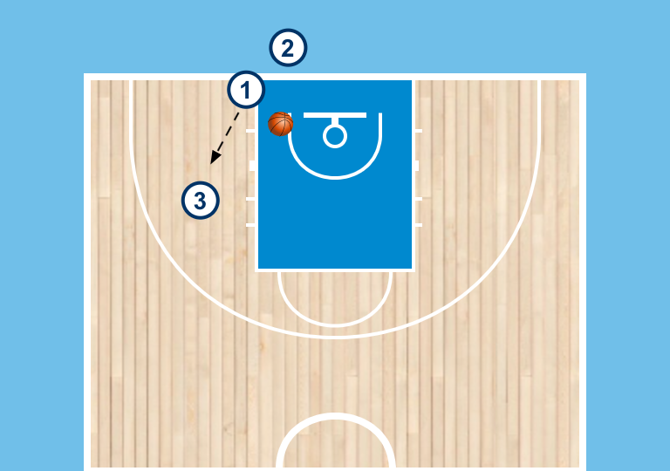  Decision Shooting  - groups of 3 with 1 ball (could adjust group size or put multiple groups at a basket)  - 2 players in line, 1 player spaces to shooting  - range.  - Pass out to shooter who catches shot ready  - Passer will give a Read/decision:  - show hands right away - Shooter will make a return pass  - no hands - Shooter will shoot  - Each time Shooter receives a pass they are reading, rep goes until a shot is attempted  - Passer becomes the next Shooter, Shooter goes to end of the line, and a new passer comes in | - Script type of passes being used  - Change location or range of the shot
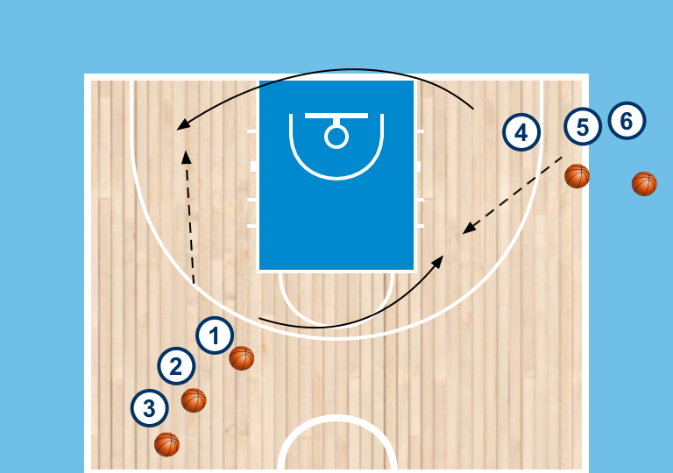  Canada Shooting  - Lines in corner and opposite swing  - Everyone had a ball except for 1st person in one of the two lines  - Person without the ball will cut first to opposite baseline shirt corner for a shot, always get your own rebound and go to end of opposite line  - After passing you become the next cutter filling across to the elbow  - Action becomes continuous | - coach guide on catch (too close or too far)  - Play from different spots or different range on the floor
Decision Shooting  - groups of 3 with 1 ball (could adjust group size or put multiple groups at a basket)  - 2 players in line, 1 player spaces to shooting range.  - Pass out to shooter who catches shot ready  - Passer will give a Read/decision:  - Too close - Shooter will drive the closeout and finish at the rim  - Too Far - Shooter will shoot  - Each time Shooter receives a pass they are reading  - Passer becomes the next Shooter, Shooter goes to end of the line, and a new passer comes in | - Change what decisions are available to the athletes to simplify or add complexity  - Incorporate penetration principles with an extra teammate  - Add triggers such as Gets/DHO(U13+) or Ballscreen(U14+)
Decision Shooting
- groups of 3 with 1 ball (could adjust group size or put multiple groups at a basket)
- 2 players in line, 1 player spaces to shooting range.
- Pass out to shooter who catches shot ready
- Passer will give a Read/decision:
  - Passer will give a Read/decision:
  - show hands right away - Shooter will make a return pass
  - Too close - Shooter will drive the closeout and finish at the rim
  - Too Far - Shooter will shoot
- Each time Shooter receives a pass they are reading, rep goes until a shot is attempted
- Passer becomes the next Shooter, Shooter goes to end

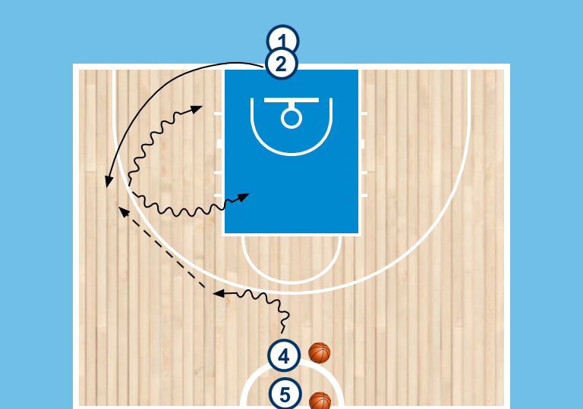  Drift or Fill Shooting  - lines at top and on baseline, basketball at top line  - live dribble at the top with baseline player filling either wing  - pass is made to the wing  - attack either direction cueing a penetration reaction to drift away or fill in behind  - Kick to shooter for shot | - deload to script direction of the drive  - Change location of passer and cutter to attack from different spots on the floor  - Add guided defender to cue finish or kick out decision
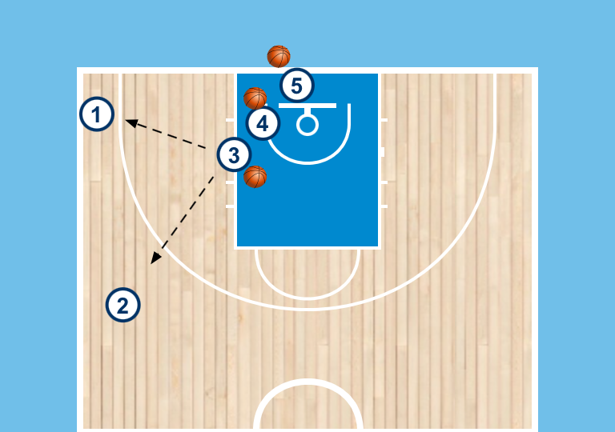  Extra Pass Shooting  - 2 offensive players in corner and 45 spacing  - guide passes to either player and can choose to guard either person  - this will create either an open shot or an extra pass when guarded | - Play from different locations (swing and swing, etc..)  - Add second defender to make it live 2v2
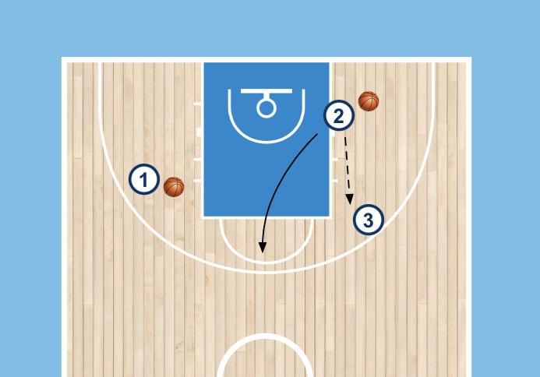  Two Ball Shooting  - 3 players and two basketballs  - continuous shooting drill  - player will shoot, get own rebound, pass to same teammate each time, and then relocate for their next shot  - each player does this to make it continuous  - play to a certain time or score | - Shoot from different ranges  - Add different types of shots (pullups, rim finishes, etc…)  - Incorporate decisions on catch with passer giving reads (show hands, closeout, etc…)
Penetration Principles / Dominoes
Penetration Progression  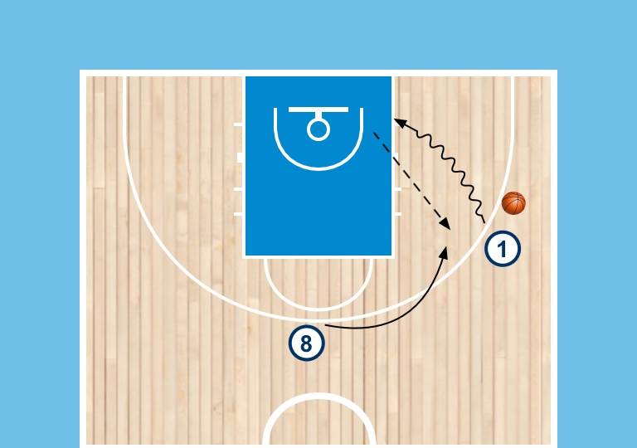  - Line on wing and at top, basketballs in line on the wing  - Player stacks baseline, teammate will fill in behind  - Pivot and pass back to a teammate for shot  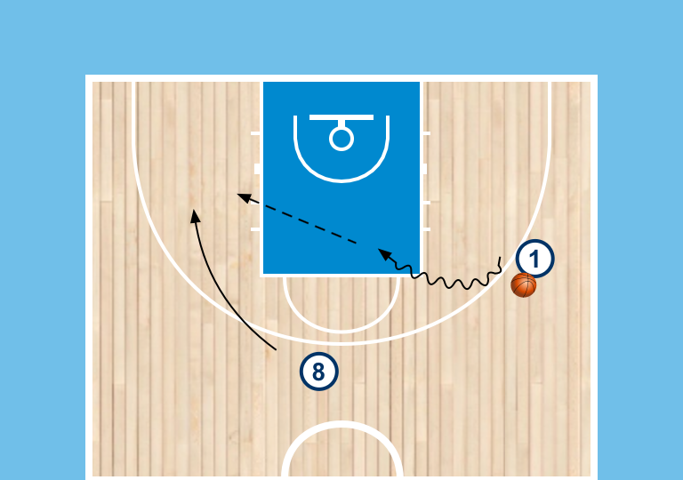  Load  - Same setup players drives middle  - Teammate will drift away from penetration to the opposite wing for a shot at basket  Load  - Attacker now has option to attack either way  - Teammate has to read the penetration and either fill behind or drift away for a shot  Final Load  - Coach guides the decision on the shooters catch, Too close or too far like above | - Change location of the attack  - Add guided defender to give read on when to finish at rim or when to pass
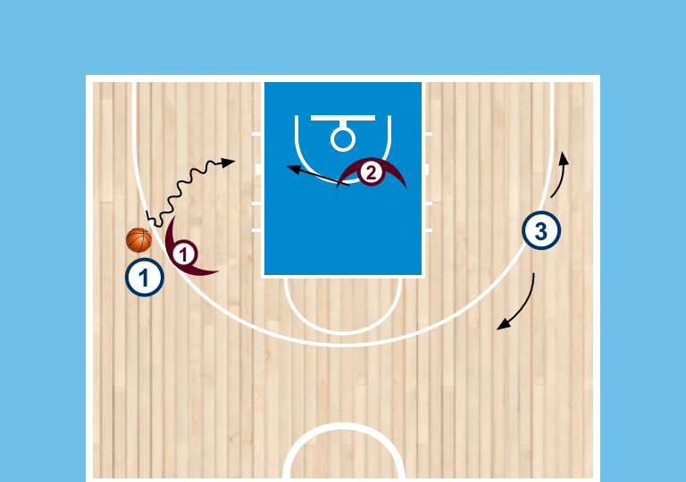  Ball on Back 2v2  - Play starts with offense and defensive players on both wings  - Defender on the ball starts facing the basket with ball on their back  - Other defender starts in help  - Live 2v2 as soon as the offensive player attacks | - Change position of the driver or the extra teammate  - Load or deload to change the number of players on the court, 2v1, 1v1, 3v2, 3v3, etc...
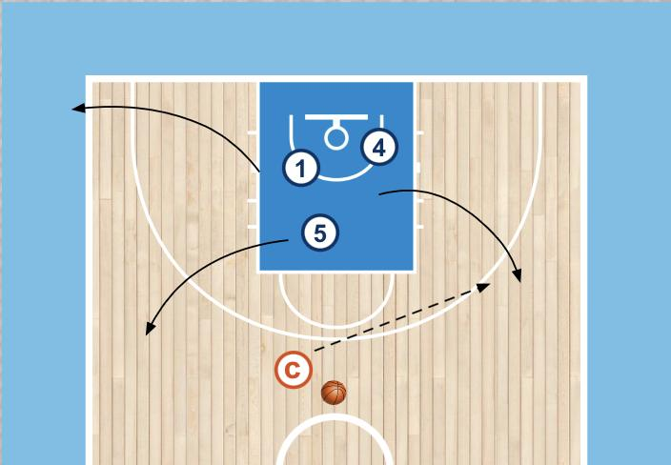  3v0 penetration  - 3 players start in key with one ball  - Player with ball will dribble out to any spot, other two players will space  - On penetration everyone has to move, kick to a shooter  Load: add passers on the baseline to get everyone a shot | - Change number of players on court  - Change spots on the floor in which offense is filling  - Include interior and interior positions  - Add guided defender to cue finish or kick out decision
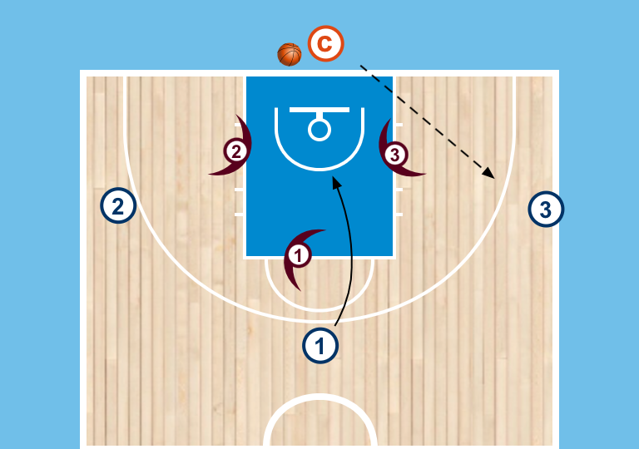  Double Gap 3v3  - offensive and defensive players start on each wing and at the top, D has to start with 1 foot in the key  - Coach starts with the ball on the baseline  - Coach will initiate play by throwing ball to either wing  - On pass to the wing player at the top will cut to the smile to create a double gap (pass, cut read, situation)  - play live on coaches pass. Play goes until offense scores or defense gets the ball | - Make it 4v4  - Constraint the offense as to how they can score or what actions can be used (U13+)
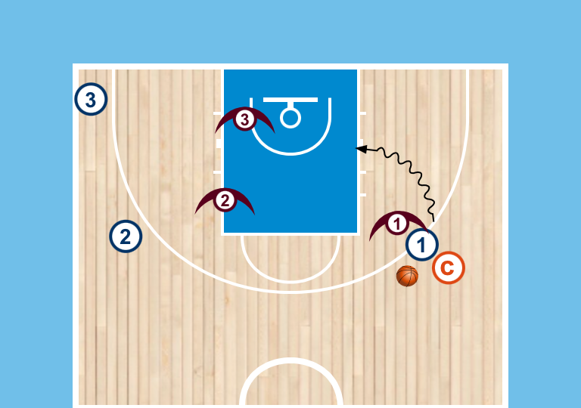  3v3 Coach Tag  - Offense and defense pairs start with 1 pair on the wing wit the ball and two pairs on the weakside  - Coach starts behind player with the ball  - Coach will show hand to one side or the other for the defense to tag  - This will cue and advantage for the offense to attack the open space and play live 3v3 | - Change the number of players on the floor (1v1, 2v1, 2v2, 3v2, 4v3, 4v4, etc…)  - Change the location of the players (could use perimeter or interior positions
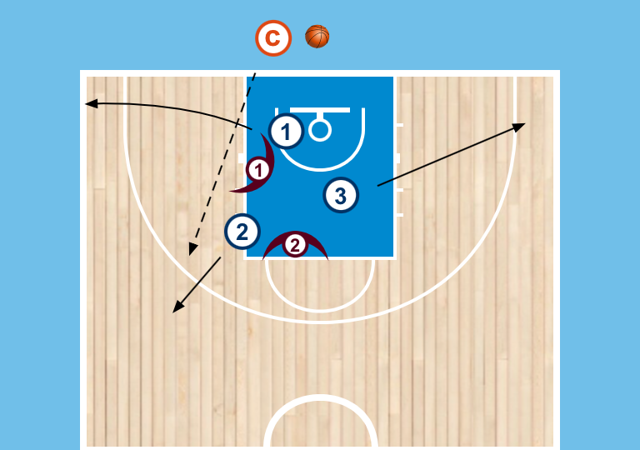  3v2 Domino’s  - 5 players start in circle in the key  - Coach has ball on the baseline  - On Go. offense will fill out to any perimeter position (corner, wing, 45, swing)  - Play live on kickout, first person to catch it has to drive  - D Rules: always guard the ball, the other takes 2 | - Change number of O and D to simplify or add complexity  - Use different spots on the floor  - Constraint to how offense can score (jumpshot only, etc..)
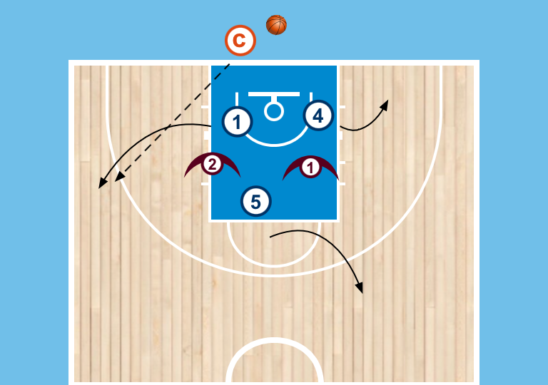
3v2 Dominoes - with interior player
- 3 offensive players and two defenders start in the key in a circle
- Coach has ball on the baseline
- on go, offensive players will fill 3 of the perimeter spots and a waiting area
- Coach will throw the ball to a perimeter player to make it live 3v2
- First person to catch it must drive

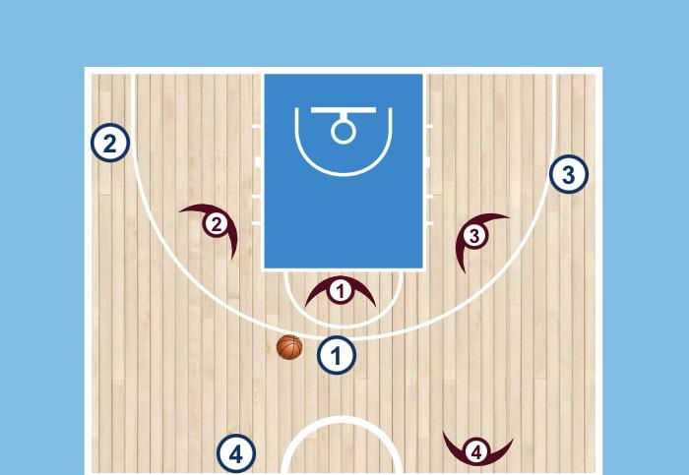  Dynamic 3v3  - Players plays half court 3v3  - On a change of possession ball has to be cleared to a player on your team positioned at the top  - They will enter it back in for play to continue. This relay person can move to make it easier to pass to  - Subs are made while ball is being cleared, need to be quick | - Change numbers of(2v2, 4v4, etc…)
Defensive Drills
Canceling Dominoes
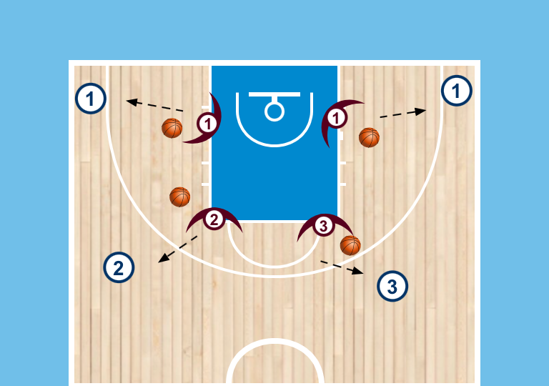
Partner Closeouts
- offense and defense pairs spread out
- D will toss and closeout to partner working on technique
- Load: guard for two dribbles

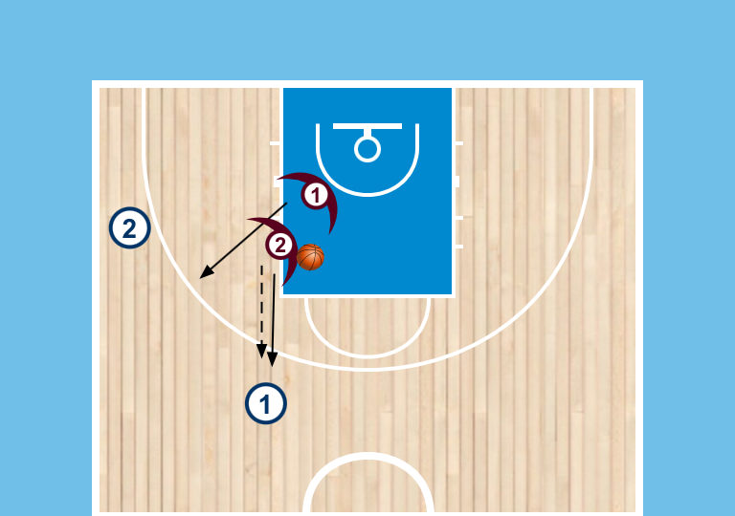  2v2 Closeouts and Gaps  - Two offensive players start 1 pass away from each other  - Two defenders start in key ready to closeout  - On pass out, 1 will guard the ball the other will guard 1 pass away  - Offense moves the ball a couple of times before it becomes live 2v2 | - Change location on the court of the players(still keeping them 1 pass away)  - Add a third pair to make it 3v3  - Once 3v3 can add movement to challenge the D more(passer can cut, etc…)
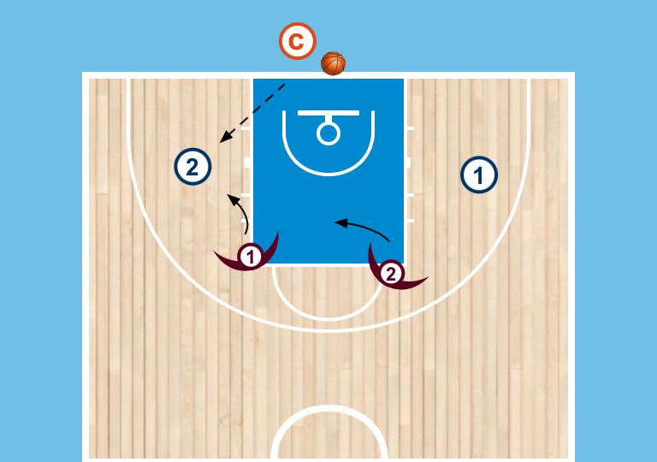  Full Court Gaps 2v2  - offense and defense pair on either side with coach on the baseline  - coach passes to either play and then we play live 2v2 full court  - Constraint for the offense in the back court  - player without the ball must stay behind the ball  - offensive players cannot change side of the floor | - make it 3v3  - Mix up constraints for O or D  - Allow double teams(U13+)
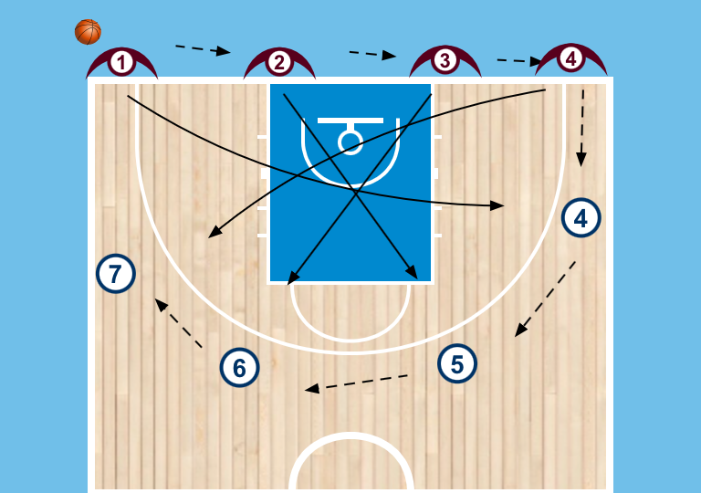  4v4 Serbian Closeouts  - Offensive players start in any 4 perimeter spots  - D starts line up across the baseline  - D will pass the ball across the baseline until it reaches the offense  - Offense will reverse the ball fully  - D can sprint to their job as soon as they make their pass, closing out the person opposite them  - Play live 4v4 on the full reversal | - Change alignment of offense (4out, 3ou-1in, etc..)  - Mix up where the play becomes live  - Transition on change of possession  - Change number of O and D on the floor (3v3, 5v5)
Transition Drills
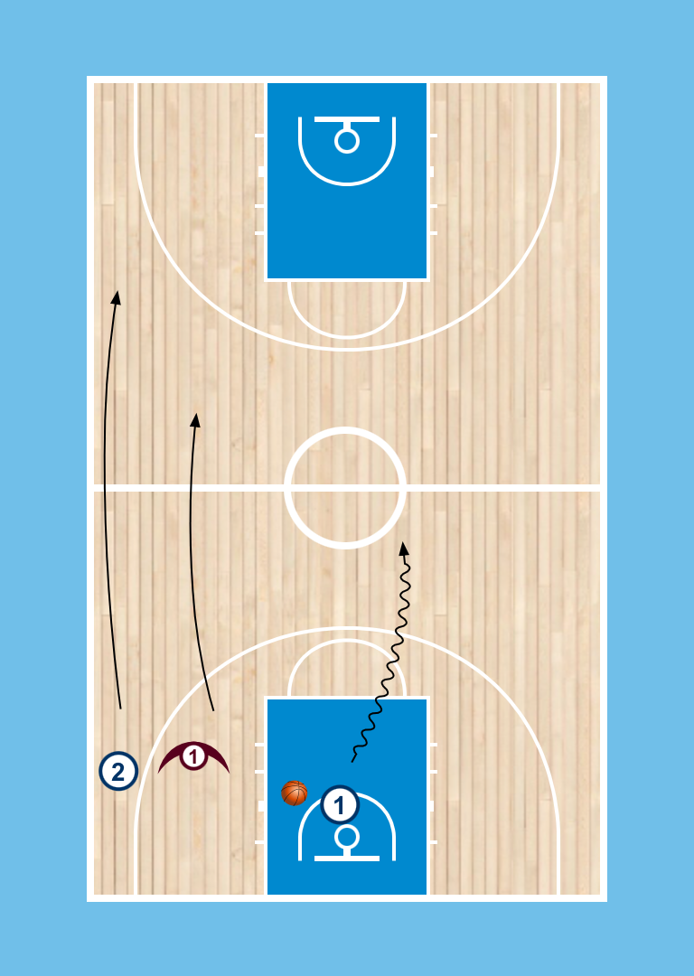  1v1 Full Court Wing Entry  - Offense and defense pair start wide on the wing  - Passer starts at the basket with a ball  - Passer initiates the drill by using a breakout dribble  - Wing lanes will run  - On pass to the wing(could be early or late) play live 1v1, passer is out | - Add offense and defensive pairs to increase the complexity( pressure on the passer to make it 2v2, another pair on other wing to make it 3v3, etc…)  - Have player throw ball off backboard to start to practice rebound and breakout dribble
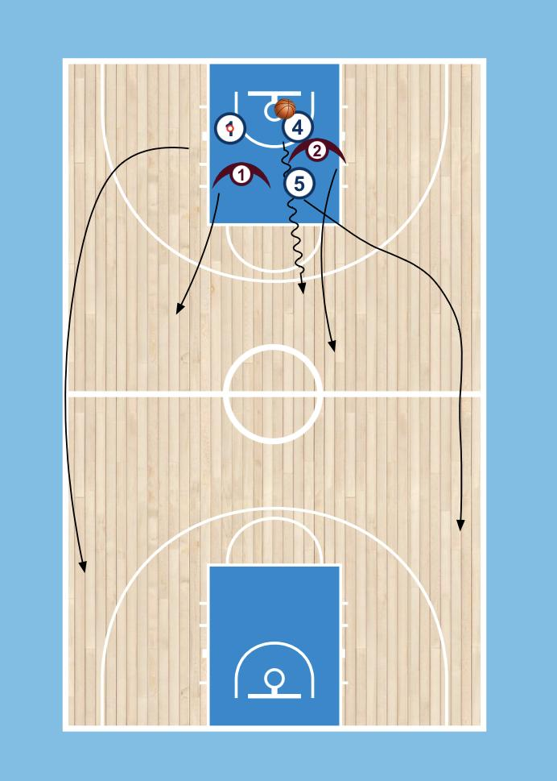  2v2 Breakout  - passer throws ball off backboard to start the drill  - 2 players from each team circle prior to ball toss  - coach will call out which team is on offense  - players will breakout and fill lanes  - passer will use breakout dribble to advance the basketball, play live 2v2 on on pass (passer is out after first pass) | - Change number of players on the court  - Could be 2v1, could be 3v2 where passer is live, offense is predetermined in this case. Ball is thrown off the board for O to rebound for complete random start  - Use perimeter and interior lanes as you add players (rim run)
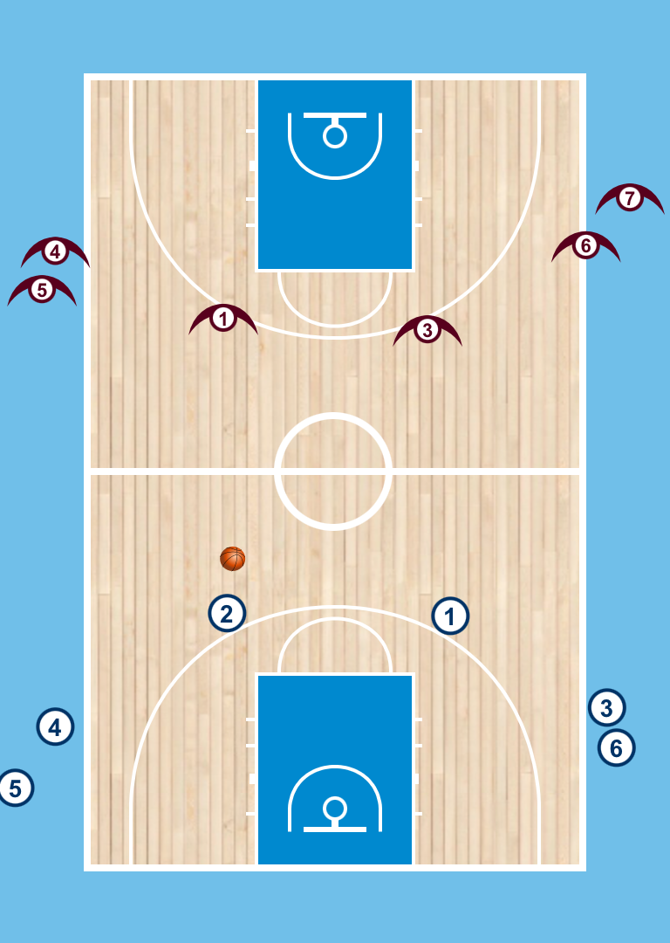  2v2 Transition  - Drill starts with each team split on either side of the court. Players will fill an outline line on either side  - Two players from each team start on the court with a 2v2 possession  - On change of possession the 2 offensive players get back on defense, the two defensive players outlet the ball to a teammate and then are off, two new players come in on offense to make it continuous  - So the rotations is always offense, to defense, to out | - Make it 3v3 by starting with 3 players on the court and having the rebounder stay each time  - Add another outlet line for each team(could be under the basket) to make it 4v4
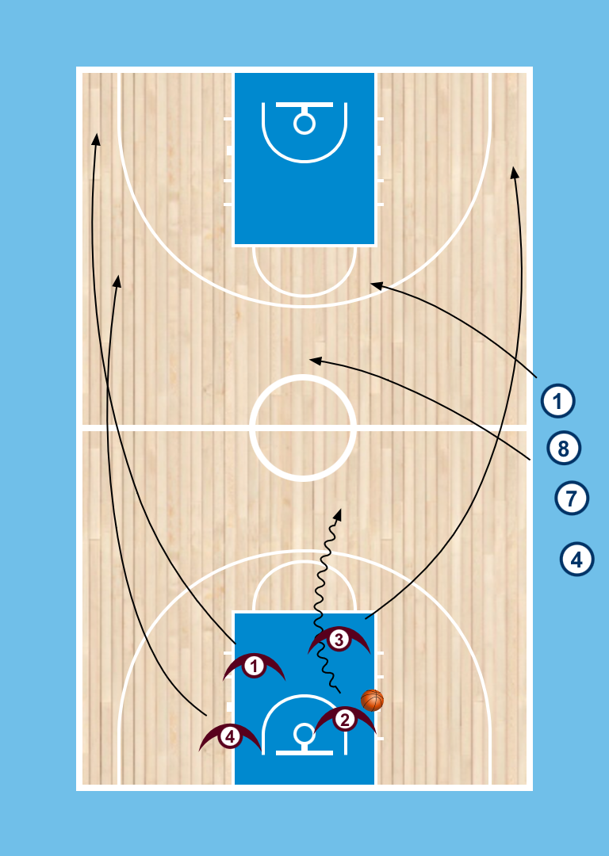  4 person breakout  - group of athletes on baseline and at half  - 4 Offensive players circle in paint and then breakout on coaches signal  - coach at half sends either 2 or 3 defenders to create advantage situation  - Play live once offense gets possession | - Change number of players on the floor to simply or add complexity  - Change number of defenders being sent in to play  - Have the remaining defenders come in late to make it 4v4 so offense has to quickly find the advantage before it's gone in transition (U13+)

