U13 DRILL LIBRARY
(Blue underlined text signifies Video link to supplemental material)

- Below are examples of drills that can be used and suggestions for what age group they are appropriate to use with. Drills listed in U11 category are easily usable and applicable for U13 and U14 levels as well with proper loads and relevant points of emphasis
- Suggested loads are also included that could be used to modify to fit your age level. Adding constraints to any of these drills will help reinforce your desired points of emphasis
- Most Drills can be adapted to incorporate transition by transitioning on the change of possession to play live for the desired number of transition trips
- Any drill with a Blue Highlighted title has a video demonstration
- Click Here to go to the BNB YouTube Drill Library to see a complete list
- You can also Click Here to access the drills from a word document that you can then copy and paste into your own Practice Plan

Suggested Age Group: U13+

Drill | Possible Loads
Penetration Principles / Dominoes Drills
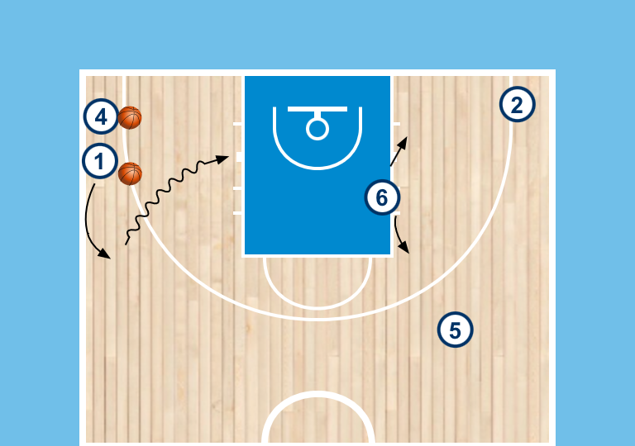  Drive and Kick Shooting  - line in corner, and opposite wing and 45, with a drop defender  - self toss to the wing, attacker must drive baseline  - drop defender will guide pass decision to either player, also guide decision of shoot or extra pass on first pass out | - Change location of the offensive players for a different drive and kick scenario  - Add second defender to make it live 2v2
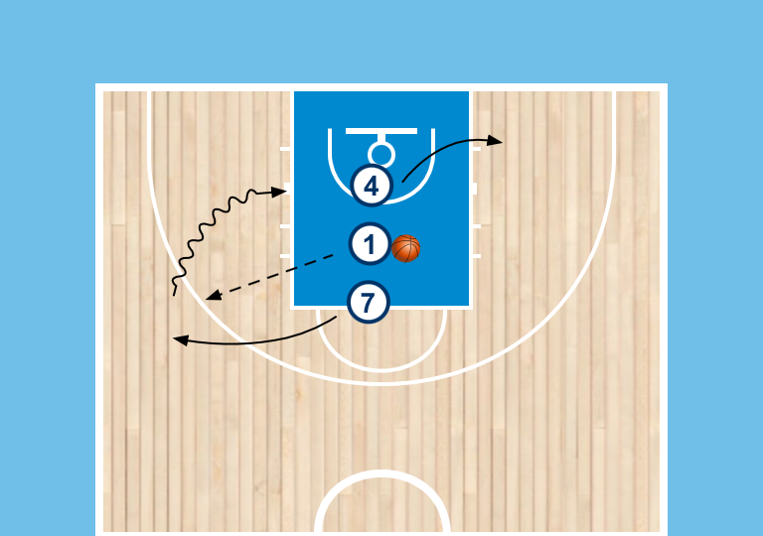  2v1 with waiting area  - 3 players line up, 1st and 3rd are on O, middle person is defender who starts with ball  - 1 st person fills any perimeter spot, 3rd person fills either waiting area  - defender throws to perimeter player and play live 2v1 on the drive | - Start offensive players in offensive positions to script the situation to start
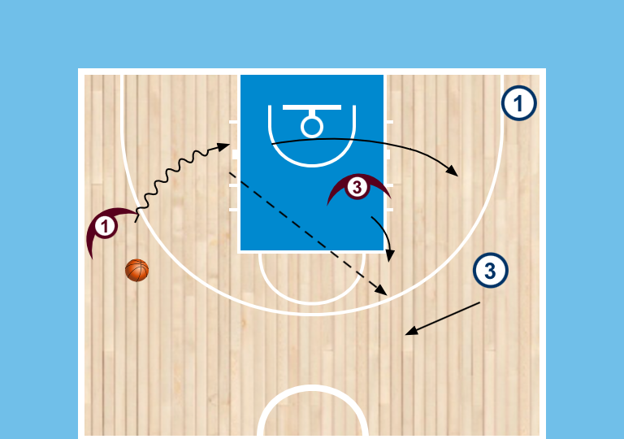  Weakside 2v2  - Start with two offensive players on weak side wing and 45  - D starts with ball and in take 2 position  - Player will drive and kick (take 2 will guide decision  - Play live 2v2 on the pass out. Take 2 will get first pass, passer will take second pass | - Change position of the players to create a different drive and kick scenario
Dynamic 1v1 Drills
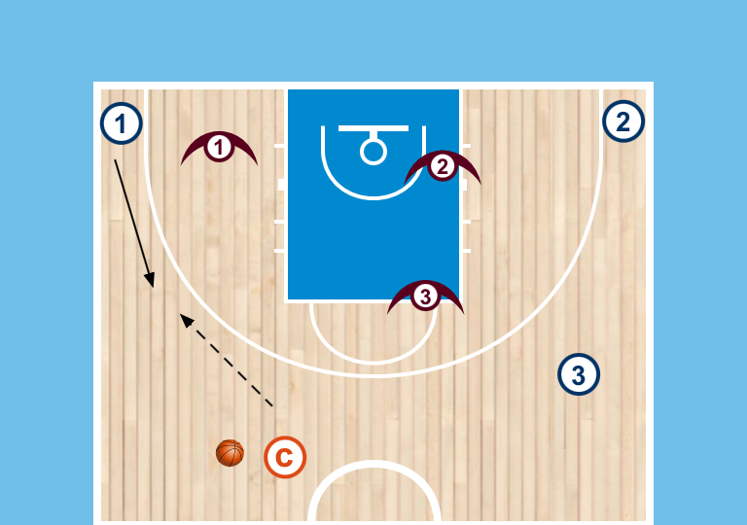  3v3 Blast Cut  - offense and defense pair in the corners and weakside 45  - extra player has ball at the top (signified by a coach)  - player will blast out of the corner for a catch  - Play live 3v3 on the entry pass, D is live on the blast cut | - Change number of players on the floor (2v2, 4v4, etc…)  - Change location of the blast cut  - Put guided defender on the blast cut who guides the decision to start  - Have pass be a live player whos in the drill after the pass
Defensive Drills
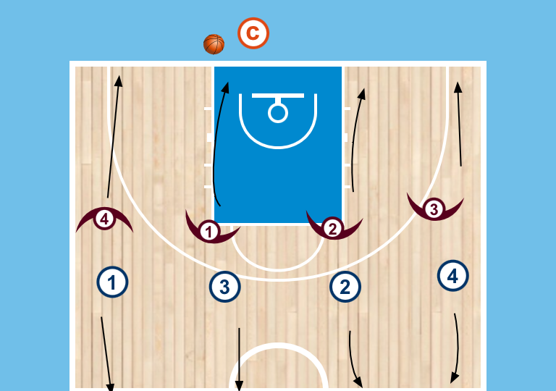  4v4 Transition Blockout  - offense and defense pairs line up with each other, coach has the ball on the baseline  - O will run and touch half while D touches the baseline  - Coach will throw to any offensive player  - player must make an extra pass then ball is shot  - players will play the rebound live and transition down once offense gains possession | - Change number of players on the floor  - Have offensive athletes fill different positions on the floor when running in (perimeter or interior)
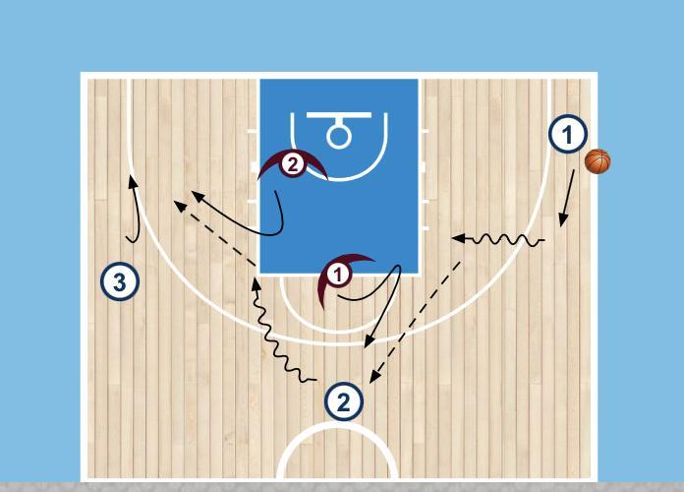  Stunt 1v1  - Start with O in corner with ball and O and D pair at top and on wing  - Self toss to the wing and drive middle  - Ball is kicked to the top, second drive happens with a kick to the 3rd player  - Play live 1v1 on the last catch | - Change location on the floor where ball is live
3v2 Stunts  - Same as above except play live 3v2 on last catch  - One defender takes the ball, the other gets to help | - Change location on the floor where ball is live
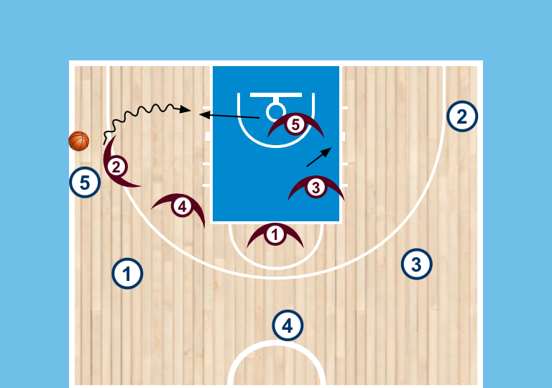  5v5 Ball on back  - Offense and defense start with 5out spacing  - defender guarding the ball starts with the ball on their back  - Play live on the first bounce  - MIx up where the ball starts | - Change the alignment of the offense (5out, 4out-1in, etc…)  - Change the number of Offense and defensive pairs (3v3, 4v4, etc…)  - Mix up where the ball starts from
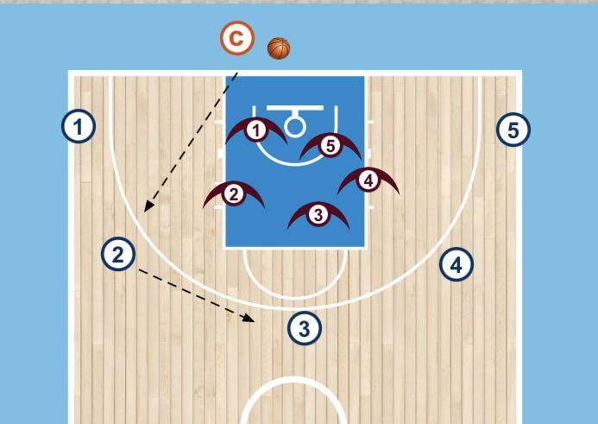  D circles - into transition  - offense starts 5 out  - D starts circling in paint  - Coach on baseline with a ball  - Coach throws to any player, they make 1 more pass with D sprinting to their jobs  - on extra pass, player will shoot  - Play live on the rebound transitioning once D gets possession | - play live halfcourt possession on coaches pass as opposed to scripting a shot  - Change the number of offense and defense (3v3, 4v4, etc…)  - Change alignment of the offense(4out-1in, 5out, etc…)  - Mix up where it's live(play live offense on throw out, live on full reversal, etc…)
Transition Drills
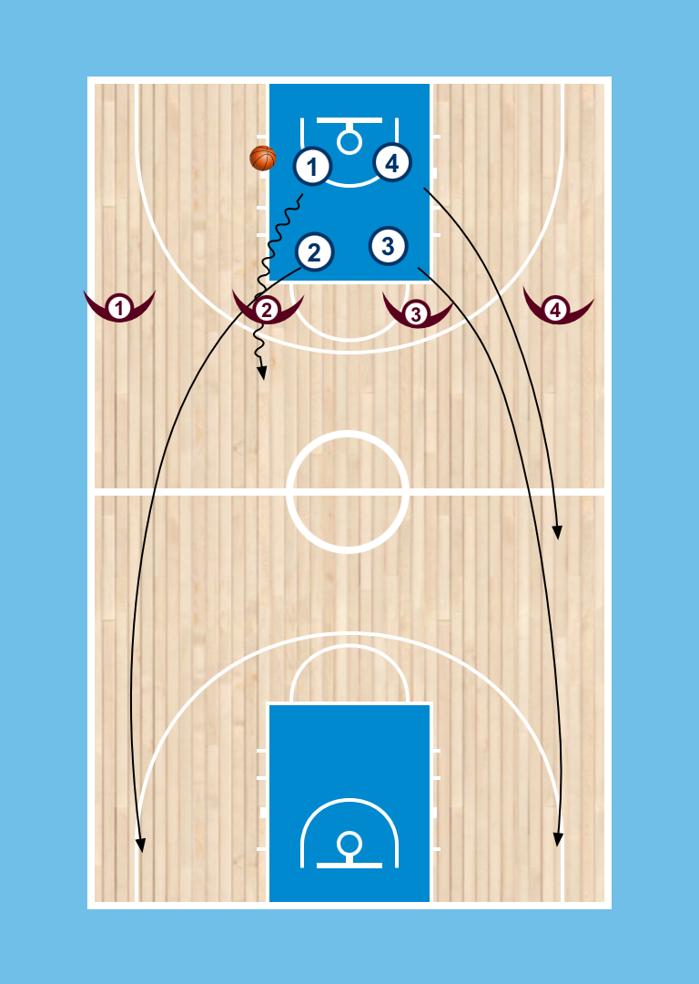  4v4 Across the FT Line  - d starts lined up across the Ft line and each lane has a designated number  - Offense starts by circling in the paint  - Coach will throw the ball to offense and call an number  - Defender whos number is called has to touch the baseline before entering the play  - Play live once offense gains possession | - Change number of players on the floor(3v3, 5v5)  - Mix up how many numbers are called (call 2 for bigger advantage, call none for a neutral possession, etc..)  - Start offense already in established laned spread along the baseline (U11+). Coach throws ball to any of the offensive players to initiate drill
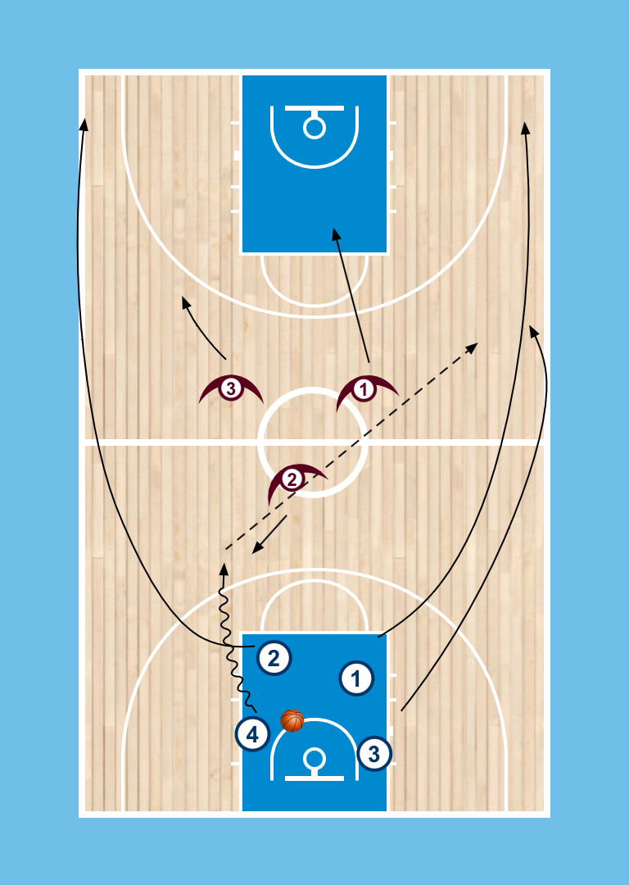  Scripted 2 side Break  - 4 Offensive players will start by circling in the paint  - defense will setup at half  - Coach will enter the ball to offense and they will play live 4v3 | - Add or subtract offensive or defensive players for the desired focus(3v1, 3v2, etc…)
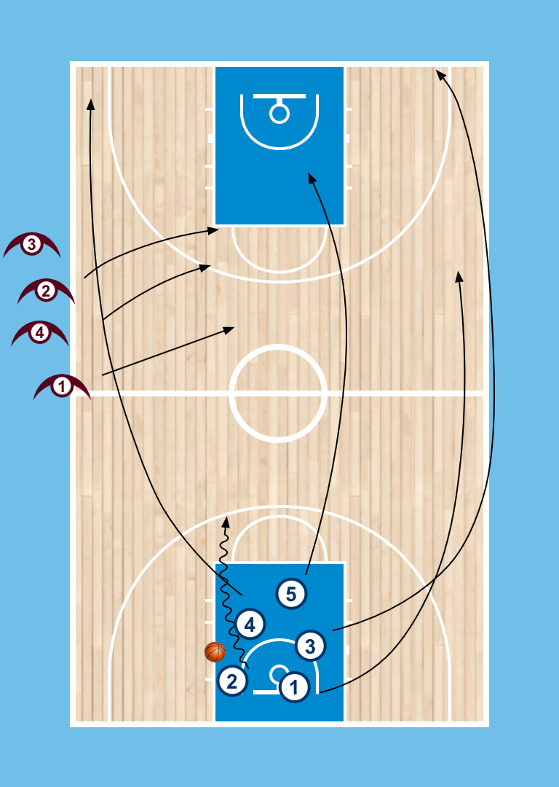  5 Person Breakout  - group of athletes on baseline and at half  - 5 Offensive players circle in paint and then breakout on coaches signal  - coach at half sends 3-4 defenders to create advantage situation  - Play live once offense gets possession | - Change numbers of defenders sent(3,4, 5, etc…)  - Extra defenders come in late(after ball cross half) to make it an even number of O and D
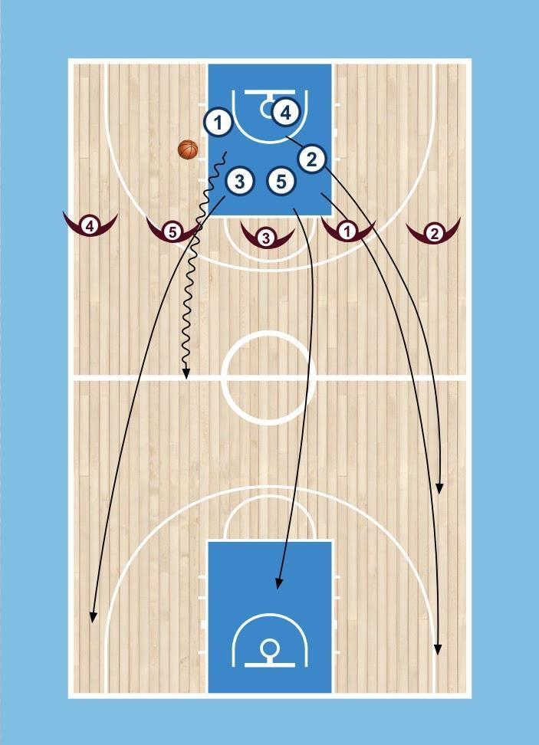
Across the FT Line 5v5
- Offense starts circling in the paint
- D starts across the Ft LIne
- Coach will enter the ball to offense and call in or out
- Out - two outside lanes touch before defending
- In - two alleys touch before defending
- Play live down and back
- Coaches will choose the coverage for D
- Use Ballscreen as trigger on Neutral
Using Triggers Drills
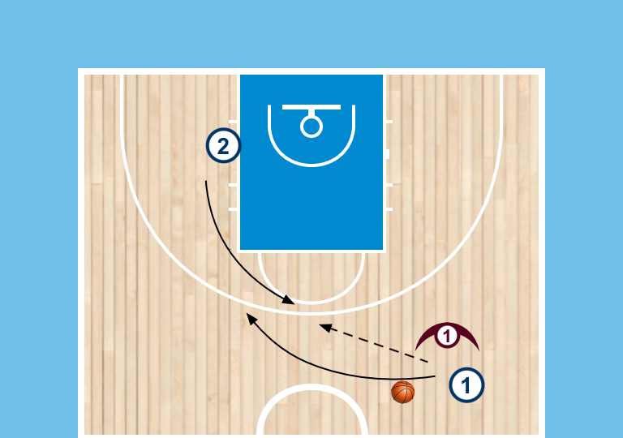  Intro to Gets  2v1 - D on the Passer  - Offense and defense up top with Offense in waiting area  - Offense has to dribble to the 45 and teammate will lift into Get  - pass goes to the Lift to execute a Get(handback)  D will Guide decision  - D Dirties the pass  - allow catch and chase over  - Load in D going under  Play live 2v1 out of the action | - Change location of the Get(elbow, wing, etc…)  - Add offensive and defensive pairs to make it (3v2, 4v3, etc…)  - Limit or add to the options for the Guided D to give the offense  - Use Twist as an option against the Under(U14+)
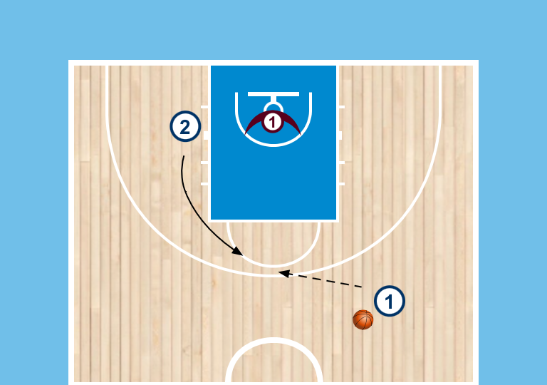  2v1 - D on the receiver  - same setup but put Defender on lift person  - play live 2v1 out of the action  - D will guide decision  - Give advantage on the lift catch  - handback happens  - Cheat to the handback | - Change location of the Get(elbow, wing, etc…)  - Add offensive and defensive pairs to make it (3v2, 4v3, etc…)  - Limit or add to the options for the Guided D to give the offense
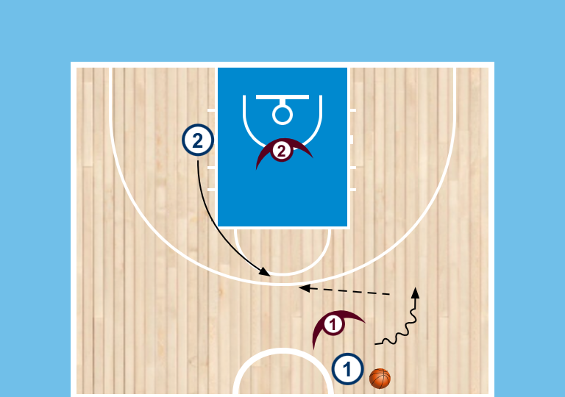  Gets  Live 2v2 out of Get  - same setup with Offense and defense pairs now  - ball is dribbled into the 45 ans waiting area lifts  - Play live 2v2 | - Change location of the Get(elbow, wing, etc…)  - Add offensive and defensive pairs to make it (3v3, 4v4, etc…)  - Place a constraint on how the defense can guard the action
Using Triggers - Get Action  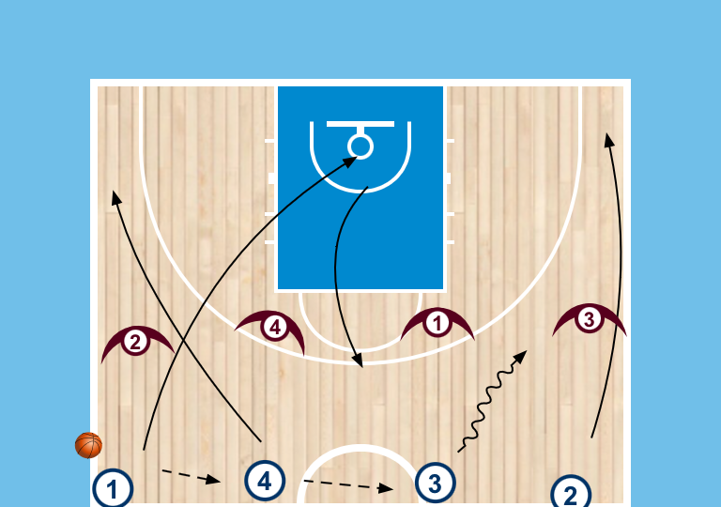  4v4 Flow - Scripted start for Trigger person  - offense starts lined up across half with D matched up but along the 3pt line  - offense pass to each other until it reaches the opposite alley  - players can run theri lane right away  - Coaches will script whether we have a Lift or Trail  - Play is live at opposite alley  - With offense starting from neutral we want to use a Get to trigger an advantage | - Change the number of offensive or defensive players (3v3, 5v5, etc…)  - Change the location of the Get(elbow, wing, etc…)  - Change triggers being used (DHO, Ballscreen(U14+), Away screen(U14+), etc…)
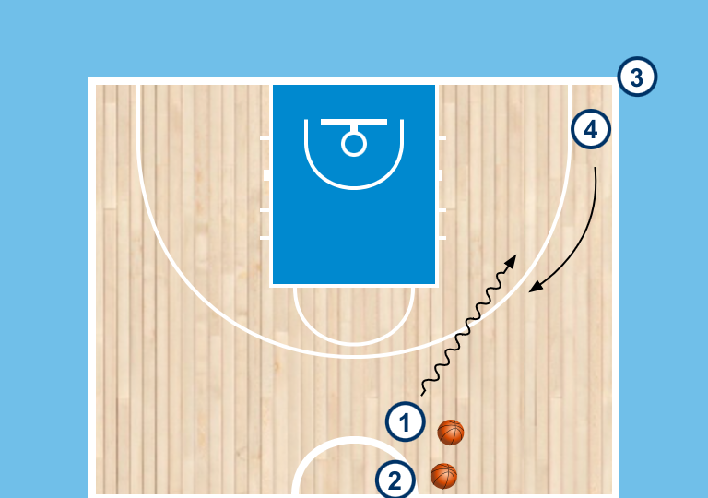  DHO Shooting  - Line with basketballs in an alley, line in the corner without balls  - execute dribble hand off  - Shot#1 - receiver drives middle to a pullup  - Shot # 2 - receiver throws it back for a catch and shoot  Load to 2v2  - add defenders to each player  - Play live 2v2 | - Change location of the DHO  - Add guided defender to cue the reads  - Use different finishes  - Add more Offensive and defensive pairs when it's live (3v3, 4v4, etc…)
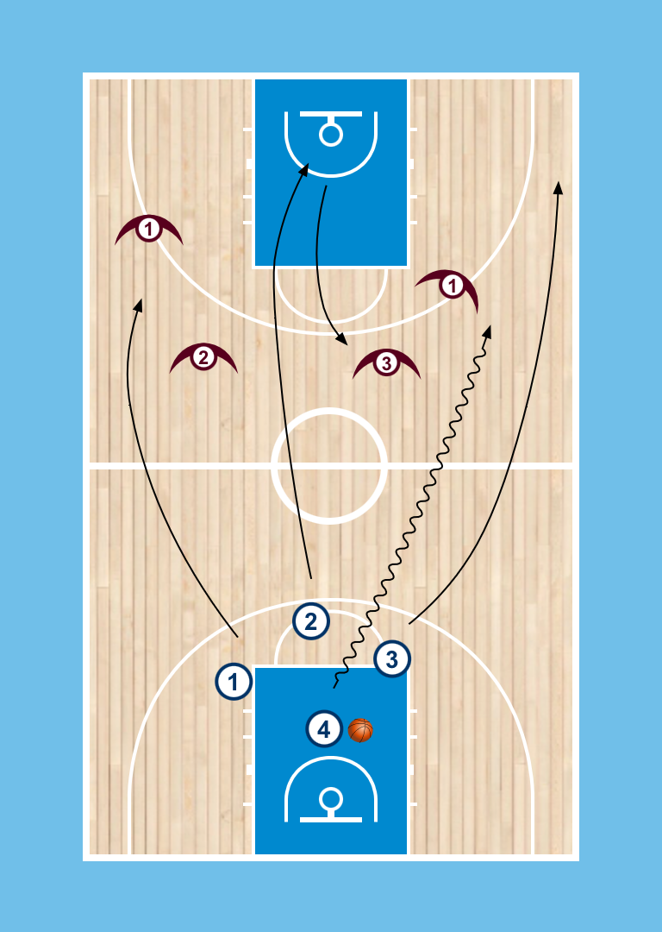  4v4 Circle - ¾ court Start  - offensive players start in a circle  - Coach throws ball to the offense to break out into lanes  - Flow into trigger in half court if neutralized | - Change the number of offensive players on the floor(3v3, 5v5, etc…)  - Change triggers being used (DHO, Ballscreen(U14+), Away screen(U14+), etc…)
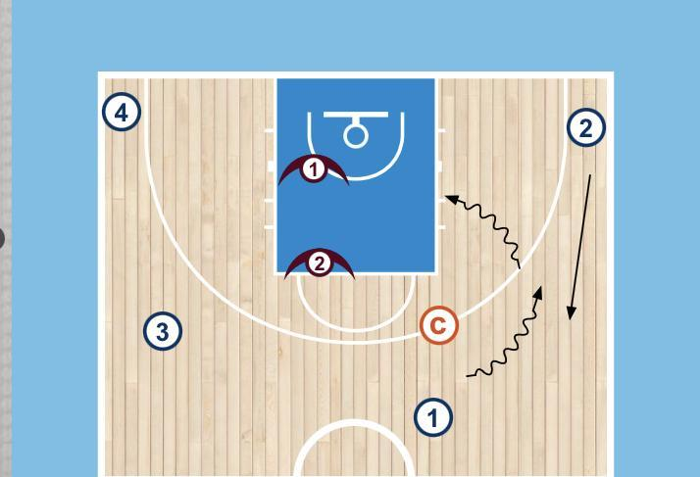  3v2 out of DHO  - start with 45’s and corners filled  - ball starts in a 45 with coach guarding and two defenders on weakside  - coach will guide keep or handoff, whoever attacks plays 3v2 with weakside players  - offense who doesn’t attack is out  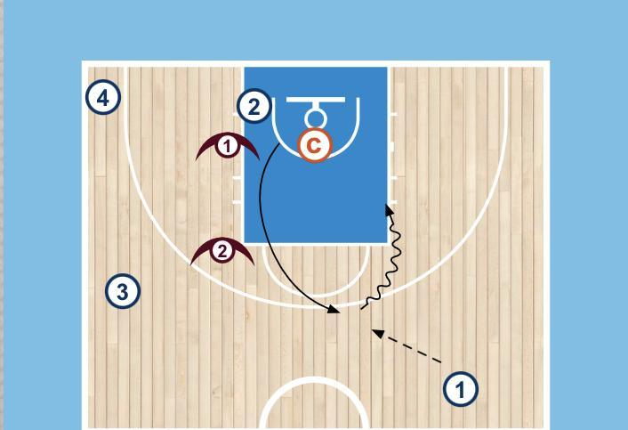  3v2 out of Get  - offense fills alley, weakside corner and 45 and waiting area  - ball starts in alley with coach on waiting area and two weaksided defenders  - offense will lift into a get where coach will guide Keep or handback, whoever attacks plays 3v2 with weakside players  - offense who doesn’t attack is out | - Change location of the action  - Change the number of players on the floor (2v1, 4v3, etc…)  - Change the location of the guided defender to cue different reads
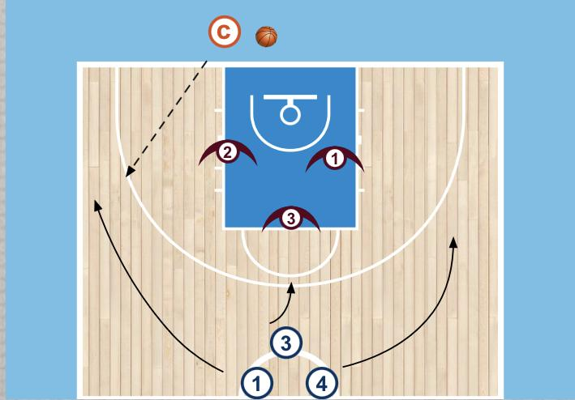  Cutthroat  - Offense players start in center circle, defenders start inside the paint  - Offense will run into position and coach will throw the ball out to any player  - Live on coaches pass | - Change the spacing being used by offense (could fill interior or perimeter positions, could be scripted or random)  - Change when the ball is live(on a reversal, out of an action, etc…)  - Change the number of players on the floor (3v3, 4v4,etc..)  - Mx up trigger being used when neutral  - Can have offense stay if the score or defense can stay if they score, always rotate having D start in paint and O coming in from half
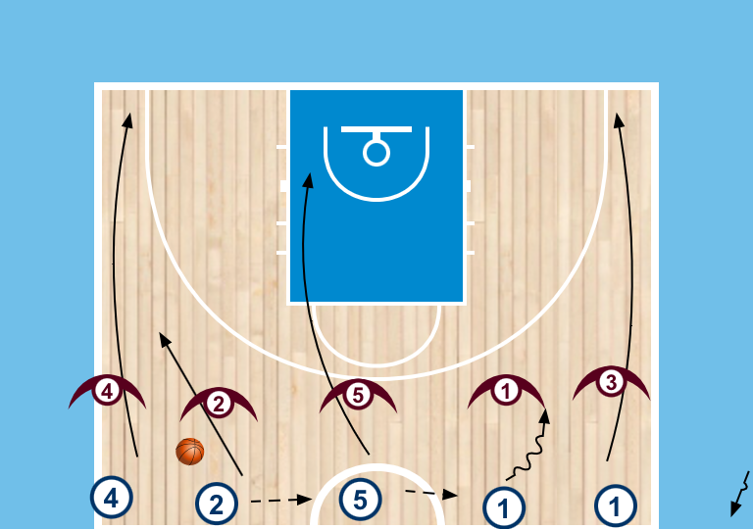  5v5 FLow  - 5 across half with D lined up to match  - Ball will be passed until it reaches opposite alley  - Everyone runs lanes after first pass  - Run trigger on neutral catch (could be DHO or straight to get or ballscreen)  - Live 5v5, transition on change of possession | - Change the number of players on the floor (3v3, 4v4,etc..)  - Mx up trigger being used when neutral

