U14 DRILL LIBRARY
(Blue underlined text signifies Video link to supplemental material)

- Below are examples of drills that can be used and suggestions for what age group they are appropriate to use with. Drills listed in U11 category are easily usable and applicable for U13 and U14 levels as well with proper loads and relevant points of emphasis
- Suggested loads are also included that could be used to modify to fit your age level. Adding constraints to any of these drills will help reinforce your desired points of emphasis
- Most Drills can be adapted to incorporate transition by transitioning on the change of possession to play live for the desired number of transition trips
- Any drill with a Blue Highlighted title has a video demonstration
- Click Here to go to the BNB YouTube Drill Library to see a complete list
- You can also Click Here to access the drills from a word document that you can then copy and paste into your own Practice Plan

Suggested Age Group: U14+

Drill | Possible Loads
Using Triggers Drills
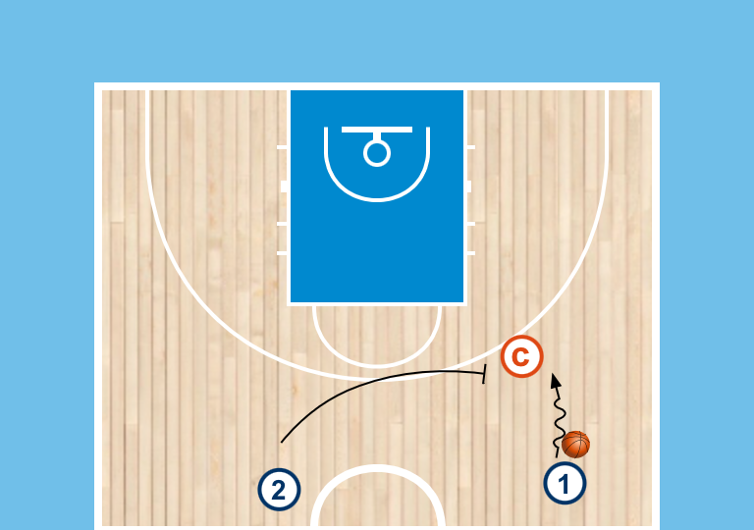
1) Skate Dribble Setup
- players with ball in 45, players without in the trail lane
- players will skate dribble to setup screen
- coach will guide reject or use
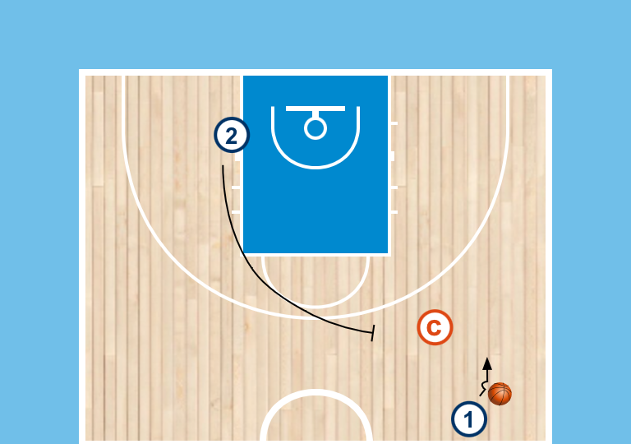
2) Half Spin / bully
- same setup but change location of the screener and change the setup move of the ball handler
- coach will guide reject or use
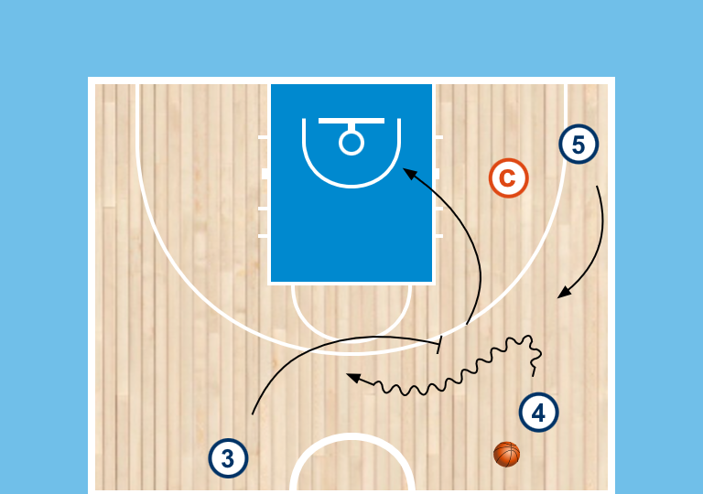
3) passive coverage - read the tag
- Offense has player with ball in 45, trail, and stringside corner, defender on screener
- Coach will guard the corner to represent tag
- will guide whether to pass to the roller or the shake
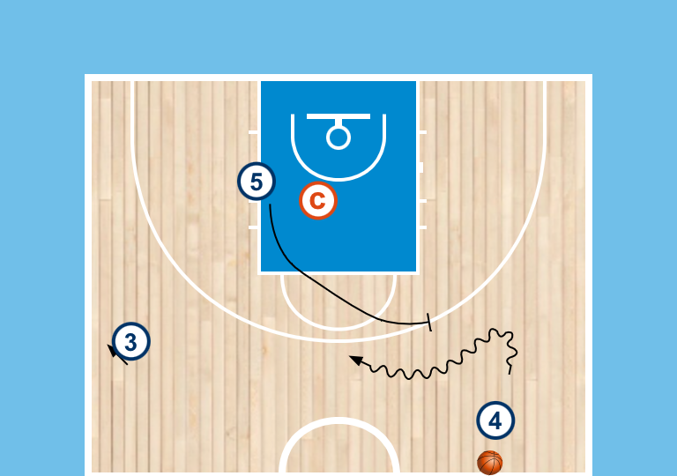
4) Aggressive Coverage - pass ahead
- Offense has players in each 45 and 1 waiting area
- coach will be waiting area defender
- ball is thrown to either 45 and waiting area sprints into screen
- coach will guide (bad switch-turn the corner, or stop the ball - pass ahead for relay to roller)
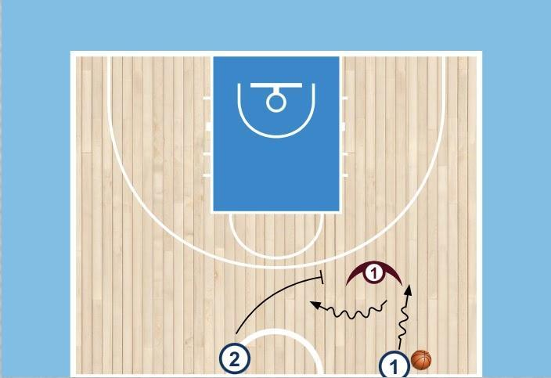  2v1 Ballscreen  - Ball handler in an alley  - Teammate in the trail position  - Ball handler dribbles into the 45 and Tral sprints to set screen  - Play live 2v1 out of the scenario  - Play from both sides | - player now live defender on the ball handler to make it 2v1  - Use a constraint on how the defender can guard the action
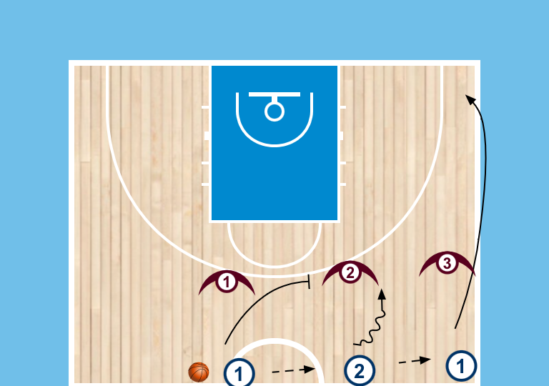  3v3 Flow - Passive Coverage  - offense starts across half with trail, 45 and corner lanes  - D lines up with O  - ball is passed once to start the drill and everyone can run theri lanes  - trail will set a drag screen for the ball handler and we play live 3v3  - Defense has to play Drop coverage | - Change the number of players on the floor (2v2, 4v4, etc…)  - Change location of the players or where the screen is taking place  - Allow defense to change the type of coverage of the screen
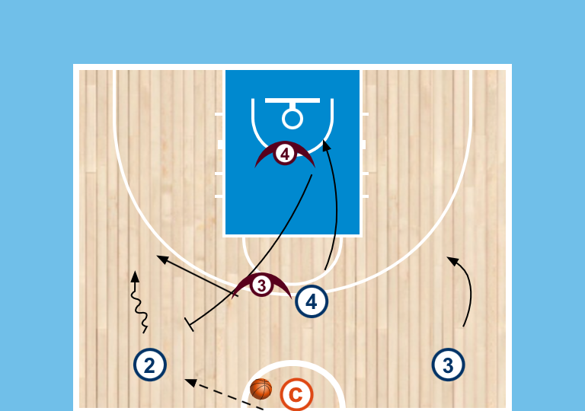  3v3 Flow Aggressive Coverage - with rim run  - offense starts lined up in alleys, and ahead of the ball, D matched up but along the 3pt line  - Coach starts with the ball and will pass to either alley  - Players run lanes on the pass  - Play live 3v3 out of the ballscreen (lift into screen)  - Defense has to switch the screen | - Change the number of players on the floor (2v2, 4v4, etc…)  - Change location of the players or where the screen is taking place  - Allow defense to change the type of coverage of the screen
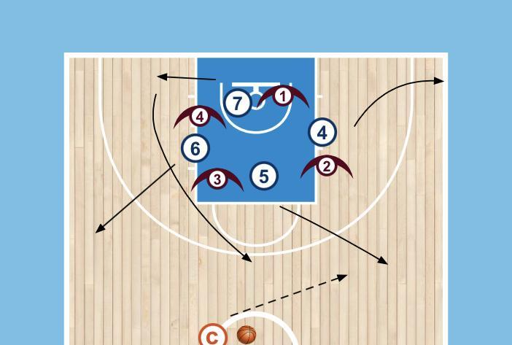  4v4 Circle - Live into Get  - teams of 4 circle in the paint with a staggered setup, coach has the ball at the top  - Coach will call a colour to signal whos offense and they will fill both 45’s, a waiting area, and a corner  - Coach enters the ball to an alley to cue live 4v4  - If neutral waiting area will lift into Get action | - Change number of players on the floor  - Change location of the players(could be interior or perimeter positions, could script or allow players to make it random)  - Change the trigger being used (post up, blast cut, DHO, ball screen, etc…)
Combining Triggers  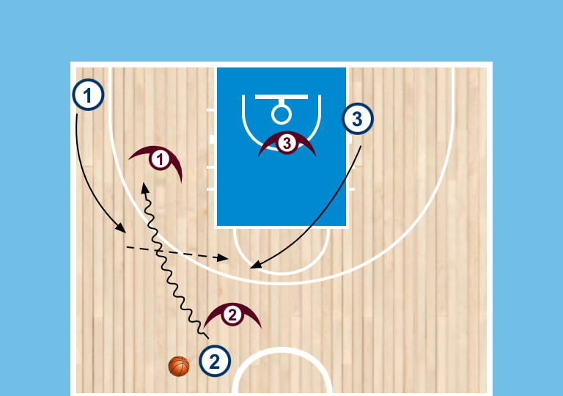  Scripted 3v3 - DHO into Get  - offense and defense pair in alley, corner and waiting area  - Play live out of the DHO  - waiting area will lift on the dribble at | - Change number of players on the floor  - Change location of the players(could be interior or perimeter positions, could script or allow players to make it random)  - Change the trigger being used (post up, blast cut, DHO, ball screen, etc…)
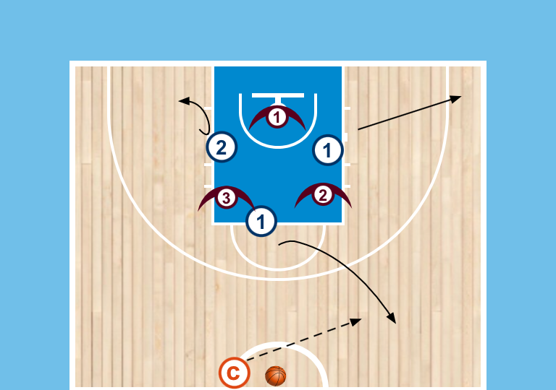  3v3 Circle - DHO to Ballscreen  - teams of 3 circle in the paint with a staggered setup, coach has the ball at the top  - Coach will call a colour to signal whos offense and they will fill 45 and corner, and a waiting area  - Coach enters the ball to an alley to cue live 3v3  - players will run DHO into ballscreen if neutral | - Change number of players on the floor  - Change location of the players(could be interior or perimeter positions, could script or allow players to make it random)  - Change the trigger being used (post up, blast cut, DHO, ball screen, etc…)
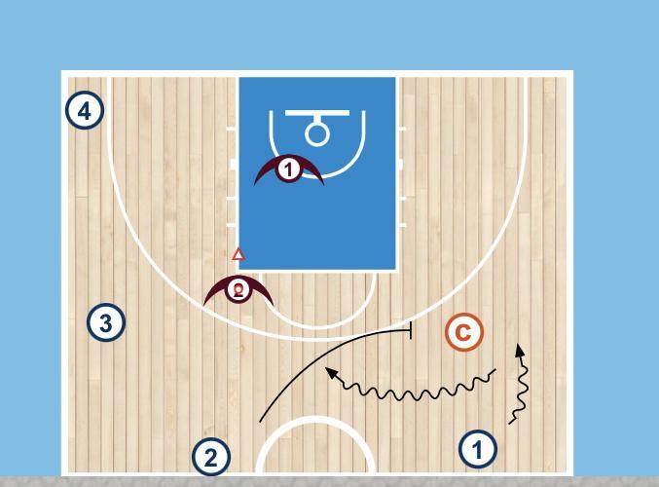  3v2 out of Ballscreen  - start with alley, trail, and weakside 45 and corner filled  - coach will guard the alley, with defenders on weakside  - coach will guide reject or use the ballscreen  - ball handler plays 3v2 on attack, screener is out | - Change location of the action  - Change the number of players on the floor (2v1, 4v3, etc…)  - Change the location of the guided defender to cue different reads
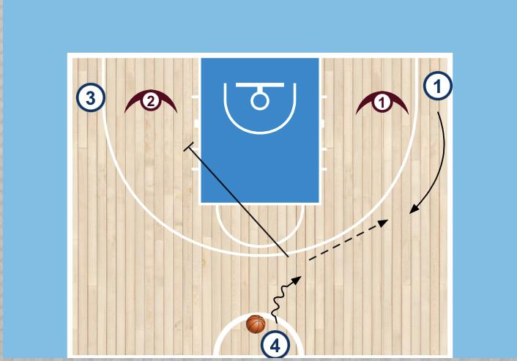
1v1 Screen Away - Guided Reads
- setup with unguarded player at top, and offense and defense pair in each corner
- player at top will dribble to one side cueing a blast cut from that side.
- on wing entry, passer will set a pin down for opposite corner
- ON ball defender is just pressuring the passer, the cutter's defender is guiding the decision of where offense has advantage.
- 3 guided reads:
  - D overplays - back door
  - D trails - curl
  - D goes under - pop to space
- play live 1v1 on the catch

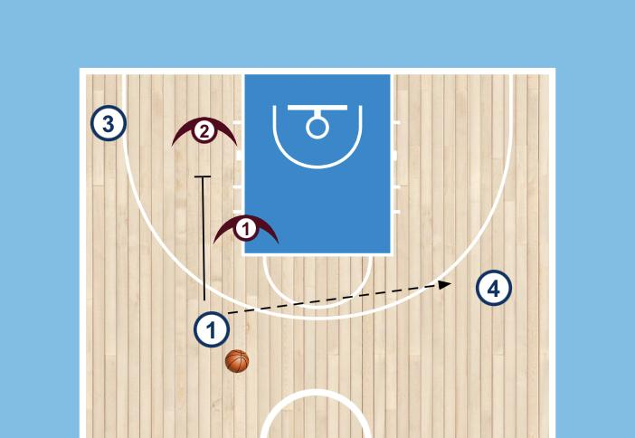  2v2 Screen Away  - Offense and defense pairs start in swing and corner, unguarded passer in opposite swing  - Pass goes to unguarded player which cues the screen away  - Play live 2v2 out of the action | - Change location of the players  - Change the number of players on the court(3v3, 4v4, etc…)
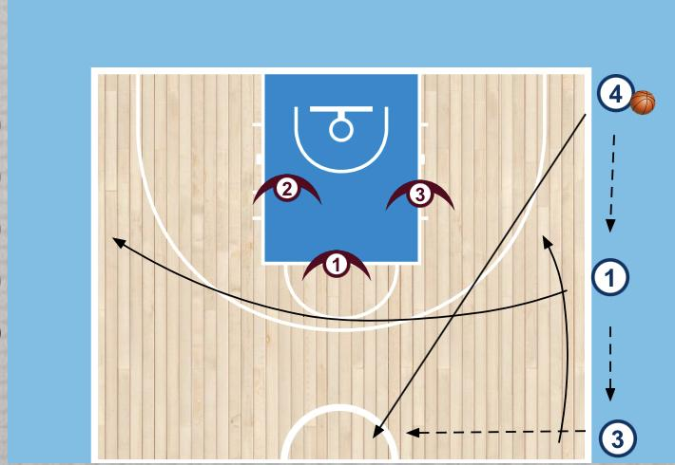  Korean Passing - Into Trigger  - Offense Players spread out up the sideline, defenders start in the paint  - Ball starts in the corner and is passed up the line with passers running to new space  - Once ball gets to the top it is live 3v3 | - Change the trigger being used (could be scripted or random, Blast(U11+), Get/DHO(U13+), Ballscreen/Away(U14+))  - Use a constraint to how the defense can guard actions (could be scripted or random)  - Change where the ball is live from
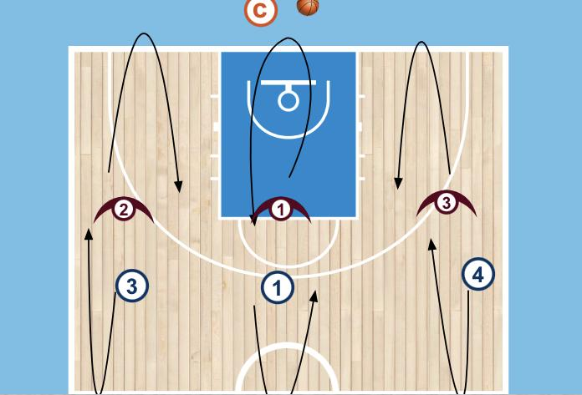  Halfcourt Touch  - offense runs to touch half, D runs to touch baseline before they sprint back to meet and play  - coach can throw out to any spot, live on first catch  - if ball goes to a wing, middle player has option to cut to create a double gap or screen away  - if pass goes to the middle, player can pass to either wing and then has option to cut to create a double gap or screen away | - Change number of players (4v4, 5v5)  - Change the locations on the court the are filling(could be interior or perimeter positions, could be scripted or random)  - Change the trigger being used (could be scripted or random allowing the athletes to chose)
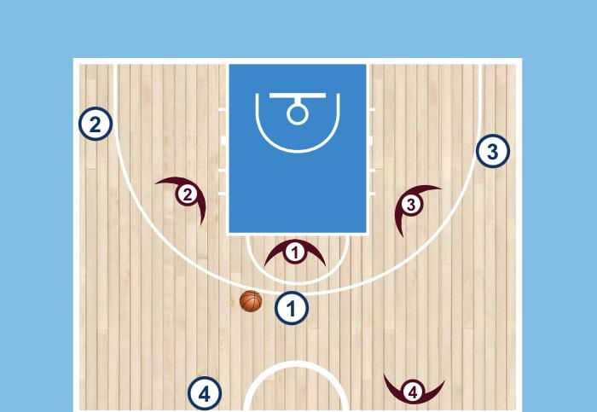  Dynamic 3v3  - Players plays half court 3v3  - On a change of possession ball has to be cleared to a player on your team positioned at the top  - They will enter it back in for play to continue. This relay person can move to make it easier to pass to  - Subs are made while ball is being cleared, need to be quick | - Change numbers of(2v2, 4v4, etc…)  - Change triggers that are being used/allowed
Transition Drills
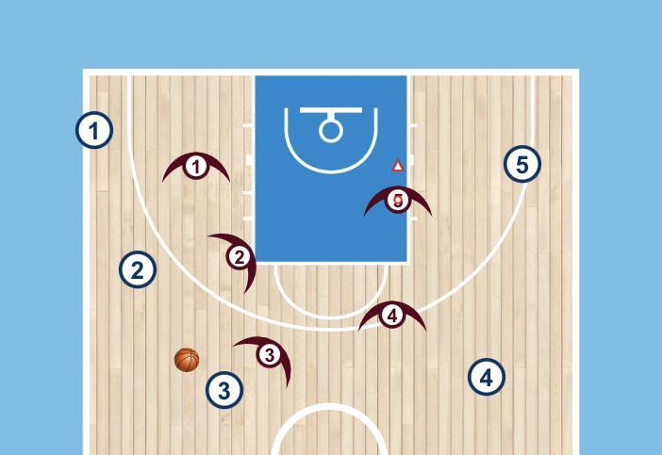  5 Passes into trips  - two teams matchup in half court.  - Offense tries to complete 5 passes in a row without a turnover (Offense has no dribble)  - Once O completes 5 passes they set the ball down and Defense takes possession and we transition down and back  - If defense forces a turnover they transition right away | - Change number of players on the floor  - Change number of passes before its live  - Change number of trips being played

