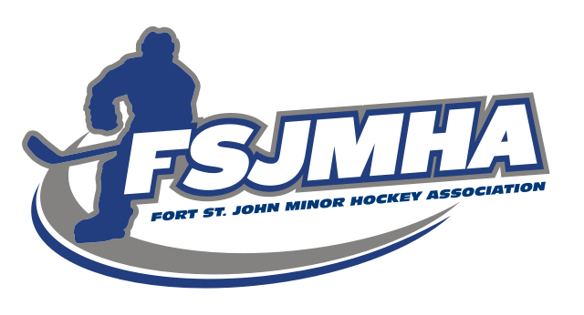

2021/2022 FSJMHA President’s Report
I would like to offer a huge thanks to the FSJMHA executive and all the other volunteers who put in countless hours to make minor hockey succeed in Fort St. John. This hockey season was another challenging season with a lot of moving parts and changing constraints to adapt and follow.
FSJMHA persevered through these challenges and managed to successfully navigate our way through the obstacles and finally have actual hockey games!
Season challenges:
2021/22 was a challenging season, but I believe the players were able to quickly adapt and enjoy the sport of hockey.
- Return to shared ice programming for practice ice times
- Alternative league for our U13, U15, and U18 Competitive teams: played in North Central District League vs. PG, Quesnel, Williams Lake
- Provincial COVID-19 restrictions for spectators and volunteers
- Cancelled January tournaments and travel restrictions
- NERHL regular season and playoffs
Through all these challenges we were able to adapt and keep the kids on the ice playing the sport they love. Thank you for your support.

Thanks,
David Batten
FSJMHA President
FSJ Minor Hockey Office:Box 6356 Fort St. John, BC V1J 4H8 (250) 787-7133 Fax (250) 787-7134
Pomeroy Sports Centre, 9324-96th Street
Email: fsjmha@outlook.com

