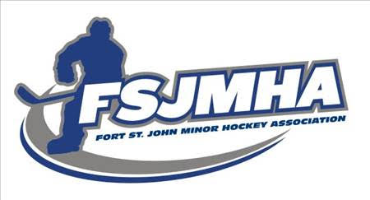

2021-2022 VP Operations Report

This season went fairly smooth. We began trying to replace all our U9 and U11 goalie gear. There where significant shortages of goalie gear available to purchase due to Covid outbreak in the factories overseas in the summer leading to product shortages. Hopefully we will be able to complete the replacement before next season. I also purchased as much good used gear as I could find to make sure we had enough sets for all teams. I still had requests for more gear then I could get my hands as there was a lot of kids wanting to try the position as well. This is definitely a good sign for our goaltending future. As soon as the season is over I will get all the goalie gear, jerseys and puck bags returned. Then I can track down any missing items so we are all set for a smooth start to the 2022-2023 season.

Paul Milne

