New Member - How to Register

If you are a new member to SPN Central looking to create your account, please visit our website at www.slo-pitch.com and clicking on in the top right corner.
Then by clicking on the register tab and filling out the information.
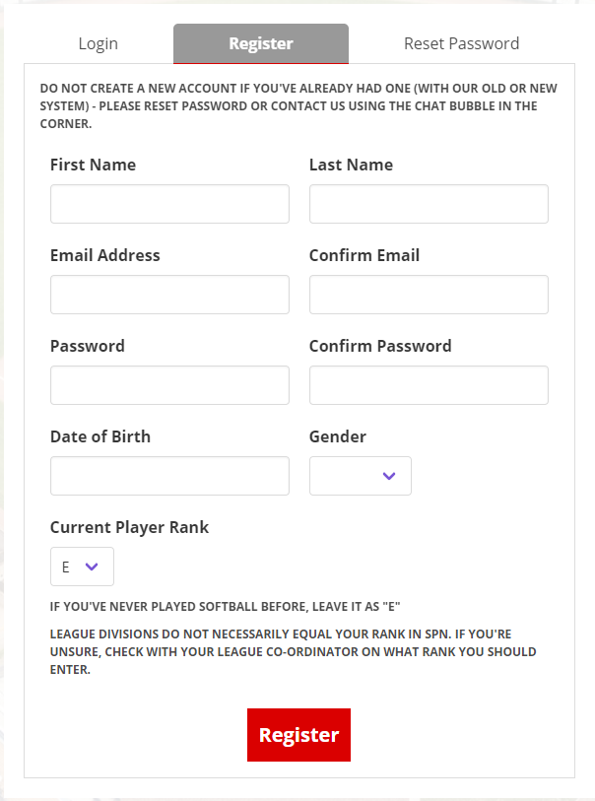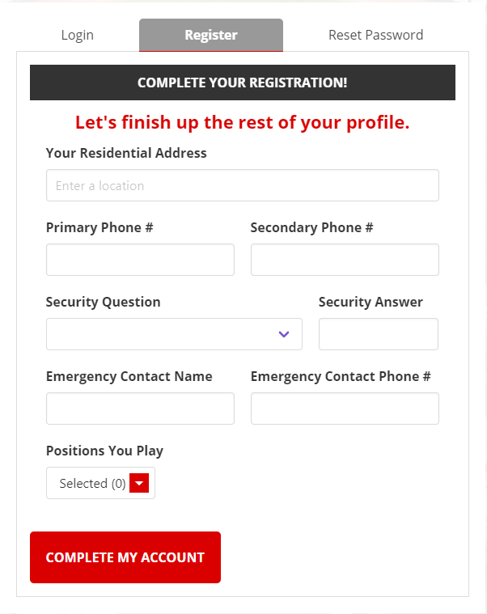
Image 1 Image 2
Once you have filled out the information and click register you will then fill out the rest of your profile information. (image 2)
NOTE: If you email is already in our database you will receive a message that your email is already is use. You can reset the password on your account using the reset password tab.
Once the information is completed click Complete my account You will receive an email to confirm your account. Once you confirm your account you will be able to access your account with the password you created!

