I am a Team Contact/Coach – How do I edit my team?
On the SPN website (www.slo-pitch.com) click LOGIN TO SPN CENTRAL (top right).
If this is the first time you are logging in for the 2021 season you will be required to reset your password. This is a one-time only security feature. Click on the Reset Password tab on the login screen. By using your email address, you will receive an email to create your new password and regain access to your existing account.
Once logged in the menu on the left under PLAYERS AND COACHES click on My Teams
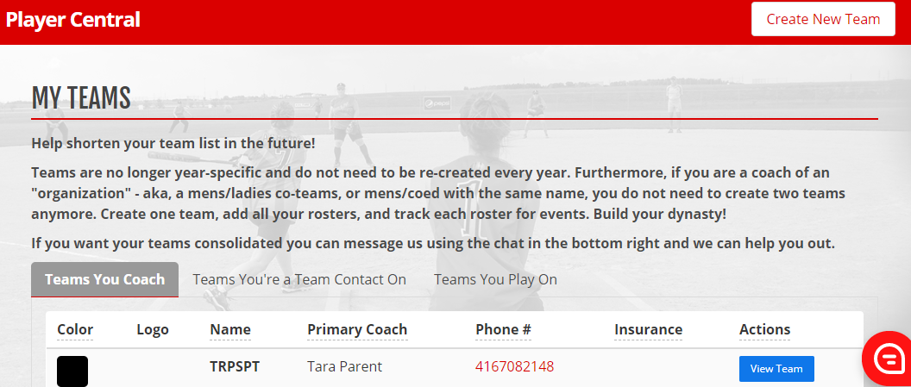
You will see on the screen that with this new system teams are no longer year-specific and do not need to be re-created every year. And, if you have a same sex team and a coed team with the same name, you do not need to create two teams anymore. Create one team, add all your rosters, and track each roster for events.
On the screen you will see 3 tabs. Choose the appropriate Coach or Team Contact tab and find the team you wish to edit and click View Team.
You now have 5 tabs to choose from. You can see Your Full Roster, see Your Event Rosters, you can Edit Your Team, find your SPN Registration #s, or Archive Your Team if it is no longer active.
Click on Your Full Roster to manage the members on the roster. From this screen you can send your players a reminder to accept their waiver, you can add players, remove players, and change their roles on the team.
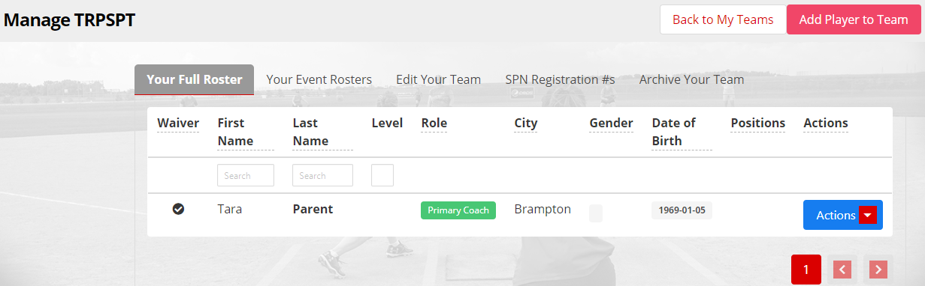

Under the “Edit Your Team” tab you can edit your team name, the city your team represents, choose your team colour and even upload a team logo!
