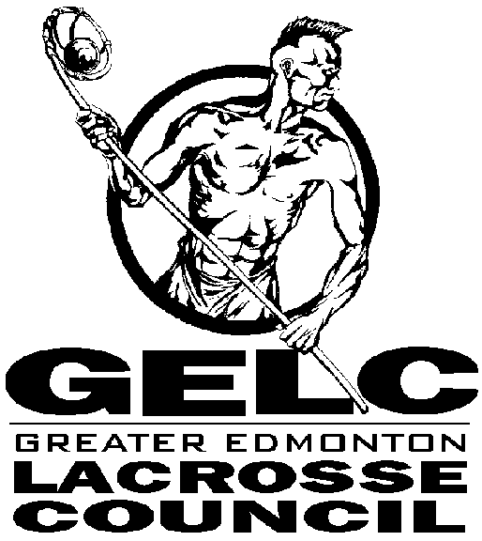
Policy | Awards Policy
Reason | To appreciate, recognize and honor contributions made by individuals to the sport of lacrosse that enhance the game within the GELC
President Award- Lifetime membership
The President Award may be presented yearly to someone who meets the following criteria.
- Outstanding service to the sport of lacrosse and the GELC.
- Past or present member of the Board of Directors of the GELC, coaches, or officials of the game.
- Members who may be considered are club presidents, club representatives on committees, Board committee chairs’, and or Board executive members.

These people will be considered lifetime members of the Greater Edmonton Lacrosse Council.
Written nominations must be submitted to the GELC Executive board via the GELC office by the 1 of November yearly. The award is to be presented at the GELC December social.

Coaching Award
The coaching Award may be presented annually to a coach, or assistant coach from one of the member clubs of the GELC.
- Required to have the minimum coaching requirements for the level that he currently is coaching at.
- Sets an example of positive leadership, and development of teams and individuals.
- Shall have been a member of the coaching ranks of the GELC for more than one season.
- Nomination must have an endorsement from a member of the coaches club.

Written nominations must be submitted to the GELC Executive board via the GELC office by the 1st of November yearly. The award is to be presented at the GELC December social.

Officials Award
The officials Award may be presented annually to an official or member of the Alberta Lacrosse Referees Association.
- Be a current member of the ALRA .
- Be a past member of the ALRA who should be duly recognized for his/her past efforts on behalf of the sport of Lacrosse in the GELC.
- Nomination comes with an endorsement from more than one individual.
- Game management skills, interpersonal skills with the coaches, and players are important criteria.

Written nominations must be submitted to the GELC Executive board via the GELC office by the 1st of November yearly. The award is to be presented at the GELC December social.

Club President
The club President Award may be presented annually to a current president, or past president of a GELC member club.
- Provided direction to their membership.
- Attended GELC board of director meetings as the Club Board member, bringing club information and channeling GELC information back to their club.
- Make extra contributions to the functioning of the GELC and its committees.
- Have their nomination endorsed by a member of the club’s board of directors.
Written nominations must be submitted to the GELC Executive board via the GELC office by the 1st of November yearly. The award is to be presented at the GELC December social.

Approval Date
To be reviewed by | Board of Directors – Oct 2016

