Date: Click or tap to enter a date.

Attention: Ottawa Police Services and the Ontario Provincial Police
The East Ottawa Girls Hockey Association (EOGHA) requires that all volunteers directly involved with children in the EOGHA obtain a Level 1 – Criminal Record Check or Level 3 – Vulnerable Sector Check (VSC) from Ottawa Policy Services or the Ontario Provincial Police.
<Enter first and last name> is a volunteer within EOGHA for the <Enter season year> season, volunteering in capacity of Choose an position with a team consisting of ages of 3 – 22 years old. This role may involve one-on-one interaction with players.
If you require further information, please contact the president of the EOGHA.
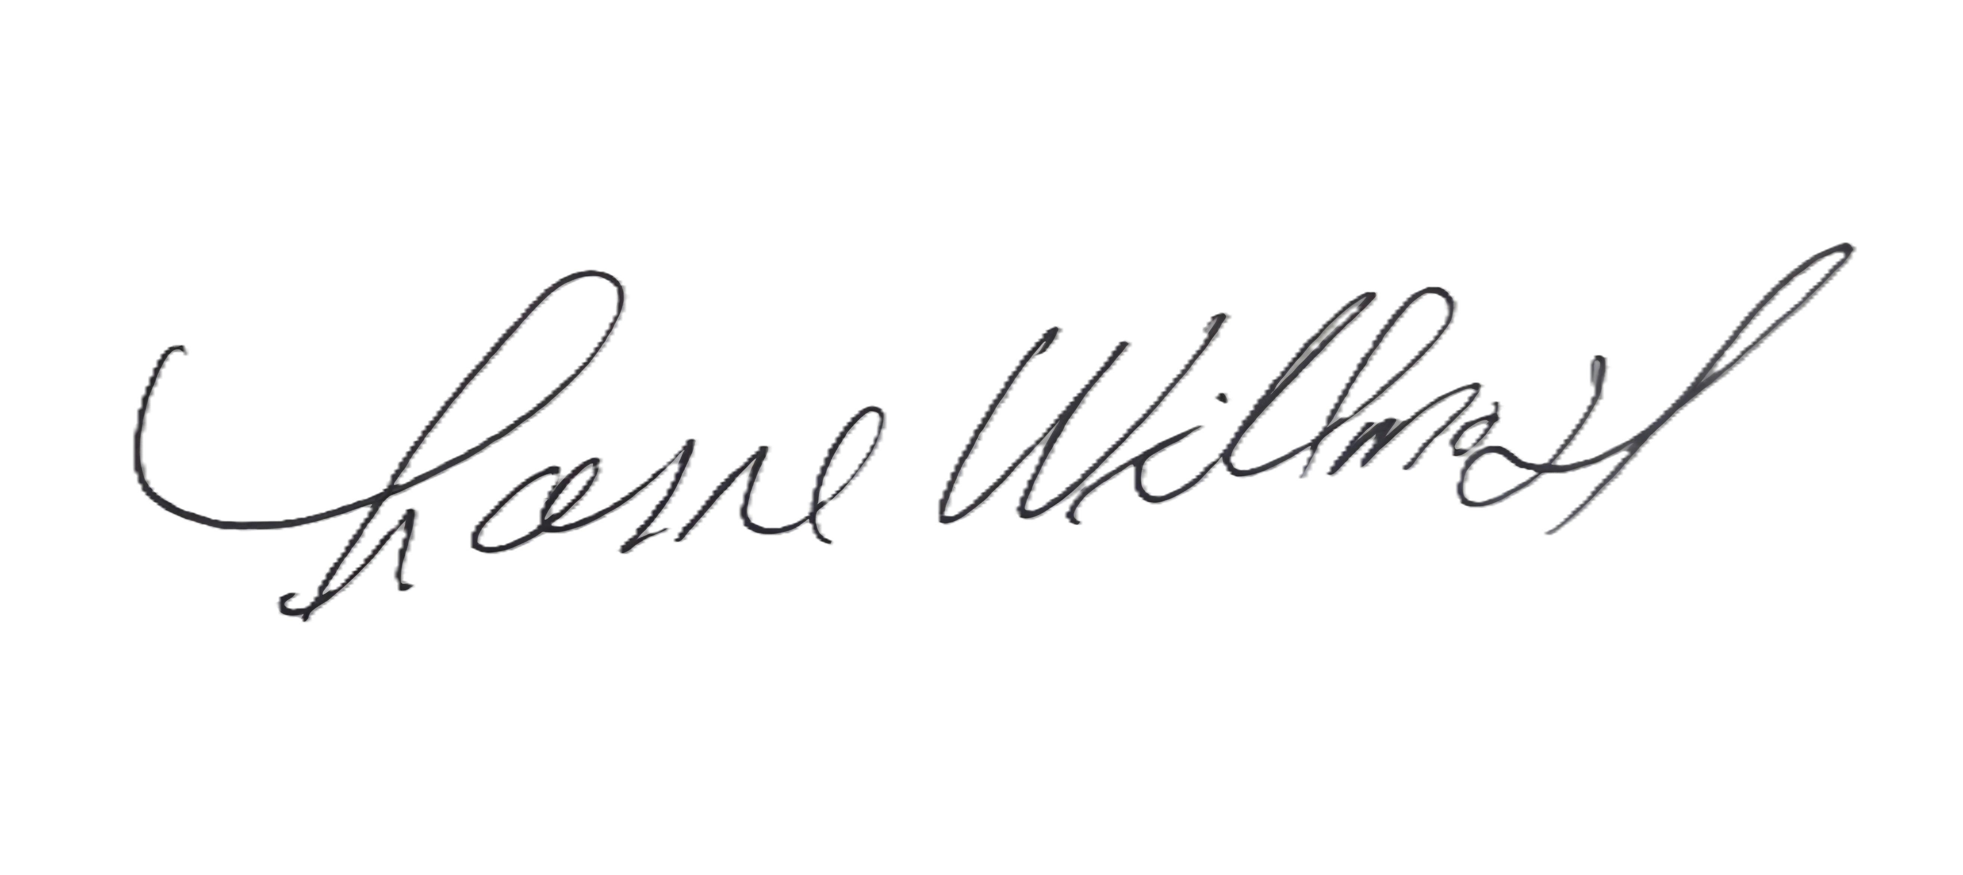
Lorne Willmott
President
Email: president@gcgh.ca

