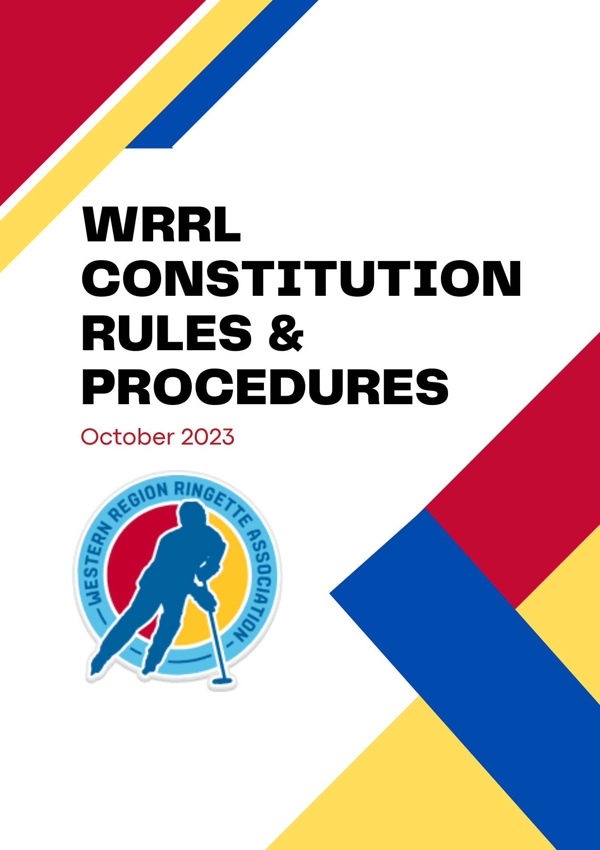

Contents

PART ONE: CONSTITUTION (2009)
Article 1: Name………………………………………………………………………. 4
Article 2: Aims and Objectives……………………………………………………… 5
Article 3: Membership……….………………………………………………………. 6
Article 4: Member Associations and Executive …………………………………… 6
Article 5: Duties of the Executive…………………………………………………… 7
Article 6: Committees………………………………………………………………… 8
Article 7: Officiating and Rules……………………………………………………… 8
Article 8: Constitution………………………………………………………………… 9
Article 9: Protection of the Directors……………………………………………….. 9

PART TWO: RULES AND PROCEDURES (2023)
WRRL Objectives……………………………………………………………………. 12
Policies……………………………………………………………………………….. 13
Team Formation……………………………………………………………………… 14
Children’s Ringette………………………………………………………………….. 17
Ice Set-up for FUN 2 League Play………………………………………………… 17
Mixed Teams…………………………………………………………………………. 18
Fair Play Rules………………………………………………………………………. 19
Game Sheets………………………………………………………………………… 20
Rescheduling Games………………………………………………………………. 21
Reporting Games……………………………………………………………………. 22
Home Team Responsibilities……………………………………………………….. 22
Substitutions………………………………………………………………………….. 23
Two Team Player Agreements……………………………………………………… 24
Penalties………………………………………………………………………………. 24
Referee Payments …………………………………………………………………… 25
Tribunal Process……………………………………………………………………… 25

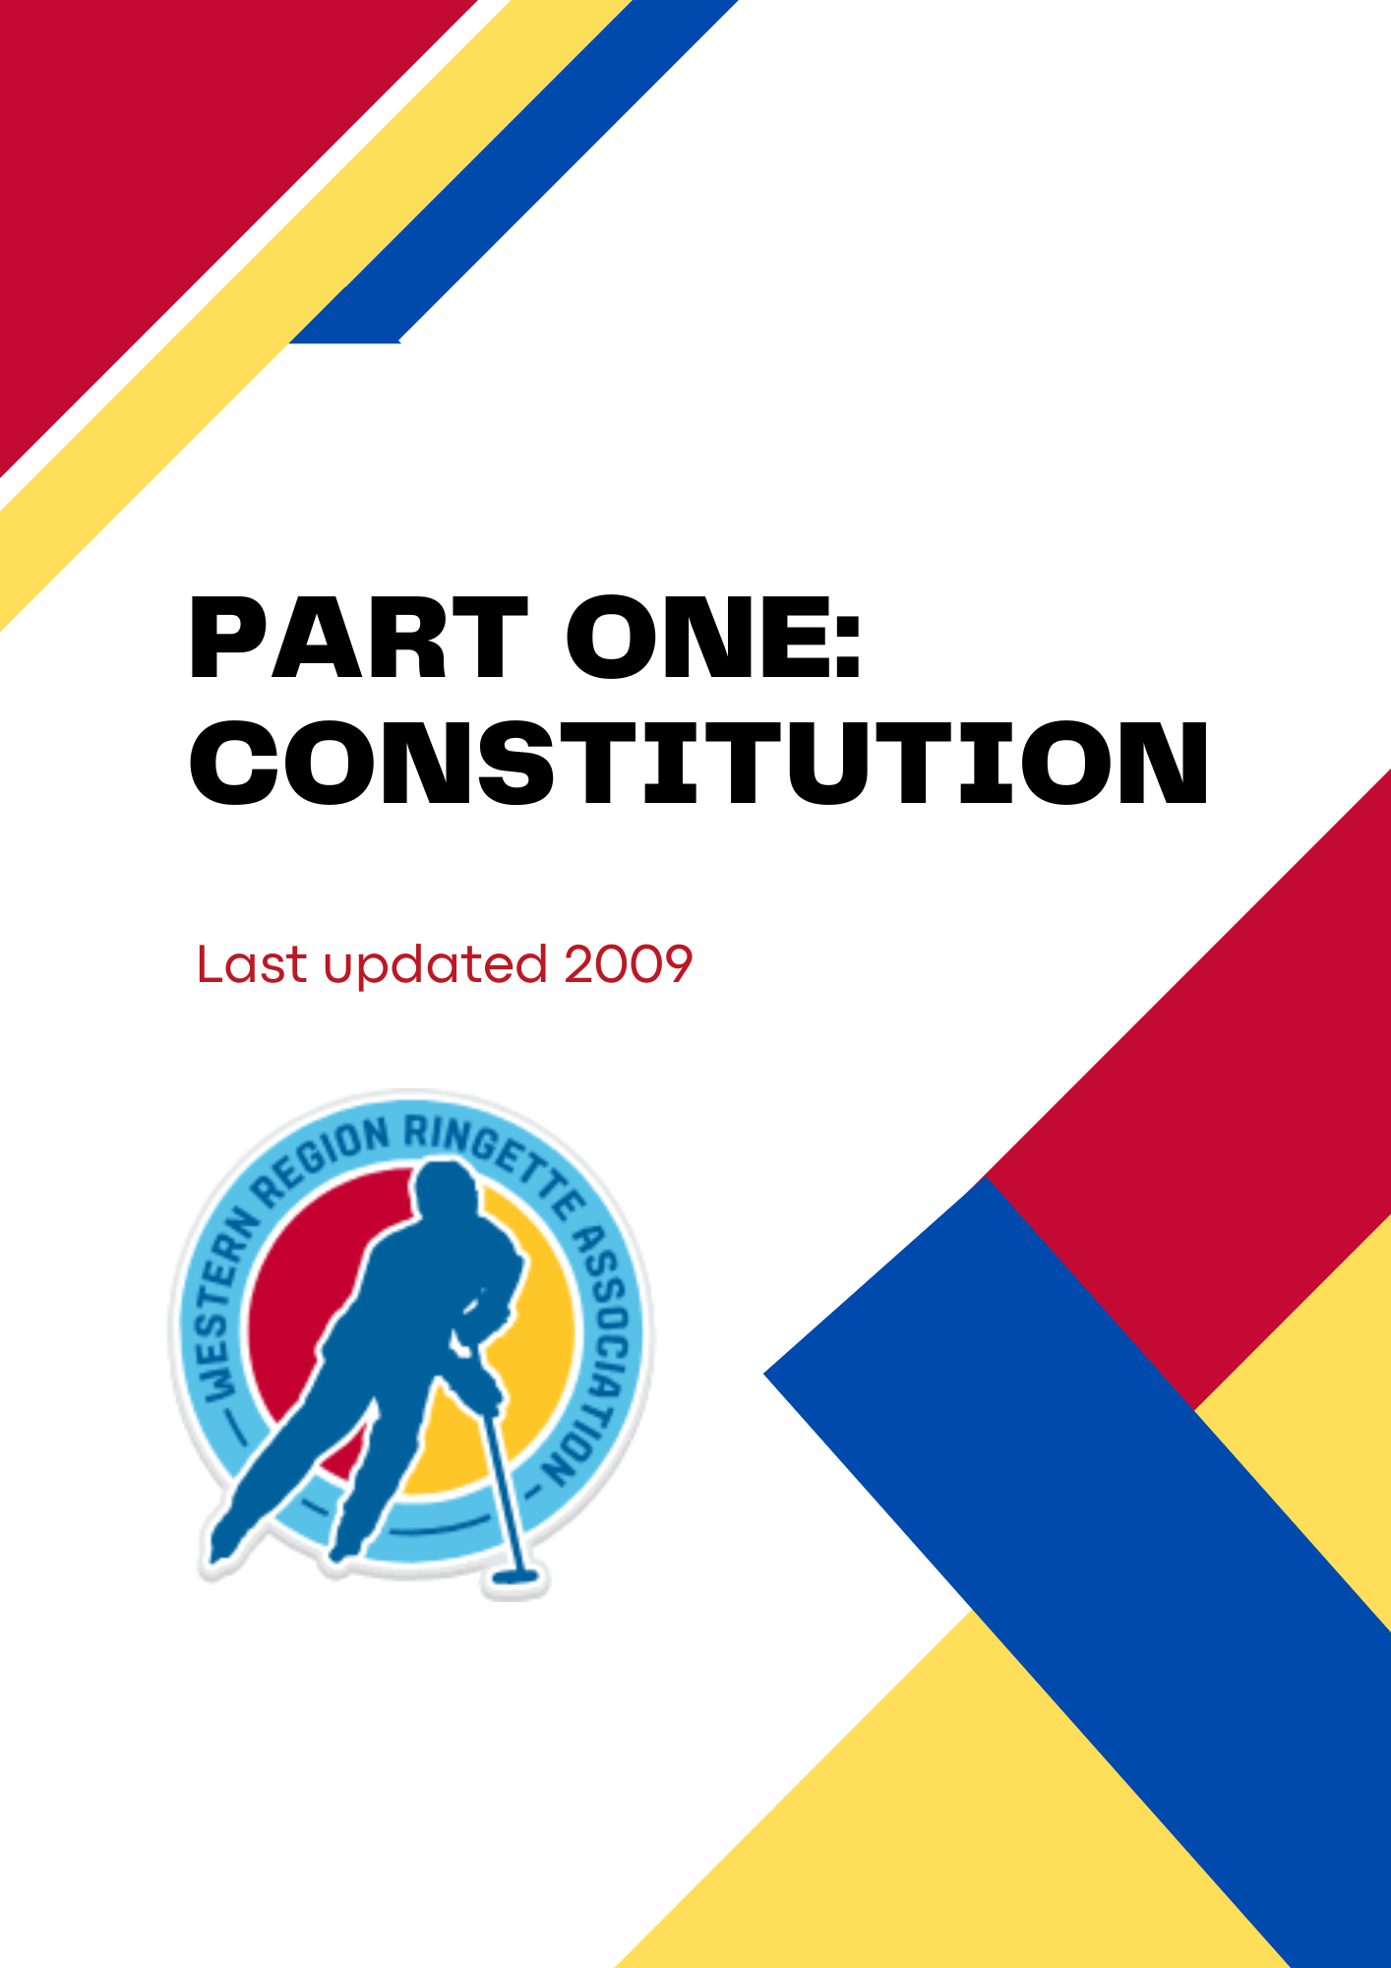

ARTICLE 1 - NAME
1. This organization shall be known as the Western Region Ringette League, hereinafter referred to as the WRRL.
2. The Western Region Ringette League shall have the power to accept donations, set membership fees, impose fines and sanctions.
3. Upon dissolution, any funds remaining in any bank accounts in the name of the WRRL shall be donated to Western Region Ringette Association (WRRA) to further the sport of Ringette.

ARTICLE 2 - AIMS and OBJECTIVES
1. To promote, govern, and develop the playing of Ringette as a mass participation team sport within the boundaries of Western Region, with an emphasis on sportsmanship and fair play.
2. To provide a venue for all associations, within Western Region, to participate in the sport of Ringette, regardless of the size of their association and without regard for their players' skill level.
3. To provide levels of competition that are fair and equitable for all member associations in an effort to stimulate public support and spectator interest in the game of Ringette.
4. To remember at all times that Ringette is a sport for the players.
5. To hold the safety and well being of the players above the outcome of any game.
6. To exercise a general supervision and direction over the playing interest of its players, bench staff, officials and executive with the emphasis on the enhancement of sportsmanship, excellence of team play, character and citizenship.
7. To abide by the Ringette Canada Official Rules as adopted by Ontario Ringette Association, Western Region Ringette Association and the WRRL.

8. To abide by and conform to the policies, procedures and rules of Ringette Canada, Ontario Ringette Association and Western Region Ringette Association.

ARTICLE 3 - MEMBERSHIP
1. Membership in the WRRL is open to all Western Region associations who agree to abide by and comply with the Constitution and Policy, Procedures and Rules of the WRRL. In order to be a member of the WRRL, associations must be registered and in good standing with the Ontario Ringette Association (ORA) and Western Region Association (WRRA) as well as the WRRL. Any out of region teams that wish to apply to participate in the WRRL may do so in writing to the Secretary and membership will be subject to the majority vote approval of the Executive. Out of region teams will not have voting privileges.
2. WRRL players must be registered with the ORA prior to participation in any WRRL activity.
3. An annual fee for each team participating in the WRRL will be set by the Executive at the first meeting of the season. Such fees are to be non-transferable and non-refundable and payment is due as per deadlines set at the first meeting of the season and no later than October 31st. Any payments made after October 31st are subject to a monetary penalty determined by the Executive.
4. The Executive upon majority vote, has the right to sanction any association, team or individual of the WRRL for conduct that is deemed to have a negative impact on the league and the sport of Ringette. An association also has the option to remove themselves from the league at any point in time but must be done so in writing detailing the reasons for their departure.
5. The League will consist of two Divisions each with two Conferences. A detailed structure of the WRRL is attached in Appendix A.

ARTICLE 4 - MEMBER ASSOCIATIONS AND EXECUTIVE
1. Each of the Member Associations in good standing shall have one vote at all general meetings of WRRL. At the Annual General Meeting (AGM), the Member Associations shall elect, from their membership, the following executive positions: President,

Vice-President, Secretary, Treasurer, Western Division Commissioner and Eastern Division Commissioner. The Past President shall carry a vote on the Executive for one year. Each association may only have one (1) elected representative on the Executive at any given time. The Executive will also include the following non-voting members: League Scheduler, Referee-in-Chief and Statistician. A WRRA representative will be designated as a voting member of the Executive.
At the inception of WRRL, the following positions will have 3 year terms: President, Vice-President, Eastern Commissioner. The following positions will have 2 year terms: Secretary, Treasurer, Western Commissioner.
2. Subsequently, the term commitment for each executive position shall be for a two year term with a maximum of two consecutive terms.
3. Vacancies on the Executive may be appointed by the Executive and ratified by the Member Associations at the next regularly scheduled meeting.
4. General meetings shall be held as required but there must be a minimum of four meetings throughout the year including the AGM. All meetings are public meetings open to any member, official, bench staff, player or parent of any Member Association.
5. A quorum shall be deemed present when a majority of the Member Association’s voting representatives are in attendance.
6. All correspondence is to be channeled through the Member Associations' representatives only. This includes protests, schedules, and/or rule changes which may occur during the course of the season.
7. Any member of an association may act as a proxy on behalf of their association representative if authorized in writing by that association's President.
8. In addition to general meetings, the Executive shall hold its executive meetings as needed. Each executive member shall be given ample notification of the meeting. A quorum is a simple majority of voting executive members.
9. The WRRL Annual General Meeting is to be scheduled during the month of April prior to the WRRA Annual General Meeting.

ARTICLE 5 - DUTIES OF THE EXECUTIVE
1. The President shall preside at all meetings and is further charged with the general management of the affairs of the WRRL. The President shall be responsible for informing the membership as to the time and place of all general meetings. The President shall be responsible for informing all executive members as to the time and place of all executive meetings. The President is an ex-officio member of all committees. The President will ensure that the league is represented at all Western Region general meetings.
2. The Vice-President will, in the President's absence, perform the duties of the President with all powers and restrictions which apply to the President. The Vice-President shall be the chairperson of the Grievance Committee and as such is charged with overseeing the administration of the committee as set out in the Grievance Policy.
3. The Secretary shall keep an accurate record of the minutes of all general meetings and executive meetings. The Secretary shall provide a copy of the previous meeting minutes to each executive member and/or Member Association. The Secretary shall be custodian of such records and/or articles belonging to the WRRL, shall keep them safe until the term of office is expired, and is responsible for passing such records on to the next Secretary.
4. The Treasurer shall keep full and accurate accounts of all receipts and disbursements of the WRRL in proper books of accounts. The Treasurer shall deposit all monies "to the credit of the WRRL" in such bank accounts as approved by the Executive. The Treasurer shall give a report at each general meeting and shall provide a financial report at the AGM. Annually, the financial records of WRRL shall be reviewed/audited by someone approved by the Executive and the results of the review/audit provided to the membership. All cheques must bear two signatures.
5. The Western/Eastern Division Commissioners shall look after all issues involving their respective Divisions and will act as a liaison between their Division’s teams and the Executive. They will deal with all minor issues that may occur from time to time within their respective Divisions throughout the season but if these issues become significant they are to advise the Executive immediately. Division Commissioners will also chair reseeding meetings that may be required to determine level of play within particular age divisions.

6. The Past President shall provide the President and Executive with advice.
7. The League Scheduler shall coordinate the scheduling of all league games.
8. The Referee-in-Chief shall deal with all matters pertaining to officiating.
9. The League Statistician shall coordinate the collection, compilation and publication of game results.
10. The Executive is empowered to determine and enforce disciplinary actions and rule on all decisions as required.

ARTICLE 6 - COMMITTEES
WRRL will form the following committees:
1. The Grievance Committee shall be chaired by the Vice-President or any other member of the executive in their absence and is charged with the handling of all grievances and complaints by any association relating to play within the WRRL. In addition to the Vice-President the committee will consist of two (2) non-partisan association representatives to be determined on a case by case basis. All grievances must be reported to the committee in writing as per the policy set out.
2. The Rules Committee shall consist of no fewer than four and no more than six member representatives plus the President or designate who shall chair the committee. The Referee-in-Chief and League Scheduler shall act as resources as required.
3.The Executive may form any other standing committee or ad hoc committee as required.
4. All committees are to keep meeting minutes and present them to the Secretary along with their report to the Executive.

ARTICLE 7 - OFFICIATING AND RULES
Referees:
1. The responsibility to train and supply on ice-officials rests solely with the Member Associations. The WRRL will not be responsible for the assignment of these duties or

payment of fees for these duties. All on-ice officials must be registered officials with the Ontario Ringette Association.
Timekeepers, Scorekeepers and Shot Clock Operators:
2. The responsibility to train and supply timekeepers, scorekeepers and shot clock operators rests solely with the Member Associations. The WRRL will not be responsible for the assignment of these duties or payment of fees for these duties.
Rules of Play:
3. The league will function within the game rules of Ringette Canada, Ringette Ontario, Western Region Ringette Association and Western Region Ringette League.
ARTICLE 8 - CONSTITUTION
1. Changes to the constitution shall only be made at the Annual General Meeting by a two thirds majority vote of the voting membership present.
2. Proposed changes to the constitution must be submitted by March 15th to the Secretary and publicized to the membership two weeks prior to the AGM.
ARTICLE 9 - PROTECTION OF DIRECTORS
1. Every Director or Executive of an Association within the WRRL or other person who has undertaken or is about to undertake any liability on behalf of the WRRL and their heirs, executors, administrators and estates and effects respectively from time to time shall at all times be indemnified and save harmless, out of funds of the league from and against:
a) all cost, charges, and expenses whatsoever which such Director or other person sustains or incurs in or about any action, suit, or proceeding which is brought, commenced or prosecuted against him or in respect of any act or deed, matter or thing whatsoever made, done or permitted by him in or about the execution of the duties of his office or in respect of such liabilities.
b) all other costs, charges, and expenses which he sustains or incurs in or about or in relation to the affairs thereof except such costs, charges or expenses as are occasioned by his own willful neglect or default.

2. No Director, Executive member or Officer of the WRRL shall be liable for the acts, receipts, neglects, or defaults of any other Director, Executive Member or Officer or employee or for joining in any receipt or act for conformity or for the loss, damage or expense happening to the League, or loss or damages arising from the bankruptcy, insolvency or tortious act of any person, firm or corporation with whom or which any moneys, securities or effects shall be lodged or deposited or for any loss, damage, or misfortune whatever which may happen in respective office or trust or in relation thereto unless the same shall happen by or through his own willful act or his own willful default.

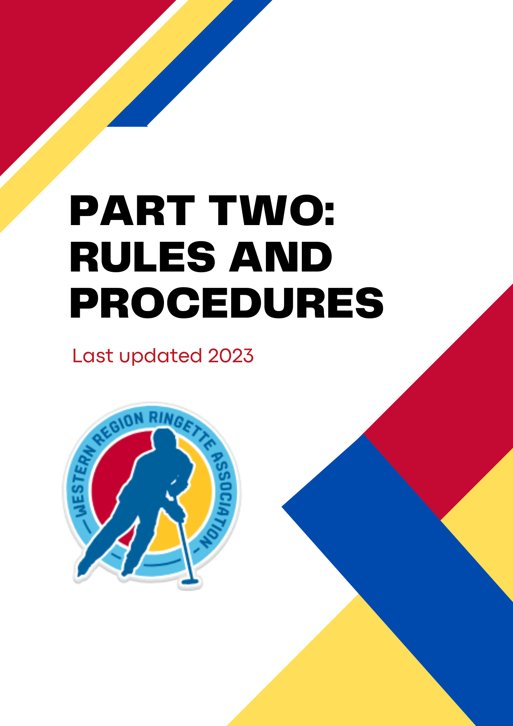

GOAL:

The primary goal of the Western Region Ringette League is to work cooperatively to create as many viable teams at each competition and age level within the Region as possible, and thereby ensuring that qualified players have a place to play.

OBJECTIVES:

- To promote, govern and improve the sport of Ringette in and around South Western Ontario.
- To encourage fun, sportsmanship, team play and a healthy competition in games.
- To support affiliated associations of WRRL to create as many teams as possible at each age level and at each level of ability.
- To strive for conditions conducive to the safety of all participants.
- To stress respect for officials by participants and coaches.
- To ensure mass participation and the opportunity for everyone to play in an atmosphere of fun.
- To work cooperatively with neighbouring regions

WRRL AFFILIATION:

The WRRL will be affiliated with the Western Region Ringette Association (WRRA), Ringette Ontario(RO) and Ringette Canada (RC).

LEAGUE JURISDICTION:

The WRRL will have jurisdiction over all players, coaches, officials and participants in the U14-U19 B/C level of play, U12A/B/C level of play and The FUN programs in Western Region.

ANNUAL FEES
The WRRL Committee shall set the annual team fee for each season at the first meeting in September.
Any Association not paying their fees and any outstanding fines by November 1 st shall be suspended from play until these are paid in full.

POLICIES:

The WRRL will act in accordance with the following Ringette Ontario rules and guidelines:

Confidentiality Policy
https://cloud.rampinteractive.com/ringetteontariogames/files/Policies/Ringette-Ontario-Confidentiality-Policy.pdf

Conflict of Interest Policy
https://cloud.rampinteractive.com/ringetteontariogames/files/Policies/Conflict-of-Interest-Policy.pdf

Team Staff Qualification Policy
https://cloud.rampinteractive.com/ringetteontariogames/files/Policies/Ringette-Ontario-Team-Staff-Qualification-Policy.pdf

Code of Conduct Policies:
https://cloud.rampinteractive.com/ringetteontariogames/files/Policies/NEW-Athlete-Code-of.pdf
https://cloud.rampinteractive.com/ringetteontariogames/files/Policies/COACHES-CODE-OF-CONDUCT-.pdf
https://cloud.rampinteractive.com/ringetteontariogames/files/Policies/Officials-Code-of-Conduct.pdf
https://cloud.rampinteractive.com/ringetteontariogames/files/Policies/RINGETTE%20ONTARIO%20PARENTS%E2%80%99%20CODE%20OF%20CONDUCT.pdf
https://cloud.rampinteractive.com/ringetteontariogames/files/Policies/RO-Spectator-Code-of-Conduct-.pdf

Rule of Two Policy
https://cloud.rampinteractive.com/ringetteontariogames/files/Policies/Rule-of-Two-Guidelines.pdf

Safe Sport Policy
https://cloud.rampinteractive.com/ringetteontariogames/files/Policies/RO-Safe-Sport-Policy-Jan-2020.pdf

Social Media Policy
https://cloud.rampinteractive.com/ringetteontariogames/files/Policies/Social-Media-Policy-NEW.pdf

Concussion Policy
https://cloud.rampinteractive.com/ringetteontariogames/files/Athletes/Rowan%27s%20Law/RO-Concussion-Policy-March-2020.pdf

Return to Play Policy
https://cloud.rampinteractive.com/ringetteontariogames/files/Policies/Return-to-Play-Policy.pdf

LEAGUE RULES:

Ringette Canada (RC), RIngette Ontario (RO) and Western Region Ringette Association (WRRA) Rules shall apply unless otherwise stated below.
All players must meet RO/WRRA player eligibility rules.
The WRRL offers recreational Ringette in the following age groups/categories on a calendar year basis at the beginning of each season:
  - FUN 2 - Under 8 years of age
  - U10 - Under 10 years of age
  - U12 A/B/C - Under 12 years of age
  - U14 B/C - Under 14 years of age
  - U16 B/C - Under 16 years of age
  - U19 B/C - Under 19 years of age
TEAM FORMATION:
The following procedures are based on the guidelines provided by Ringette Ontario.
https://cloud.rampinteractive.com/ringetteontariogames/files/Ringette-Ontario-Team-Formation-Guidelines-23-24.pdf
U14 B/C - U19 B/C
Associations can choose to host a team at the B or C level in each group from U14 to U19. The WRRL will do its best to run all divisions, however there will be times when B and C leagues will be combined because of a lack of teams at a level.

It is recommended that associations evaluate all players and determine the level of the team based on the evaluations.
In cases where associations will be hosting more than one team at an age group, the association may choose to balance the teams (2 B teams or 2 C teams) or tier the teams (1 B and 1 C team). In either scenario, players must be evaluated by experienced and non-biased evaluators. Please see the RO guidelines for further explanations and examples.
U12 A/B/C
Ringette Ontario encourages smaller roster sizes for U12 Club teams to facilitate increased ring touches, player engagement and overall enjoyment of the game.
In addition, smaller rosters assist with the following player development initiatives:
- Increased engagement for all players as they are more active during practices and games
- Increased opportunities to experience playing different positionsIncreased opportunity for skill development
- Increased opportunity for players to experience different game situations; and
- Increased opportunities for coaches to train and develop all the athletes on their team while recognizing individual skill levels of players.
Players in the U12 division will be evaluated for placement on A, B, C tiered teams in a manner which is standardized, fair, transparent and provides meaningful competition using a series of evaluation sessions.
Decisions around team formation for the U12 age group will be left up to associations. WRRA encourages associations to work together to form the best combination of teams for the area.
There are some parameters that must be followed:
- Evaluations at U12 can occur on or after September 1st, of any given year.
- If evaluations are completed, they must be completed for all players in the age group, not just for “A” level as has been done in the past.
- Evaluations need to be completed by qualified evaluators and not the coach alone
- When evaluations occur, there must be a minimum of two for every player - coaches/associations can then add additional evaluations and be “invite only” scenarios.

- All U12 teams will be categorized as mixed
- No U12 team can have more than 2 overagers unless approved by the WRRL
- All U12 divisions will have the same amount of games per season and at tournaments
- All U12 teams will have the opportunity to play in the RO U12 year end event if they choose to do so.
For further information on U12 team formation please refer to following documents:
https://cloud.rampinteractive.com/wrra/files/WORL/U12%20Team%20Formation%20.pdf
https://cloud.rampinteractive.com/wrra/files/WORL/U12%20for%20Parents.pdf
https://cloud.rampinteractive.com/ringetteontariogames/files/Operating%20Resources/Ringette-Ontario-Team-Formation-Guidelines%20-%20U12%20%281%29.pdf
https://cloud.rampinteractive.com/ringetteontariogames/files/Operating%20Resources/U12%20Team%20Formation%20FAQ%20-%20Updated%20Sept%202023.pdf
FUN 3 (U10)
All FUN 3 teams will be considered mixed
It is recommended that teams at the FUN 3 level should have rosters less than 15 when possible
If an association is hosting 2 or more FUN 3 programs, the teams must be balanced. If it is discovered that teams are not balanced, players can be moved between the teams to get a better balance
Associations
Any fines levied on the WRRL by WRRA or the RO as a result of actions or omissions of a member association shall be paid for by the association that was the cause of the fine.
All Team or Association fines must be paid before the team or teams in question are allowed to remain in good standing.
All games are to be officiated by two referees certified and in good standing as a member of Ringette Ontario.. It is recommended that at least one ice official shall be of the level determined by the game.

CHILDREN’S RINGETTE:

- The WRRL will follow the Ringette Canada guideline to Children’s Ringette https://www.ringette.ca/wp-content/uploads/2020/08/Childrens-Ringette-Guidelines-2020-21.pdf
- For game play at the FUN 2 level, ice will be set-up as described in the Ringette Canada Guide to FUN Jamborees. This will allow for consistency during league play and at tournaments. https://www.ringette.ca/wp-content/uploads/2018/11/Ringette-Canada-Jamboree-Guide-1.pdf
- No score will be kept
- Associations may assign a referee or coaches can act as referees during game play.

The following diagram outlines how the ice will be set-up for games during league play. This will be followed by all associations with FUN 2 teams in the WRRL league.

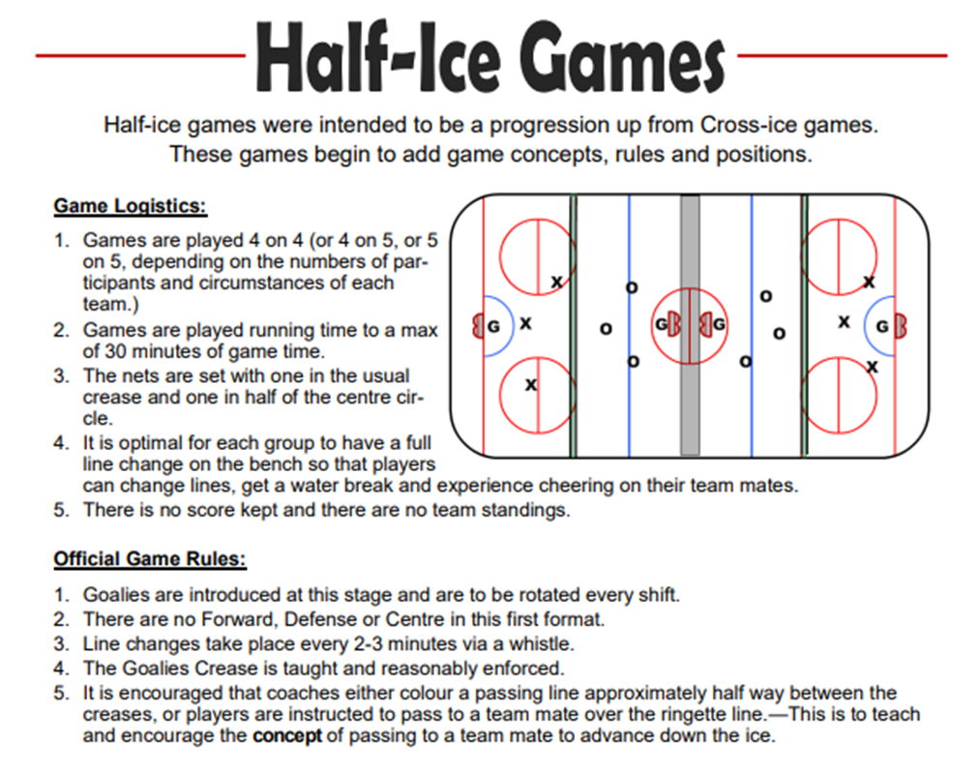

MIXED TEAMS (U14 - U19) (League Play and Regionals only)
When possible, WRRL will try to create an all female loop and a mixed team loop. In order to reduce animosity between teams, it is suggested that a minimum of 6 teams be in each loop to make it viable.
There will be no more than 2 male players on the ice for one team at any given time with the ability of the teams to agree otherwise at least 24 hours in advance. In the event a team has a small bench and is short female players and cannot meet the 2 males only requirement, they would play a 5 on 4, unless otherwise agreed upon 24 hours in advance.
Goalies WILL count in the number on the ice. Therefore, if a team has a male goalie, they may only have one male skater. If a team has a female goalie, teams may have 2 male skaters on the ice.
If the mixed team has a penalty, this DOES NOT impact the amount of males allowed on the ice. At any given time during a game a team may only have 2 male players on the ice unless otherwise agreed upon 24 hours in advance.
Two males on the ice at any given time supersedes the fair ice policy for the WRRL.
ENFORCEMENT
Ensuring the number of males on the ice IS NOT the responsibility of referees. This is impossible to police during game play by referees. No coach will make a complaint to referees during game play.
The process will be as follows:
STEP ONE: The Head coach will inform his/her association’s Coach and Player Development representative and/or association president in writing.
STEP TWO: The representative will forward the complaint to the offending coach’s association representative and the Chair of WRRL.
STEP THREE: The offending association will investigate, and discipline the coach appropriately.
STEP FOUR: Subsequent complaints will lead to consequences levied by WRRL and could lead to the removal of the head coach for the season or permanently.

FAIR PLAY RULES (League play and Regionals only)

 | U10 &  Under | U12 | U14 | U16 | U19
Game Type | Regional | Regional | Regional | Regional | Regional
League Development Games (before Jan 1st | E | E | E | E | E
League Competition (after Dec 31st ) | E | E | D2 | D2 | D2
Regionals | E | D1 | D2 | D3 | D3

EQUAL (E)
Is defined as equal ice-time every game to the best of the coach, allowing for the uncertainty in the frequency in stoppages of play.

DISCRETION 1 (D1)
Is defined as equal ice time every game, however, there is the ability for a coach to use select players in the last two (2) minutes of regulation time and overtime.

DISCRETION 2 (D2)
Is defined as equal ice time every game, however, there is the ability for a coach to use select players in the last two (2) minutes of regulation time, overtime and any situation that does not require five (5) skaters vs. five (5) skaters.

DISCRETION 3 (D3)
Is defined as equal ice time every game, however, there is the ability for a coach to use select players in the last two (2) minutes of regulation time, overtime and any situation that does not require five (5) skaters vs. five (5) skaters. Further, coaches have the ability to use players anytime during post round robin play as they decide.

GOALTENDERS

Goaltenders have the option of changing at half-time of each game or playing full games as long as they have equal game time throughout a season and/or tournament. Goaltenders are restricted to a one game differential throughout the season and during tournaments. Further, coaches have the ability to use goaltenders anytime during the post round robin play as they decide. There is an expectation that throughout the season, each player will have accumulated approximately the same amount of ice time, to the best abilities of the coach.

ENFORCEMENT
Ensuring fair play IS NOT the responsibility of referees. This is impossible to police during game play by referees. No coach will make a complaint to referees during game play.
The process will be as follows:
STEP ONE: The Head coach will inform his/her association’s Coach and Player Development representative and/or association president in writing.
STEP TWO: The representative will forward the complaint to the offending coach’s association representative and the Chair of WRRL.
STEP THREE: The offending association will investigate, and discipline the coach appropriately.
STEP FOUR: Subsequent complaints will lead to consequences levied by WRRL and could lead to the removal of the head coach for the season or permanently.
If a team or coach feels the process has not been fair, they may request a tribunal to investigate.
GAMESHEETS
All WRRL games FUN 3 and above will be recorded using RAMP Gamesheets. It is the responsibility of each team and association to ensure the scorekeeper at each game is trained on the app. Below is a cheat sheet created by Ringette Ontario,
https://cloud.rampinteractive.com/ringetteontariogames/files/Ringette-Ontario-Provincial-RAMP-GameSheet-App-Guide.pdf
https://cloud.rampinteractive.com/ringetteontariogames/files/Electronic-gamesheets-For-Timekeepers.pdf
https://cloud.rampinteractive.com/ringetteontariogames/files/RAMP-GAMESHEETS-Questions-and-Answers.pdf
Scores displayed on the scoreboard at any given game will only show a maximum of a 7 point spread. If there is a 7 goal spread in the second half, run-time will be implemented for U12 and up.

Coaches are not to run up scores. Every effort should be made to keep the game fun for each team especially in the lower divisions. If a coach allows their team to dominate a game with no effort to hold back the team it is to be brought to the attention of the WRRL Chair immediately upon which disciplinary action may be taken.
RESCHEDULING OF GAMES:
All teams are expected to adhere to the provided WRRL schedule.
If games need to be rescheduled due to extenuating circumstances (e.g., inclement weather), this must be communicated between head coaches and a game change form submitted on the WRRL website by the home association.
Inclement weather - when it comes to inclement weather, it is better to err on the side of player safety. It is the responsibility of the Head Coach of the team canceling the game to contact the other team Head Coach as soon as possible to confirm the decision to cancel due to inclement weather. The teams involved must NOT assume that the other team knows of the inclement weather. If the home team is not advised appropriately and in a timely manner, a fine may be levied.
The Association of a team that forfeits a scheduled WRRL game will automatically be fined $500. The Association must pay this fine within 30 days. An Association may appeal the fine to the WRRL Executive for a refundable fee of $100 (See Appeals Policy).
Association may present its case to a WRRL Appeals Tribunal, as appointed by the WRRA Executive. If the appeal is approved, and the fine is canceled, the fee will be refunded. If the fine is not canceled, the Association must pay the $500 fine immediately (in addition to the $100 appeal fee). If the fine is not paid, the WRRL Committee may take appropriate disciplinary action, including expulsion of the team/Association.
Of the $500 fine, $250 will be paid to the Association of the other team involved in the canceled or forfeited game to compensate for ice costs and officials.
When a cancellation has been agreed upon, the home association must offer three alternative ice times, and the visitor association must respond within 48 hours or forfeit the game.

A team that fails to play a scheduled league game, after being given three alternative dates to replay the game, will be subject to a fine of $250 (first occurrence), $350

(second occurrence) and $500 (third and subsequent occurrences), payable to WRRA by the offending association and further disciplinary action may accompany the fine where deemed necessary.
Timeline: the resolution (game being rescheduled) must be made within 2 weeks of the originally scheduled game. If not resolved, then the appropriate Executive member(s) will be called to take action.
If by the end of the season all games to be rescheduled are not played and reasonable efforts were tried to reschedule the game, the team initially canceling the game is declared to have forfeit the game in question.
REPORTING OF RESULTS
The home association is responsible for ensuring game results are reported on the WRRL RAMP game portal (https://admin.rampcms.com/login) within 24 hours of the scheduled start time of the game.
The reported score should not show goals greater than a 7-goal differential.
A warning will be issued if a score is not reported within 24 hours. If more than 3 late
scores are accumulated, a $25 fine will be levied to the home association.
If an error is made in a score, it is the home team’s responsibility to make the change.
In forfeited games, the score shall be recorded at a 4-0 game with the winning team awarded two points in the standings.
THE HOME TEAM
The home team shall be the team listed first in the league schedule and identified as the “Home Team”.
The home team shall be responsible for the game referees, score and timekeepers, and shot clock operators (U12 and up) during WRRL league play regularly scheduled games.
The team roster and the coaching staff are the responsibility of each team. Last name followed by first initial (first name is preferred) is mandatory.
All substitute players must be indicated by selecting “associated player” in the RAMP Game Sheet app.

The home team shall have the choice of uniforms in the event of a colour conflict. A team that does not comply will be levied a fine of $100.
AWARDING OF POINTS
Two points shall be awarded to the winning team following completion of a WRRL game and 0 points to the losing team.
There shall be no overtime played for tie games during the regular season. Each team will receive one point.
In the event of a tie in points for standings at the end of the season, Ringette Ontario tie breaking procedures will be used.
For a game that is at risk of a curfew, the home team must make the visiting team aware prior to the start of the game.
SUBSTITUTIONS
WRRL to follow Ringette Ontario substitution rules.
https://cloud.rampinteractive.com/ringetteontariogames/files/Operating%20Resources/Player%20Substitutions%20for%20Invitational%20Tournaments%20-%202023.pdf
Maximum number of substitute games played per season for all skaters is 5 games and for all goalies is unlimited. Important: It is the responsibility of the Home Association President or designated replacement, Home Team Head Coach, or designated replacement (this is the home association/team of the player being called up to substitute and play a game for another team) to ensure that their respective players do not exceed playing more than 5 games for any team during WRRL play.
All substitute players must be indicated by selecting “Associated Player (AP)” in the RAMP Game Sheet app.
Fines for improper use of substitutes will be as follows:
- More than 5 games substituted by 1 player - $500 fine to violating team and suspension of player for 1 league game.
- Violation of any substitution rules will result in a forfeit of the game. Important: It is the responsibility of the Receiving Association President or designated replacement, Receiving Team Head Coach, or designated replacement (this is the association/team that the player being called up to substitute will be playing a game for) to ensure that the called-up substitute player has not exceeded playing more that 5 games for any team during WRRL play.

TWO TEAM PLAYER AGREEMENTS

Two team player agreements can only apply to agreements between a regional team and a provincial team. Two team player agreements cannot exist between two regional teams. As per RO rules, a two team player is considered a full time player on both teams and will participate fully with both teams.
https://cloud.rampinteractive.com/ringetteontariogames/files/RO%20-%20Two-Team%20Player%20Procedures%20-23.pdf

All two team player agreements must be submitted to the WRRA Membership Services Representative no later than Nov. 15. All paperwork must be submitted for the agreement to be valid.
https://cloud.rampinteractive.com/ringetteontariogames/files/Operating%20Resources/Two%20Team%20Agreement%20-%20August%202023.pdf

PENALTIES (From RO)

A Head Coach whose team receives thirty (30) minutes in accumulated penalty time in regulation play (overtime is exempt) shall be suspended from the next regularly scheduled game. Should that person be the coach on more than one team, the one game suspension must be served with the team that received the excessive penalties.

A player who receives ten (10) minutes in accumulated penalty time, overtime included, shall be ejected from the remainder of the game. The player shall be suspended from the next regularly scheduled game.

All excessive penalties (Ten (10) minutes in a game for a player or thirty (30) minutes in a game for a coach) must be reported to the Tournament Host Chair and Ringette Ontario Operations Director (or designated Program Coordinator) within twenty-four (24) hours by both teams or prior to the next schedule game – whichever is sooner. The Operations Director will report all excessive penalties in the Region(s) for tracking purposes.

For all other Competition Playing Rules please refer to:
https://cloud.rampinteractive.com/ringetteontariogames/files/Operating%20Resources/Competition%20Playing%20Rules%20-2023.pdf

REFEREE PAYMENTS

In order to ensure consistency throughout WRRL, referees will be paid the following per game:

FUN 2 - $25 per game
FUN 3 - $25 per game per referee
U12A-U19B - $30 per game per referee

If Associations choose to pay their referees a higher rate than listed above, they may choose to do so.

For travel costs, Associations may choose to pay a flat travel rate for outside referees or a rate based on KM. Associations can then apply to the WRRL for reimbursement for these costs at the end of the year so that smaller, distant associations are not at a disadvantage. The WRRL will pay up to $0.50 per KM.

TRIBUNAL PROCESS

If at any time a player, coach or association has a grievance with the WRRL, they may opt for a tribunal. The tribunal will be conducted by the WRRA.

WRRA will follow the process outlined by Ringette Ontario, but within the region.

Tribunals require a fee to be paid by the complainant.

https://ringetteontario.com/wp-content/uploads/2020/01/RO-Appeal-Policy-Jan-2020.pdf

