
Great Lakes Ringette League
Annual General Meeting Agenda
Monday May 25, 2026 - 7:00 pm
Zoom

ROLL CALL:
1) Welcome – Shannon Crinklaw
2) Roll Call – Carrie McKichan
Individual Reps in Attendance:
Position/Association | Name | Present/Absent/Regrets
President | Shannon Crinklaw | Present
Vice President | Brian Kettles | Present
Past President | Vacant
Scheduler | Jim File | Present
Treasurer | Ron McArthur | Present
Secretary | Carrie McKichan | Present
RIC | Emma Bragg Smith | Present
Director at Large 1 | Holly Davies | Present
Director at Large 2 | Adam Natsheh | Present
Director at Large 3 | Aaron Kratt | Present
Scheduler 1 | Steve Baker | Regrets
Scheduler 2 | Tara Armstrong | Regrets
Schedule 3 | Rob Ellis | Present
Ajax (Observer) | Beth Swarbeck/Tirza Douglas | Present
Barrie | James Van Lierop | Present
Burlington | Kevin Aubertin | Present
Cambridge | Michelle Whissell | Present
Chatham | Eric Vandermeer | Present
Dorchester | Nicole Lindsay | Absent
Elora Fergus | Jolene West | Present
Etobicoke | Erin Filey | Present
Forest | Rachel Orvis | Present
Guelph | Jared Pulleybank | Present
Hamilton | Scott Eason | Absent
Kitchener | Neil Murray | Present
London | Jess Walker | Present
Mississauga | Andrea Law | Present
Mitchell | Carrie McKichan | Present
Oshawa | Holly Davies | Present
Paris | Anne Hodgson | Present
Richmond Hill | Scott Dyer | Present
St. Catharines | Kara Sanders | Absent
St. Mary's | Brent Foley | Present
Sudbury | Shelley Ahmad | Absent
Sunderland | April Carter | Present
Tillsonburg | Matt Freelan | Absent
Waterloo | Carolyn Baltz | Present
West Ferris | John Blahut | Present
Whitby | Susan Tantalo | Present

Total Votes Present – 25 votes out 29 present.
50% or 12 associations needed for Quorum .
Others in Attendance: Colin Deans
3) Approve Agenda for AGM 2026
- No additions requested
- Approved by Forest
- Seconded by Chatham
- No one opposed
4) Adopt Minutes of May 26, 2025, GLRL AGM (Posted Online as Draft)
- Approved by Forest
- Seconded by Burlington
- No one opposed
5) Presidents Report – Shannon Crinklaw
- Season Overview
  - First year for Hub weekends
  - Reduce Ref costs
  - 2 Disciplinary Committee submissions – responded to within timely manner and no changes to policy required
  - GLRL league representation on both RO committees
  - Arbiter used for both regional and provincial leagues to try and make efficiencies with Ref scheduling
  - Investigating expanding league for next season – New associations and New Division 18+
  - Survey to plan for end of year event conduct – will not be pursing at this time based on responses.
- Team Membership Overview
Division | 2026 Teams | 2025 Teams
U14A | 14 | 11
U14AA | 6 | 5
U16A | 15 | 12
U16AA | 5 | 7
U19A | 12 | 11
U19AA | 5 | 6
TOTAL | 57 | 52
- 24 associations
- New Associations: Elora Fergus, St. Catharines, Tillsonburg

- Games Played
  - 547 games scheduled
  - 2 games not played, 545 played
  - Compared to 512 played (6 not played) in 2025
  - 5 Fall Hub weekends for U16AA and U19AA and 1 Hub Weekend in Barrie for AA/A

- Games Re-scheduled
  - 140 Game Changes
    - Admin Changes (Time, initial setup, typo) – 35%
    - Weather – 22%
    - Facility/Contract Issues – 19%
    - Team not available – 13%
    - Ref Availability – 11% (Total of 15 games) – compared to 22 games in 2025
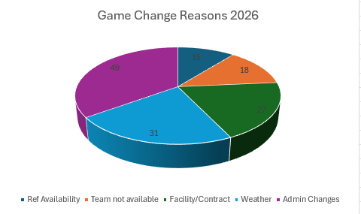

League Champions of this year 2025-2026:
  - U14A – Dorchester Dragons
  - U14AA – Richmond Hill Lightning
  - U16A – Mitchell Stingers
  - U16AA – Richmond Hill Lightning
  - U19A – Forest Xtreme
  - U19AA – Burlington Blast
7) Treasurer’s Report – Ron McArthu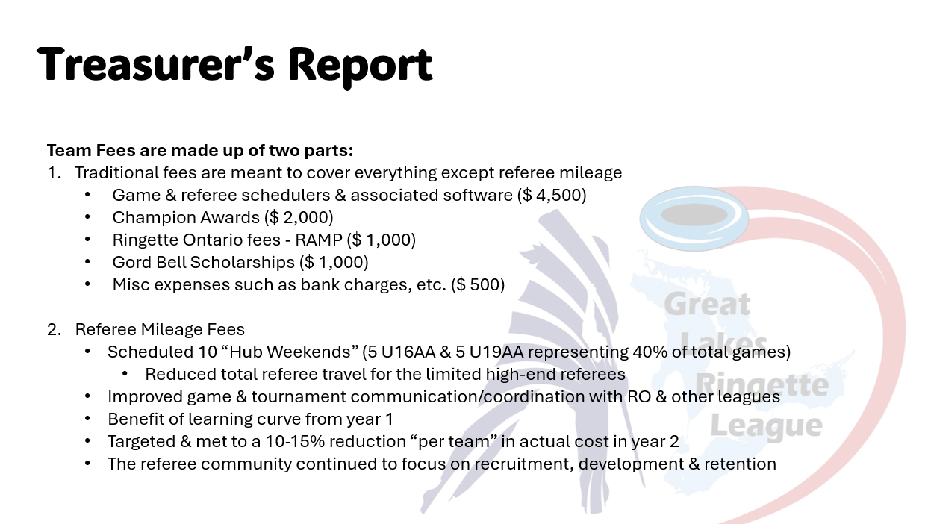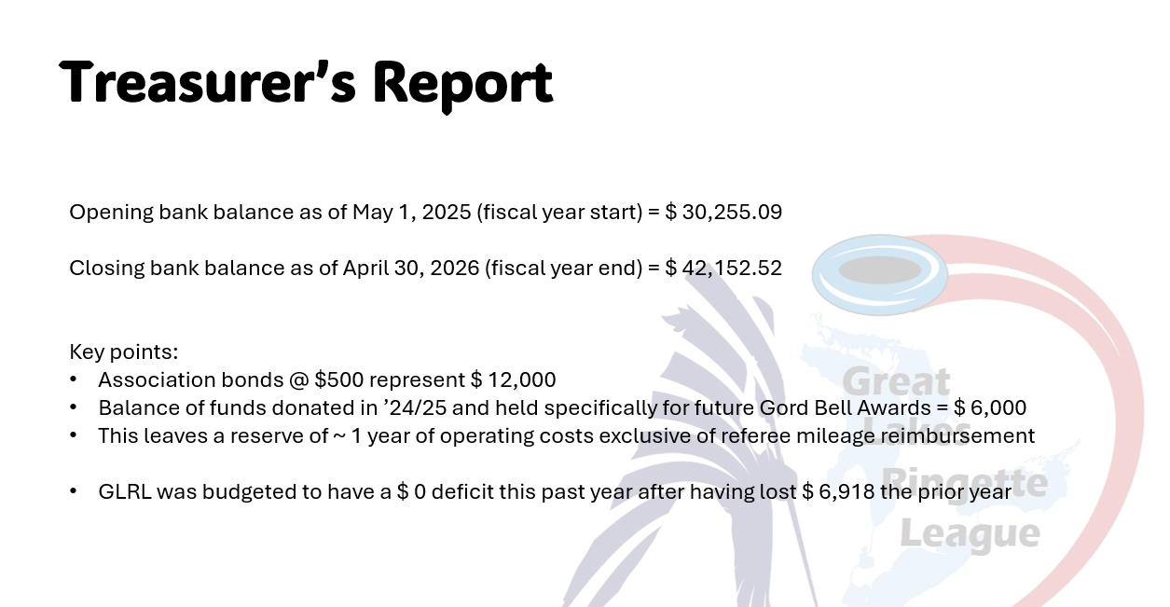
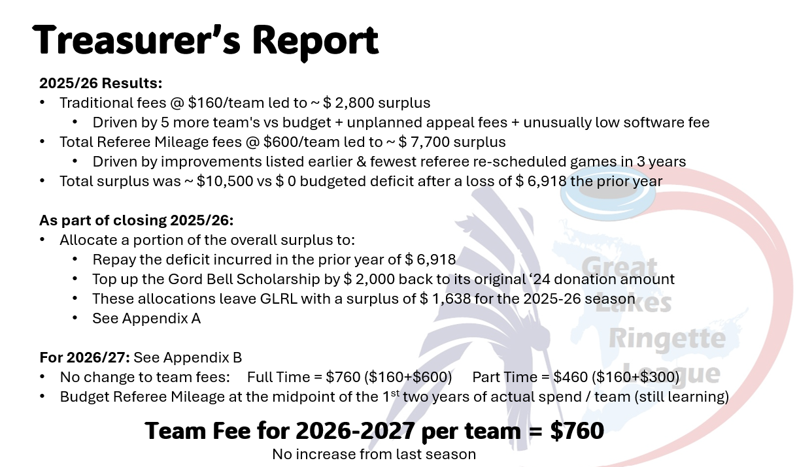
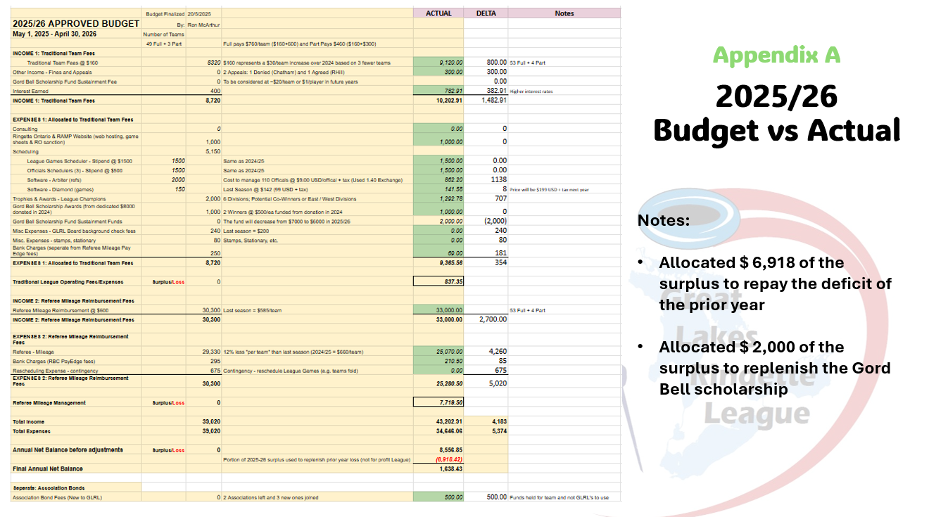
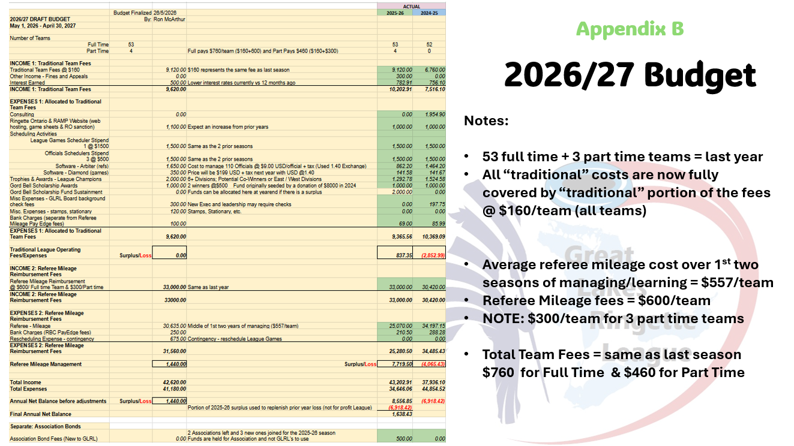
- Reviewed report in full and no questions
- Team fees proposed to stay the same as last year - $760 per team ($460 prorated for part-time teams)
  - Motion to approve the team fee for next season
  - Approved by Forest
  - Seconded by Elora Fergus
  - No one opposed
- Motion to approve report.
  - Approved by Barrie
  - Seconded by Burlington
  - No one opposed
8) Gord Bell Awards – Shannon Crinklaw
- 2 Winners
- 10 applicants
  - 5 committee members (unbiased)
  - Review all applications and select top 3 in order
  - Looking for how applicants contribute back to Ringette community
  - Winners will be notified by email from GLRL President
  - Treasurer will coordinate payment
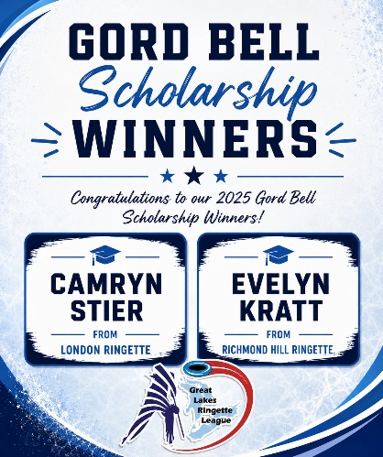
9) ELECTIONS TO BOARD OF DIRECTORS
Vice-President & Treasurer Positions are up for election to a 2-year term.
• To be carried out by Shannon Crinklaw
- Vice - President Nominations
  - Ron McArthur nominates Jim Fille, Jim accepts
  - No other nominations
  - No one opposed
  - Acclaimed
- Treasurer Nominations
  - Carrie McKichan nominates Ron McArthur, Ron accepts
  - No other nominations
  - No one opposed
  - Acclaimed
- Directors At Large #1 (currently Holly Davies) – 1 year Term only
  - Brian Kettles self nominates
  - Emma Bragg-Smith nominates Colin Deans, Colin accepts
  - 22 votes submitted privately (11-10 vote split)
  - Colin is named Director #1
- Director At Large #2 (currently Adam Natsheh) – 2-year term
  - Adam Natsheh sent email earlier in the week to Shannon & Carrie to self nominate
  - No other nominations
  - No one opposed
  - Acclaimed
10) Introduction of 2026 – 2027 GLRL Executive Officers
- President - Shannon Crinklaw
- Vice President - Jim File
- Secretary - Carrie McKichan
- Treasurer - Ron McArthur
- Past President - Vacant
- Director At Large 1 - Colin Deans
- Director At Large 2 - Adam Natsheh
- Director At Large 3 - Aaron Kratt
Action Item: President to send email to regions to confirm who the rep will be for upcoming season 2026-2027
11) Changes to Bylaws or GLRL Rules
- No changes proposed at this time
- If proposal to include 18+AA to league is approved, will need to modify some rules to accommodate this age level only (example, substitutions, # of players allowed)
12) Review of GLRL Referee Scheduling (Emma)
- Review of the season and expectations for next year
  - Pool of 250 referees in Arbiter
  - GLRL used 80 referees from the pool
  - 15-20 referees will be developed into GLRL – A level
  - Able to use referees who relocated in other areas (retention)
  - Use Arbiter for scheduling GLRL and LORL to create efficiencies
  - Hubs were welcomed by Referees – multiple games covered in one spot
- Hub Weekends to be scheduled for 2026-2027 season and will start later than last year
- No questions from the associations
13) Vote: Request to join the League for 2026-2027
- Sudbury U14A, U16A, U19A
- West Ferris U16A (New to GLRL)
- U14A, U16A & U19A will be guaranteed 8 games to be scheduled
- No teams will be required to travel to Sudbury or West Ferris unless agreed on by the team in advance
- Hub weekends will be used in place to limit travel arranged with the GLRL scheduler at the beginning of the season
- Sudbury & West Ferris participation in the league must be voted on as approval at each AGM
- Coaches must review and agree to League rules
- Team bench staff and parents must be made aware of the increase cost for Sudbury & West Ferris teams including more travel, hotel stays for hub weekends, etc.
- Inclement weather can be a factor which may result in games being cancelled, bench staff should take into consideration incoming weather before weekend play
- Sudbury & West Ferris teams are required to abide by GLRL requirements including team fees and providing a bond cheque.
Vote to approve Sudbury to the league for 2026-2027 season
- Motion approved by Guelph
- Seconded by Barrie
- No one opposed

Vote to approve West Ferris to the league for 2026-2027 season
- Motion to approve by Chatham
- Seconded by Guelph
- No one opposed

14) Vote: Request to expand League to 18+ AA, University
- This would be one division which could include 18+A, 18+AA and University (including U19AA teams)
- We would allow 8 teams to join the division (what we can handle) - we would ask for interest and if more than 8 teams show interest then we would have a lottery.
- Divisions would be told the pre-conditions - must provide ice time, follow GLRL rules, etc. before signing up
- Some GLRL rules will need to be added/updated to add specific clauses for this division - allowing for substitutions and game times
- Due to only having three U19AA teams this season, we will ask the U19AA if they want cross over play with this division. If so, games will be 1.5 hours, if not, games will be 1 hour
- We will focus on the main GLRL league games to get up and running first in September then focus on Hub weekends and league play to start October/November for this division
- Teams must be within the GLRL current boundaries – Oshawa/Barrie to London
- Refs would be provided by GLRL and Teams would need to pay the team fee and mileage rate.
- The Board could appoint a Board Observer with title - 18+ Coordinator
- 18+ schedule would be 8-10 games.
- 18+ schedule will not be balanced

Discussion:

- Forest – passionate about 18+, would forest be in boundaries? Yes, forest is in boundaries.
- Adam- would these be all hub weekends? It will be a mix of weekend games and hub weekends like the current league play
- Could Trent be included – would need to arrange ice out of Oshawa and able to meet GLRL
- General consensus is associations agree with baby steps to move forward and expand the league.
- Currently we have about 20 18+AA as a pool to draw from
- Emma concerned with 18+A and could they be competitive
- Aaron Kratt: Will the conditions include reciprocal discipline agreements? How would discipline cross over to UCC and RO if something happens in GLRL. Action Item: need to investigate with RO and University teams discipline cross over
- Adam - When 19AA playing an open / university team, the call up rules should remain the same for each of 19AA and Open/University due to difference in Background check regulations. Yes, rules would be updated.

Motion to approve the addition of 18+ and University to GLRL league for 2026-2027 season
- Motion to approve by Guelph
- Seconded by Forest
- No one opposed

15) Planning for 2026/27 Season - Tryouts Progress, Team Formation, Scheduling
- Team Declaration Form – online GLRL website to be completed by June 30
Scheduling Request:
- August 1st – all ice must be submitted to GLRL.
- Add maximum # of blackout dates teams are allowed to submit for ice time submission
- GLRL to send form for associations to submit.
- Request made to all AA teams to look for Hub weekend ice
- AA games normally start the 3rd week of September
- A games start the 4th week of September – September 26th
- Request to A teams if Hub weekends can be also scheduled
- 20 game schedule – 10 home and 10 away games – request 15 time slots per team
- AA will try to get 10-12 games in before Christmas which worked well last year due to # of tournaments, championships and ref availability
Discussion for Scheduling:
- Jim Additions: When submitting the ice and blackout dates, ensure you don’t submit ice if you cannot attend.
- RO stated the sanctioned tournament announcement is July 14th
- Hub weekends for U16AA and U19AA may have to be melded together – Jim to investigate
- Sudbury looking at Nov 7-8th for Hub weekend.
- Barrie looking at Hub weekend in February.

15) Open Forum – Questions from the Floor
- No questions from the floor

16) Next Meeting – Monday, August 24th, 2026 via Zoom
- September 21st
- October 19th
- November 23rd
- January 25th
- February 22nd
17) Motion to adjourn.
- Approved by Forest
- Seconded by Mitchell
- No one opposed.

Voting for 2025-2026 Season:

