Great Lakes Ringette League
Meeting Minutes
Monday August 30, 2021 - 7:00 pm
ZOOM ONLY
ROLL CALL: (State your Association & Full Name)
Central Region – Ajax (Allan Ross), Oshawa (Holly Davies & Stacey Wright), Sunderland (Krystin O’Grady), Whitby (Absent)
Southern Region – Barrie (Jim Van Lierop), Burlington (Brett Richardson), Cambridge (Jeremy Slotegraaf), Markham (Neil Wang), Mississauga (Andrea Law), Newmarket (Melanie Fedigan), Paris (Michelle Falkiner), Richmond Hill (Stephen Fraser)
Western Region – Chatham (Absent), Dorchester (Shelley Handley), Elora Fergus (Alison Curtis), Forest (Absent), Guelph (David Wilcott), Kitchener (Late – Sid Perron), London (Andrew Wilkie), Mitchell (Jessica Ward), St. Mary’s (Lisa Linton), Waterloo (Neil Henderson)
Attendance (From Zoom Participant List): Phil Singeris, Shannon Crinklaw, Jim File, Rob Beraldo (Webmaster)
- Requests for items to be added to the agenda & approval of agenda
  - Motion to approve agenda
  - Motion by Waterloo
  - Seconded by Dorchester
  - Agenda Approved

- Approval of GLRL Meeting Minutes of Jan 18, 2021
  - Motion to approve minutes as reviewed
  - Motion by Jim File
  - Seconded by Barrie
  - Minutes approved

- 2020 – 2021 GLRL Executive Officers
- President - Phil Singeris
- Vice President - Jim File
- Secretary - Shannon Crinklaw
- Treasurer - Tom Anderson
- Past President - Greg Turner
- Central Region Rep - Holly Davies
- Southern Region Rep - Roy Reedon
- Western Region Rep - Shelley Handley

- Planning for 2021/22 Season
- Tryouts Update
      - Western region has system with intents to be filed with tryouts starting on September 24th for U12A and AA teams with A tryouts to follow ending October 27
      - Central region Update
        - Ajax – on schedule to finish September 25th
        - Oshawa – on schedule to start September 10th and finish September 25th
        - Sunderland – on schedule to start September 10th and finish end of September for A teams
        - Whitby – working with the other central region and will be ready end of September
      - Southern Region
        - Barrie – starting September 25th and will be finished by 2nd weekend in October
        - Burlington – final tryout U19AA on September 30th so will form teams early October
        - Cambridge – only U12A, will start September 21st and be complete September 27th
        - Markham – starting tryout September 20th and will A tryouts start September 27th. Hoping to form teams early October
        - Mississauga – starting tryouts in September with 4 weeks of ice and team formation mid-October
        - Newmarket – don’t know when the ice will be put in. Will host U16A and U19A and working to hit the October team formation timeframe
        - Paris – waiting for Burlington ice times. Will have team formations done by mid-October but based on Burlington with goal of having team formed October 1st.
        - Richmond Hill – skates start mid-September with AA tryouts done by end of September and A teams by beginning of October

- Team Formation
 | # of teams | U12A | U14A | U16A | U19A | U14AA | U16AA | U19AA
Ajax | 5 | x | x | x | x |  | x
Barrie | 2 | x |  | x |  | x
Burlington | 4 | x | x |  |  |  | x | x
Cambridge | 1 | x
Chatham | 1 | x
Dorchester | 4 | x |  |  | x | x | x
Elora Fergus | 1 |  |  |  | x
Forest | 4 | x | x | x | x
Guelph | 5 | x | x | X (1 of) | x |  | X (1 of) | x
Kitchener | 2 |  |  |  |  | x | x
London | 6 | x | x | x | x |  | x | x
Markham | 4 |  | x | x | x |  | x
Mississauga | 4 | x |  |  | x | x | x
Mitchell | 1 | x
Newmarket | 2 |  |  | x | x
Oshawa | 6 | x | x | x | x | x | x
Paris | 2 |  | x |  | x
Richmond Hill | 7 | x | x | x | x | x | x | x
St. Mary’s | 3 |  | x | x | x
Sunderland | 3 | x | x | x
Waterloo | 6 | x | x | x | x |  |  | x (2 teams)
Whitby | 4 | x | x | x |  |  |  | x
TOTAL | 77 | 16 | 13 | 12 | 14 | 6 | 10 | 7

- Looking to keep A levels divided by East and West to avoid travel
- AA level will be expected to play all over Ontario
- Paris would like to be considered based on travel distance VS the region they are in and requested to play in the western loop.
- Will look at weighed vote changes once the team formations are solidified and fees have been paid. For now, will go based on previous year # of teams.

- Ice Availability per Association
  - Guelph is having some issues with Ice. Currently University is only allowing 20 participants on the ice pad, the City of Guelph is allowing 30 participants including officials, coaches, etc. on the ice. Having difficulty scheduling tryouts and warm-ups. 1 spectator per participant.
No ice costs reduced due to limited people on ice.
  - Paris is having the same issues as Guelph. There was a trial last week and waiting for health unit to raise numbers but right now is 20 participants on the ice. 1 spectator per participant.
  - Barrie is having some limits and each team visiting will need to do their own screening with the Region of Barrie.
  - Richmond Hill – having some issues. Ok with # of players on the ice but # of players in the dressing room is 10 people which is creating an issue. Spectators are allowed up to a limit. Maximum of 80 people per pad and 50 people on the ice.
  - Oshawa’s challenge is similar to Guelph. Each facility has different limits. City is limit of 30 and University is limit of 40. Challenge with tryouts so had to reformat the tryout structure. Put each participant in a colour group with 4 groups then rotated so each colour group is on the ice with a different group.
  - Key Action: Team Managers will need to notify teams of the COVID protocols when travelling to other areas.

- Season Scheduling Update
  - Working with Kevin Sweeney (Ice Scheduler) who is working with RAMP
  - Some communication issues and trying to work through them.
  - Kevin will have a meeting with all Ice Schedulers to review how to enter ice.
- Ice Submission Form – To Association Ice Scheduler by Sept 20th, submitted by Sept 30th
  - Moving forward with Ice Submission form available through RAMP
  - Will be sent out to each Ice Scheduler by September 20th
  - Goal to be submitted by September 30th
- Where schedules will be posted
  - Schedules will be NOT loaded on GLRL website
  - Will be on separate website for Ringette Games Centre Ontario
  - Any associations who use RAMP will be able to link directly via the Home Website

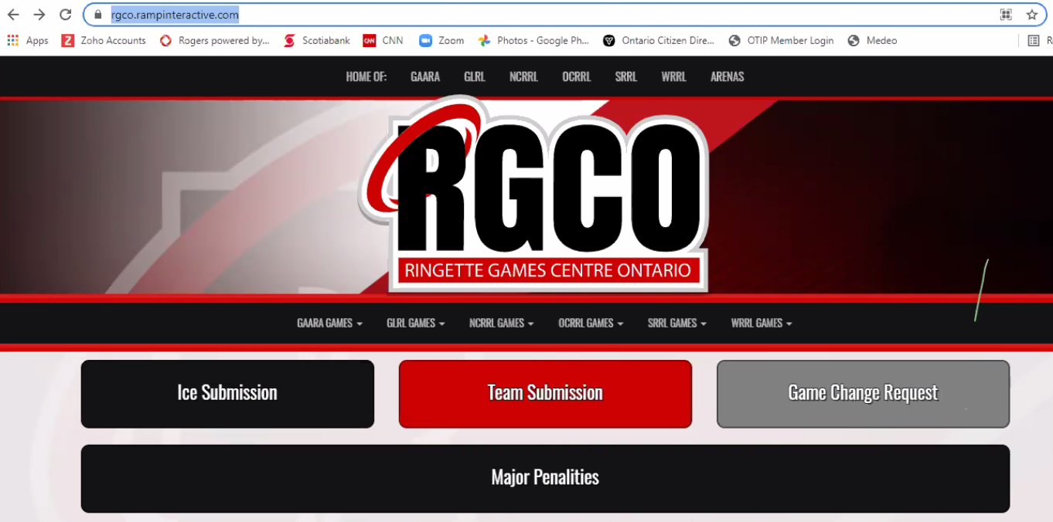

- Click on GLRL and will take to game schedule
- Ice Schedulers will click on “Ice Submission” to submit ice times
- Will also be used for Game Change Request form and Major Penalties
- If an association is on a RAMP system, the Division Bar will link direct to Ringette Games Centre Ontario

- Existing GLRL Website
  - Will house announcements, meeting minutes, and historical data.
- Schedule Format - AA Teams
  - All AA teams will play everyone in the league
- Schedule Format – A Teams including U12A
  - A teams will play games geographically (East/West Split)
- Number of games per division
  - Hope to start the games November 1st
  - Try to get 6 weeks of games before Christmas (12-14 games)
  - No tournaments in first half so will front load the schedule
    - The region has suggested smaller funfest type tournaments. Example 6 teams come together for a 1-day mini tournament.
  - G&T does not have any insight into how tournaments will be assigned and how will they be set-up
    - Potential Tournaments
      - Ajax
      - Burlington
      - Guelph
      - London
      - Newmarket
      - Paris
      - Richmond Hill
      - Waterloo
  - Usually, 20 game seasons but unlikely this year, Target is 16 game seasons
  - Associations should look at fee structure for charging teams because of less games
- U16AA & U19AA game format
  - Four 11-minute period formats used in history to use full 90-minute games
  - Ringette Canada is making change to four 10-minute periods
  - This will continue into this season

- GLRL Team Fees for 2021/22 Season
  - Last time there was league play, the cost was $100 per team for 20 game schedules
  - Will pro-rate for 16 game schedules (approx. $80 per team)
  - Holds $500 bond for every association, which GLRL would still have

- U12A Year End Event?
  - No Ringette Ontario announced no year-end U12A event this year
  - Ringette Ontario has requested that GLRL does not host U12A year-end event and would like U12A incorporated into regional year-end championships
  - What is reason behind this decision? Chris Sharpe shared that long-term athlete development would not have this age group classified as provincial level of play. Change to “A” level language and not grouped as “provincial” level play.

- Other Business
  - Request to Add “Boys in Ringette” from Neil Henderson
    - Are any associations anticipating boys to attend tryouts or have boy’s ringette team plans?
      - Western Region – each region is looking at this individually. Two associations have boys interested (Chatham, Kitchener) at U12A level. Suggested to post both for co-ed and girls’ tryout.
      - Request made to Ringette Ontario to provide a policy/procedure on how to communicate and post boys able to come to tryouts to reduce risk and liability. This policy/procedure would be for all associations to follow.
      - Michelle Falkiner (Paris) has 2 boys at U19A with intents to tryout and Paris is awaiting guidance.
      - If boys are on a co-ed team, will be limited who they can play against in provincial championships. Could have a choice if people want to play against the co-ed team or not. Will not affect the GLRL league games.
      - Chris Sharpe weighs in with previous meetings – do not have separate tryouts, have mixed tryouts. Boards should not be declaring the gender of a team prior to tryouts.
  - Electronic Game sheets
    - Not currently on the radar. May test later.
  - Help to find a female coach? (Alison Curtis)
    - Can submit to WRRA page to ask for help
    - Can reach out to other associations
    - Newmarket ringette also in need of female coaches
  - Covid Vaccine Requirements (Andrea Law)
    - Waiting on Ringette Ontario guidelines
    - London has put in recommendations for everyone 12 years and older to be vaccinated on the ice
    - It is suspected that the RO will request vaccinations mandate for anyone eligible that is 12+ years old but official confirmation has not been provided from RO yet.
  - Action Items:
    - Need to set-up a key contact form for each association including President, Ice Scheduler, Meeting Rep and Ref payment– Secretary to set-up
    - Associations to email GLRL if planning to host a tournament by September 30th
    - Southern/Central to discuss U12A regional event for end of year
    - If boys are trying out, let GLRL know.

- Next Meeting – Monday Oct 4, 2021 – 7:00 via ZOOM

- Motion to adjourn
  - Motion moved by London
  - Second by Waterloo
  - Meeting Adjourned

