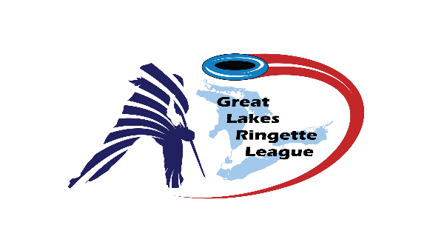
Great Lakes Ringette League
Meeting Minutes
Monday January 18, 2021 - 7:00 pm
ZOOM ONLY
ROLL CALL:
Attendance (From Zoom Participant List): Phil Singeris, Shannon Crinklaw, Chris Sharpe, Stephen Fraser (RHRA), Lisa Tucker, Alison Curtis (Elora-Fergus), Jessica Ward, Tom Anderson, Annette, James, Christine Senior (Whitby), Leah Chapman, Michelle Falkiner (Paris), Holly (Ottawa), Jim File, Tina (Burlington), Michelle (Newmarket), Andrew Wilkie (London), Nancy Nicolson, Mike H, Neil Wang (Markham), Mark Woods, Shelley Handley (Dorchester), David Woolcott (Guelph), Stacey Wright (Oshawa), Nancy (G&T Western), Greg Turner
Central Region – Ajax - Gord, Oshawa – Holly Davies and Stacey Wright, Whitby – Christine Senior
Southern Region – Barrie - James, Burlington - Tina, Markham – Neil Wang, Mississauga – Mark Woods & Roy, Newmarket - Michelle, Paris – Michelle Faulkiner, Richmond Hill- David Price
Western Region – Dorchester, Elora Fergus, Forest - Annette, Guelph – David , Kitchener – Nancy Holmes, London - Andrew, Mitchell – Jessica Ward, St. Mary’s-Absent, Waterloo – Leah Chapman
Cambridge - Absent

- Requests for items to be added to the agenda & approval of agenda
  - London first
  - Barrie second
  - Agenda approved

- 2020 – 2021 GLRL Executive Officers
- President - Phil Singeris (Present)
- Vice President - Jim File (Present)
- Secretary - Shannon Crinklaw (Present)
- Treasurer - Tom Anderson (Present)
- Past President - Greg Turner (Present)
- Central Region Rep - Lisa Tucker (Present)
- Southern Region Rep - Vacant
- Western Region Rep - Shelley Handley (Present)

- 2020/21 Season – Official Declaration of end to this Season
- Now in January without a season and currently Ontario in state of lockdown
- Original hope for the season was to have some small season if possible, including playoffs or tournament but this does not look attainable with the current
- Some municipalities are starting to remove ice and some associations have stopped the season already
- Request to declare end of season with information posted on website and communications to be sent out
- Motion to move “Declaration to end the 2020/2021 season”
  - Guelph motioned to proceed
  - Dorchester seconded
  - Unanimous in favour- carried

- Planning for 2021/22 Season - Tryouts, Team Formation, Scheduling
- Without knowing when things will return to normal, discussions around planning can be discussed
- Best case scenario would be Fall tryouts with league play following. There will not be any tryouts in the Spring.
- We are all in a holding pattern until more information from the province and health units is provided
- Dorchester question: is there any further information on if U12p will be offered next year?
  - No decision has been made on this yet by Ontario Ringette
  - Chris Sharpe to follow-up with Ontario Ringette and get back to GLRL
- Waterloo question: What are the options being considered for U12p?
  - Ontario Ringette looking to align U12 with sports development framework
  - There would potentially not be an end of the year U12p provincial event
- Waterloo question: Would regions have any say in this decision with Ontario Ringette?
  - The group who is working on this issue have representation from all areas of the province
  - Once the process gets going again, there will be regional representation and could even extend to associations.
  - Ontario is the only province left having U12p end of year event.
- Will start planning for next season closer to AGM once we know more about the current Ontario situation
- Kitchener question: boys in competitive level ringette
  - G&T stated that boys can be involved if there are enough teams to allow for a separate division of boys or coed at tournaments. However, all girls’ teams do not have to play teams with boys (not required) so leaving boys without a place to truly play competitive ringette
- Kitchener question: if we return to normal tryouts, how would the releases and moving between work?
  - Will need to discuss but believe we’d have to go back to the previous year since 2020/2021 didn’t happen. Tryouts were not completed, and teams were not made.
  - Everyone was required to return to their local association and Ontario Ringette stated that this return would have no impact on provincial tryouts in future years

- AGM – Official Wrap Up and Election of Officers
  - Monday April 26th will occur over Zoom
  - Election of Officers will occur
    - President – up for election (2-year term)
    - Secretary – up for election (2-year term)
  - Tom Anderson will give a financial report
    - Currently $1500 better than previous
    - Received $2500 from CORAL to support Gord Bell awards in the future
  - May look to invite Pam Julian from Ontario Ringette attend for open discussion questions

- Gord Bell Award
  - Even though there was no season, should we continue with awarding the Gord Bell award?
  - Gord Bell Award – former president of CORAL and CORAL put in $2500 to pot for awarding this award
  - There are players who are eligible in U19A and U19AA levels that would be going to college
  - Criteria would be:
    - Was registered this year
    - Played competitive level in 2019/2020
  - Motion: should we move forward with awarding the Gord Bell
    - Unanimous yes to continue with the award this year
  - There will be 2 awards for this year, one from Gord Bell and one from GLRL award
    - Western region to discuss the name of the Western region award

- Next Meeting – AGM - Monday April 26th, 2021 – 7:00 via ZOOM

- Motion to adjourn

  - Motion to adjourn – Ajax
  - Second – Dorchester
  - Motion approved

Action Items:
- Phil Singeris to invite Ontario Ringette to AGM for questions and send out agenda
- Communication on end of season on website and from associations
- Chris Sharpe to follow-up on Ontario Ringette future plans for U12p
- Phil Singeris to follow-up with posting Gord Bell application on the website

