

Great Lakes Ringette League
Meeting Agenda
Monday February 23rd, 2026 - 7:00 pm
ZOOM ONLY
ROLL CALL: (State your Association & Full Name)

Position/Association | Name | Present/Absent/Regrets
President | Shannon Crinklaw | Present
Vice President | Brian Kettles | Absent
Past President | Phil Singeris | Regret
Scheduler | Jim File | Present
Treasurer | Ron McArthur | Regrets
Secretary | Carrie McKichan | Present
RIC | Emma Bragg Smith | Present
Director at Large 1 | Holly Davies | Present
Director at Large 2 | Adam Natsheh | Present
Director at Large 3 | Aaron Kratt | Present
Scheduler 1 | Steve Baker | Absent
Scheduler 2 | Tara Armstrong | Absent
Schedule 3 | Rob Ellis | Absent
Ajax (Observer) |  | Absent
Barrie | James Van Lierop | Absent
Burlington | Kevin Aubertin | Present
Cambridge | Andrew Lovely | Present
Chatham | Eric Vandermeer | Present
Dorchester | Nicole Lindsay | Present
Elora Fergus | Jolene West | Present
Etobicoke | Erin Filey/ Aaron Kratt | Present
Forest | Rachel Orvis | Present
Guelph | Jared Pulleybank | Present
Hamilton | Scott Eason | Present
Kitchener | Jessica Ward | Absent
London | Jess Walker | Present
Markham (Observer) | Allison Motts | Present
Mississauga | Andrea Law | Present
Mitchell | Carrie McKichan | Present
Oshawa | Jamie Lynn Vanderlinde | Present
Paris | Jen Mayhew | Present
Richmond Hill | Scott Dyer | Present
St. Catharine’s | Kara Sanders | Absent
St. Mary's | Brienna Lee Feeney | Regrets
Sudbury | Shawn Bomhhower | Present
Sunderland | April Carter | Present
Tillsonburg | Matt Freelen | Absent
Waterloo | Courtney Proudfoot | Present
Whitby | Stacey Beck | Present

Others in Attendance:

Requests for items to be added to the agenda & approval of agenda. -

Approved: Guelph - Second: Hamilton

Approval of GLRL Meeting Minutes of January 19, 2026

Link: Link to Meeting Minutes -

Approved: Chatham -Second: Cambridge

2025 – 2026 GLRL Executive Officers
  - President - Shannon Crinklaw
  - Vice President - Brian Kettles
  - Secretary - Carrie McKichan
  - Treasurer - Ron McArthur
  - Past President - Phil Singeris
  - At Large Rep #1 - Holly Davies
  - At Large Rep #2 -Adam Natsheh
  - At Large Rep #3 - Aaron Kratt
  - GLRL Board Observers:
Scheduler - Jim File
Referee in Chief (RIC) -Emma Bragg-Smith
Referee Scheduler -Steve Baker: Western Region Area
Referee Scheduler -Rob Elis: Southern Region Area
Referee Scheduler -Tara Armstrong: Central Region Area

Financial Report –Ron McArthur

Nothing to report. Our finances since the last meeting with no spending or receipts. The next big financial events will be taking place in April when we determine and pay the final referee mileage reimbursements. Everything remains on track to meet this year’s budget.

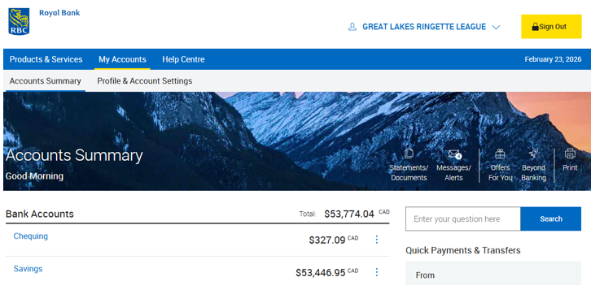

Discipline Committee – Brian Kettles

No new submissions

- GLRL Administration
- Outstanding Games to be re-scheduled/Scores
The league is close to completing the season with just a few outstanding games needed to be rescheduled before the March 31st deadline. The number of outstanding games is fewer than last year, indicating improvement in scheduling efforts. Rescheduling games after provincials is acceptable to ensure all games are played. Email reminders will be issued if games aren't scheduled by early March.

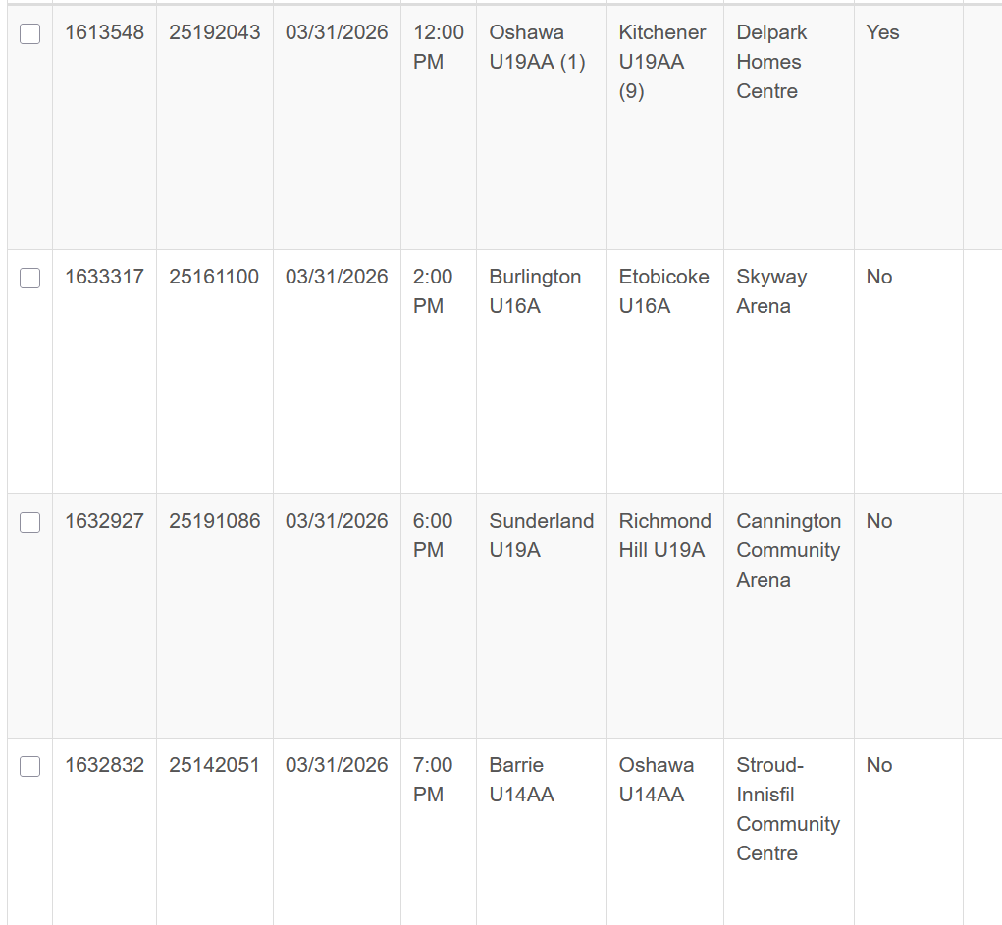

- Gord Bell Scholarship Application to be open online
The scholarship program is reopening soon with clear criteria and a structured application process aiming to recognize passionate players heading to post-secondary education. The award is open to all active players playing this season in GLRL. Two recipients will be selected regardless of the region. Applications must submit a 300 word essay, a letter of reference, and a resume. Applications close at 11:59pm on April 30th and are submitted through the Great Lakes rep for each association. Selection is made by a small executive committee. Announcement of winners will occur at the AGM on May 25th. Applications will be live on the website soon. GLRL rep is to submit submissions to Carrie McKichan and Shannon Crinklaw.

- Appeals for Match Penalties – GLRL Rules
The league clarified that referee calls on the ice are final and cannot be overturned, but is exploring options for reviewing suspensions linked to match penalties with input from the development committee. Current appeal rules do not allow overturning on-ice referee calls but permit appeals on additional suspensions and fines. Appeals require a 14 day process including a hearing, which is lengthy compared to the urgency of game suspensions. The league recognizes the need to make the appeal process more athlete-centric and timely. Discussions underway to evaluate whether match penalty suspensions could be reviewed post-game with video evidence. Emma and the development committee will provide recommendations on appeal timelines and procedures. There is a concern about opening frequent challenges to referee calls, which could deter referee retention. Currently a match penalties automatically carry a two game suspension with no variance. Any review process would require clear rules, potential deterrents (like fees), and video evidence standards. The league will seek to balance support for referees with fairness for athletes in potential policy updates. Consideration given to limiting reviews to clear, conclusive evidence including referee point of view footage. Referee shortage and retention challenges heavily influence cautious approach to appeals.

- Request for GLRL Playoffs
There is a renewed interest in hosting a GLRL end of the year tournament for teams not qualifying for provincials, but logistical challenges and referee availability pose significant barriers. Previous polls showed low interest in GL playoffs, but recent feedback suggests demand for consolation events. Example: Oshawa hosts the Presidents Cup, provides successful round robin and skills competition for local teams. Teams finishing their regular season without provincial qualification face a sense of abrupt season end. Key logistical hurdles include securing ice time, coordinating hosts for multiple age groups and ensuing referee availability. Referees often reduce their participation before provincials due to injury concerns. Hosting would require advance planning, likely shortening the regular season or scheduling after provincials. Potential solutions include a centralized weekend event separate from provincial tournaments to maximize referee presence. Polls will be send to gauge interest and ice availability for potential hosts. Some clubs already participate in informal year-end events, indicating grassroots demand. Association reps emphasized athlete engagement as a priority despite logistical complexities. A separate championship weekend could maintain player motivation and provide closure. Coordination with RO on scheduling and official resources is necessary.

Sending Poll out

- Scheduling Update & Hubs Weekends – Jim File
The league is preparing for next season's scheduling with emphasis on hub weekends to reduce travel and improve officiating efficiency, while balancing ice availability and association capacity. Teams and hosts should be identified by the end of March, with ice allocations due August 1st, 2026. Tryouts in April and May will inform team formations and hosting intentions. Associations will be asked in June about willingness and capacity to host a hub day. Hub days cluster multiple games at one location to streamline referee assignments and improve scheduling. AA hubs have been successful and the league plans to expand hubs to include A level teams. Hub days typically require 6-8 hours of ice, with some associations able to host 10+ hours. Scheduling must avoid overlapping hub weekends in the same region to prevent referee shortages. Coordination will aim to stagger hubs across east, central and west regions. Regional games may also be integrated into hubs to aid referee development. Associations are encouraged to submit ice availability and hosting interest early to enable effective planning. The league will continue to monitor and adjust planning based on association feedback and logistical constraints.

- Officials Update – Emma
The referee program has improved this season with fewer cancellations, positive feedback on hub weekends, and ongoing efforts to develop officials at all levels. Hubs weekends are favoured by referees for logistical ease and improved scheduling, reducing travel and workload. Referees prefer staying in one location for multiple games rather than multiple venues.. This setup has helped increase referee availability and satisfaction. Referee development focus is on building skills at foundational levels like U14AA, U16AA, and U19AA. The shortage of high-level referees is due to the limited number of high-level twos and threes. Development requires time for mastery, game management skills, and coach communication. Potential to assess referees during hub weekends is being explored, with emphasis on appropriate levels for evaluations. The league aims to use hub weekends to support referee progression while maintaining quality and confidence. Regional games may be included to provide more opportunities for officials. Referee tracking and scheduling tools like Arbiter help maintain visibility of officials who move or play elsewhere. The system ranks referees and matches them to appropriate games, aiding retention and development. Communication with regional referee coordinators ensures officials remain engaged across the league.

Request to add Open Division to the League

A proposal to add an Open A division for next season is being evaluated. The Open division would feature fewer games (10 instead of 20) and require association registration and insurance compliance. Teams must provide ice times for scheduling and use RAMP for game sheets. The division would be Open A level only, excluding Open AA and University teams due to complexity. Interest will be gauged via a poll sent to associations to determine viability and ice availability. Open teams currently scheduling their own games and seek structured league play. The league will consider a trial year to evaluate open divisions success and logistics.

Risk Audit Results – Game sheet discrepancies
Game sheet audit revealed issues with missing signatures and incomplete minor official information across games. Referee and bench staff not consistently signing game sheets; minor officials often not listed. The league plans to work with officials to improve compliance and may update the rules accordingly. The audit highlights the need for better documentation to reduce risk and improve record accuracy.

Meeting Schedule for Year:
Next meeting is the AGM and the following positions are up for election, Vice President, Treasurer, Directions at Large #2 - Adam Natsheh. At the AGM we will announce the winner of the scholarship. Membership approvals will be needed for Sudbury and West Ferris to be added to the league for the 2026/2027 year.

- Motion to adjourn. - Approved - MRA Second -Guelph

