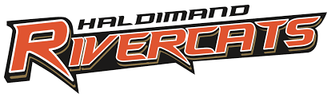
HGHA AWARD APPLICATION

AWARD | HOUSE LEAGUE COACHING STAFF OF THE YEAR
Due Date: | March 14, 2025
Submit To: |  | scholarship@rivercats.ca
Eligibility: | This award recognizes excellence in a HL Coaching Staff.
Who Can Nominate: | Anyone in the HGHA membership may nominate the coach/coaching staff from any HL Team.
Criteria: | HL Coaching Staff of the Year Award recipients must fit the following criteria:  • The head coach and coaching staff that instills a love of the game in their players while enjoying the opportunity to coach the youth in our organization.  • The head coach and coaching staff that developed the players on their team so each one could reach her full potential.  • The head coach and coaching staff that always displayed good sportsmanship and ensured players all learned and understood the meaning of good sportsmanship, on and off the ice.  • The head coach and coaching staff that displayed exemplary leadership abilities by always setting a good example for their players.  • The head coach and coaching staff that always expressed a positive approach to the game of hockey, no matter what the outcome of the game.  • The head coach and coaching staff that ensured everyone had fun on the ice.
Application Submitted by:
Criteria:

