Emergency Action Plan - Halton Hills Eagles – xU Tier y

Cell phone number of coach: | # (Name)
Cell phone number of assistant coach: | # (Name)
Phone number of home facility: | 905-693-2726 or 905-749-0168  (Halton Hills Parks and Rec After Hours)
Address of home facility #1  (address, city, province): | 1 Park Ave, Georgetown, ON  (Georgetown Fairgrounds)
Address of home facility #2  (address, city, province): | 11494 Trafalgar Rd, Georgetown ON  (Trafalgar Sports Park)
Address of nearest hospital  (address, city, province): | 1 Princess Anne Dr, Georgetown, ON
Charge person (1st option): | Name - Head Coach – (#)
Charge person (2nd option): | Name - Assistant Coach - (#)
Charge person (3rd option): | Name - Team Manager (#)
Call person (1st option): | Name - Assistant Coach (#)
Call person (2nd option): | Name - Assistant Coach (#)
Call person (3rd option): | Name - Parent (#)

Directions from Facility #1 (Georgetown Fairgrounds) to the Georgetown Hospital
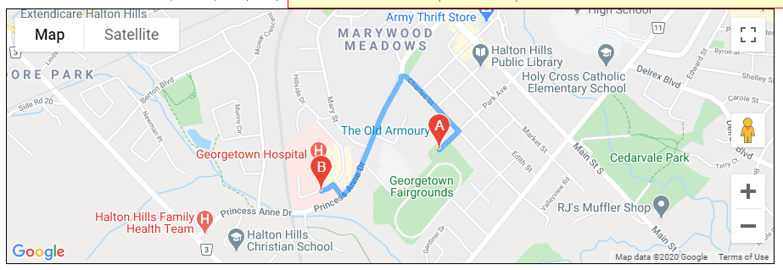
Directions from Facility #2 (Trafalgar Sports Park) to the Georgetown Hospital
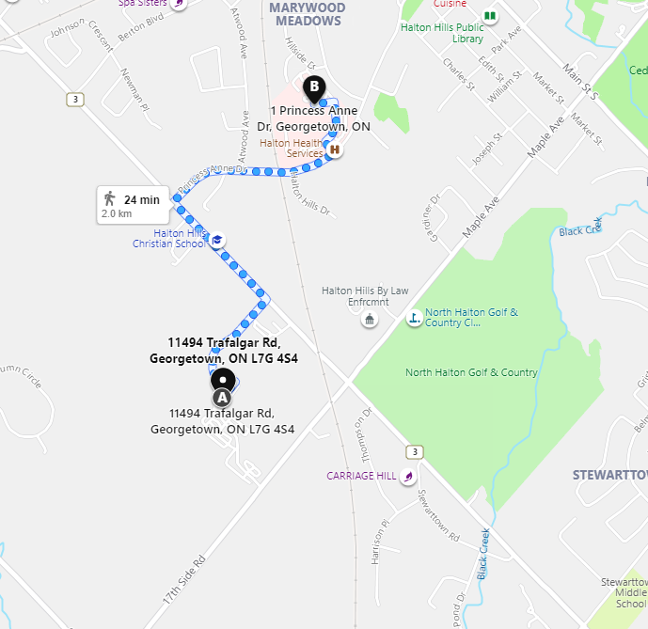

We will likely play most of our home games and practices at the Georgetown Fairgrounds and this facility does not have a main office so I have used the Halton Hills parks and rec after hours phone number as the contact information.

COVID 19 ERP
The latest copy of the HHMBA COVID-19 ERP can be found here
https://www.hhmba.ca/emergency-response-plan (Parent Info -> Emergency Response Plan)

John Behara (HHMBA President) is our ERP Lead - Email john.behara@hhmba.ca
