

Hay River Minor Hockey Association

2025-26 Hockey Season Preview

For further information: http://hayriverminorhockey.com/
or check out Hay River Minor Hockey Association on Facebook
Projected start date: week of October 6th (ice schedule below)
Registration currently open at http://hayriverminorhockey.com/
→ $425 early bird rate → $475 early bird rate → $350 multiplayer discount*

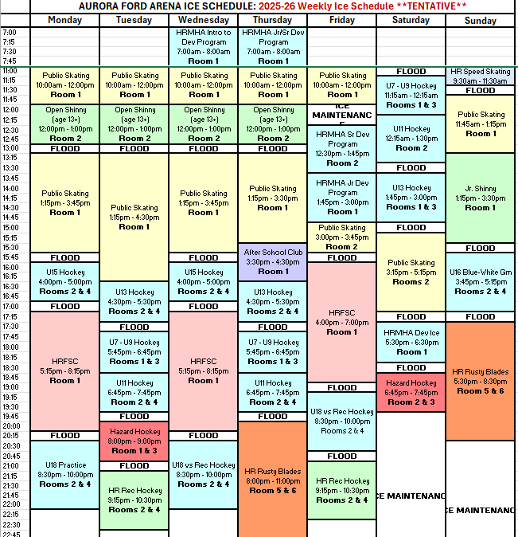

Division | Birth Years | Director | Head Coach
U7 | 2019 - 2021 | Kara King | Kurt King
U9 | 2017 - 2018 | Shailyn Atwell | Curtis Rowe
U11 | 2015 - 2016 | Cynthia McMeekin | Courtney Fraser
U13 | 2013 - 2014 | Dayna King | Mike King
U15 | 2011 - 2012 | tbd | Stephane Millette
U18 | 2008 - 2010 | Mary Buckley + Annette Rupert | Devan King

HRMHA Executive positions
  - Treasurer: Drew Queen treasurer@hayriverminorhockey.com
  - Secretary: Alexa Rowe secretary@hayriverminorhockey.com
  - Vice-president: Mark Robillard vicepresident@hayriverminorhockey.com
  - President: Stephane Millette president@hayriverminorhockey.com

Other HRMHA volunteer positions
  - Registrar: Annette Rupert
  - Website coordinator: Jordan Bassett
  - Ice coordinator: Mark Robillard
  - Special events coordinator: tbd
  - Referee coordinator: vacant

Many thanks to HRMHA sponsors and funders for the ongoing support!!!
 |  |  | 
U7 division | U9 division | U11 division | U13 division
 |  | 
U15 division | U18 division | Practice jerseys | Hockey NWT

