AYHL NON TRAVEL LEAGUE REGULATIONS

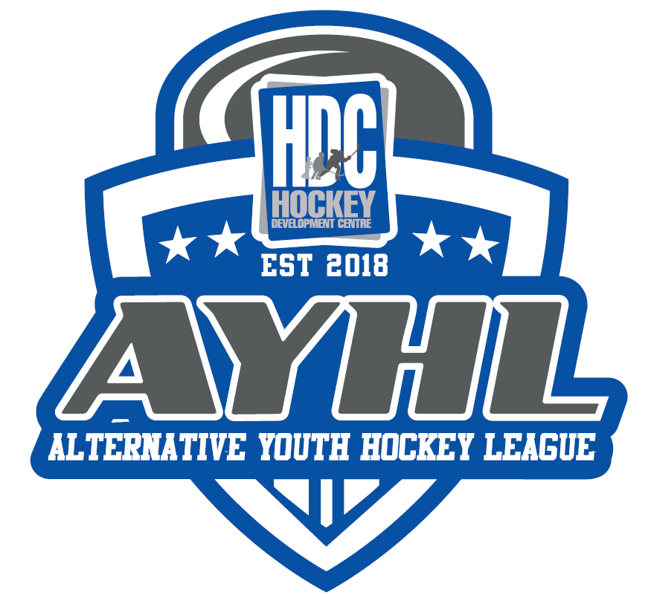
- League Governance
The AYHL aims to ensure the safety, enjoyment and development for all players. We have created a governance model to ensure that all stakeholders are aware of the rules and expectations of the league.

- Game play
The goal of the AYHL is to provide players with a “real feel” Hockey game that includes all the rules thus better preparing players for upcoming years of “full-size” ice.

Official game rules as of September 26, 2019 were designed to reduce stoppages in play while also allowing players to learn game concepts. Rules will be monitored closely by the AYHL to continue to maximize development and player enjoyment.

- Games will be 55 minutes in length with a 5 min warm up.
- 4 on 4 lines
- 3-15 run time periods
- Players will change ends each period
- Icing and offsides will be called
- No whistles on goalie coverages, offensive line must clear the zone and re-enter
- Change on the fly
- 5 onz pucks will be used for games
- All penalties will result in a penalty shot
- Goalies will be provided for games unless an AYHL player wishes to play in net for an upcoming game. Coaches will contact Gord Wong @ gord@calgaryhdc.ca a week in advance to submit their request.
- All other pertinent rule information will be housed at www.hdcleagues.ca

- Tournaments
As part of registration, teams will participate in two tournaments. Each tournament is designed to provide an opportunity to play full ice hockey while forming and nurturing relationships-tourney style!
- Ice Breaker – October 5 & 6 2020 in Cochrane
  - Tournament details will be announced by October 2nd
- Grand Finale Tournament – March 15 – 17, 2021
  - The AYHL Grand Finale tournament will take place March 15-17, 2021 at the North East Sportsplex.
  - Tournament details will be announced by February 15th

