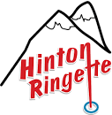
Parent Information Handbook

This has been produced as an information guideline for parents. Policy and procedures of the HRA can be found on the website https://www.hintonringette.com/ and are based on the rules/regulations and operational requirements of the Black
Gold League (BGL) and Ringette Alberta (RAB). For a complete listing of rules and operations information visit the Black Gold League website at www.blackgoldleague.com. and Ringette Alberta website at www.ringettealberta.com

The Parent Information Handbook is a live document, subject to amendments, additions, and deletions as necessary. Please visit the HRA website at https://www.hintonringette.com/ for most current version.

MESSAGE TO PARENTS

HRA is committed to the growth and development of its players. The following document outlines what HRA expects from parents and coaches throughout the Ringette season to optimize the experience for the players. If these expectations are not met, the individuals will be dealt with in accordance with the HRA Code of Conduct Policy. (Please see HRA website for all policies)

- Parent to Parent

It is important that you as parents are positive with each other. The parent-to-parent message is critical. Positive comments about the team, the coaches, your child, and other parent’s children create a positive environment for everyone. Remember every position is important in a team sport - not one more than another.

- Parents in the Stands

Behavior in the stands generates the type of team you will be known as. The association and coaches expect all parents to cheer for their own team and not against another team. We expect positive comments from both teams. Parents are also responsible for the behavior of spectators that have come to the game to support their player.

In addition, it is essential that coaches, parents, and players understand the importance of actively displaying respectful and ethical behavior towards officials. The HRA supports the concept of Zero Tolerance where there is abusive behavior towards game officials.

The HRA expects parents to control their emotions when it comes to the officials in the game. The association will exercise zero tolerance where there is abusive behavior towards game officials. Displaying any of the following behaviors may result in immediate suspension from attending any Ringette practices/games until a full investigation can be completed:

  - The association will not tolerate loud, obscene, abusive, or obnoxious behavior by team personnel, players, parents, or spectators.
  - Any inappropriate conduct, threats, harassment, or abuse directed towards officials will not be tolerated and may result in immediate consequences.
  - Under no circumstances will parents, team personnel, spectators or players approach an official after a game off-ice
  - Parents, spectators, and team personnel are not permitted in the officials’ room before or after a game.

- Parents with Coaches

We expect parents to treat their coaches with respect. They have volunteered their time; they have committed to the roles and responsibilities of a coach as laid out by the association. If you have a
serious concern or question for the coach, email the coach, request a face-to-face meeting, and include your division coordinator in the email. Please never discuss issues in front of the players before games and after games. These are not appropriate times to have a meeting and will be less likely to result in a positive outcome. When you wait 24 hours before having the discussion with the coach, it allows you to determine if your child has the same perception as you do! If you do not feel comfortable discussing the issue with the coach, contact your manager.

- Parents to Player

First, understand your child’s strengths then compliment them on the things they do well. Try to limit what you tell them they need to do - that is the coach’s responsibility. Ensure that your child comes to the games well nourished, well rested, properly equipped and in good spirits. Encourage them to work hard and to listen to their coach, as you are getting them to the rink. Do not contradict the coach with instructions as this confuses the players. Be positive and understand that a big part of your child’s enjoyment this season will be based on your comments and behavior.

LINES OF COMMUNICATION:

The following flowchart outlines the only acceptable lines of communication to reach Black Gold League and Ringette Alberta, as adopted by Zones 4 through 8 at the 2010 Annual General Meeting of the Black Gold League. Parents/guardians are to communicate first with their team staff, then HRA Divisional Director.
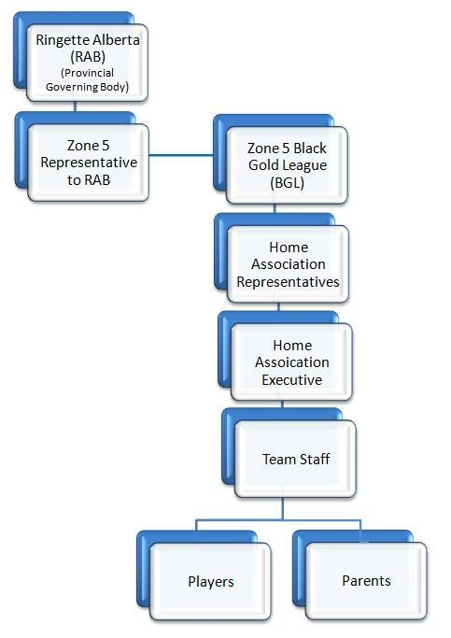

HISTORY OF RINGETTE

Ringette is a unique winter team sport developed in 1963 by the late Mr. Sam Jacks, Director of Parks & Recreation of North Bay, Ontario. Originally designed to be a unique winter team sport for girls and an alternative to hockey, Ringette has evolved into a fast paced, exciting sport that combines the speed of hockey with the strategy of basketball or lacrosse. The first game played in Espanola, Ontario, was nothing like the sport of today.

First introduced in Alberta in 1974 – the sport has never looked back.

Ringette is now considered an international sport with participating teams from Canada, Finland, Sweden, Germany, and the United States of America competing in the annual World Ringette Championships.

RINGETTE PHILOSOPHY AND HOW TO PLAY

Ringette is an ice sport similar to hockey but uses a ring instead of a puck. It is a non-contact sport at all age levels. Ringette becomes a very fast and exciting game as you advance through the divisions.

The players highlight exceptional skills in ring handling and skating, while the goalies are particularly challenged with the variety of shots on the ice and the flip shots in the air.

A team can consist of up to 18 players. The age brackets for Ringette are as follow (age as of December 31st of the current year):

Active Start 8 and Under
U10 10 and Under
U12 11 and Under
U14 13 and Under
U16 15 and Under
U19 18 and Under
Open 19 and Over

Ringette has a major advantage in that it is a team participation sport. It forces the passing of the ring across the blue lines to another player on the team. Basic Ringette rules state that the last player to touch the ring prior to the ring crossing the blue line may not touch the ring again in the next zone before another player has touched it. This encourages and enforces team play.

A maximum of six players per team are on the ice at any time; teams consist of a goaltender, two defensive players, two forwards, and one center.

The Game begins much like soccer with the Visiting team is awarded a Free Pass in the Centre Ice Free Pass Circle; known in hockey or lacrosse as face-off circles. Free Passes are also Ringette’s way of restarting games after penalties, violations, goals, or any other stoppage of the game such as when two players from opposite teams have joint control of the ring and it becomes frozen or immovable.

Free Passes in Ringette are like free kicks or throw-ins in soccer, like throw-ins in basketball, like the quick restart in lacrosse after a violation, or the “face-off” of hockey. The ring is placed in the Free Pass circle; in the side nearest their own goal, there are two blue placement dots inside each of the five free pass circles. The referee determines which free pass circle is to be used and which team has the free pass. One player takes possession and, on the whistle, has five seconds to either shoot or pass to a teammate; they must pass it completely out of the circle; they cannot skate past the middle of the circle or out of the circle with the ring. Failure to move the ring results in the free pass being given to the other team. During these five seconds, no other player is allowed in the Free Pass circle. A shot on goal is permitted during a Free Pass.

Zone Play - Any 3 In: The deep offensive and defensive zones extend from behind the goal net to the Free Play Line - the thin red line at the top of the face off circles. Within these deep offensive and defensive zones, each team is allowed only three skaters (not including the goalie) while at full strength. If a team has more than one penalty they are only permitted two skaters in their deep defensive zone.

The free play line or Ringette line is the red line running across the ice at the top of the free pass circles in each end of the ring. On offence, the two forwards and the center usually play in the restricted area and on defense; the two defensive players and the center usually are defending their end.

Joint Control: Joint possession of the ring, or as the rulebook calls it, "Joint Control," is when two or more opposing players place their sticks in the ring, and it becomes immovable. The concept of the rule is very simple. The ring is awarded to the team gaining second control. That simply means the ring is awarded to the team that did not initially control it when that struggle for possession began. If the player first in control momentarily removes her stick from the ring, allowing an opponent to gain control and then takes joint control again, the ring is still awarded to the team that gained second control from the start of that play. Simple, eh? Why? The reason for the rule is very simple. Possession of the ring in Ringette is so important and by the very nature of the stick inside the ring, it is very difficult to 'take the ring away' from a player in possession. The rule used to be that when a defensive team attacked the ring carrier, often the player in possession would be tied up by a good check by the defensive team only to be given the ring back because they had initial possession. The rule was changed to *Second Possession* to encourage and reward defensive teams to attempt to gain possession. This rule has sped the game up immeasurably and reduced "ring ragging" as a concept of ring control.

Blue Line Violation: A player cannot carry the ring over a blue line in either direction. The ring must be passed over the blue line to another teammate. That teammate is permitted to skate ahead of the ring carrier and already be across the Blue Line before the ring crosses it. This is quite different from hockey where the puck must cross the Blue Line before any offensive player does. Ringette does not have an ‘offside’ call.

The requirement to pass the ring over the blue line eliminates the situation where one player can carry the ring from one end to the other. It also is one of the keys to Ringette being such a “Team Game.”

Goal Crease: If the ring lands in or on the crease the only player who can touch it is the goalie. The goalie usually picks up the ring and throws it like a Frisbee to a teammate. The Goalie may not throw the ring beyond the Blue Line. If the Goalie does, then the offensive team regains possession on a Free Pass back inside the Goalie’s deep defensive zone. The goalie has five seconds to pass it out of her crease. She may also choose to hit it with her stick or skate, instead of picking it up and throwing it. Neither team can enter the goal crease, not even their stick. If the team with the ring enters the crease, then they lose possession. If the defensive team loses the ring, then the offensive team gains the ring on a Free Pass in the attacking zone. If the offensive team loses the ring, play is restarted with a Goalie Ring.

Goalie Ring: Replaces a defensive zone Free Pass on all violations by the offensive team inside their offensive zone. On a Goalie Ring the goalie is given five seconds to throw the ring towards a teammate after the referee blows the whistle to signify restarting of play. The main difference between the Goalie Ring and a normal Free Pass is the speed of restarting the game as play is not held up for player substitution (you can’t change players on a goalie ring). This adds much to the speed and excitement of the game.

Two Blue Line Pass: There is no icing in Ringette, but there is a two-line pass, called slightly different than in hockey. The feet have nothing to do with it and there is no Center Ice Red Line in Ringette. When the ring crosses both blue lines, untouched, no player from the team that put it there can touch the ring until one of their opponents does first. For example, on an offensive two-line pass, no member of the offensive team can touch it before the defense gets control of the ring. Touching it prematurely is a violation that sends the ring all the way back to the zone it originally was in for a Free Pass by the non-offending team.

Penalties: Penalties exist for various infractions. Most penalties in Ringette are unintentional and are the result of accidentally running into someone when trying to stop or when checking the ring carrier and missing the opponent's stick. Rough intentional body contact of any type is not allowed and the penalty for that is much more severe. However, like basketball and soccer, bodies sometimes accidentally collide.

Violations: Similar to basketball, violations are also called for various infractions, such as skating over the blue line in possession of the ring or unintentionally shooting or holding the ring out of play, or as detailed above, in the two-line pass.

At no time can a player raise the playing end of the stick above the shoulder height - this includes celebrating a goal for safety reasons and failure to comply will result in a high sticking penalty.

Black Gold League Game Length

All games are two periods long as described below:

Division | Game Duration | Period Duration (Two Periods)
U10 (All Stages) | 50 minutes | 18 minutes, Stop Time
U12 | 60 minutes | 18 minutes, Stop Time
U14 OR | 60 minutes | 18 minutes, Stop Time
U14AA | 75 minutes | 23 minutes, Stop Time
U16 & Above | 75 minutes | 23 minutes, Stop Time

NOTE: ** There is no overtime in regular season league play **

SHOT CLOCK OPERATION (U12 & up)

Shot on Goal:
A shot on goal is taken when the team in possession of the ring legally propels the ring toward the other team’s goal and:

- The ring enters the net;
- The ring contacts a goal post or the cross bar;
- The ring contacts the goalkeeper or AGK within the goal crease;
- The ring contacts the goalkeeper outside the goal crease and that contact prevents the ring from entering the net.

Playing Rule:
- The shot clock shall be set to 30 seconds at the beginning of each period;
- The shot clock shall count down only when the game clock counts down.
- The shot clock shall be started when play is started and stopped when play is stopped; • The shot clock shall be reset to 30 seconds when:
  - The team in possession of the ring takes a shot on goal; o Control of the ring changes from one team to the other team.
  - A delayed penalty is signaled. If additional delayed penalties are signaled before play is stopped, the shot clock shall not be reset again.
  - A penalty causes the non-penalized team to commit a violation, and play is stopped as a result; o A player on the team not in control of the ring commits a violation, and play is stopped as a result.
  - A player on the team not in possession of the ring is injured, and play is stopped as a result.

- When the shot clock reaches zero seconds, an audible signal will sound when:
  - Play is stopped, as the team last in control of the ring has committed a violation; then the shot clock is reset to 30 seconds and the ring is awarded to the non-offending team, in the nearest circle within the zone in which the ring was last contacted or controlled.

- If the shot clock’s audible signal sounds in error:
  - Play is stopped; the shot clock is reset to 30 seconds; and the ring is awarded to the team last in control of the ring, in the nearest circle within the zone in which play was stopped.

- If the shot clock is reset in error, play continues.
- The shot clock display units shall be turned off when there is less time remaining in the period than there is on the shot clock. If the display units cannot be turned off, then the shot clock shall be reset to 30 seconds and stopped.

Shot Clock Operator:
The shot clock operator is a minor official, responsible for the operation of the shot clock. The shot clock operator shall be positioned so that they can see the rink and follow play, while being protected from interference or distraction by spectators or team staff. The on-ice officials must be able to communicate easily with the shot clock operator. At the end of the game, the shot clock operator shall sign the Official Game Report.

RINGETTE ICE SURFACE
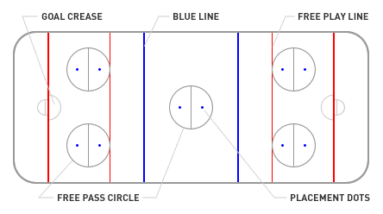

REFEREE SIGNALS
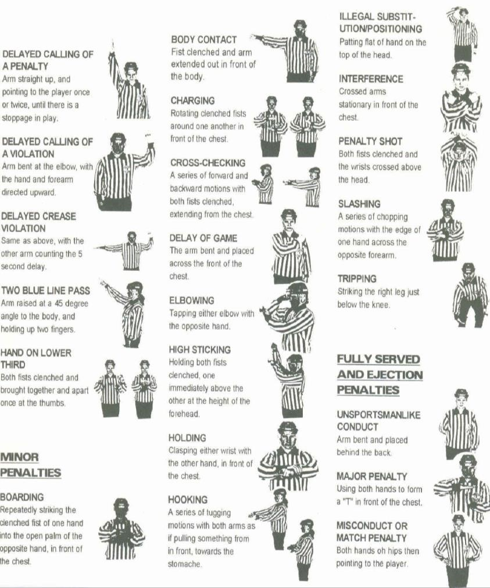

Thanks to Ringette Canada, Ringette Alberta & the Black Gold League for the above information!

LEAGUE PLAY

Hinton Ringette Association (HRA) plays within the Black Gold League (BGL). Your team (U10 to U19) has been registered with the BGL. Currently, Active Start teams do not play in a league. Instead, they will have fun games or exhibition style games coordinated by each team. HRA operates following the bylaws of the Zone 5 Ringette Association and the BGL Operations Manual. Both can be found on the BGL web site www.blackgoldleague.com. It is your responsibility to review BGL Operations Manual.

The BGL league covers 5 of the 8 Zones in which Alberta is divided into for sport association purposes. Spruce Grove is in Zone 5. For Ringette to obtain provincial funding there must be a team in every zone. The smaller associations require the support of larger organizations to provide competition. As such all teams (at all levels) are expected to travel to play the games they have been assigned to by Black Gold League (typically two games / year). Examples of other locations: Red Deer, Lacombe, Hinton, Drayton Valley, and Fort McMurray. The Black Gold League game scheduler deals with 1000+ games and considers travel time, tournaments, blackout dates, and other factors.

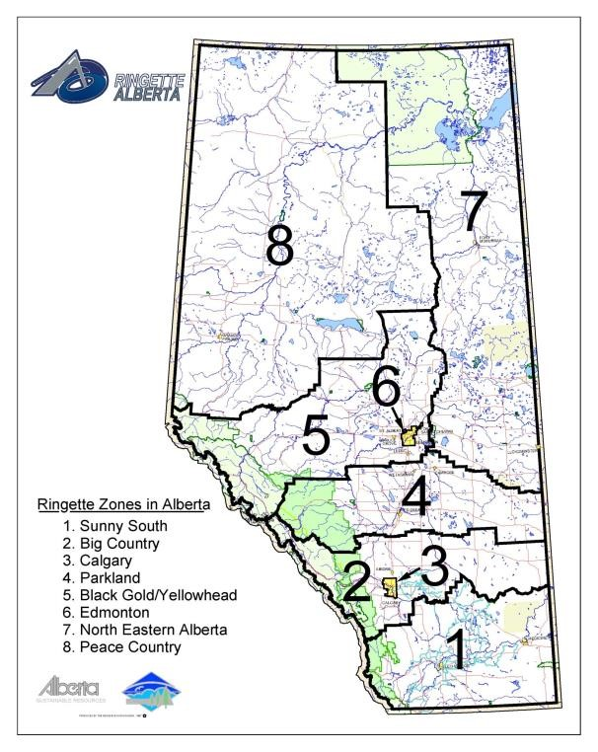
The season is divided into two sessions and posted on the BGL website at www.blackgoldleague.com. Changes to the season structure are reviewed and may have adjustments made for each season and will provide for a more accurate assessment of competitive equality and provide for the development and preparation for playdowns and Provincials. See the BGL website for season start dates and number of games scheduled for the current season.

Teams are re-pooled according to their record of the first session with the intent of making more competitive games and divisions in the second session.

Failure to play a league-scheduled game without just cause (as defined by Black Gold League) will result in the team being assessed a fine from the League. All league games must be played and take precedence over practices, tournaments, or team events.

Please note – that ‘not wanting to travel’ outside of metropolitan Edmonton is not acceptable to either HRA or the BGL.

RESCHEDULING A GAME - Team staff must contact the HRA Director of Ice Acquisition and Allocator (HRA Ice Allocator). At no time should coaches be involved in the rescheduling of league games. The HRA Ice Allocator will talk directly to other Association Ice Allocator as well as BGL.

RINGETTE SEASON

For Spruce Grove, Ringette typically begins in early September with evaluations and team equalization sessions taking place. At no time during the pre-season or regular season is a participant allowed to be on the ice without full equipment. The regular season begins in October and runs through to March.
Zone playoffs and Provincial playoffs are in March and April.

For the older aged participants wanting to try out for “AA Divisions” you must let your intentions be known at the time of registration as we must notify the AA Coordinators.

TEAM FORMATION

Ringette Alberta made a major change for the 2014-2015 season moving towards a “step-based” structure for the U10 Division. This new structure ensures athletes are placed in an environment that is optimal for their long-term development. The following stages are included in the new U10 Division structure:

- Active Start
- U10 Step 1
- U10 Step 2
- U10 Step 3

All players will participate on ice for standardized assessments. Where there are enough players for more than one team in a specific stage, those players will be divided to make balanced teams. See the Evaluations link found on the HRA website for further information.

Hinton and other associations in Black Gold tier their teams at U12 level and above. The number of teams HRA puts in each tier depends on the total number of teams in that division and is based on a tiering policy provided by Ringette Alberta (RAB).

ICE TIMES

The Ice Allocator is responsible for scheduling all practices based on the available ice slots that we have allotted. Game slots are submitted in the middle of September to the BGL Scheduler who will determine the game schedules. This information is returned to HRA approximately one week before the start of the season to allow for scheduling of all remaining slots by the Ice Allocator. The HRA Ice Allocator will endeavor to ensure that the teams receive equal amounts of desirable and undesirable ice times from all practice slots remaining. Practices are scheduled after school during the week and on weekends beginning as early as 7:00 am. Games are scheduled in the evenings and on weekends. Generally, there are two ice times per week – one practice and one game slot. Teams that participate in tournaments, power skating, coaching clinics, or other ice-based events are considered as ‘practice ice’ times for team allocation. Any time on the ice is good ice!

TOURNAMENTS

Most teams enter tournaments each year although it is not mandatory. HRA encourages a maximum number of tournaments per season. This thinking encourages the younger levels to play as the cost will stay affordable. HRA encourages participation and does not want to deter families from the sport. Tournaments are typically held from Friday, during school hours through to Sunday, but this depends on the size and hosting association of the tournament. Tournament fees, accommodations, food, and travel expenses are an extra cost to the team.

Tournaments may interfere with BGL scheduled games. BGL games MUST be played regardless of if you are in a tournament or not. Please note that the home team of the season game DOES NOT have to honor a request to the rescheduling of a scheduled game. Your team must play the scheduled game before the end of the session.

Check out Black Gold League or Ringette Alberta’s website for a listing of all sanctioned tournaments and registration information: www.ringettealberta.com

TEAM FIRST AID AND SAFETY

Ringette is a very fast and physically demanding sport. Even with the best training and preparation, accidents and injuries can occur. Thankfully many of the injuries are minor and do not require a player to miss a shift or game. However, there is the rare occasion when injuries can be more severe.

HRA has taken steps to establish a basic safety and first aid guideline for all injuries on and off the ice. Information and guidelines can be accessed by visiting the Team Safety and First Aid section of the HRA website. This area has resources for coaches, team staff and parents such as the Team Safety and First Aid Response Plan which includes a Medical Response Plan, Activity Action Plan, Return to Play and Insurance Claim forms, as well as other reference material in relation to concussion awareness, asthma in sport and Ringette Alberta Insurance information and flow chart.

The Team Manager should always have in their possession, or in the First Aid kit, a copy of the Medical Response Plan and Insurance Claim forms. The Insurance claim forms need to be completed at the time of an attending physician post injury or accident.

The Association does not collect medical information for its players. During the registration process a parent/guardian agreed to advise the team staff of any medical conditions that may need to be disclosed. As we do not want to collect and protect unnecessary information, we do not ask for personal health numbers or specific information. If a player ever gets hurt or injured, the parent should be in attendance. The association will not be responsible for maintaining up to date medical information. Alberta Health Services will access available medical information such as personal health numbers. Parents/guardians will be present or called right away to provide all necessary medical background to the emergency medical professionals.

JEWELLERY

Ringette has a zero-tolerance rule for wearing jewelry (Yes, even those brand-new pierced ears may cause a problem!) Teams can, and have been, assessed a penalty for players wearing jewelry. Opposing coaches have been known to wait until the most in-opportune time to point out the infraction to the referee.

VOLUNTEERING

For many years, we have developed a strong relationship with our parents and the community that leads to a ‘family like’ atmosphere of cooperation and support. In addition to the volunteer requirements outlined at the time of registration (i.e.: bingo/casino shifts, etc.), there are plenty of opportunities for you to get involved with your child’s team or volunteer for our special events.

FUNDRAISING

HRA has many fundraising opportunities that arise throughout the year. Participation in these events would be credited to your volunteer commitments with HRA.

Teams may decide to do additional fundraising to off-set team costs, such as tournaments, apparel, etc. Ideas include bottle drives, raffle tickets, pub nights, etc.

In addition, the HRA is fortunate to have a Fundraising Coordinator on the Executive to bring further individual fundraising opportunities to association members throughout the year which can be applied to your individual player account. These opportunities can include Cookies, Dough Sales, meat sales, Kernels Popcorn Sales, etc. PLEASE NOTE: Fundraisers organized by the Association may change from year to year and are determined by the incoming Executive and Fundraising Coordinator.

Any fundraised monies over and above next season’s registration fees will be forfeited to the Hinton Ringette Association.

REGISTRATION FEES

HRA often gets asked what the registration fees cover. The following is a list of a few items that your
registration fees help with: (Please note: All figures shown below are based on the 2016/2017 season)

- Ice costs ($150,000)
- Referees’ costs (approx. $14,000)
- Administration (approx. $17,000) o Office o Player Photos o Website o Advertising
- Credit card and bank fees, Insurance & Membership Fee’s ($27,000) o Ringette Alberta Fees for players, referees, team staff of Black Gold League Fees
- Jerseys ($11,000)
- Equipment Purchases and Replacement (approx. $6,000)
- Clinics Coach (approx. $5,000)
- Coaching Certification
- Referee Certification

TEAM FINANCIAL INFORMATION

TEAM VOLUNTEERS

Once evaluations are complete and the teams have been determined, parent involvement becomes crucial! Parent involvement with the teams is an extremely important aspect of Ringette. If everyone shares the workload, it will provide a smooth-running team. All teams have need for the following positions:

Head Coach, Assistant Coaches, On-Ice Assistants, Junior Coach, Trainer, and Goalie Coach (where applicable)

Every team needs to have a Coach and at least one Assistant Coach. Ringette requires that at least one certified coach on the bench be female. Head Coaches and Assistant Coaches must have appropriate certification set out by Ringette Alberta. Training costs (Coaching Clinics) are reimbursed by HRA; if you are interested, please contact the Coaching Director on the Executive, and check the Ringette Alberta website for locations.

HRA encourages each team to have a Goalie Coach or one Assistant Coach whose priority is to ensure that the goalie is not forgotten and help develop their skills.

Coaches plan practices, direct games and share their wisdom with their players. Anyone interested in coaching is required to fill out an application (available through our website).

Team Manager:

- Act as a liaison between the parents and coaches.
- Provide information to the parents.
- Coordinates the activities of the team to allow coaches time to teach the players.
- Schedule outside league games, and additional practices.
- Assists coaches with scheduling of off-ice activities such as dry land.
- Assist with distributions and collection of HRA equipment and jerseys to the team.
- Ensure game sheets are labelled with proper player and coaching staff information.
- Ensure game sheets are collected and distributed appropriately after games.
- Email game stats to HRA and Black Gold League Statisticians according to BGL guidelines.
- Submit hard copies of game sheets to HRA Statistician.
- Manager will have access to HRA equipment storage at Arena, holding responsibility for providing shot clock remotes to workers prior to games, and returning to lock-up after games.
- Submit Provincial Tournament Applications to Ringette Alberta.
- Cannot be an immediate family member of a head or assistant coach.

Tournament Coordinators:

- Obtain input from coaches and parents as to how many tournaments the team will want to attend throughout the season; ensuring input includes how many out-of-town tournaments the coaches and parents are able to commit to.
- Research and inquire about available tournament.
- Responsible for filling out and submitting tournament application forms and payment (payment obtained from Treasurer).
- Inquire about team rates and reserve blocks of hotel rooms for out-of-town tournaments; and
- Provide coaches and parents with information regarding upcoming tournaments, hotels and booking instructions.

Fundraising Coordinator:

- Obtain input as to what type of fundraising activities the team would be interested in throughout the year.
- Discuss budget with team staff and parents, to decide how these budget goals will be met.
- Work with HRA Fundraising Coordinator, collecting and providing orders for HRA coordinated individual fundraising efforts (Coordinate any additional fundraising efforts decided on as a team (Ex. Bottle Drives).

REQUIRED RINGETTE EQUIPMENT

Equipment required for Ringette is similar to hockey including a CSA approved helmet with a Ringette specific facemask (diamond shape openings not rectangular guard) and a BNQ certified neck protector. A Jill strap and a padded girdle are worn under the game pants instead of the traditional hockey pants and jock strap. The Ringette stick shall be a regulation stick and is cut off somewhere between the chest bone and the armpit (with skates on) for proper length.

The top of the stick (cut off end) must be taped as well – similar to a hockey stick for safety and to allow easier pickup off the ice surface should it fall. Please check with your coach if you have any questions regarding equipment. There must not be any tape or grip support on the bottom third of the stick.

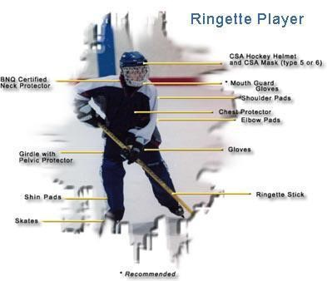

Good used equipment is available at used equipment stores and equipment exchanges. The best time to buy equipment is in August with the best selection available pre-season. The following is a list of a few companies that offer goods and services; please check your local phone directory for a complete listing.

Equipment can be bought, and in some instances, sold, or traded at the following places (but is not limited to):

- United Cycle (Edmonton)
- Source for Sports (St. Albert)
- Klondike Cycle (Edmonton)
- Pro Hockey Life (Edmonton)
- ProSkate (Edmonton)
- Pro Hockey Life (Edmonton)
- All Sports Replay (Edmonton)
- Totem Outfitters (Edmonton)

