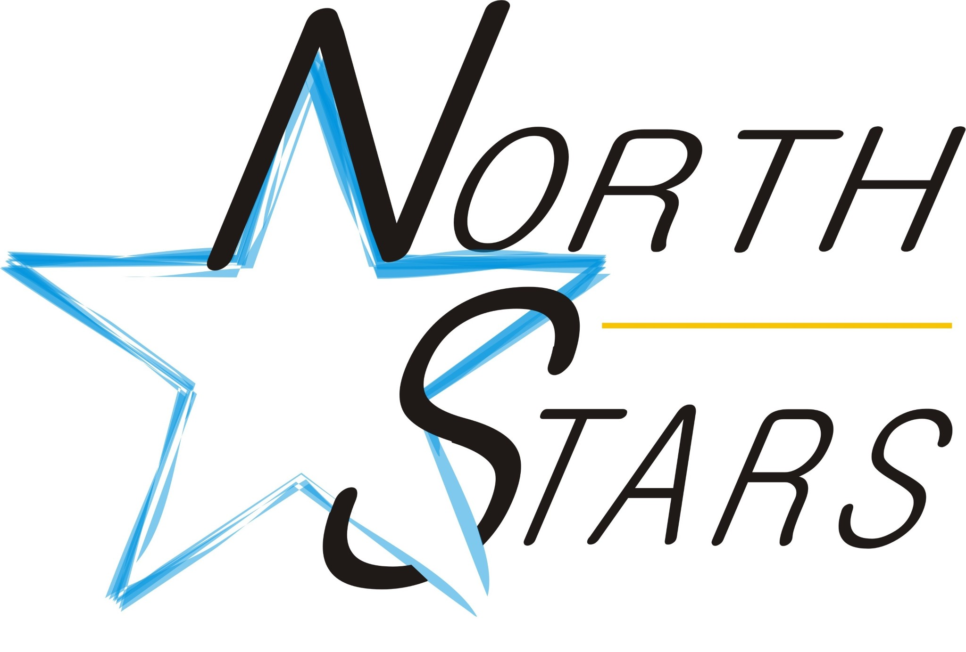 2020/2021 PLAYER
APPLICATION FORM
PLAYER INFORMATION (complete all fields):

Name: ____________________________ _____________________ __________________
Last First Middle

Mailing Address: ______________________________________________ Legal Land description: ______________________

Town/City: ___________________________________________________ Postal Code: _______________________________

Alberta Health Care: ____________________________________________ Phone #: __________________________________

Birth date: _______ _____ _________ Gender: M / F
Month Day Year (Circle)

Email Address: _________________________________________________________________

Last Place Registered: _____________________________

Division: _____________________________ Position: Player / Goalie
(Circle)

Year of Birth | Division | Registration Fee
Age 7 by Dec. 31/2020 | Pond Hockey |  | $300
2014-2015 | U7 |  | $495
2012-2013 | U9 |  | $740
2010-2011 | U11 |  | $840
2008-2009 | U13 |  | $840
2006-2007 | U15 |  | $940
2003-2004-2005 | U18 |  | $940
Goaltenders | U11-U18 | 50% of division fee

Respect in Sport Certificate #:__________________________________________

PARENT/GUARDIAN INFORMATION

Guardian(s) Name: ______________________________________________________________________________

Phone (H): ____________________________________ (C/W): _______________________________________

Emergency Contact: _____________________________ Phone: ___________________________

There will be no reimbursement of fees after Dec 30, refunds shall be issued in accordance with HLMHA registration policy. See hand book for more information,

Keep your receipt NO COPIES will be issued at tax time.

Informed Consent

I acknowledge and authorize HLMHA and/or any of its members or sponsors to publicize photos of my child for promotional purposes directly related to hockey.

I acknowledge that I have read and understand the HLMHA Fundraising Commitment Policy and have provided the necessary payment outlined in this Policy. I will also do my best to volunteer to assist in making this hockey season a great experience for my player and all players involved in HLMHA.

I understand that all registrations are subject to review by the Registrar and HLMHA board and no registration will be approved until all fees are cleared and required documentation is received. Registration is undertaken with the understanding that additional team fees and travel cost will be required.

I assume all responsibility for risks, injuries and hazards incidental to such participation in HLMH including transportation to and from activities.

I agree to return at season finale/or upon request, the Jersey and any other equipment issued to my child in as good condition as when received except for normal wear and tear.
I agree to abide by all minor hockey rules as outlined in the HLMHA handbook, particularly the Code of Conduct (pg 10-11), I understand that my child could be suspended from HLMHA if I do not.
I declare that I have read, understood and agree to the contents of the INFORMED CONSENT form in its entirety

___________________________________________
Date

___________________________________________ ___________________________________________ Parent/Guardian Signature Witness Signature

