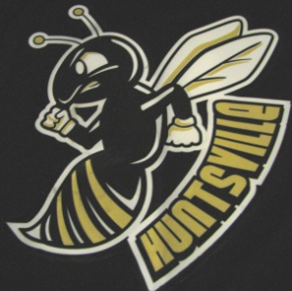
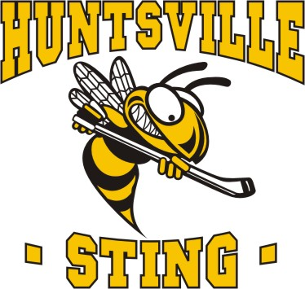
Huntsville Girls Hockey Association
c/o Canada Summit Centre
20 Park Dr, Huntsville ON

May 13th, 2025

To Ontario Provincial Police,
298 Ravenscliffe Rd, Huntsville ON

Please be advised that __________________________, date of birth_____________ will be volunteering with the Huntsville Girls Hockey Association for the 25/26 season.

Position:
The named individual will be serving as Team Trainer on a minor youth hockey team.

Activities/ Duties of Position:
Will be involved with vulnerable sector in both on-ice and off-ice activities which includes assisting with hockey practices and games. Dry land training, being in dressing rooms, assisting with medical issues that arise playing hockey and being a leader for the team.

As a condition of this service, it is a policy of the Ontario Women’s Hockey Association, the governing body for the Huntsville Girls Hockey Association, that all volunteers engaging in activities with minors MUST obtain a VULNERABLE SECTOR CHECK.

Thank you for your assistance, please reach out with any questions you may have.

Sincerely,

Kerri Vallentin
Huntsville Girls Hockey Association
President
hgha@hotmail.ca
(705)571-6979

