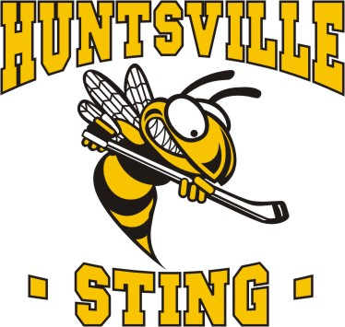

**Huntsville Girls Hockey Association**

**c/o Canada Summit Centre**

**20 Park Dr, Huntsville ON**

May 13th, 2025

To Ontario Provincial Police,

298 Ravenscliffe Rd, Huntsville ON



Please be advised that ________________________, date of birth_____________ will be volunteering with the Huntsville Girls Hockey Association for the 25/26 season.



Position:

The named individual will be serving as Assistant Coach on a minor youth hockey team.



Activities/ Duties of Position:

Will be involved with vulnerable sector in both on-ice and off-ice activities which include coaching hockey practices and games. Dry land training, being in dressing rooms, assisting with medical issues that arise playing hockey and being a leader for the team.



As a condition of this service, it is a policy of the Ontario Women’s Hockey Association, the governing body for the Huntsville Girls Hockey Association, that all volunteers engaging in activities with minors MUST obtain a VULNERABLE SECTOR CHECK.



Thank you for your assistance, please reach out with any questions you may have.



Sincerely,



Kerri Vallentin

Huntsville Girls Hockey Association

President

[hgha@hotmail.ca](mailto:hgha@hotmail.ca)

(705)571-6979