

**REGISTRATION**

Innisfail Minor Hockey Association is continuing with offering registration online using ‘TeamSnap’ for the 2025/26 hockey season. This process streamlines registration by allowing the option of paying by credit card & allowing 24/7 access. (***Offline payments will still be accepted by cheque or cash in the IMHA office***.)

You must have an existing ‘TeamSnap’ account or create one in the registration process.

If you have issues with the registration process, please check here: <https://helpme.teamsnap.com/>

If you still can't find the solution to your problem, please email [innisfailminorhockey@gmail.com](mailto:innisfailminorhockey@gmail.com).

**RESIDENT PLAYER REGISTRATION**

Use this registration if your player is:

* A current resident in Innisfail or within the Immediate Surrounding Area
* Innisfail Minor Hockey is their 'Resident' Association
* A returning player from U13 through U18

In order to complete this registration, ***you must have the following***:

1. TeamSnap Account: [https://TeamSnap.com](https://teamsnap.com)
2. Player's Hockey Canada ID Number:  The process has changed slightly and you will need to create a new account with <https://register.hockeycanada.ca/home>
3. Respect In Sport Parent **Valid** Certificate Number: <https://hockeyalbertaparent.respectgroupinc.com/>

**Please check the Expiry Date for your ‘Respect In Sport Parent’ as it expires every 4 years**

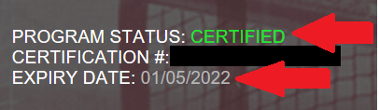

**Once you have the above the registration can be started here:** [**https://go.teamsnap.com/forms/484628**](https://go.teamsnap.com/forms/484628)

You will be greeted with this screen:

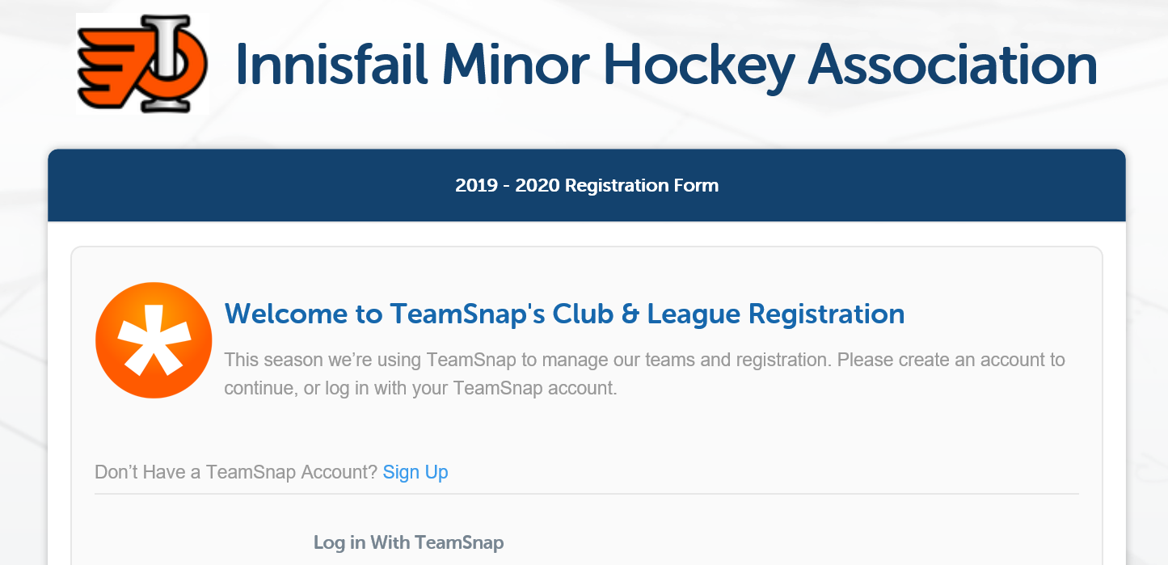

**FIRST TIME REGISTERING FOR MINOR HOCKEY?**

You will need **two** things before you can register with our association:

1. First will require a new Hockey Canada ID Number that you will obtain through our Executive Director. Please send an email request to: [innisfailminorhockey@gmail.com](mailto:innisfailminorhockey@gmail.com) & include the following information:
   * The Player’s Name
   * The Player’s Date of Birth
   * The Player’s address (If you live in a rural location, please also send your legal land description)

You will then be provided your Hockey Canada ID and will be able to register your player with IMHA once you complete the Respect in Sport Certificate (see #2)

1. You will be required to complete the ‘Respect In Sport Parent’ Program to obtain your certificate number before registration can be completed (<https://hockeyalbertaparent.respectgroupinc.com/>). There is a $30.00 fee to obtain this certificate that is mandated by Hockey Alberta. The course takes approximately 1 hour to complete online. ***This certificate is good for 4 years and can be attached to all your children playing hockey; you do not need to complete for each player***

**NEW TO INNISFAIL MINOR HOCKEY – PLAYED IN ANOTHER MINOR HOCKEY ASSOCIATION LAST YEAR**

Members who are new to IMHA (but exist in a different association) ***will not be able to register online until the player is transferred to IMHA*** through the Hockey Canada Registry.  If you attempt to register online, you will receive an error as your player’s Hockey Alberta ID is not associated with us.  In order to register online, you will need to first be transferred to IMHA.  To transfer a player to IMHA you will need to submit one of the following forms, dependent on the described circumstances:

● If you reside in another community or association, you will need to complete a Player Movement Form. This can be found on the Hockey Alberta website Player Movement Form

● If you have recently moved or will be moving within the IMHA boundaries, you will need to complete the Parent/Guardian Declaration Form (Now an on-line form): [**Parent Declaration Form | Hockey Alberta**](https://www.hockeyalberta.ca/parent-declaration-form/)

If either of these situations apply to you, please complete the applicable form and submit it via email to: [innisfailminorhockey@gmail.com](mailto:innisfailminorhockey@gmail.com) Once you have been transferred to IMHA, you will be able to register online  
___________________________________________________________________________________________

* Register before July 31st,2025 to take advantage of the payment plan
* Register before July 31st,2025 to avoid an increase in fees from U9 through U18
* ***NOTE: You must register with IMHA before forms can be signed to try-out in other Associations***

**ALL OFFLINE PAYMENT MUST BE RECEIVED BY THE IMHA OFFICE BY JULY 31st,2025   
ANY PAYMENTS RECEIVED AFTER THIS DATE WILL BE SUBJECT TO PAY THE REGULAR RATES**