JDF Minor Hockey Association

Return to Play Plan

Record of approval - JDFMHA Board of Directors 3
Introduction 4
Guiding Resources 4
Pre-season Communications Plan 4
Member Communication 5
Member/Participant Virtual Meeting 5
Phase 2: Transition Measures Requirements 6
Upon Arrival 6
Hygiene 6
Arrivals and Departures 6
Attendance Limits 7
Physical Distancing 7
JDFMHA Facility-specific Requirements 8
Responsibilities 9
Return to Play Committee 9
Communications Officer 9
Hockey Canada Safety Program (HCSP) Personnel - Team Safety 10
Manager 10
Coaches 10
Parents / Guardians / Spectators 10
Participants 11
Officials 11
Protocols 12
Attendance Tracking 12
Stay Away When Sick 12
Onsite Symptom Response Plan 1​3
Return to Play after Illness 1​3
Test Positive Notification Plan 1​4
Tools 1​5
JDFMHA Return to Play Agreement 1​5
Screening Questionnaire 17
First Aid Modifications 1​7
Attendance Tracking Form 1​8
Return to Play after Illness Form 1​9
Failure to comply 20
APPENDIX A: First Aid Procedural Modifications 21
APPENDIX B: All CRD Facility-specific requirements 22
APPENDIX C: Naden/Wurtele Arena Specific Requirements 23
APPENDIX D: ​ViaSport Return to Sport Activity Chart 24
APPENDIX E: EAP (EMERGENCY ACTION PLAN) Covid Modifications 25

JDFMHA Board of Directors
The JDFMHA Return to Play Plan as shown in this document and attached digitally has been reviewed and approved by board members:
Harold Bloomenthal, President JDFMHA
Ian Taylor, Vice President Operations JDFMHA
Mike Hales, Vice President Administration, JDFMHA

Introduction
Juan de Fuca Minor Hockey Association (JDFMHA) has created this Return to Play plan for restarting operations to inform all participants, team staff, officials, parents/guardians, officials and spectators about the policies and procedures in place to prevent the transmission of COVID-19 and maintain a safe and healthy environment for all during the COVID-19 pandemic.
In addition, JDFMHA worked with our neighboring associations to meet with our facility partners in developing our Return to Play plan and included facility guidelines where available, including:

- Wurtele Arena / Naden Athletic Complex (late June / early July) with VMHA and CRFMHA
- Westhills Arena (June 16) with CRFMHA and JDFMHA
- West Shore Parks and Recreation Society (mid-Summer) with CRFMHA and JDFMHA

This ​Season Phase 3 Phase Plan​ will continue to be changed as new facility requirements are provided and/or as Provincial Health Orders are updated.

Phase 3 and 4 plans to be determined as per provincial guidelines allow and at the direction of our Facility Partners, via Sport, Hockey Canada and BC Hockey.

Guiding Resources
JDFMHA is continuously monitoring guidelines from the BC Provincial Health Officer, local health authorities, hockey governing bodies and provincial recreation and facility organizations, including:

BC's Restart Plan viaSport - Return to Sport Guidelines for BC
Hockey Canada Return to Play - Safety Guidelines
BC Hockey - Return to Hockey
BC Parks and Recreation Association - Guidelines for Restarting Operations Recreation Facilities Association of BC - COVID-19 Resources

Pre-season Communications Plan

Member Communication
The JDFMHA Return to Play plan will be distributed to the members through:
- Email
- Shared through social media channels
- Regular Team Safety and Manager updates
- A team manager/safety rep meeting (to be held through an online meeting platform)

Team Manager/ Team Safety Rep Virtual Meeting
- Initial meeting with managers/safety reps to review Return to Play plan
- Address questions
- Topics include but are not limited to:
- JDFMHA protocols and responsibilities for team staff, participants and members
- Importance of social distancing both off the ice
- Facility-specific guidelines for maximum participants and spectators.
- Facility-specific guidelines for use of entrances/exits, dressing room use and/or capacity, washroom facilities, pre- and post-event time limits, waterbottles
- The importance of mandatory attendance tracking
- The importance of staying home when sick
- Return to play from illness
- Safety person, manager and coach roles in Covid return to play o
- Equipment guidelines and item storage
- Mandatory notification of test positive COVID cases for participants, members, team staff, officials or anyone they have been in close contact with

Phase 2: Transitional Measures Requirements
All members including participants, team staff, officials, parents/guardians, officials and spectators must adhere to the following requirements in order to return to play.

Upon Arrival
- Meet your team’s screener prior to entry to log attendance and answer screening questions (screening questions can be found under tools) If the team is using the RAMP app then all of this can be done through the app which has built in COVID screening questions. An excel spreadsheet can be populated from this app through the JDF Website for distribution in the event of contact tracing.

- No members will be permitted if they exhibit ​ANY​ symptoms of illness
- If symptoms present during an event, the participant will be excused and asked to follow our return to play protocol

Hygiene
- Wash hands or use hand sanitizer upon entry to the facility
- Water bottles: Bring pre-filled and labelled water bottles clearly
- Water available in some facilities, but please limit contact
- Do not share water bottles
- Absolutely no spitting; participants found spitting will be asked to leave and the area will be cordoned off for sanitization
- Washrooms available with limited capacity
- No showers are available onsite at facilities

Arrivals and Departures
Facility specific guidelines can be found under facilities, but the general requirements are as follows:
- Arrive no earlier than 15 minutes prior to ice time or as dictated by the facility
- Enter and exit through the designated entrance door
- Dressing rooms may not available
- Arrive in full gear aside from gloves and helmets
- If at all possible, arrive in skates with guards as there is limited room and time for skate tying

There may be no locked area to store your items on site at some arenas

Parent/guardian to hold player’s belongings; bring as little as possible, goalies will be provided designated area to put on gear but come as fully dressed as possible

- Follow one way arrows/markings if provided
- All participants must exit the facility within 15 minutes of their ice time end

Attendance Limits

Facility specific guidelines can be found under facilities, but the general requirements are as follows:
- There are limits of 24-30 people on-ice including participants and coaches (numbers may change)
- U7 and U9 divisions are permitted to have one person accompany a participant to assist with skates as long as total numbers stay under 50. Best practice is for these players to come with skates and skate guards on.
- No siblings permitted
- One spectator per participant, ​ if facility allows

Physical Distancing

- Players to maintain 6 ft distance at all times off the ice or wear masks (in some facilities)
- Coaches may assist players with equipment
- Coaches must wear with face masks when unable to social distance and sanitize hands before and after
- Maintain physical distancing while awaiting entry to the facility
- Physical distancing is not required on the ice, the penalty box or the players bench for players
- Spectators (where allowed) must maintain physical distancing and remain in designated spectator areas

JDFMHA Facility-specific Requirements

PHASE 3 | Panorama | Pearkes | UVic | OBRC | SOFMC | ABSC | Naden | WSPR | Westhill s | SEAPAR C
PPE | Not stated |  |  | Not stated |  |  | Masks at all times | Masks in dressing rm | Not stated
Maximum occupancy | 50 | “Limited” |  | 50 |  | 40 | 50 | 50 | 50
Arrival time | 15-30 min |  |  | 15 min |  |  |  | 20 min | 15 min
Arrive in Gear | n/a | YES; Including skates |  | YES |  | Preferred | Yes | Preffered | Preferred
Entrance door | Main |  |  | North Exterior |  |  |  | North Entance | Front
Signage | Yes |  |  | Yes |  |  |  | Yes | Yes
Water available | Touchless | YES |  | YES |  | NO |  | Yes | NO
Vending machines | Yes |  |  | Not stated |  | Not stated |  |  | Drinks only
Hand Sanitizer | Lobby |  |  | Common areas |  | BYO |  | West Entrance | Througho ut
DR Capacity | A - 6 B - 8 | 10 |  | 0 - N/A |  | 0 - N/A |  |  | 8
Skaters (max) | 30 | 30 |  | 20 |  | 40 | 30 | 30 | 24-30
Coaches (max) | 3 (1:6 ratio) | (incl in 20) |  | (incl in 20) |  | Incl in 40 |  | (incl in 20) | Incl in max)
Bench | Not stated | Open |  | Closed |  | 5 | Open | Open | Open
Penalty Box | Not stated |  |  | Closed |  | 3 | Open | Open | Open
Body Contact | None |  |  | None |  | None | Yes | Yes | Yes
Spectators (per player) | 1 |  |  | 1 |  | 40 Arena 8 Upper Lobby 14 Lower Lobby | 1 | 1 | 1
Arena Seating | None |  |  | Designate d |  | No congregat ing | Designated | North end | Designat ed
Showers | None | None |  | None |  | None |  | None | None
Vacate | 15 min |  |  | 15 min |  |  | 15 min | 15 min | 15 min
Touchpoint | Staff | Staff |  | Staff |  | Staff | Staff | Staff | Staff

Responsibilities

Return to Play Committee
JDFMHA has assigned a ‘return to play’ committee under the direction of our vice president of administration, with input from the JDF President, JDF Vice-President and Operations and JDF Head Coach.
The committee’s responsibilities include:

- Creating the plan for the safe return to play
- Monitor updates to local and provincial guidelines, via Sport, Hockey Canada and BC Hockey
- Host regular meetings with team staff
- Ensuring teams are following the prevention guidelines set by hockey Canada
- Monitor event screening and incident reports
- Provide guidance and support to team staff including team safeties
- Update the return to play plan as restrictions and health guidelines are updated

Communications Officer
Each MHA is required to designate a communications officer as per our governing bodies:
- Hockey Canada
- BC Hockey
- Vancouver Island Amateur Hockey Association (VIAHA)
The Communications Officer is responsible for:
- Communicating with the facilities used by each MHA to determine when they plan to resume operations.
- Providing this information to the members and to the communications officer in the
District.
- Receiving information from the District on the status of other MHAs and subsequent effect on resumption of league play, updates from BC Hockey and HC and sharing best practices with other MHA.
- Responding to member inquiries.
- Ensuring new Covid-19 cases are reported
The Communications Officer is Mike Hales, Vice President Administration.

Hockey Canada Safety Program (HCSP) Personnel - Team Safety
Each team will assign a safety person who is responsible for duties as outlined by Hockey
Canada. In addition, the team safety will be responsible for:
- Ensuring any return to play updates are communicated to their team (this can go through the team manager)
- Ensuring that participants, parents and team staff are adhering to the return to play plan
- Ensuring there is no shared equipment and any required equipment (cones/pucks,etc) are sanitized after use with approved sanitizer (alcohol based) or sanitizing wipes
- Ensuring that participants are excused if displaying symptoms of illness
- Ensuring that each participant follows all protocols after an absence for illness including completing the return to play form
- Provide site specific safety plans to managers for weekly team communications
- Attend all safety meetings with your association’s safety director

Manager
- Include safety messaging and site specific safety plans in regular team communications
- Keep attendance records for all team events
- Support safety person in their duties
- If required, assist safety person with event screening or creating an event screening rotation; support team safety in communicating this information to the team

Coaches
- Ensure physical distancing is taking place on the ice and dressing areas in support of team safety
- Maintain communication with safety person to address any updates to plans or issues
- Assist team safety in ensuring that participants and team staff are adhering to the return to play plan

Parents / Guardians / Spectators
- Discuss the return to play plan with your participant(s) to ensure they understand
- Assist team safety in ensuring that your participant(s) is adhering to the return to play plan
- Understand the ramifications of failing to comply with the Return to Play plan
- Promptly leave the event where spectators are not allowed
- Sign the JDFMHA Return to Play Agreement with your player and comply with requirements
- Assist team staff when requested in order to support them in this challenging time
- Notify your team staff and your communications officer immediately if you, your player, your family or anyone you have had close contact with tests positive for Covid-19 or is a presumptive case

Participants
- Water bottles
○ Bring pre-filled and labelled water bottles
○ Water available in some facilities, but please please limit contact
○ Do not share water bottles
- Keep hand sanitizer in their equipment bag
- Keep a non-medical facemask in equipment bag in case physical distancing can not be observed in facility
- Meet with the Team Manager and/or HCSP to complete the Screening Questionnaire before entering the facility/Naden base- without exception.
- Do not share equipment with any other player.
- Clean and wash equipment frequently.
- Wear hockey gloves continuously from the designated dressing room/area, throughout the ice session and until return to the dressing room.
- Maintain physical distance between you and other participants while on the ice
(approximately equal to the length of your arm plus your stick)
- Avoid body contact during drills in practice and in competition.

Officials
When gameplay is approved, officials need to meet the following requirements:
- Follow all general requirements stated in Phase 2 Requirements
- Water bottles
○ Bring pre-filled and labelled water bottles
○ Water available in some facilities, but please please limit contact
○ Do not share water bottles
- Keep hand sanitizer in their equipment bag
- Keep a non-medical facemask in equipment bag in case physical distancing can not be observed in facility
- Maintain physical distancing from participants except when necessary for safety reasons

Protocols

Attendance Tracking
Attendance tracking is required for every event. Parents should update their attendance, including spectators, in the RAMP app (when available) or using the attendance tracking form that will be completed by the team safety or manager upon arrival. If using TeamSnap for tracking attendance, please note the following:
- Update attendance in RAMP on the day of each event, not prior to
- Update affirmative attendance is also your confirmation that you meet all requirements of the screening questionnaire
All participants and spectators will re-confirm that they meet all requirements of the screening questionnaire when they arrive at the facility before entry or at the entrance to an arena.
Managers must retain their attendance lists for every event and produce the list upon request to the association.

Stay Away When Sick
No participant, team staff, parent/guardian, official or spectator should attend an event or facility if they are unwell. The symptoms of COVID-19 are similar to other respiratory illnesses including the flu and common cold.

Please refer to the BC Center for Disease Control as included symptoms change weekly.

All members are advised to stay at home if they are feeling unwell.

If they start experiencing symptoms while at an event, they must:
- isolate themselves from others immediately
- notify their manager
- excuse themselves from the event as soon as possible

Members who start displaying respiratory symptoms should use the ​BC COVID 19 self- assessment tool​ and follow all instructions provided. JDF has also provided the BC Health Authority Guidance for K-12 Document which assists what to do.

Onsite Symptom Response Plan (Emergency Action Plan or EAP)
Hockey Canada Safety EAP is found ​here
Covid Symptom Response EAP is incorporated in Team/Association EAP and includes: If any participant, team staff, parent/guardian, official or spectator:
- Presents with symptoms upon arrival
- Answers ‘yes’ to any screening questions
- Develops symptoms during an event

Then you must:
- isolate the participant, team staff, parent/guardian, official or spectator from others
- provide a non-medical facemask
- notify your manager
- excuse them from the event/facility as soon as possible
- follow the return to play after illness protocol
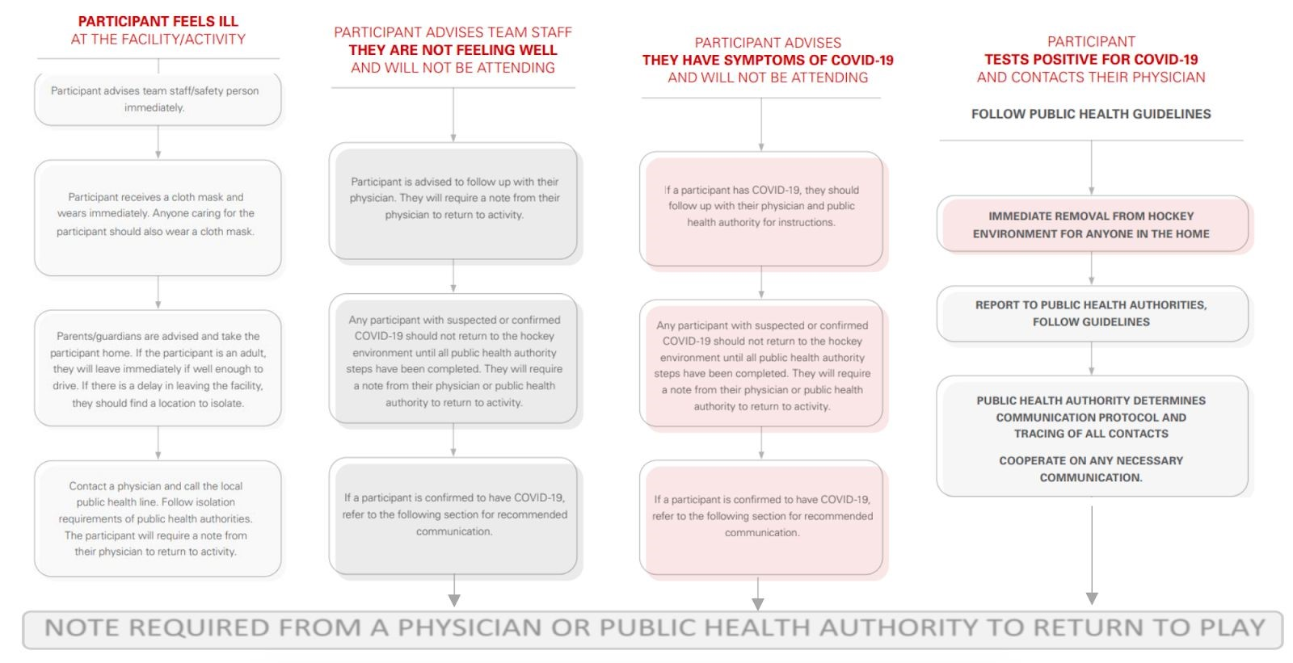

Return to Play after Illness
Members can return to play after 10 days when all symptoms have resolved. If a member tests positive for COVID-19, they can return to play only after clearance from a physician. See the return to play form under tools.

Test Positive Notification Plan
If a participant, team staff, parent/guardian, official or a member of their household tests positive for COVID-19, they are required to inform the association’s risk manager ( ​safety@jdfminorhockey.com​ ) and communications officer ( vp-admin@jdfminorhockey.com ​​).
The communications officer will report test positive cases to the following:
- the facilities that the person attended
- our governing body, VIAHA
- the team
- the membership

Tools

JDFMHA Return to Play Agreement
Application - all athletes, coaches, members, volunteers, participants and family members of participants while in attendance at club activities (“Participants”)
All Participants of ​Juan de Fuca Minor Hockey Association (JDFMHA)​ agree to abide by the following points when entering club facilities and/or participating in club activities under the COVID-19
Response plan and RTP Protocol:
- I agree to symptom screening checks, and will let JDFMHA know if I have experienced any of the symptoms in the last 14 days.
- I agree to stay home if feeling sick, and remain home for 14 days if experiencing
COVID-19 symptoms.
● I agree that when I confirm my attendance at a JDFMHA event I am agreeing to the following:
○ The participant and their household is symptom free
○ The participant and their household has not travelled outside of Canada within the last 14 days
○ The participant is not caring for or come into contact with anyone who is a presumptive case or confirmed case of Covid-19
- I agree to sanitize my hands upon entering and exiting the facility, with soap or sanitizer.
- I agree to sanitize the equipment I use throughout my practice with approved cleaning products provided by the club (shared and personal equipment).
- I agree to continue to follow social distancing protocols of staying at least 2m away from others.
- I agree to not share any equipment during practice times.
- I agree to abide by all of my Clubs COVID-19 Policies and guidelines.
- I understand that if I do not abide by the aforementioned policies/guidelines, that I may be asked to leave the club for up to 14 days to help protect myself and others around me.
- I acknowledge that continued abuse of the policies and/or guidelines may result in suspension of my club membership temporarily.
- I acknowledge that there are risks associated with entering club facilities and/or participating in club activities, and that the measures taken by the club and participants, including those set out above and under the COVID-19 Response Plan and Return to Sport Protocols, will not entirely eliminate those risks.

Participant Name: __________________________
Participant Signature: _______________________
Date: ____________________________________

Parent Name: _____________________________
Parent Signature: __________________________
Date: ___________________________________

Screening Questionnaire

The screening tool will be used for every participant, team staff, parent/guardian, official or spectator attending a JDFMHA before entering a facility.

Have you experienced any of the following symptoms of illness in the last 14 days, including:
Cough
Breathing difficulty / short of breath
Fever
Chills
Severe Fatigue
Muscle pain
Sore throat
New loss of taste or smel​l

Have you or anyone you are in close contact with travelled outside of Canada in the last 14 days?

Are you taking care of or are you in close contact with someone that has symptoms of or tested positive for coronavirus?

For the Team Safety or Manager: If any of the above questions result with a “yes” proceed to Onsite Symptom Response Plan.

First Aid Kit Modifications
Team safety kits must contain:
- Medical face mask, preferable with attached face shield
- Hand sanitizer
- Examination gloves
Please see Appendix A for first aid procedural modifications.

Attendance Tracking Form
List to be submitted to be retained by team manager and provided to Safety and Risk Manager upon request.
Date: ______________________________
Person Completing Attendance: ______________________________
Team: ______________________________
Players attendance: (include parent as +1 if applicable)
*Please write clearly or complete electronically

Team Staff Attendance:

JDFMHA Return to Play after Illness Form

Participant Name: ______________________________

Date: ______________________________

Player Illness Start Date: ______________________________

Player Isolation Dates (From - To): ______________________________

Date Symptoms Ended: ______________________________

Seen By Physician? ____ Yes ____ No

Tested for Covid-19? (if Yes, include physician signature and ensure your team safety is aware for contact tracing): ____ Yes ____ No

Result of Covid-19 Test: ____ Positive ____ Negative
If positive, ensure your team safety/association has been notified)

Physician:
Is the player able to return to sport with the following considerations:
-On ice activity with others
-Attendance at recreation facilities
-Physical activity (list any restrictions)
I, the undersigned, understand that this information must be completely entirely and approved by my team safety/association safety director prior to being permitted to return to Hockey. I understand that myself and/or my player must isolate for a minimum of ten days if ill and a minimum of fourteen days if contracted Covid-19.

Parent Signature: ______________________________

Date: ______________________________

Physician Signature (If Covid Test was completed and positive):__________________________

Date: ______________________________

*Form to be completed by players/parents in all illness situations, regardless if positive Covid-19 test is returned. No player is permitted to play when ill, to any degree, and must isolate as per provincial protocol if they become ill.

Failure to comply
Failure to comply with the JDFMHA Covid Return Plan and/or Facility Specific Guidelines will result in immediate removal from the event.
Participants or members failing to comply will be reported to Safety Director and potentially the disciplinary committee.
Repeated failure to comply with direction may result in suspension from JDFMHA events.

APPENDIX A: First Aid Procedural Modifications
- Both the First Aid provider and the injured must wear a mask covering mouth and nose
- First Aid provider should wear face shield when appropriate and when providing first aid to a referee (WCB requirement)
- First Aid provider must also wear sanitized gloves
- First Aid must be provided from 2m/6ft physical distance when possible
○ First Aider can provide clean supplies to injured and direct on the use of supplies
○ First Aider can provide clean supplies ot parent or member of participants household and provide direction on use
- When life sustaining first aid is required, all available precautions should be used to keep the first aider and the injured safe, including scene assessments, PPE and physical distance from helpers
- First Aid certified members should advise their team’s safety person of their qualifications and cary their first aid certificate with them

APPENDIX B: All CRD Facility-specific Requirements

 | Panorama | Ian Stewart | West Shore  Parks &  Recreation | Westhills | SEAPARC
Maximum occupancy | 50 | TBD | TBD | 44 | TBD
Arrival time | 15-30 min | TBD | TBD | 15 min | TBD
Arrive in Gear | n/a | TBD | TBD | Preferred | TBD
Entrance door | Main | TBD | TBD | Front | TBD
Signage | Yes | TBD | TBD | Yes | TBD
Water available | Touchless | TBD | TBD | NO | TBD
Vending machines | Yes | TBD | TBD | Drinks only | TBD
Hand Sanitizer | Lobby | TBD | TBD | Throughout | TBD
Dressing Room  Capacity | - - 6  - - 8 | TBD | TBD | 5 | TBD
Participant  Maximum | 20 | TBD | TBD | 10 | TBD
Coach Maximum | 3 (1:6 ratio) | TBD | TBD | 2 | TBD
Bench |  | TBD | TBD | Closed | TBD
Penalty Box |  | TBD | TBD | Closed | TBD
Body Contact | None | TBD | TBD | None | TBD
Spectators | 1 | TBD | TBD | 1 | TBD
Arena Seating | None | TBD | TBD | Designated | TBD
Showers | Closed | TBD | TBD | Closed | TBD
Vacate | 15 min | TBD | TBD | 15 min | TBD
Touchpoint cleaning | Facility | TBD | TBD | Facility | TBD
Exit door | - Door 15;  - Door 12 | TBD | TBD | West Entrance | TBD
UPDATED: | June 11 | TBD | TBD | May 29 | TBD

APPENDIX C: ViaSport Return to Sport Activity Chart

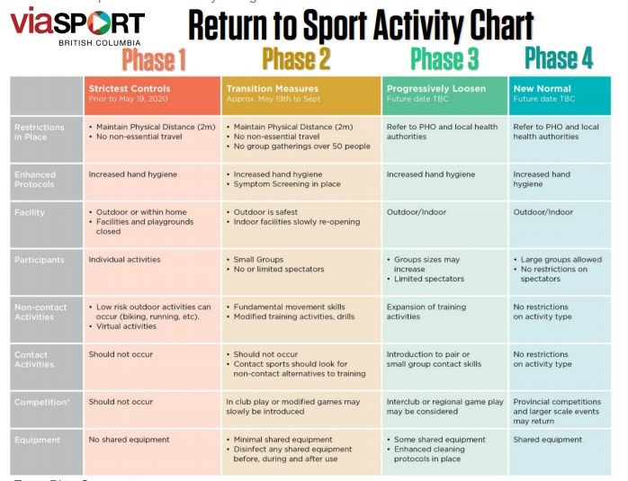

APPENDIX D: EAP (Emergency Action Plan) Covid Updates
When creating the team’s EAP for the safety binder, the EAP should now include the following (in addition to information previously required):
- Entrance and Exit points in relation to the rink
- JDFMHA Safety and Risk Manager and Covid related Communications contact information ○ safety@jdfminorhockey.com​ and ​vp-admin@jdfminorhockey.com
- Current JDFMHA Safety Return Plan must be immediately available for reference should it be required (due to potential frequent updates, the document should be reviewed at minimum weekly if printed or kept electronically in an “available offline” mode due to service disruptions at some facilities
EAP​:
https://cdn.hockeycanada.ca/hockey-canada/Hockey-Programs/Safety/Safety-Program/Download s/eap_organization_form_e.pdf

