Westhills Game Dressing Procedures
**No spectators allowed in building, all facility rules still in place.
Like Cohort teams will be assigned dressing rooms 1 and 3 (blue) or 2 and 4 (orange).
Each dressing room holds 11 players with the remaining overflow in the following areas:
Blue: 14 additional seats available in Corridor and Party Room to lace skates.
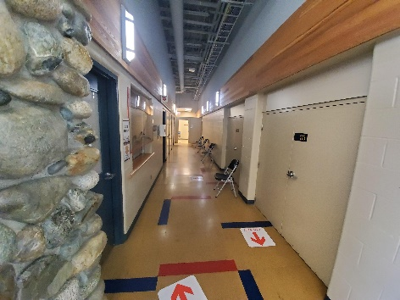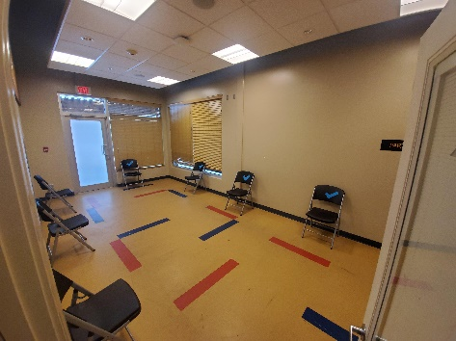
Corridor Party Room
**As these areas will host both home and away teams, managers must place team staff (2 deep rule) in this area to ensure players behave. Players enter and exit the ice via the penalty box gate.

Orange: 14 additional seats available in the lobby and ice entrance area to lace skates.
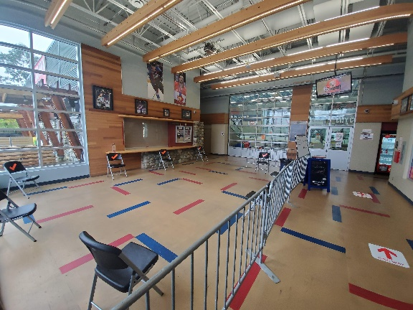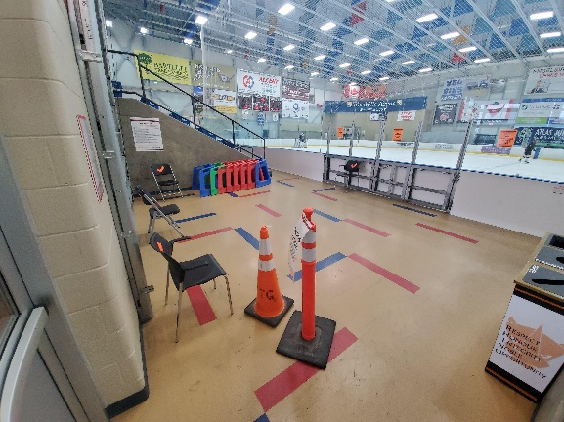
Lobby Ice Entrance

Dressing must be supervised. Either door propped open and a staff member outside or 2 deep inside, wearing masks and in middle of dressing room or showers.
Referees will lace up in the coaches area on provided seats near the female change room.

