Greg Scollan U15 BB 2023-2024

Dear Parents and Players,
My name is Greg Scollan and I am excited to have been selected to coach the U15 BB Rangers for the 2023-2024 season. I have coached female hockey in some capacity over the last 7 years and I look forward to this new opportunity.
Philosophy
My philosophy is to lead, develop and promote a safe and positive hockey experience for all players. Players will work to develop individual technical skills and individual tactics, while continuing to expand on team tactic/play concepts. We will challenge the players to work hard and improve, helping them develop confidence and experience a sense of personal achievement. Most importantly, we will ensure to keep it fun! I believe in being supportive, encouraging, open and honest. For anyone to be a great coach or leader, it’s imperative that they are adaptable and have a willingness to learn and work with others.
Commitment

The team is expected to have 3-4 mandatory hockey commitments per week. The priority will always be family, school, and hockey. A strong commitment to the team will lead to increased success for the player and team.
Please be mindful that there are no call-ups permitted for playoffs and playdowns, so please keep that in mind if considering any travel in February and March. Black-out dates are a good opportunity for travel.
The expectation is that all coaches, players and families are committed to bringing a positive and respectful attitude to all team activities. Furthermore, players will be expected to bring a strong work ethic and a high level of compete to every practice and game.

Season and Tournaments
Our season will consist of 22 regular season games, playoffs and playdowns.
We will also compete in 2 away tournaments (Etobicoke, TBD), and 2 local tournaments (KGHA, TBD). We will strive for a 5th tournament (Provincials) in April.
Team Fees
Team fees will be in the range of $1,500 - $1,800 depending on tournaments selected and making Provincials. These fees are in addition to registration fees. The team budget will be determined at the beginning of the season and discussed in the parents’ meeting.

Tryouts
Please see the tryout schedule below or at (https://kgha.ca/content/spring-competitive-tryouts)

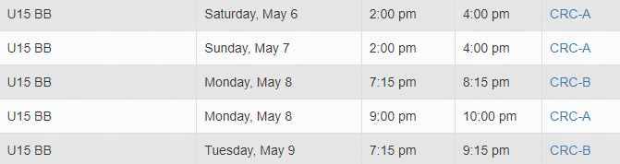
Be sure to check the website regularly for updates (https://kgha.ca/content/tryout-results)

Feedback will only be given for the players in the final release, if requested.

If you have any questions or concerns, please feel free to contact me at any time.

Good luck to all players!
Thanks,
Greg

g_scollan@hotmail.com

