REGISTRATION FOR COACHES

New Coaches

Step 1:

Login to your RAMP Account you created while registering your player at

Kentville Minor Baseball : RAMP Registrations

Step 2:

You will be brought to the following login

Enter your email
Enter your Password
Hit “login”

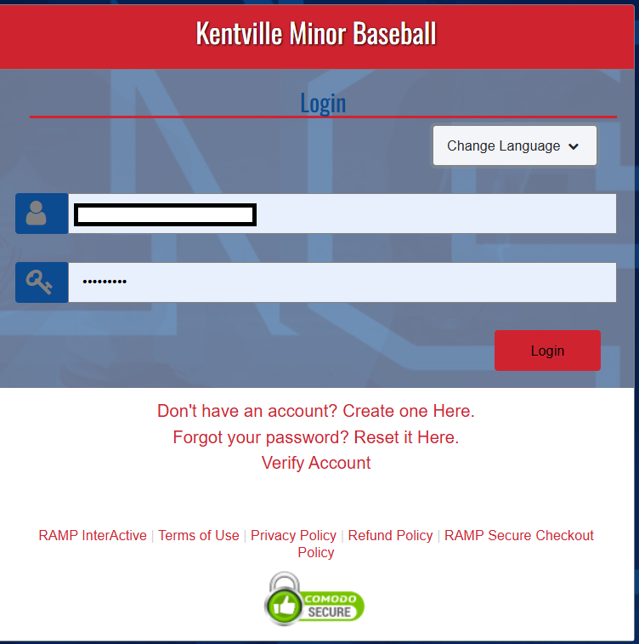

Step 3- **IF YOU ARE A NEW COACH WITH KMBA ONLY**
RETURNING COACHES GO TO STEP 5

Once Logged into your profile you will see the following screen

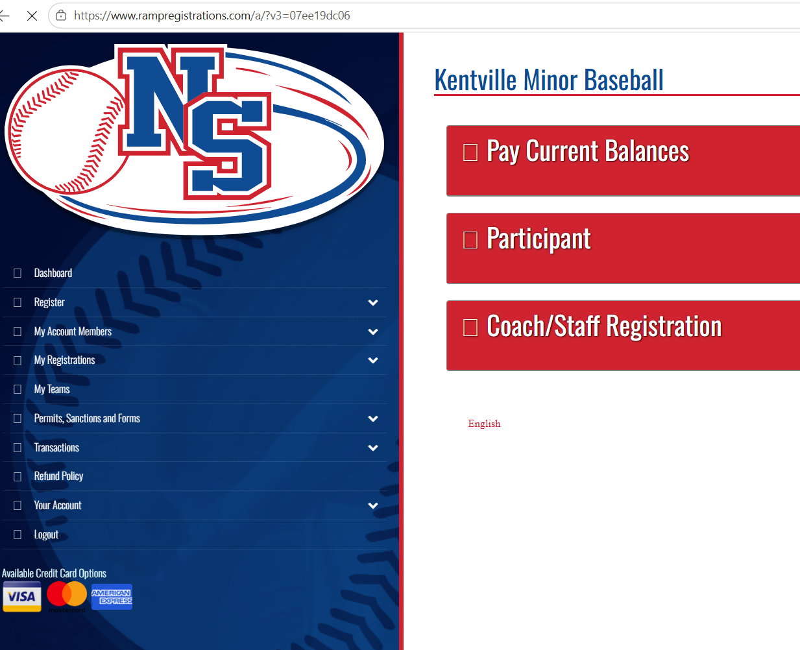

You must first Add an Account Member by

Clicking My Account Members
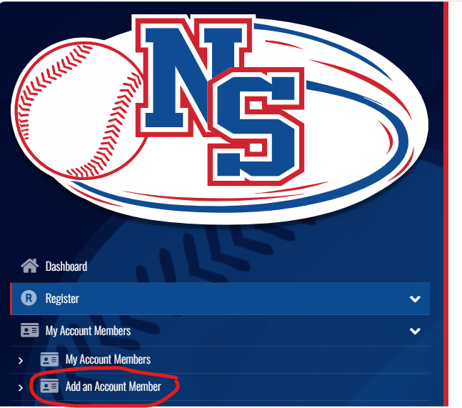

You Must fill out the following highlighted Information

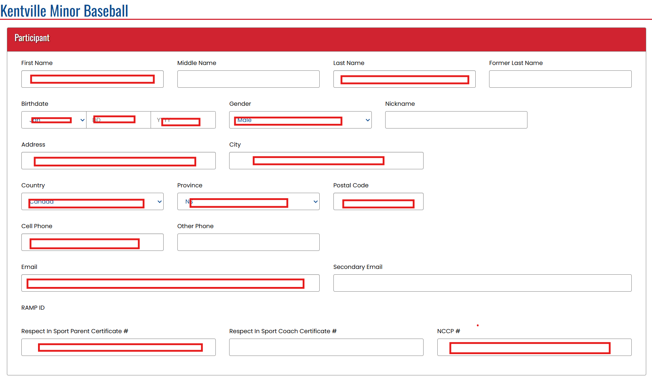

NOTE: NCCP# is only required is Coaching at the TRAVEL/COMPETITIVE LEVEL ONLY

If you already have your Checks done please upload now.
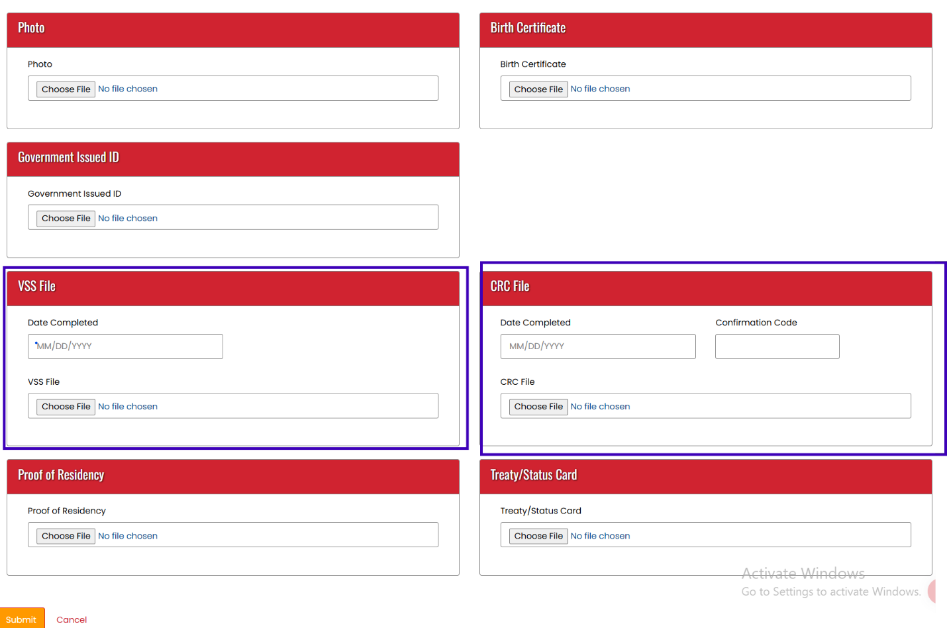

YOU MUST UPLOAD YOUR VSS OR YOUR CRC to ONE SPACE ONLY. IN THE FREE SPACE YOU WILL UPLOAD YOUR CHILD ABUSE REGISTERY CHECK

Step 4
IF YOU DO NOT HAVE YOUR CHECKS BACK OR DONE SUMBIT YOUR REGISTRATION AND COME BACK LATER TO ADD THEM.

Below are examples of what goes where

This is an example of the VSS from the RCMP which must be uploaded into 1 of 2 spaces

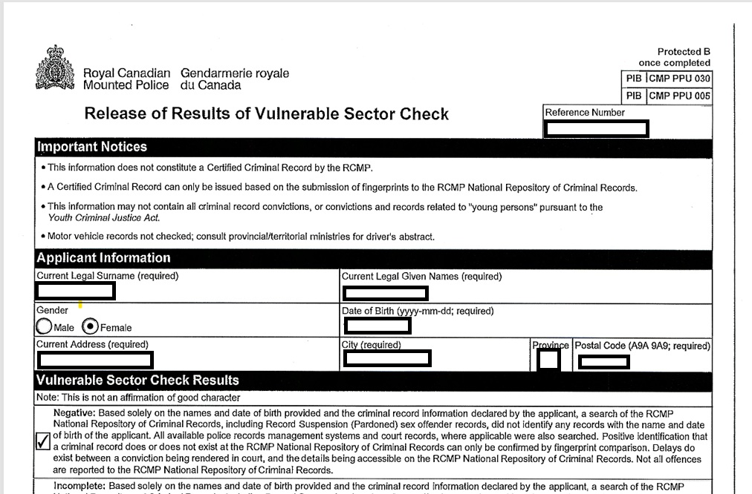

And

This is an Example of the Child Abuse Registery Check that must be online at

Apply for a Child Abuse Register search - Government of Nova Scotia

You will receive the results by mail and must be uploaded into the other Free Space
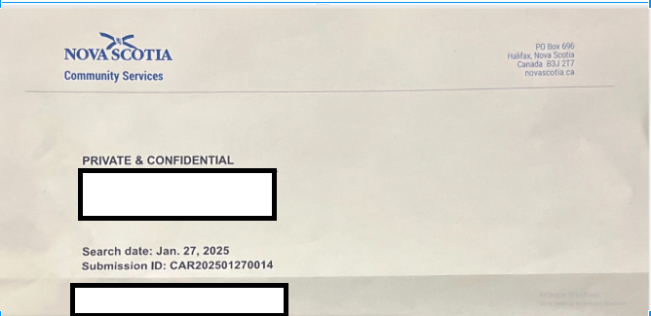

Step 5- RETURNING COACHES AND UPDATING DOCS

Once you are logged into your RAMP account

Select Coach/Staff Registration

Choose your name from the drop down under “CHOOSE ACCOUNT MEMBER…”
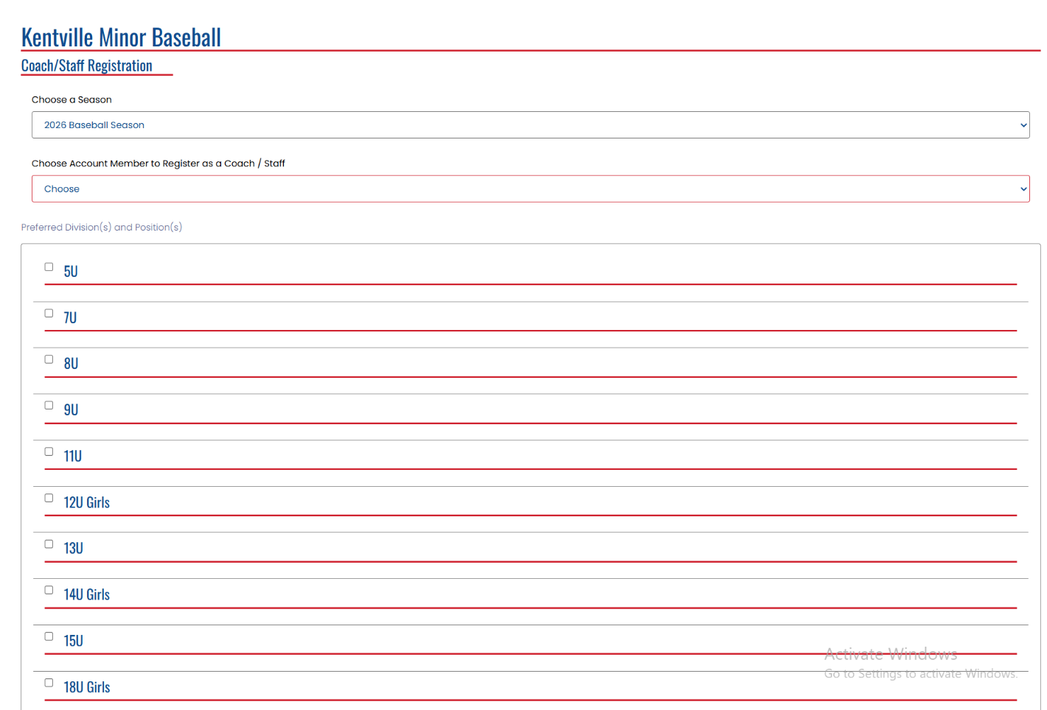

Choose the Division you would like to coach this season

*DO NOT CHOOSE BUDDY- As this is used for players who help coach only*

You can choose to help out multiple divisions by clicking more divisons

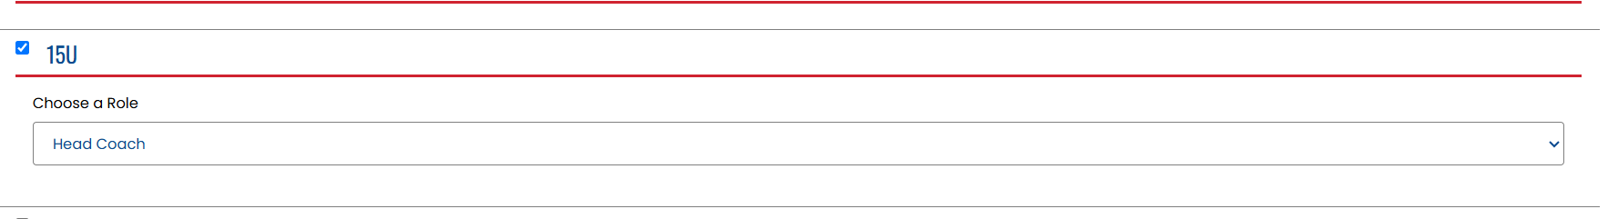

When done click the Continue

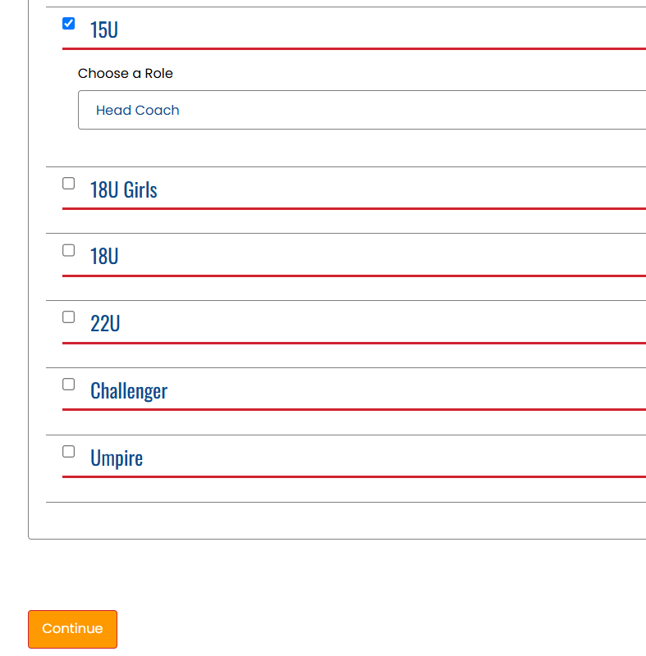

PLEASE UPLOAD NEW DOCS IF REQUIRED and Continue
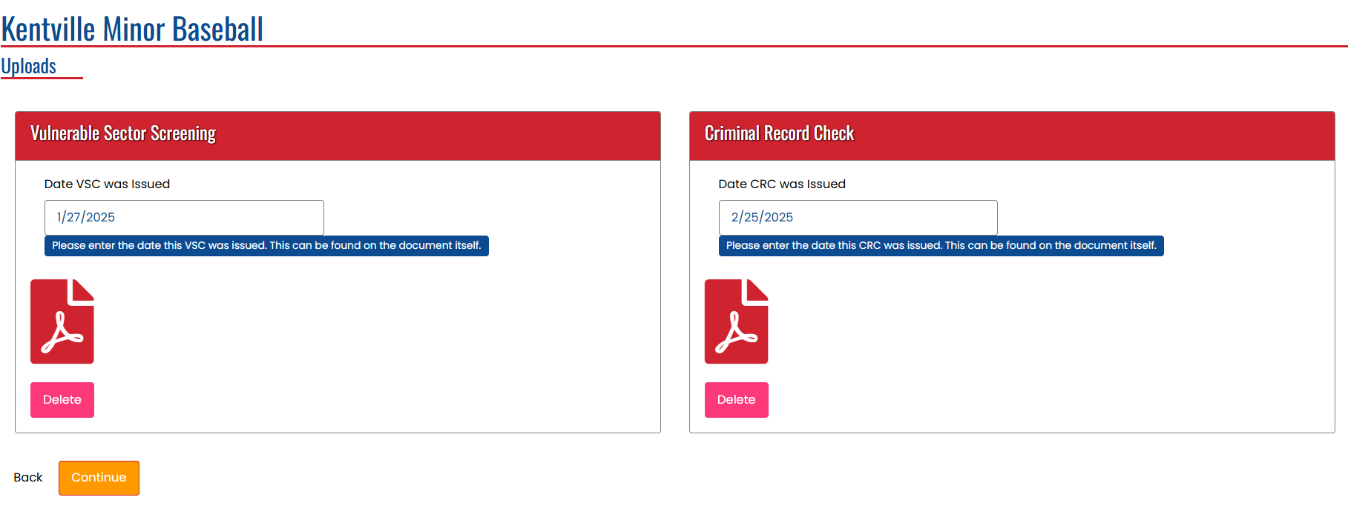

Review your information below

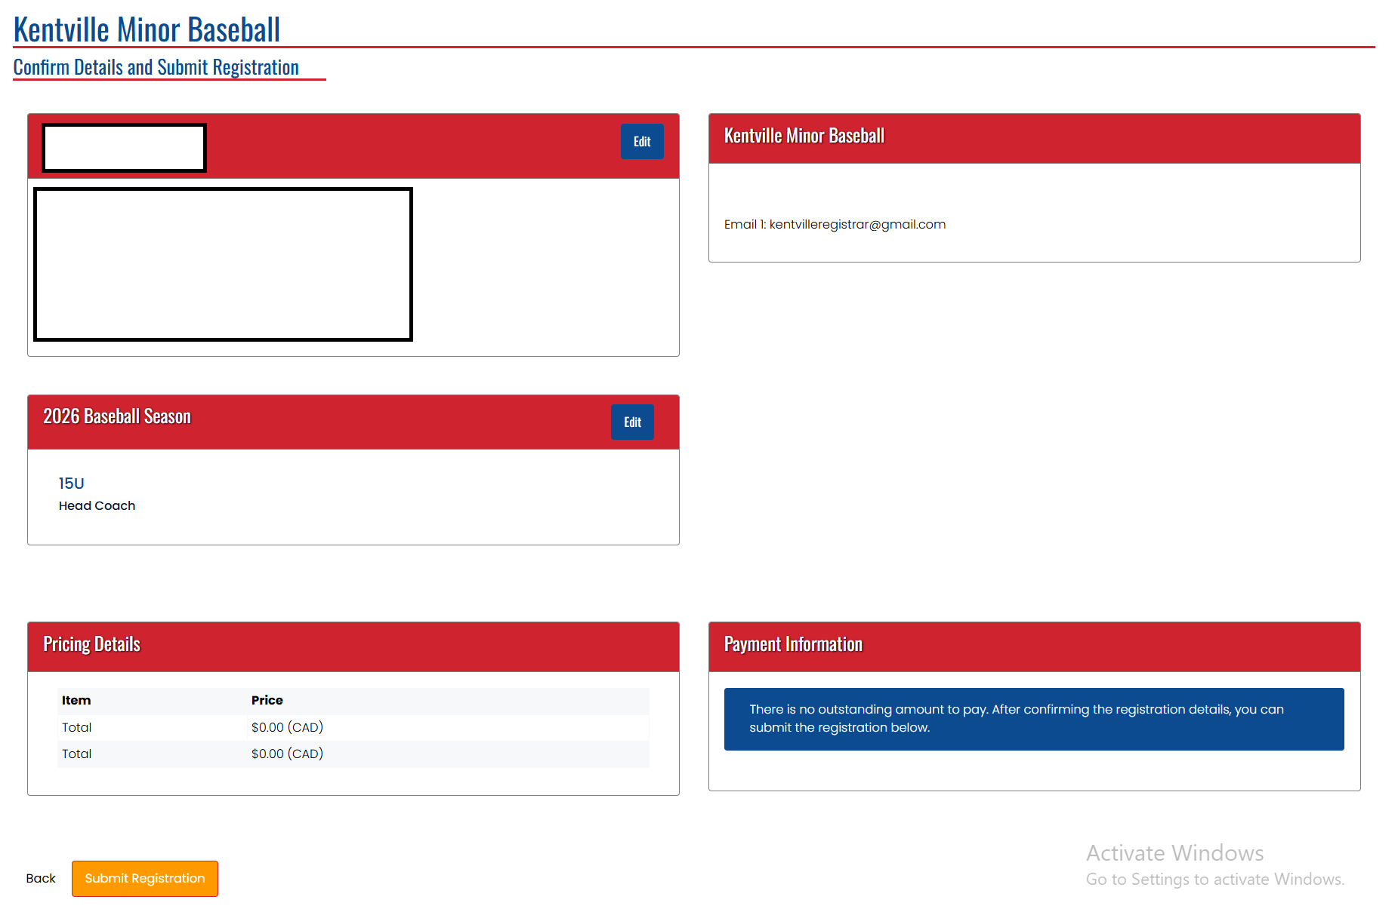

SUBMIT REGISTRATION

ADDING AND UPDATING COACHING CHECKS

Step 1:

Login to your RAMP Account you created while registering your player at

Kentville Minor Baseball : RAMP Registrations

Step 2:

You will be brought to the following login

Enter your email
Enter your Password
Hit “login”

On this Screen Choose – My Account Members

*DO NOT CREATE A NEW PROFILE*
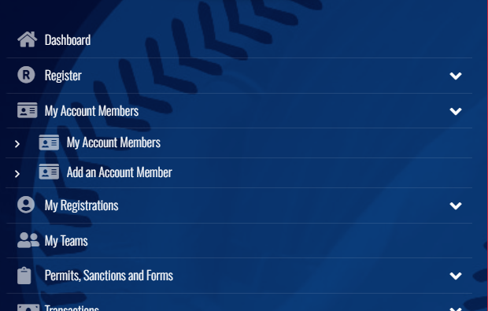

Find your profile

Select the EDIT Button

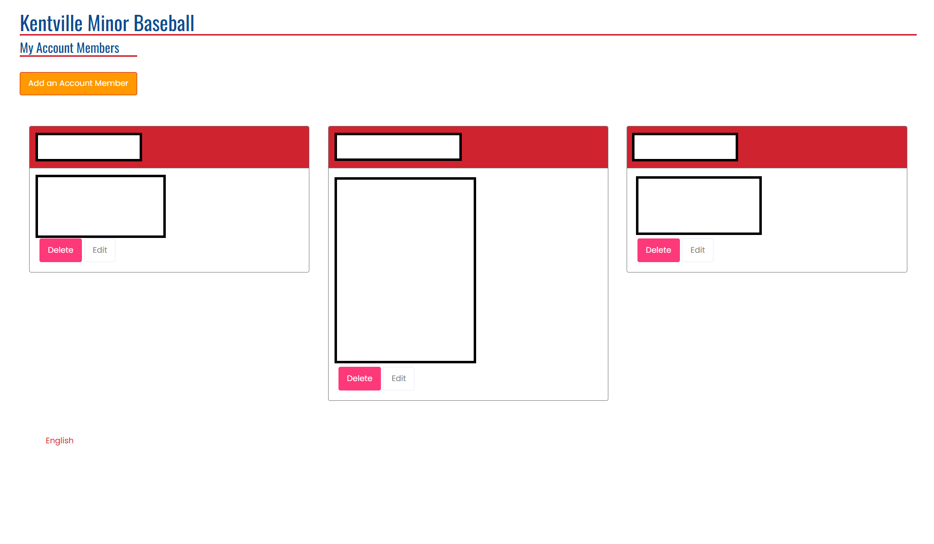

You will see your full profile like below
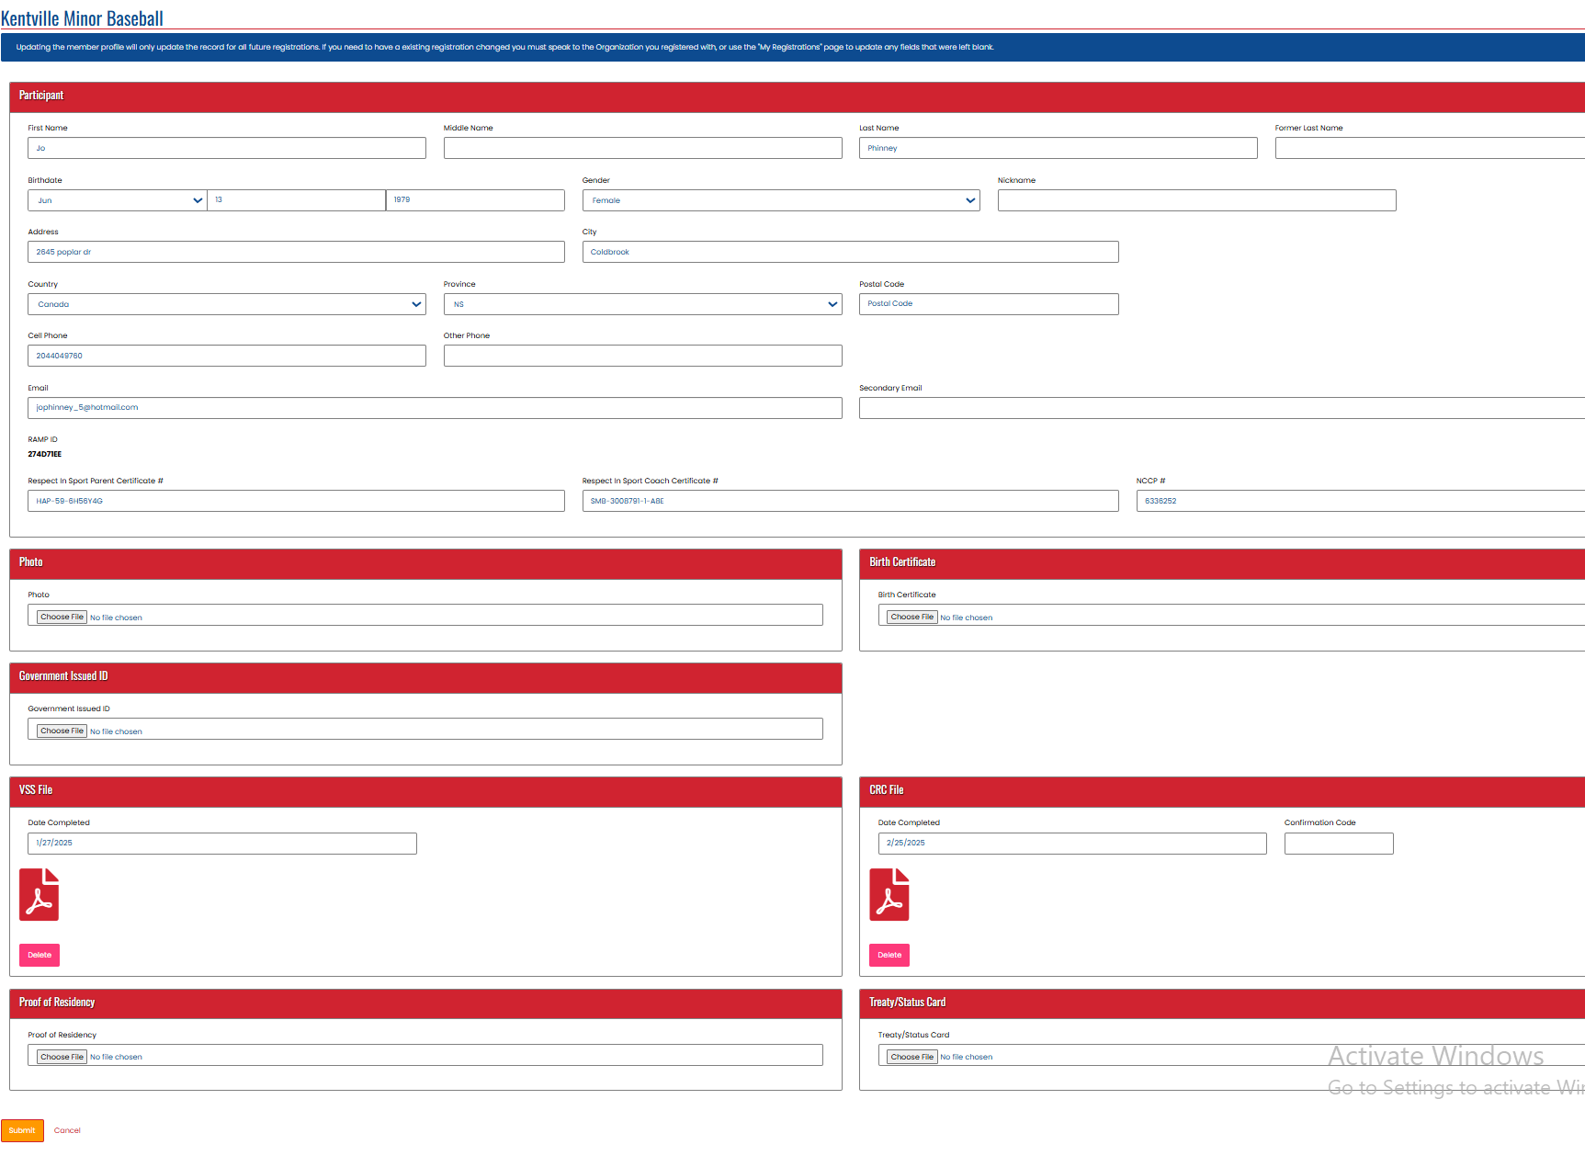

Scroll down to and upload your new documents or add them for the first time.

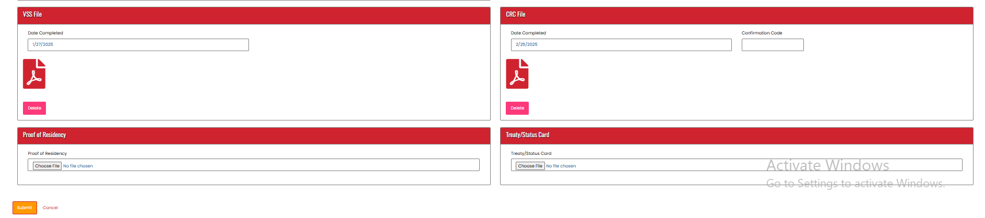

HIT SUBMIT once docs are uploaded

