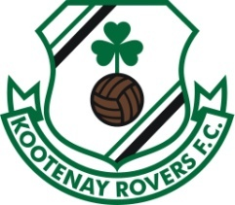
KOOTENAY EAST YOUTH SOCCER ASSOCIATION

Adult soccer Code of Conduct

I will be respectful of my fellow players, volunteers and officials
I will participate in all programs drug and alcohol free
I will respect and follow BC soccer, Canada Soccer, FIFA and KEYSA’s rules for game play
I will respect and follow participant rules in New Dawn place by not having any food or beverages in the facility other than water or a sports drink like Gatorade, not spit in the facility and not wear my outdoor shoes on the green playing surface.
I will follow BC Soccer’s policy of wearing cleats, shin guards and no jewelry

Upon completion of KEYSA Adult soccer registration, I acknowledge that as a member of KEYSA I must be aware of and adhere to the adult soccer code of conduct.

