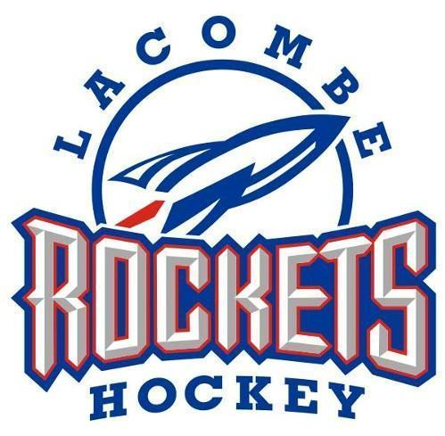

The aim of the Lacombe Minor Hockey Sponsorship program is to help raise funds to supplement the cost of hockey, as well as to involve the Corporate Community in our program. There are 5 levels of sponsorship as detailed below.

# Platinum - $1,500.00

As a Platinum Level Sponsor you are the proud sponsor of a Lacombe Minor Hockey team. Your Corporate Name will be on the back of both the Home and Away Jerseys for all to see. As a sponsor, your support goes to helping with team expenses and equipment replacement. You will receive your Corporate Logo on the team’s home page, as well as the team being named after your Company eg. “Your Business Name” U11 A Rockets.” We will also provide you with a Sponsorship Item to be proudly placed in your Business.*If you wish to have your specific company logo made for the jerseys, this could be created at an extra cost, or provided by your company*



# Platinum 3year - $4,000.00

We are promoting the Platinum 3 year Sponsorship option which is a 3-year commitment at the Platinum Sponsorship level. With the three year Platinum, Sponsors are asked to submit a one-time payment of $4,000.00 to get the $500 savings. 3 years is the typical lifespan of the LMH jerseys.

**Platinum +Apparel**

Thinking you would like your business name on your sponsored team’s apparel? As a platinum Sponsor, you have the first chance to fund your team’s tracksuits, warm up jerseys or dryland training gear. If this is an addition that you would like to have added to your platinum package, please let your Sponsorship rep know at the time of agreement so an apparel price list can be forwarded to you.

# Gold - $750.00

As a proud Sponsor of Lacombe Minor Hockey you can have your company name on a jersey. Gold sponsorship of a team will place your Company name on the upper right chest of the jersey and your business listed on our website/social media page.*If you wish to have your specific company logo made for the jerseys, this could be created at an extra cost, or provided by your company*

**Friends of Minor Hockey - up to $500.00** Funds at this level are pooled together to cover costs associated with Minor Hockey Awards, Tournament Sponsorship and Player/Coach Development. You will be recognized on our website and banners placed up outside the office and on display during tournaments.

We feel very strongly that organized team sports help build solid foundations of our youth and we are proud to be associated with each and every one of our athletes as well as the members of the Lacombe community. Your continued support of the Lacombe Minor Hockey Association is valued and we thank you for being a part of the family.



Company Name:

Contact:

Email:

Address:

Phone #:

Sponsorship Level:

𝥁 Platinum 3 $4,000.00

𝥁 Platinum Plus Apparel $1,500.00 + Team Apparel

𝥁 Platinum $1,500.00

𝥁 Gold $750.00

𝥁 Friends of Minor Hockey -up to $500.00

We are asking that all Sponsorship confirmations be submitted to the Lacombe Minor Hockey Sponsorship Committee no later than August 25th to allow for the Sponsorship names to be added to the jerseys. Please send this form back to the committee at lacombehockeysponsorship@gmail.com. One of the Sponsorship members will be happy to pick up your Sponsorship cheque or they can be mailed directly to the Association at:

Lacombe Minor Hockey Association

Box 5180

Lacombe, AB T4L 1W9

Should you have any questions in regards to the Sponsorship program, please don’t hesitate to contact us.

Thank you for your support!

Corey Rintoul 403-350-9032 or

Jerilee Wilson 403-348-3189

[lacombehockeysponsorship@gmail.com](mailto:lacombehockeysponsorship@gmail.com)