LMHA Team Budget and Fundraising Policy Approved June 2024

Team Budgets

All teams must use LMHA Bank accounts created for each team. Banking information will be given to tema treasurer by the LMHA treasurer once a team budget is approved.

Step One Creating the Team Budget

The team treasurer is to create the budget and have it approved by 90% of the players/caregivers (1 vote per player) and then sent to the division director and LMHA treasurer for approval. A vote can take place in person, by email or through a survey. A record of all who approved and did not approve the budget must be kept.

Parents should be given options for the budget including fundraising or no fundraising. See appendix A for sample budgets.

Budgets can only include expenses that are for the hockey season:

* Home Tournament (Raffle prizes, etc)
* Away Tournament
* Team Bus Transportation
* Team Wear (Helmet Stickers, Practice Jerseys, Warm up Gear etc)
* Team Training (extra ice, dryland etc)
* Jersey Cleaning (U11 & Up $200)
* First Aid Kit refill

Income can come from five places:

* Slush Funds
* Home Tournament
* Fundraising
* Sponsorship
* LMHA Fundraising Kickback

The initial budget should have net proceeds of $0. Sample Budgets can be found in Appendix A.

The total budget shall not exceed amounts outlined below without approval by the LMHA Treasurer, and applicable Director.

| **Max Total Budget per team by division** | | | | | | |
| --- | --- | --- | --- | --- | --- | --- |
| U7 | U9 | U11 | U13 | U15 | U18 | CAS AA |
| $4,500 | $7,000 | $9,500 | $9,500 | $9,500 | $9,500 | $25,000 |

For greater clarity, these are not specified budgets but rather they are limits to ensure that playing hockey remains affordable for all team members.

Any amendments to the budget over the course of the season will require a new vote and must be approved by a 90% vote of the parents. Once the amended budget is passed it must be sent to the division director and LMHA treasurer for approval.

In regards to cash calls or contributions from parents, the team can only require parents to contribute the amount set out below or 2/3rds of the budget amount, whichever is greater. The balance must be obtained by fundraising or team sponsorship. All cash calls from parents must be paid by January 10th of the current season. The expectation is that all cash calls are returned to parents at the end of the year prior to spending money on any gifts (player, coaches) and paying for a team windup.

| Max Cash Call per player by division | | | | | | |
| --- | --- | --- | --- | --- | --- | --- |
| U7 | U9 | U11 | U13 | U15 | U18 | CAS AA |
| $150 | $200 | $250 | $300 | $300 | $300 | $400 |

Any concerns with a team budget or with the process by which a budget was approved should be directed to the appropriate Divisional Director and the LMHA treasurer.

Approved team budgets are due by November 1st. Once your budget is approved by your members it needs to be sent to the LMHA treasurer for approval [lacombehockeytreasurer@gmail.com](mailto:lacombehockeytreasurer@gmail.com). Once approved you will receive your banking information and you can collect/deposit funds. Approved team budgets are dues by November 1st.

*Teams must use the LMHA budget tracking sheet to track deposits and expenses, see appendix B

All payments must be receipted for the protection of Coaches and team officials. No expenses are to be paid without a receipt or, in the absence of a receipt, a written authorization from the Team Manager.

**Budget Guidelines**

1. No expenses shall be paid to parent coaches, even when the player is injured.
2. Teams with unpaid non-parent coaches can cover reasonable expenses such as hotel cost as approved in the team budget
3. Teams with paid coaches are not required to cover any expenses for them, if the team would like to cover any costs for coaches this needs to be voted in by at least 90% of the parents (excluding any paid coach families)
4. Gifts given to team staff may not exceed $50 per team staff member unless approved by 90% of parents and LMHA treasurer
5. Year end wrap up events shall not exceed more than $50 per player this includes any activities, food etc

**Step Two Mid Year Check**

By December 31st each season the team treasurer must submit their team budget tracking sheet and team budget with up to date information. If teams do not submit their budget or tracking sheet they will not be allowed on the ice until it is received. If the tracker is not completed or budget amounts have been exceeded, the team will have 7 days to hold a parent meeting to have the budget amended and approved by 90% of the parents/caregivers or they will lose all practices.

**Step Three End of Year**

Reconcile the budget - ensure all cheques written are accounted for. A column with budgeted and a column with actual should appear.

Before issuing any cash calls/slush fund refunds, a final budget must be done with actual final amounts. Cash calls/slush funds can only be returned to parents to a max of what they contributed. $150 cash call equals $150 max return to parents.

Once the final budget is completed it must be approved by a 90% vote of the parents/caregivers. One parent from each player shall be entitled to vote on the final budget.

The budget must then be submitted to the Lacombe Treasurer. Deadline to send the final budget is March 31st. Once the final budget is approved slush funds can be returned.

Each individual team shall establish a budget and be responsible for levying fees to team members, sufficient to pay for the team’s operations for the entire season.

All payments must be receipted for the protection of Coaches and team officials. No expenses are to be paid without a receipt or, in the absence of a receipt, a written authorization from the Team Manager.

Following completion of the season and confirmation from the LMHA Treasurer that the bank account has been reconciled, refunds of credit balances held in individual team accounts shall not be distributed until all revenue has been collected and expenses paid. If there is an excess of funds after all team expenses have been paid, parents may be refunded to a maximum amount equivalent to the actual cash contributions provided by each parent to the team over the course of the season. As part of a non-profit organization, teams cannot refund a parent more than what was contributed "out of pocket" or for any fundraising amounts raised by parents over the course of the season. All excess team funds following refund of parent contributions shall be provided to the Association to be applied to the LMHA equipment fund or other fund deemed appropriate by the operating committee. Slush funds must be returned prior to any year end activities or gifts are purchased for team members.

No parent or family can provide goods or services to the team and/or players where the parent, relatives of the family, or their place of business profits from the sale of goods or services without divulging such conflict to the entire team. In such case the parents on the team must approve the use of such conflicted parents by 90% vote (excluding the conflicted parent) and must obtain the applicable divisional directors’ approval.

LMHA is not responsible for any costs associated with banking, including bounced cheques, overdraft charges, cheque printing etc.

**Special Event Budget**

Should a team plan a large special event such as attending a tournament out of province or hosting provincials or another event of equivalent nature, a special event budget should be created and funds should be treated separate from team funds. This includes a separate cash call from parents and separate fundraising. The budget and approval to attend the event needs to be approved by executive prior to any fundraising or spending occurs and 90% of parent group (one vote per player).

Fundraising

The purpose of fundraising and sponsorship is not to allow additional expenses to be added to the budget or purchase non-essential items or clothing. Successful fundraising or lower spending should result in a budget surplus which is to be refunded to parents at the end of the season up to cash call

1. The only contributions to a team’s budget which are not considered as fundraising are contributions made by parents. Fundraising must be conducted in such a manner and at such time, as to cover actual expenses, or anticipated expenses only. In no case, shall any member or team be permitted to engage in fundraising where it is not anticipated those funds will be used to cover team expenses as set forth in an approved budget. Any member of the Association who violates this Policy is liable to suspension or other sanction by the Association for a violation of the provisions hereof.

2. All fundraising must follow Hockey Alberta's or Hockey Canada’s guidelines as may be established from time to time.

3. All fundraising activities shall be approved by the LMHA executive prior to the date of such fundraiser.

4. It is the responsibility of the team to comply with all requirements, licenses and approvals as dictated by the Alberta Gaming Liqour & Cannabis Commission or equivalent. If not in compliance with the license guidelines, the team and its member may lose their fundraising privileges.

For clarity NO TEAM shall use the Association’s Alberta Gaming Commission license number for any team fundraising activities but shall make such application under their own license.

**Team Fundraising Sources**

All team fundraising must be approved by executive including bottle drives. If a team goes ahead with fundraising without approval they may be fined be fined 25% of their fundraising profits or $200 whichever is greater. LMHA Executive reserve the right to remove up to all fundraised profits from the team dependant on the severity of the situation.

**Soliciting Funds from Businesses (Sponsorships)**

1. In regard to fundraising, teams shall not approach any existing LMHA Sponsor for fundraising or sponsorship at any time unless permission is granted from the LMHA Fundraising Conveynor. “Fundraising” includes any fundraising recognized as being a team effort to obtain funding including such activities as bottle drives, silent auctions, raffles, product sales, concession attendance or team sponsorship.

2. If any team encounters a business which expresses concern over the amount of times that they have been approached to provide funds to the Association or a team of the Association, they shall advise the Association. The Association will then in turn request that teams refrain from approaching this business.

3. Any funds received through sponsorship may not be returned to parents by way of cash or gift cards.

**General Guidelines**

1. Community fundraising activities may include product sales like chocolates, raffles, bottle drives, flyer delivery, social funds and other activities which do not involve solicitation of businesses.

2. No team shall be involved in a fundraiser which involves the sale or consumption of alcohol, tobacco products, marijuana or other substances not approved by the Association unless approval has been provided by the Association in accordance with this policy.

3. Any fundraiser proposal submitted that involves selling products from a source outside our community will need to include a cost comparison from our local suppliers to justify the choice to go outside our community. This does not mean that the proposal will be approved. The Association wishes to support the local business community as that community supports our

program.

**Do you need a Raffle License:**

Raffle: $20,000 and less

What is a Raffle?

A raffle is a lottery scheme where ticket purchasers pay for a chance to win a prize.

Any time you pay a price for a chance to win a prize, a raffle licence is needed.

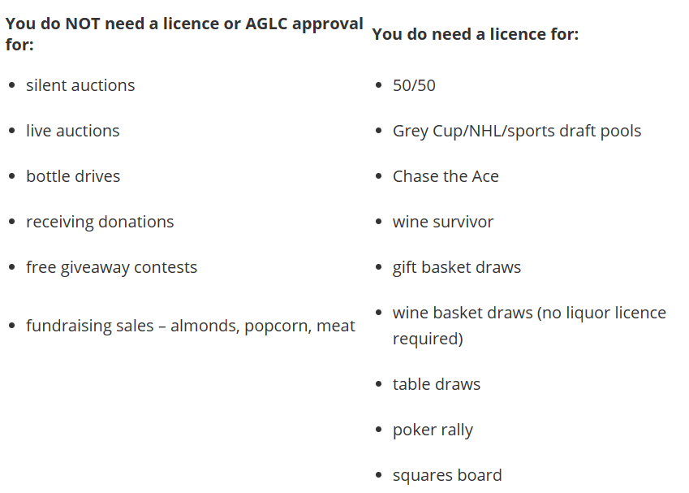

**Appendix A**

| ROCKETS BUDGET ($200/Player) | | | |
| --- | --- | --- | --- |
| INCOME  *not guaranteed income |  | EXPENSES  ** optional expense |  |
| Slush Fund | $3800.00 | Name Bars (Creation, adding and removing)** | $635.50 |
| LMHA Raffle* | $800.00 | Away Tournament** | $1600.00 |
| LMHA Tournament Proceeds* | $500.00 | Jersey Cleaning | $200.00 |
|  |  | Miscellaneous Team Expenses (Helmet Stickers, Labels, Team Functions etc) | $700.00 |
|  |  | LMHA Tournament** | $850.00 |
|  |  | Dryland Gear (T-shirt and Shorts)** | $760.00 |
| TOTAL INCOME | $5100.00 | TOTAL EXPENSES | $4745.50 |
|  |  |  |  |
| ROCKETS BUDGET ($250/player) | | | |
| INCOME  *not guaranteed income |  | EXPENSES  ** optional expense |  |
| Slush Fund | $4250.00 | Name Bars (Creation, adding and removing)** | $635.50 |
| LMHA Raffle* | $1000.00 | Tournament** | $2000.00 |
| LMHA Tournament Proceeds* | $500.00 | Jersey Cleaning | $200.00 |
|  |  | Miscellaneous Team Expenses (Helmet Stickers, Labels, Team Functions etc) | $700.00 |
|  |  | LMHA Tournament | $850.00 |
|  |  | Dryland Gear (T-shirt and Shorts)** | $680.00 |
|  |  |  |  |
| TOTAL INCOME | $5750.00 | TOTAL EXPENSES | $5065.50 |
|  |  |  |  |
| ROCKETS BUDGET ($150/player) with Fundraising | | | |
| INCOME *not guaranteed income |  | EXPENSES ** optional expense |  |
| Slush Fund | $2550.00 | Name Bars (Creation, adding and removing)** | $635.50 |
| LMHA Raffle* | $1000.00 | Tournament** | $2000.00 |
| Fundraising* | $1100.00 | Jersey Cleaning | $200.00 |
| LMHA Tournament Proceeds* | $500.00 | Miscellaneous Team Expenses (Helmet Stickers, Labels, Team Functionsetc) | $700.00 |
|  |  | LMHA Tournament | $850.00 |
|  |  | Dryland Gear (T-shirt and Shorts)** | $680.00 |
|  |  |  |  |
| TOTAL INCOME | $5150.00 | TOTAL EXPENSES | $5065.50 |