Active Start / New Players

1. My daughter just attended the Come Try Ringette session in Lacombe. I would like to enrol her in Intro to Ringette. I would like to know the days and time commitments for each of these before registering.
The ice times are decided upon in September and are posted to the website as soon as they are finalized. You can find all information related to Intro to Ringette on the Intro to Ringette section of the website.
2. My daughter is 4 years old and does not yet know how to skate. On your website it states her birth year of 2012 is registration eligible but when I read through your site it states that ringette is for players 5 years of age and up. Can you verify please?
Lacombe Ringette Association runs a program for first time ringette players called Active Start and your daughter's birth year signifies that she does fit the age restrictions for the program.
My child is age eligible but because she can't skate, would that prevent her from getting into the program?
Previous skating skills would help her maneuver the ice, although they are not mandatory to participate.
3. My child is 6 and wants to start ringette. Do you have a beginner program?
We have an Active Start program and a U10 Program for beginners in that age group.
If she is fairly confident with her skating skills, she may be able to participate in our entry level U10 teams (we have 3 levels in U10.) The difference with the U10 division is that the teams play more games.
4. My daughter is 8 and is not an experienced skater. What level should she register in and how can she get prepared for the season?
In U10, we do hold “evaluations” which consist of 3 components: conditioning, UAA, and scrimmage.
The evaluations help us sort the players based on their skill and athleticism, so we have teams that are evenly matched. This process should not be seen as a test of the players skill or ability. The UAA is a mandatory process that is required by Ringette Alberta, but the other components allow the girls some time to get used to their skates as well as play a few games prior to the teams being formed.
5. My daughter has taken skating lessons last season but has never played ringette before. She is 7 years old and wants to try ringette this season. What are her options to learn and play this season?
The Lacombe Ringette Association hosts a FREE event called Come Try Ringette. All that is needed is skates, gloves and a helmet. The children are on the ice with qualified hosts learning about the sport and trying out their legs on skates.
If you are interested in this event, please watch the website or social media for upcoming dates and registration.
We also host a division called Active Start, which is a great introduction to the sport of ringette.
6. Can I sign up my son for ringette?
Yes, ringette is a co-ed sport. Many people think ringette is a girl’s sport only, but there are plenty of male players at all levels of play across the country.
7. Will my child play half ice or full ice?
For Active Start and some of U10, play will occur on a smaller surface (cross-ice or half-ice) with appropriately sized nets to allow each player more ring time and opportunities to hone ring control, passing and shooting skills, as well as fundamental skating skills.
Active Start will play 3 vs 3 plus goalies, cross-ice games, when games are played. Note: Ringette Alberta does not recommend games at Active Start.
U10 Step 1 will play 3 vs 3 plus goalies, half-ice games
U10 Step 2 will play 3 vs 3 plus goalies, half-ice games
U10 Step 3 and U12 will remain on full ice
Officials will not be used for U10 Step 1 and Step 2 games.

Registration

1. My daughter might not be able to play ringette this year due to unforeseen circumstances/injury. What is your refund policy?
Our registration, participation and refunds policy can be found on the registration page.
Refunds minus $65.00 admin fee until Oct 1 or Oct 31 for 1st time players.
2. Can players outside Lacombe register?
The Lacombe Ringette Association is governed by the policies and procedures of Ringette Alberta (RAB). The RAB residency policy provides all the details about player’s home associations and the process for players wishing to register outside of their home associations.
If Lacombe is your closest ringette association even if you’re living outside of Lacombe, you will be accepted into the program.
The policy can be found at www.ringettealberta.com/policies
3. What gear do I need for my child to play ringette?
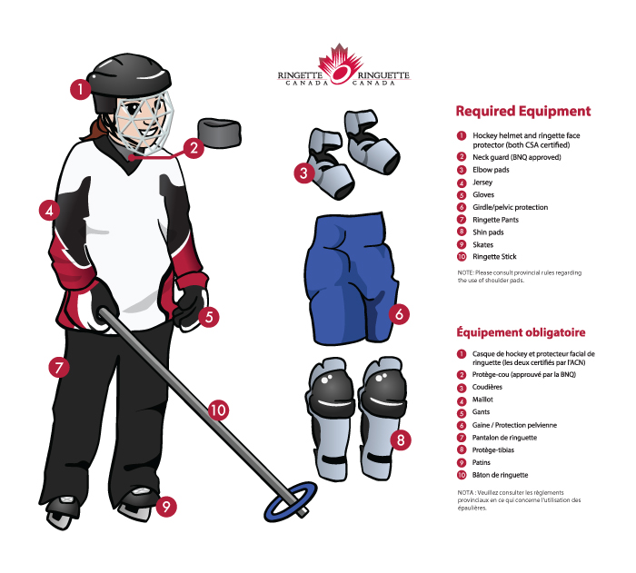
*Please note - Shoulder pads are not included in this picture and not required in Alberta, however they’re highly recommended.
4. My child wants to play goalie; can I register them as a full time goalie?
You can register your child as a full-time goalie and receive a discounted rate starting at U14 and above. U12 and below do not currently have full time goalies and do not accept registration for goalie positions.
5. Do we need to register for Come Try Goalie events?
There is no need to register. Your coach should be aware based on a notice from your division coordinator. All we need to understand is the number of goalies from each team and if they need equipment.
Do we need to bring goalie equipment?
We will have someone available that can access goalie equipment and will help with sizing.
Can more than one player from a team attend?
Absolutely, we are encouraging all players interested in the goalie position. There is no maximum # of goalies, so long as we can get everyone in equipment.

Further questions can be sent to admin@lacomberingette.ca

