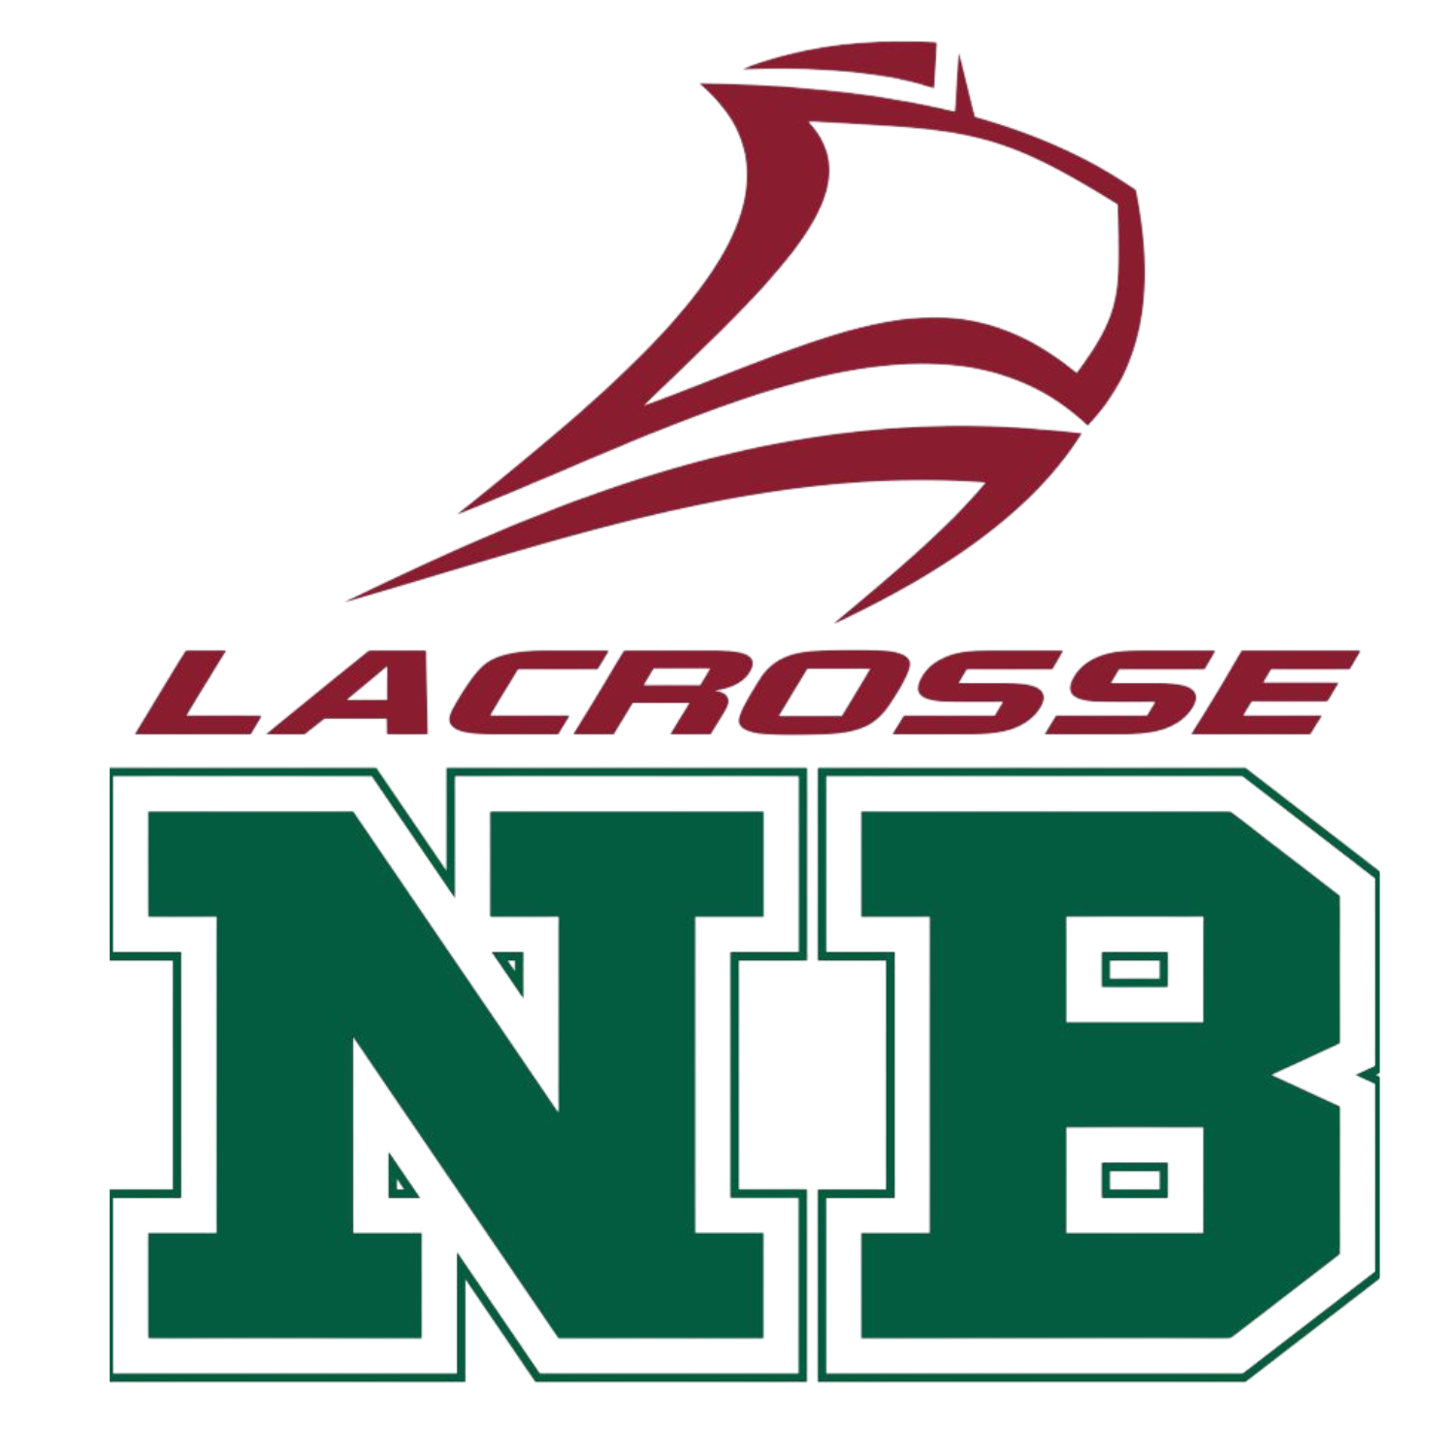
Lacrosse New Brunswick

Age Dispensation Request Form

Athlete Information
Athlete Name:
Date of Birth (D.O.B):
Member Association:
Parent/Guardian:

Request Information
Current Age Category:
Requested Age Category:
Reasoning for Request:

Lacrosse New Brunswick Office Use Only
LNB Executive Member / Technical Director:
Date Received:
Date of Completion (Must be within 7 days):

