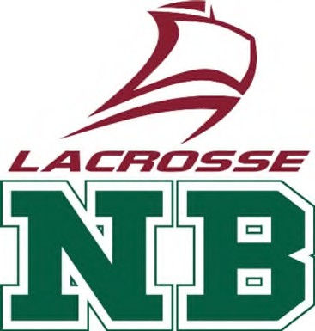
Lacrosse New Brunswick
Team NB Player Evaluation & Evaluator Guide
An In-Depth Guide to Athlete Selection and Provincial Representation
Lacrosse, a sport interwoven with the heritage and athletic spirit of New Brunswick, continues to grow across the province. The National Championships stand as the pinnacle of competition, offering players the chance to represent their province and compete against the best from across Canada. Central to this honour are the processes of player evaluation and team tryouts, which ensure New Brunswick fields the most competitive and cohesive teams possible.

Overview of Lacrosse in New Brunswick
Lacrosse New Brunswick (LNB) governs the development, organization, and promotion of lacrosse throughout the province. With competitive programs in box and field lacrosse, the province has established pathways from grassroots to elite levels, culminating in the selection of provincial teams that compete at the annual Canadian National Championships. These championships feature divisions across age groups, including U13 (Box), U15 (Box), U17 (Box & Field), U19 (Field), U22(Box) and Senior (Box), in both male and female categories.

Objectives of Provincial Team Selection
- Fair and Transparent Evaluation: To ensure every eligible athlete is provided an unbiased opportunity to showcase their abilities.
- Competitive Representation: To field teams that represent New Brunswick with pride, skill, and sportsmanship.
- Development Focus: To encourage long-term athlete development and promote a positive sporting experience.

Eligibility Criteria for Tryouts
To be considered for a provincial team representing New Brunswick at the National
Championships, athletes must meet the following requirements:
- Be a registered member of the LNB and in good standing.
- Reside in New Brunswick or meet residency exceptions as outlined by the LNB Provincial Team
- Coach & Athletic Selection Process & Team Operating Policy.
- Be of the correct age for the targeted division (as defined by Lacrosse Canada).
- Commit to attending all required practices, development sessions, and the National Championship

Announcement and Registration for Tryouts
Provincial team tryouts are typically announced several months in advance of the National Championships. On March 15th LNB communicates key dates and registration details through its website, local clubs, social media, and email blasts. Athletes register online and pay a $75 fee to LNB to participate, intended to cover facility rental, equipment, and administrative costs.

Structure of the Tryouts
Tryouts are designed to provide comprehensive evaluation over multiple sessions. The process will include:
- Fitness Assessments: Measuring speed, agility, endurance, and strength through standardized drills. Fitness testing will be completed by the Canadian Sport Institute Atlantic (C SIA) at UNB at the YMC A Field House in Saint John with ForFitness and Athletics.
  - This ensures:
  - Professional facilitation and oversight o Expert tracking and administration of testing o Accurate scoring and reliable data consolidation
  - Results will be shared with the Coaching Staff once all data has been consolidated by CSIA.
  - Fitness testing results will be combined with technical evaluation results to determine progression to the tactical evaluation stage.
- Technical Evaluation: Including evaluating cradling, passing & catching, shooting technique/accuracy, etc.
  - Participant only need to complete one technical evaluation session; however, it is recommended they attend all three sessions. Their best score will be submitted. o This ensures consistency in conditions and repetition across all athletes.
  - Evaluators must ensure all participants receive the same number of attempts.
- Attempts Per Skill o Drills 1, 2, 4, 5, 6, 7, 8, 9: 5 attempts each
  - Drill 3: 10 attempts
  - Note: If facilities permit, evaluators may record both ends of the floor. Data should then be consolidated after the session to ensure accuracy.
- Tactical Evaluation: Invitation only. Rosters can be selected following the Tactical
Evaluation session. If a team requires another session they can book it on their own. Keep in mind the Peter Fox Tournament is held the second weekend in May.
- Focus of Session
  - This session is primarily note-taking and observation-based. o Evaluators are responsible for assessing tactical awareness, decision-making, and game sense. Recommendations
  - Filming is strongly recommended to support post-session review, cross-checking of notes, and evaluator consistency. o Ensure athletes are given equal opportunities to demonstrate tactical understanding in game-like scenarios Game Play: Scrimmages and controlled game scenarios to assess individual skills i.e. cutting, clock management, defending picks
& screens, presses, etc., teamwork, decision-making, communication, floor positioning, situational lacrosse, adaptation under pressure, etc.
- Coach Interviews: For older age groups, brief interviews may be held to gauge commitment, leadership qualities, and understanding of team goals.

Player Evaluation Criteria
Selection is based on holistic evaluation, combining objective data with coach observations. Key criteria include:
- Technical Skills: Proficiency in passing, catching, shooting, ground balls, and defense.
- Tactical Awareness: Ability to read the game, anticipate plays, and execute team strategies.
- Physical Attributes: Fitness, speed, agility, and overall athleticism.
- Teamwork & Communication: Willingness to collaborate, communicate effectively, and support teammates.
- Coachability: Openness to feedback, attitude, and eagerness to learn and improve.
- Commitment: Attendance, dedication to training, and respect for team culture.

Selection Process and Notifications
Following the completion of tryouts, coaching staff and evaluators convene to review all assessments, discuss player strengths and weaknesses, and finalize team rosters. In some cases, a second Invitation Only session may be held if competition is particularly strong.
Once selections are made, athletes are notified via email, phone call or in-person conversation and the team roster is posted on the LNB website. It is recommended those not selected are provided with feedback and encouraged to continue participating in development opportunities.

Documentation & Data Consolidation
- All evaluators must submit technical, fitness, and tactical notes to the Head Coach immediately following each stage.
- Video recordings (where applicable) must be shared with the coaching staff for centralized review.
- Final selection decisions will be based on consolidated results and discussion among evaluators.

Athlete Feedback
- It is highly recommended participants who do not advance to the Tactical Evaluation stage should be provided with data-informed suggestions for improvement.
- Feedback should be constructive, specific, and directly tied to the athlete’s technical and fitness testing results.
- This ensures that all athletes leave the process with a clear understanding of their developmental needs and a pathway for improvement.

Key Principles for Evaluators
- Consistency: All athletes receive the same number of reps and opportunities.
- Fairness: Evaluations must be impartial, based strictly on observed performance.
- Accuracy: Record all data clearly, double-check results, and ensure notes are complete.
- Confidentiality: Athlete evaluation data must remain confidential within the selection committee.

Commitment and Training
Selected team members commit to a rigorous schedule of practices, team-building activities, and development camps in the weeks leading up to the National Championships. Training focuses on refining technical skills, building tactical understanding, and fostering strong team chemistry.
Training Components
- On-floor/field practices (minimum twice weekly once league season finishes, once weekly during regular league season), blending technical drills and tactical instruction.
- Film study and strategy sessions.
- Strength and conditioning programs tailored to lacrosse performance.
- Team-building exercises to promote unity and resilience.

Competition at the National Championships
Provincial teams from New Brunswick travel to the host city to compete in the Canadian National championships. Athletes face high-calibre opponents from across the country, gaining exposure to elite competition and valuable experience. The event includes round-robin play, elimination rounds, and placement games, with medals awarded to the top finishers.

Benefits of National Championship Participation
- Opportunity to represent New Brunswick at the national level.
- Exposure to scouts, collegiate coaches, and national team selectors.
- Personal and athletic growth through high-level competition.
- Networking and friendships with players from across Canada.
- Potential for future selection to regional or national teams.
Player Evaluation and Provincial Team Tryouts for the National Championships
Coaches/Evaluators
- On-floor lead plus a minimum of four coaches on the floor to run the session
- Minimum of four off floor evaluators to rate/score the players
- Age-division coordinator to collect and tabulate the scores
- A minimum of four evaluations and a maximum of five evaluations should be used to place players on teams:
  - Session 1 – 3 will be on technical skills (same drills, player only needs to attend 1 session, however it is recommended players attend all 3 sessions. Their highest score will be submitted).
  - Session 4 will be Invitation Only and will be a Tactical Evaluation for assessing tactical awareness, decision-making, and game sense.
- If further evaluation is required, then Session 4 can be repeated as necessary to get players evaluated

LNB Organized Tryout session
(Below schedule – late enough for us to get a rink vs a gym, plus it allows the Associations to get settled)

LNB Provincial Team Tryouts Open Tryouts (Technical Skills)
Facility |  | Date | City | Team
 |  | Friday April 17
Kaye Arena |  | 6:30 pm – 8:30 pm | Moncton | U17 Female
 |  | Saturday April 18
Kaye Arena |  | 11:30 am – 1:30 pm | Moncton | U13 Female
Kaye Arena |  | 2 pm – 4 pm | Moncton | U13 Coed
Kaye Arena |  | 4:30 pm – 6:30 pm | Moncton | U15 Female
Kaye Arena |  | 7 pm – 9 pm | Moncton | U15 co-ed
 |  | Sunday April 19
Peter Murray Arena |  | 9 am – 11 am | Saint John | U13 Female
Peter Murray Arena |  | 11:30 am – 1:30 pm | Saint John | U13 Coed | Fitness Test YMCA Field House 3:00 pm – 5:00 pm
Peter Murray Arena |  | 2 pm – 4 pm | Saint John | U17 Female | Fitness Test YMCA Field House 5:00 pm – 7:00 pm
Peter Murray Arena |  | 4:30 pm – 6:30 pm | Saint John | U15 Female
Peter Murray Arena |  | 7 pm – 9 pm | Saint John | U15 co-ed
 |  | Saturday May 2
Grant-Harvey Center |  | 9 am – 11 am | Fredericton | U13 Female | Fitness Test UNB 12 pm –2 pm
Grant-Harvey Center |  | 11:30 am – 1:30 pm | Fredericton | U13 Coed
Grant-Harvey Center |  | 2 pm – 4 pm | Fredericton | U17 Female
Grant-Harvey Center |  | 4:30 pm – 6:30 pm | Fredericton | U15 Female | Fitness Test UNB 2 pm – 4 pm
Grant-Harvey Center |  | 7 pm – 9 pm | Fredericton | U15 co-ed | Fitness Test UNB 4 pm – 6 pm
 | Invitation Tryouts (Tactical Skills)
 |  | Sunday May 3
Peter Murray Arena |  | 9 am – 11 am | Saint John | U13 Female
Peter Murray Arena |  | 11:30 am – 1:30 pm | Saint John | U15 Female
Peter Murray Arena |  | 2 pm – 4 pm | Saint John | U13 co-ed
Peter Murray Arena |  | 4:30 pm – 6:30 pm | Saint John | U15 co-ed
Peter Murray Arena |  | 7 pm – 9 pm | Saint John | U17 Female

Rosters can be selected following the Tactical Skills session. If a team requires another session, they can book it on their own. Keep in mind the Peter Fox Tournament is held the second weekend in May.
Potential Independent Evaluators
1 |  | 10
2 |  | 11
3 |  | 12
4 |  | 13
5 |  | 14
6 |  | 15
7 |  | 16
8 |  | 17
9 |  | 18
Needed Resources
Facilities
Cameras for videos
Balls
Pennies
Nets
Drills
4 Independent Evaluators per session
Lead coach for each session
Score sheets for marking scores for each player
Tryouts – players do not wear Provincial Team swag including clothing, shorts, jerseys, helmets, gloves, plus jersey they are wearing should not have their name on it.


Team NB Tryouts - Technical
estimated total minutes: 120
Technical Evaluation Content createdwith Laxlife
applications and coaching support tools
-Coaches/Evaluators, please refer to "LNB Player Skills Tracking Sheet" for tracking details.

Warm Up Drill #1: Running Around The Perimeter
drill #: 1
minutes: 5
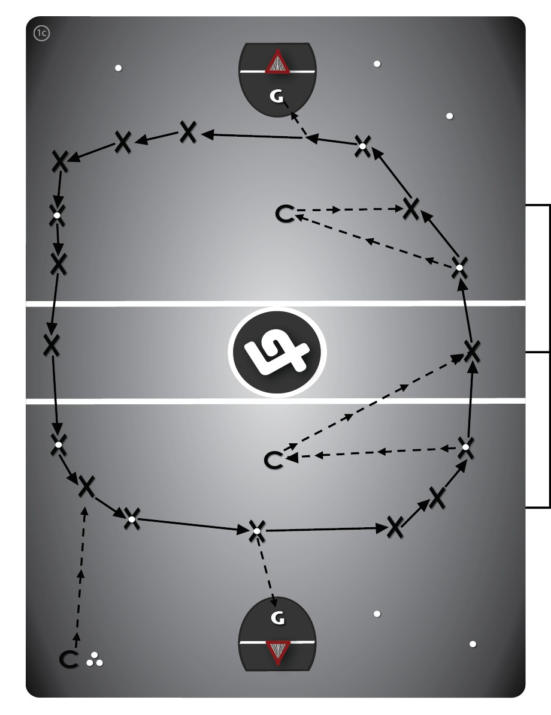
  Variation #1C (5 min): "With Shots."
  Have players run around the entire outside of the box (both directions), with balls. players are now permitted to take shots on the goalie if they make eye contact with each other. Players gather loose balls and are also able (and encouraged) to pass amongst each other, and the coaches (in the middle), freely.

Fundamental Skills Analysis
drill #: 2
minutes: 5

  Dynamic Stretch (5 mins)
  -Knee Hug
  -Quad Pull
  -Frankenstein (Leg kick)
  -Lunge and Twist
  -Sumo Squats (groin)
  -Walking arm circles

Stickwork Drill #1: Passing Against The Boards (“Wall Ball”)
drill #: 3 minutes: 10
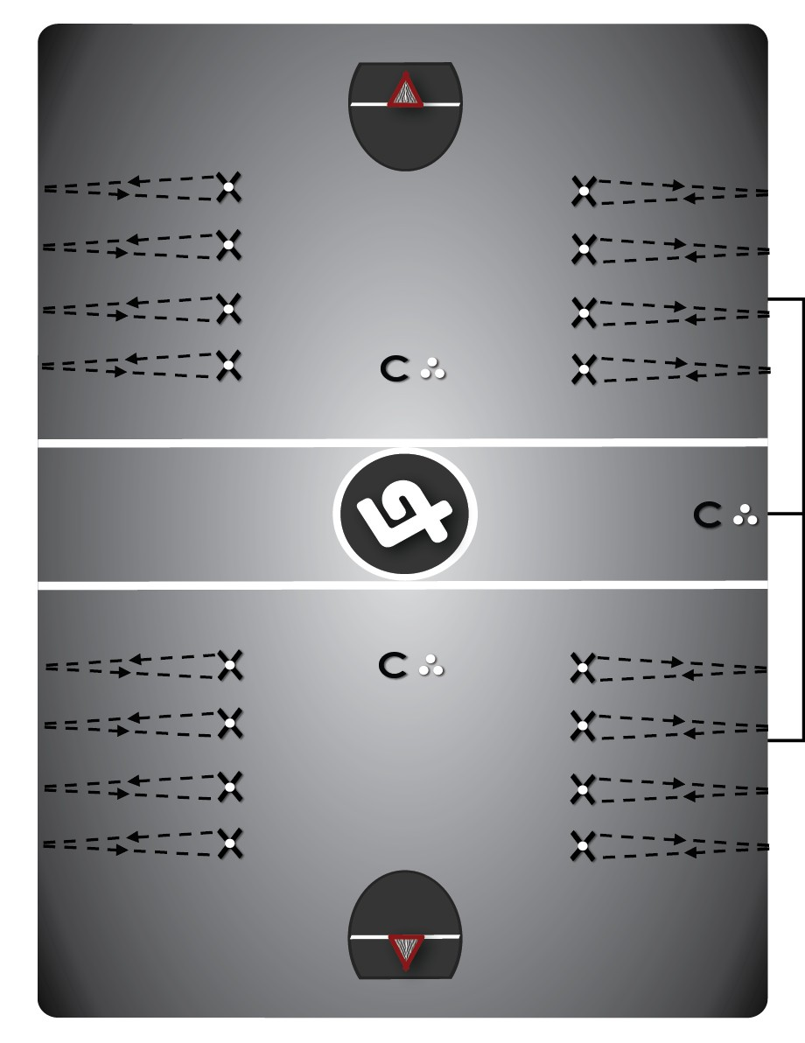
  Group players up into 4 lines (1 evaluator per line)
  Players stand 10m away from the boards (marked on floor), and will take 10 attempts at passing at a 30x30cm box (taped on glass/wall).

Loose Ball Drill #10: Loose Ball “Battles”
drill #: 4 minutes: 15
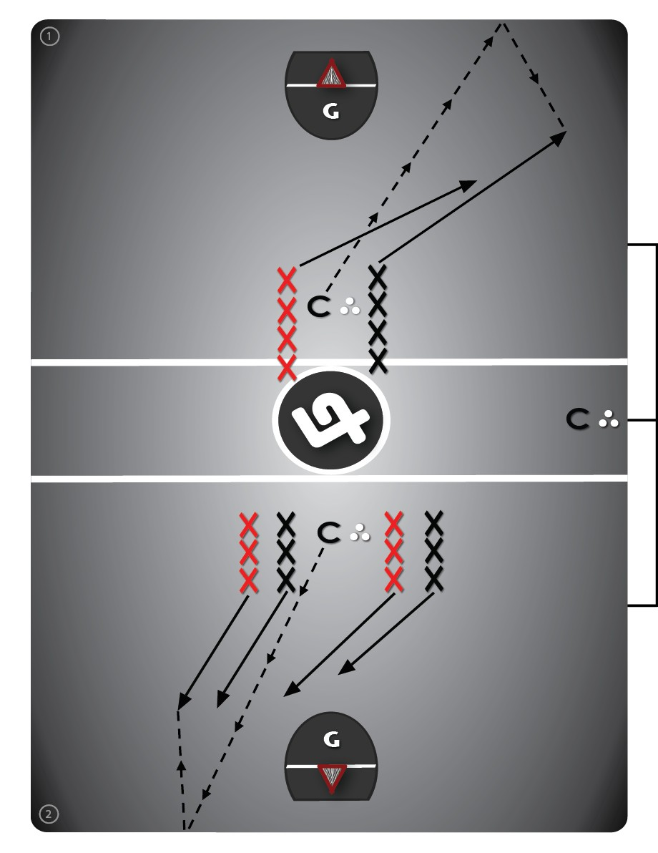
  Variation #1 (10 min): "1 Vs. 1 Battle." Have a line of players positioned on each side of the coach (facing the goalie), who is standing with balls at the point position, in one or both ends of the floor. The coach rolls the ball into either corner, with players reacting upon first sight of the ball.
  The two players battle for the loose ball.

Goaltending Drill #3B: Goalie Mid-Range Pass
drill #: 5 minutes: 15
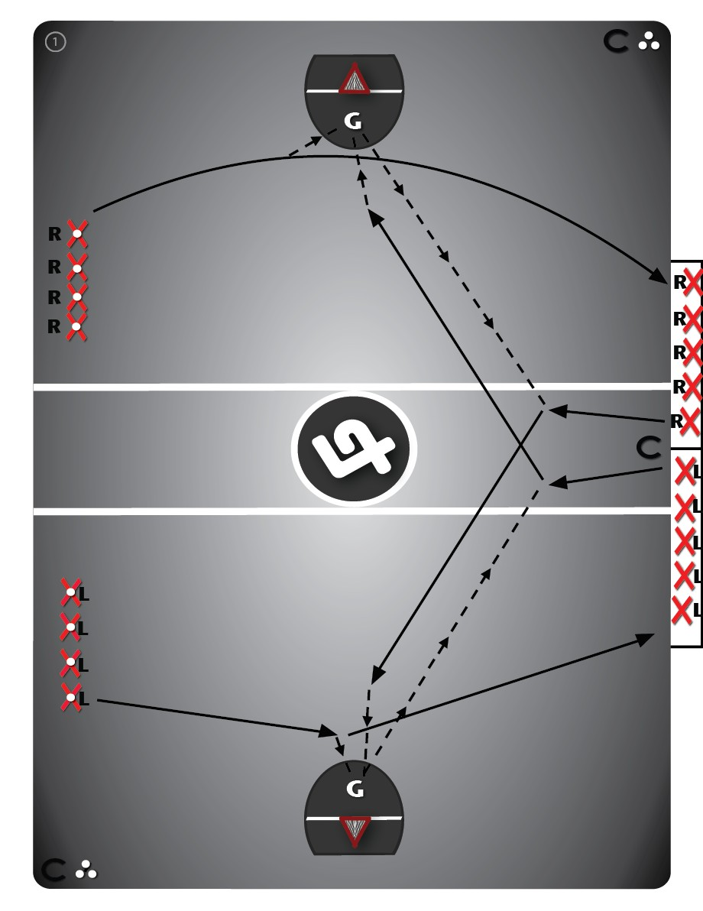
  Have half of the lefty's/righty's line up in opposite ends of the floor at the far-side mid-boards, on their proper floor sides, with balls. The other half of same-handed players should be on the bench in the same-end, ready to catch an outlet pass and eventually run to the opposite end on a breakaway.
  The drill starts with a player from the line at the mid-boards, in both ends (at the same time), running to the middle of the defensive zone and rolling a ball into the goalie (or coach if there's only one goalie), then running hard to the defensive door in the close-end ("short change"). A same-handed player then comes off the bench out of the offensive door close to the restraining-line/centre-floor, with the goalie making the pass to this player anticipating and timing the pass (“leading” them).

Stickwork Drill #6A: Catch & Shoot
drill #: 6 minutes: 15
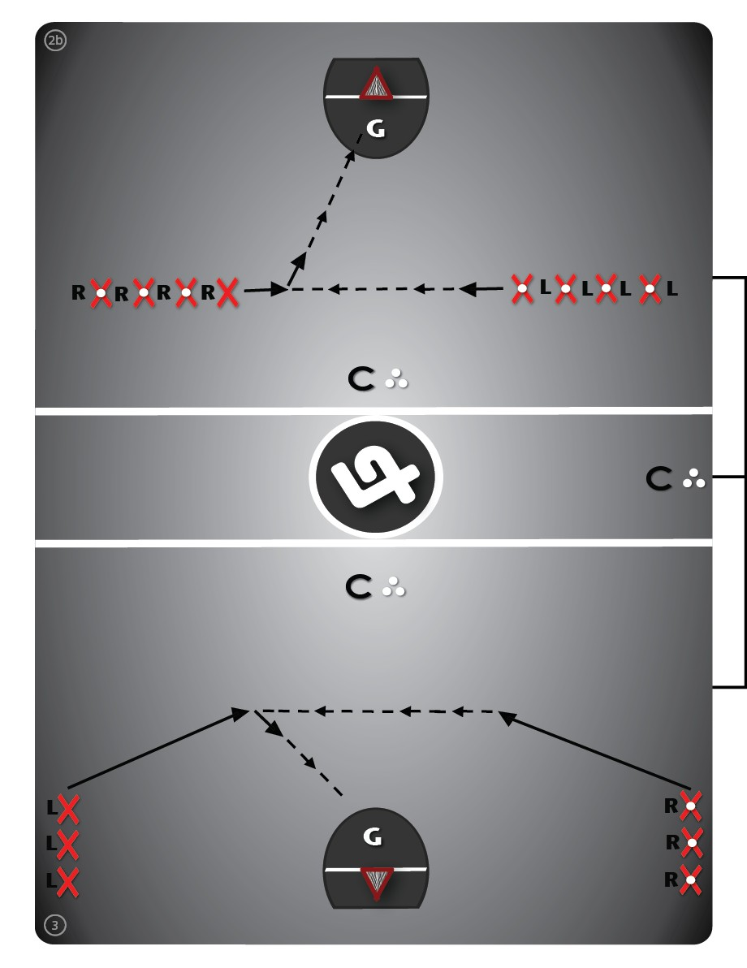
  *Variation #2 (15 min): "Shooter To Shooter."
  Begin with a line of left-handed and a line of right-handed players on their proper floor sides, a few steps back from the shooter positions.
  Both lines have balls except for the first player in one line, with the ball carrier first being a threat, then passing to the opposite shooter for an outside shot.

Defense Drill #6A: 4 Corner Checking (“Top-Side Defense”)
drill #: 7 minutes: 20
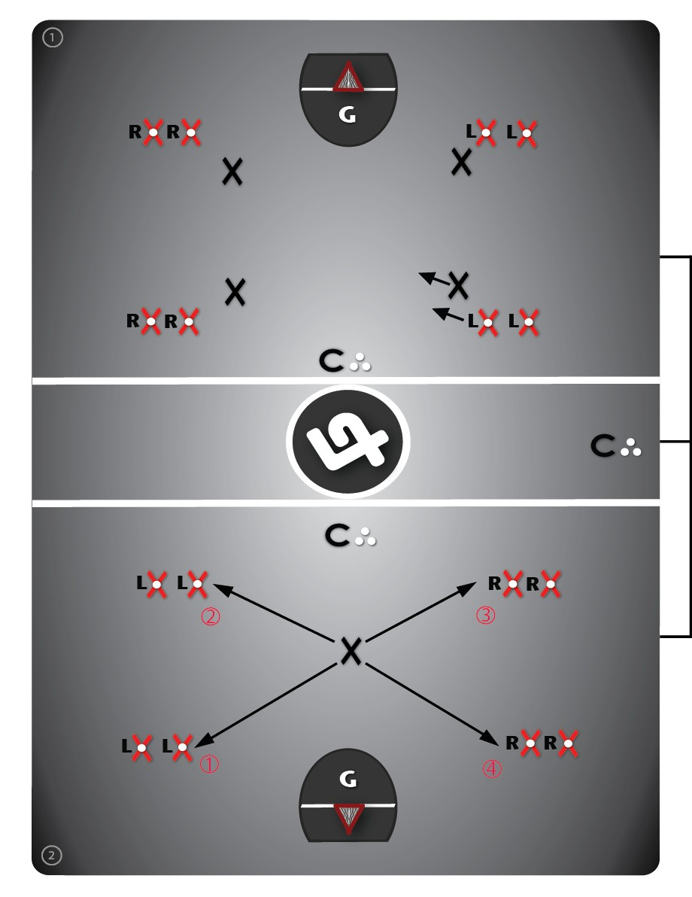
  *Variation #2 (15 min): "All 4 Corners." Have one volunteer, or appointed player, start in the middle of the defensive zone ready to play defense. This player then goes sequentially from corner to corner, eventually playing 1-on-1 defense against an offender from each respective corner.
  Offensive players do not take their turn (5 seconds max) until the defender is in position, starting once the defender touches the offenders’ gloves with their stick (etiquette).
  Continue until every player has had a turn on defense.

2-on-1’s from Center
drill #: 8 minutes: 15
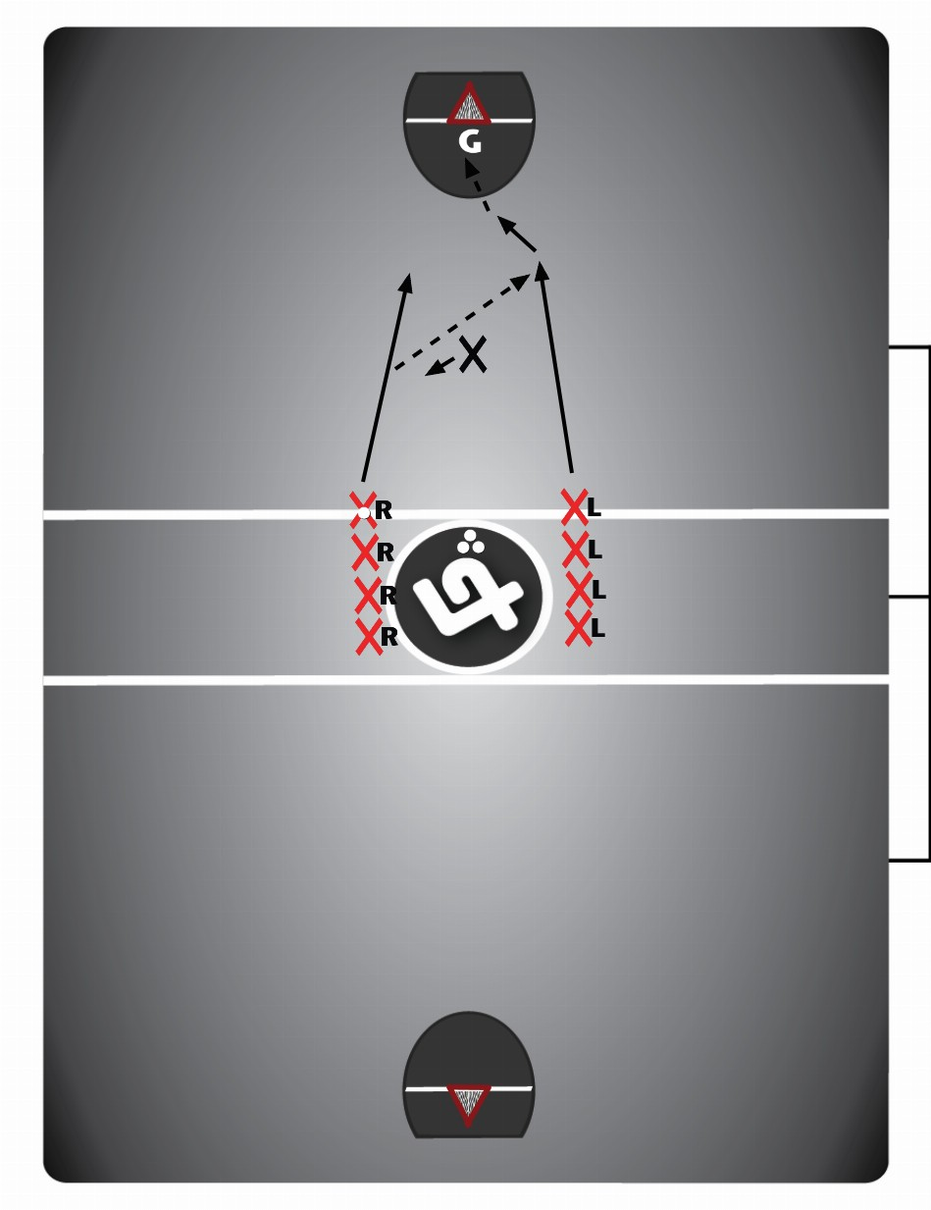
  *Variation #1A (10 min): "Defender At Centre."
  Offensive players attempt a 2-on-1, with the defender starting in the middle of the floor with their "stick up," ready to "fall back." Following the first rep through the drill, the last offensive player to touch the ball is out of the drill, running out of the drill along the side-boards; while the other offensive player gets into defensive positioning for the next 2-on-1.

Defense Drill #12A: 2 Vs. 2 On-Ball (High/Low “Walling”)
drill #: 9 minutes: 20
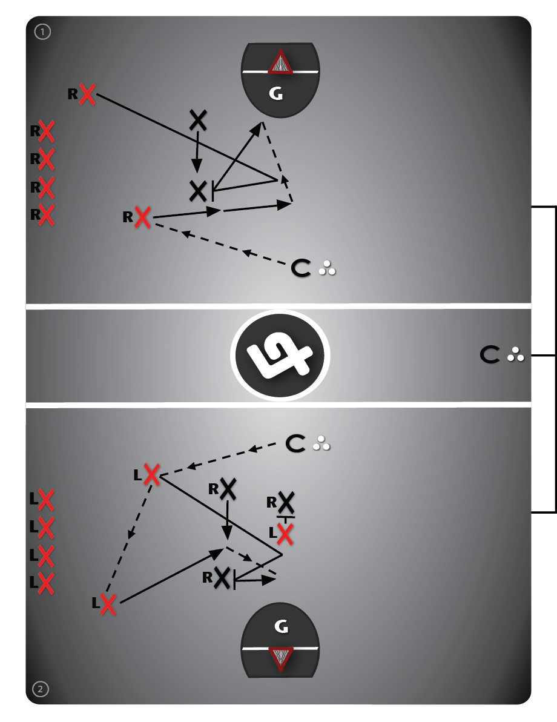
  *Variation #1 (15 min): "2 Vs. 2."
  Start with an offensive player at the crease ("low") and shooter ("high") positions, with 2 defenders stationed in top-side defensive positioning ("the wall"), in one or both ends of the floor. Make sure that each end has an even mix of both right and left-handed players.
  Offensive players start with a ball (passed in from coach), attempting to get a quality shot by continuously picking, sealing and/or cycling for each other, trying to create "separation" on-ball by keeping their feet moving. Allow 10 seconds max for players to make a play. Continue the play if possible after a shot (attack rebounds), at the discretion of the coaches whistle.
  Right-handed players go against left-handed players ("proper defensive side"), with offensive players doing the drill, then going to defense; defensive players exiting the drill. Bring all of the lefty’s or righty’s into opposite ends after 5-10 minutes to practice “cross-handed” defending.

Team NB Tryouts - Tactical
estimated total minutes: 119
Tactical Evaluation Content createdwith Laxlife
applications and coaching support tools

Warm-Up Drill #17A: Hockey Blue Line Drill (Short Pass)
drill #: 1 minutes: 5
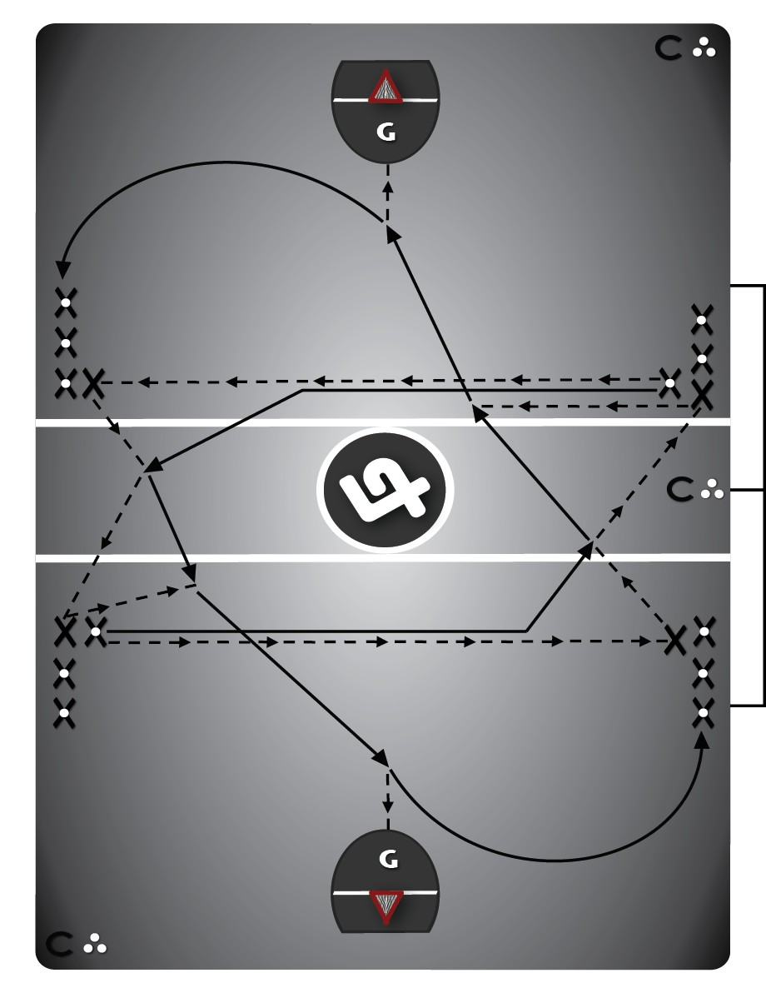
  Begin with 4 separate lines (as shown in diagram), or two lines of players and two coaches (not shown in diagram), each 5 metres back from the restraining lines, against the boards, and facing the neutral zone. The first and second players in each line need to be ready at all times.
  Variation #1 (5 min): "Give & Go." The drill reps always start with two players in diagonally opposite lines making eye contact (so they leave at the same time), afterward running forward and passing to the line (or coach) directly across from them (side-boards to side-boards). These two players are now running mirror image patterns. They cut up-floor, receive a give-and-go pass back from the line they just passed to, then pass again to the near-side line they are running towards, receiving a breakaway pass back from the second player in that line.

Fundamental Skills Analysis
drill #: 2 minutes: 5
Dynamic Stretch (5 mins)
-Knee Hug
-Quad Pull
-Frankenstein (Leg kick)
-Lunge and Twist
-Sumo Squats (groin)
-Walking arm circles

Transition Drill #3A: 2 Player Out & Ups (“Push” The Ball)
drill #: 3 minutes: 7
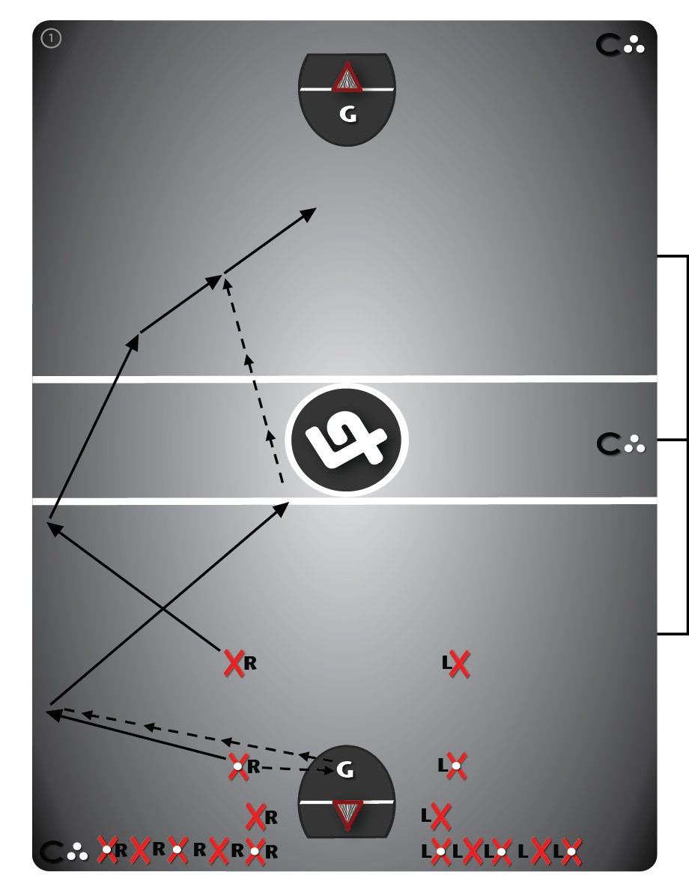
  Start with 2 lines of players, on their proper floor sides, on both sides of the crease, at one end of the floor.
  The second player in line should be ready with a ball and the first player in line should be ready without a ball. The drill alternates from side to side with the next two players set to go in the drill waiting until the group ahead is at least half-way to the far-end before they go.
  Variation #1 (7 min): "Outlet Pass." The first player in line steps out to the shooter position and the second player to the same-side crease position. The low outlet rolls or bounces the ball into the goalie and then runs (or backpedals) to the mid boards, while the high outlet runs hard near the side-boards (in the "outside lane") toward the other end of the floor (not leaving the defensive zone until the goalie has control of the ball).
  The low outlet receives a pass from the goalie near the mid-boards, cuts to the middle and runs hard up-floor (towards centre-floor), making a pass to the high outlet (eye contact), who simultaneously cuts away from the boards on a 45° angle towards the net for a breakaway shot. The low outlet then becomes the high outlet after the other side takes their turn; with a new low outlet entering the drill. Otherwise, coaches can make both players run together "in two's," with the low outlet attacking the net for rebounds or loose balls after making the initial pass.

Clark’s Loose Ball fast break drill
drill #: 4 minutes: 7
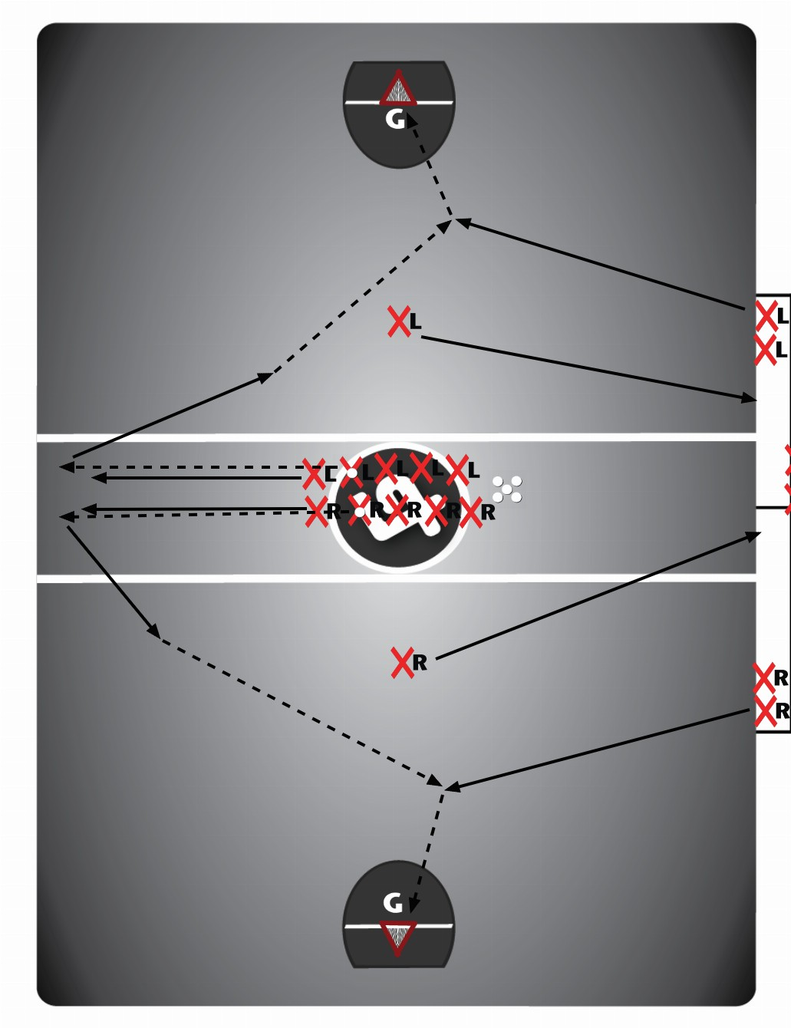
  Keys:
  -Anticipation of loose ball win and getting to the bench (hold guy)
  -LB, eyes up floor and getting to the middle
  -Create passing lane by moving
  Rotation: LB, Hold, Bench
  2nd Variation: Long-pass
  -Lots of traffic in front of ball carrier (lob pass)
  -Ball carrier needs to throw ball over the "mess" in the middle -Ball carrier needs to find the guy off of the bench "non-verbal communication"

Transition Drill #8A: 2-On-1 & 3-On-2 “Fast Breaks” From Centre
drill #: 5 minutes: 10
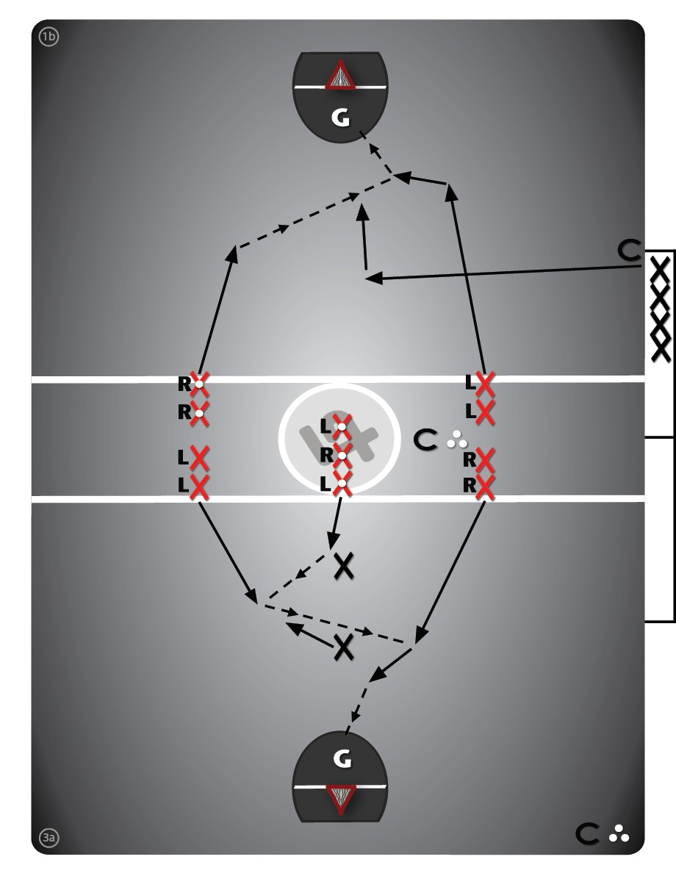
  *Variation #1B (10 min): "3-on-2" Bottom Diagram
  Start with three lines of players at the restraining-line on their proper floor side, facing one or both directions. The middle line will have balls.
  Two volunteer players play defense. The 3 offensive players come down in an attempt to successfully execute on a 3-on-2 fast break. The last player to touch the ball will go back to the offensive line, while the other two offensive players will play defense on the next rep.
  Note: Only shots in the prime scoring area will count as a successful repetition.

Broken Play 4 v 3
drill #: 6 minutes: 10
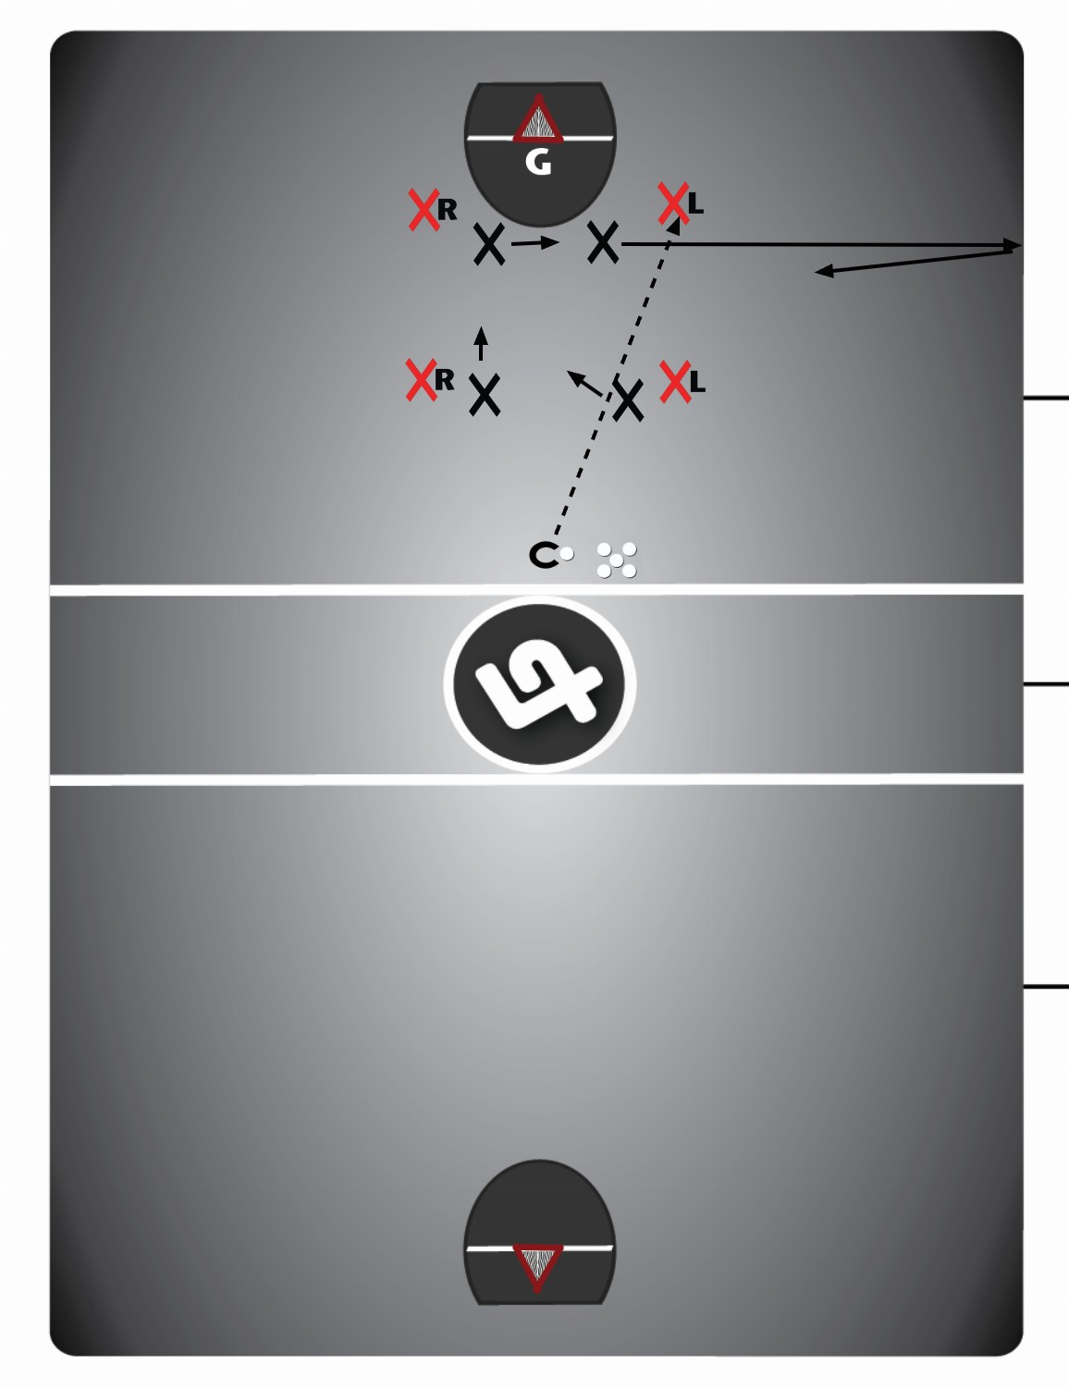
  Variation #1A (10 min):
  4 Offensive players and 4 Defensive players will start, in a 4v4 scenario.
  A coach will throw a pass to one of the offensive players. Upon the pass being thrown, the defensive player covering the offensive who receives the pass, will sprint to the side boards and back (in an attempt to recreate a 4v4 scenario).
  Upon receiving the pass, the offensive players will attempt to create a quality shot.

Offense Drill #4A: “Seal/Screen” The Shooter
drill #: 7 minutes: 10
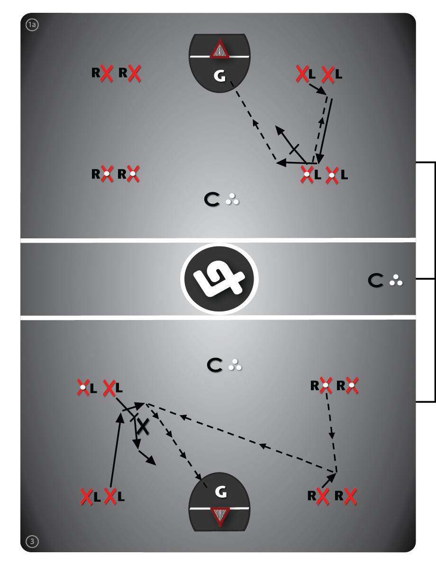
  Arrange players in one or both ends of the floor depending on numbers. Have them stationed on their proper floor sides, at the crease and shooter position on both sides of the floor.
  Variation #1 (10 min): "High Screen & Shot." The shooters begin with the ball and start the drill on one side with a pass down to the same-side crease player (who "pops" out to receive the pass).
  After receiving the pass the crease player runs up to the shooter position and the player at the shooter position seals an imaginary defender. The timing of this exchange is paramount, with the player coming overtop of the seal ideally doing so at the exact same time that the seal is getting locked in and "brushing shoulders" with the sealer. The crease player then takes an outside shot around or over top of the screen being established by their teammate (could be a set-shot, drag or sweep).

Offense Drill #6A: On-Ball Skeleton Pick & Rolls
drill #: 8 minutes: 15
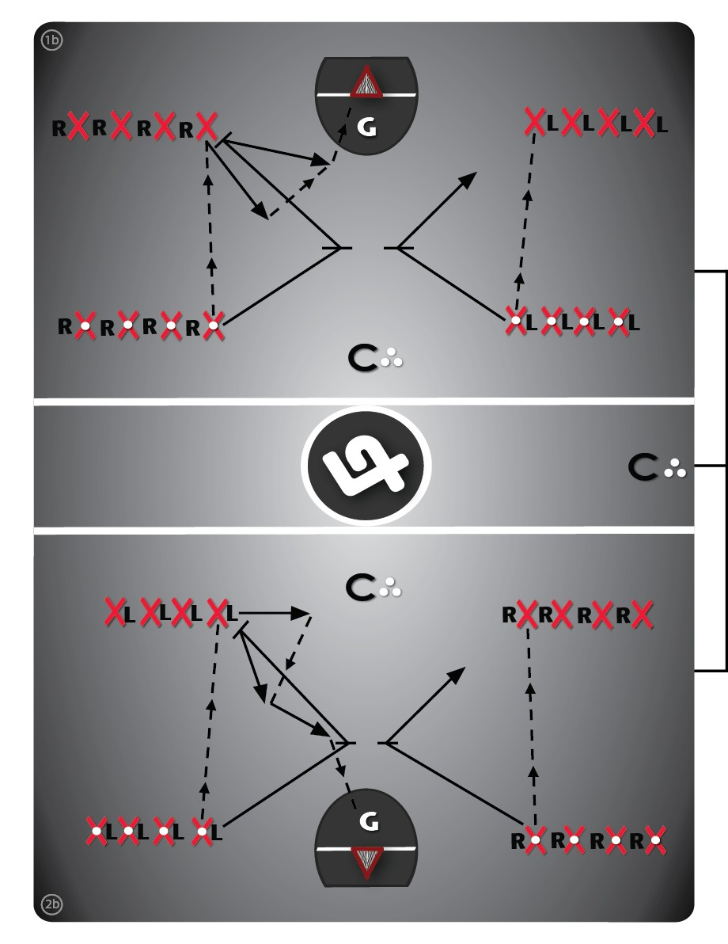
  Have players line up in equal numbers on their proper floor side crease and shooter (or mid-boards) positions, on both sides of the floor.
  There are two "picks" to be practiced in this drill (Up or Down) and there are also two options off of each pick: shoot (Variation A - 5 min) or pass to the roller (Variation B - 5 min). In a down-pick scenario (Variation #1), the shooter picks for the same-side crease player. In an up-pick scenario (Variation #2), the crease player picks for the same-side shooter. Start with a pass down or up, depending on which variation players are running; with the receiver of the pass "popping out" to receive the pass, as a good habit.
  Picks can be set on any side of an imaginary defender (east-west or north-south); read the ball carrier's body position. The player being picked for should "react" to which direction the pick is set and not leave until the pick arrives. At that point, they come around the pick on either the top-side or board-side, with the "roller" taking the opposite "lane" to the net (inside lane vs. outside lane). Make sure the pickers are rolling after setting the pick, turning the shortest route possible towards the net, without "turning their back towards the play" (I.e. roll 90° instead of 270°). Even if they don't get the pass they should be prepared to "attack rebounds."

Defense Drill #12B: Continuous On-Ball 2 Vs. 2
drill #: 9 minutes: 15
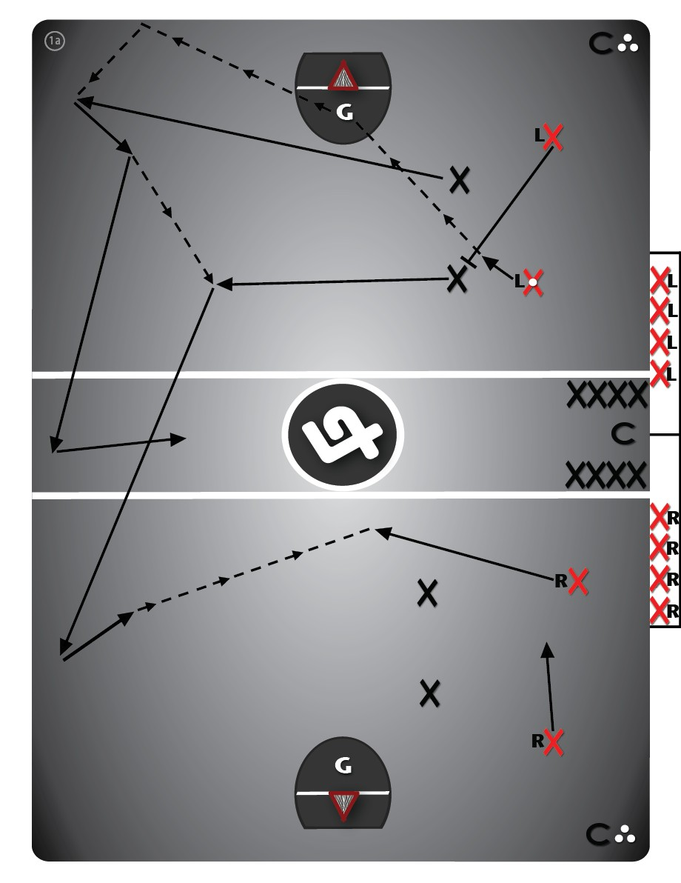
  Start with an offensive and defensive player stationed at the crease position and shooter position. All other players will be on the bench, coming off the bench and offensive players becoming the defensive players the next time through the drill.
  Players should be permitted a maximum of 10 seconds to try and create a quality shot on offense, otherwise the coach blows the whistle and they most drop the ball if they still have it. When the defenders pick it up, the offensive players should ride them to try and force a quick turnover (giving them another 10 seconds), otherwise allowing the defenders to breakout along the far-side.
  These two defenders run the ball deep ("in two's"), then pass the ball to one of the two offensive players that come off the bench in the far-end. These defenders then perform a 90 degree change and sprint back to the bench. Offensive players stay and play defense in the next rep.

Defense Drill #13B: Off-Ball “Help” (Dynamic)
drill #: 10 minutes: 10
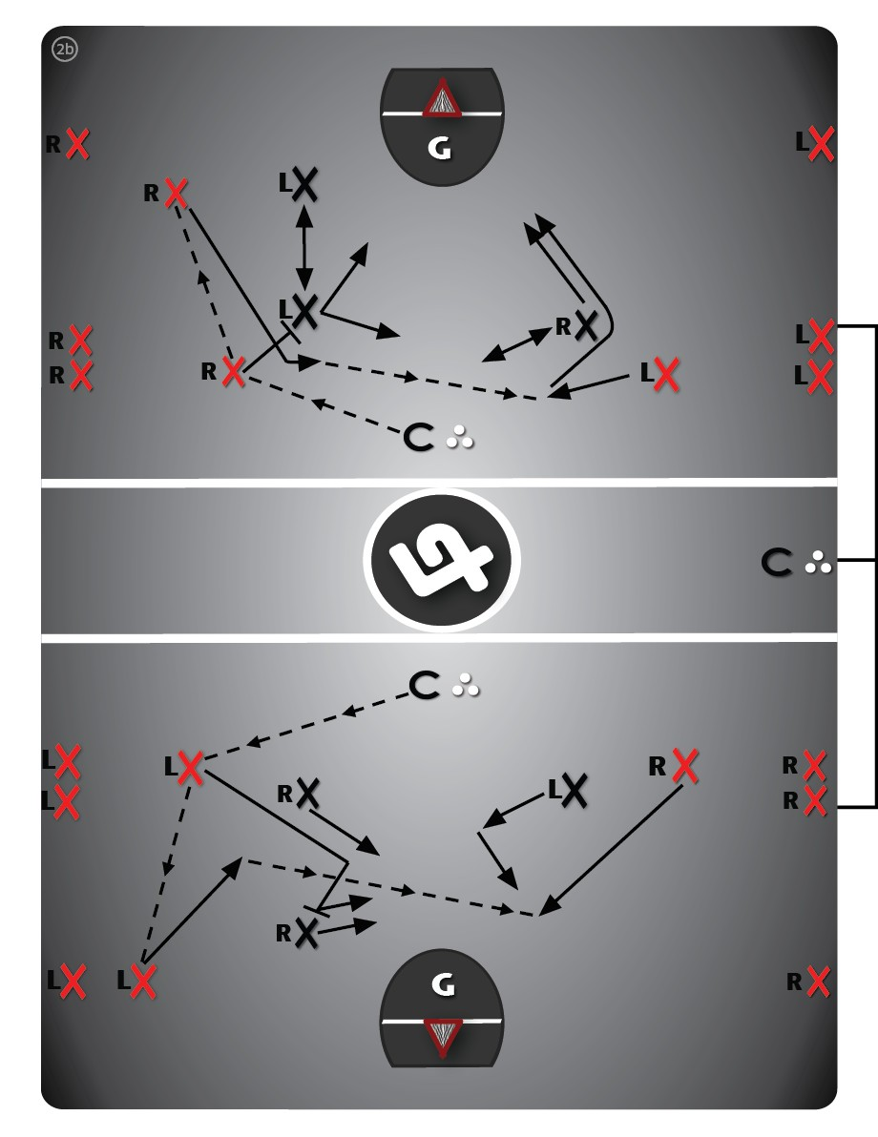
  Variation #2B (10 min): "3 Vs. 3." Start with 2 offensive players at the crease (low) and shooter (high) positions respectively, with the 3rd offensive player starting in the shooter position on the opposite side.
  Match up 3 other players in their respective defensive positions. Coaches should allow the offensive players 15-20 seconds max to get a shot off, also allowing them to continue to play if there’s a “re-set” from a shot. The weak-side shooter is now able to back-door cut and/or go one-on-one to the net, if the opportunity presents itself. If the goalie makes a save or there is a rebound, the defensive players should try to successfully clear the zone with the ball.
  For rotating through the drill, players who started the drill at the crease position (on both sides; defense & offense) are out of the drill, and players who started at the shooter position (defense & offense) are now at the crease position on the weak-side; with two new defenders/offenders entering the drill on the strong-side.
  Offenders/defenders should switch between being on defense or being on offense each time through the drill.

Defense Drill #14B: 5 Vs. 5 Build Up
drill #: 11 minutes: 15
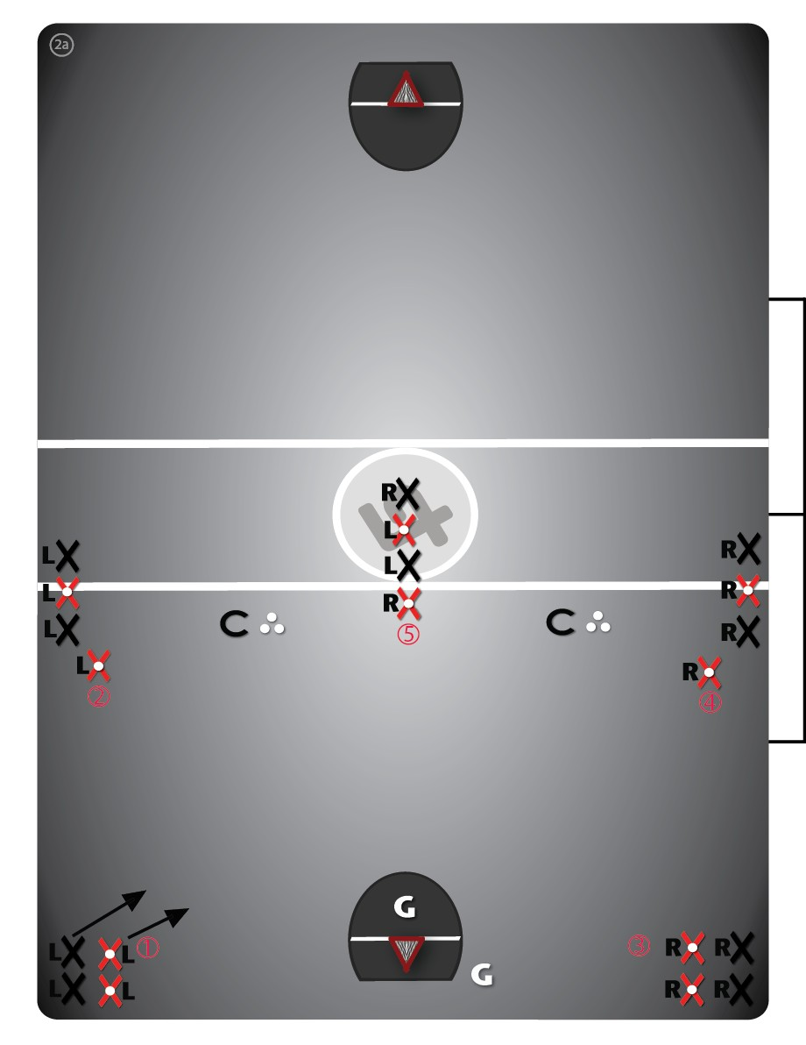
  Begin with two teams (different coloured pinnies) in 5 separate lines, a few steps back from the 5 standard offensive positions, facing the net, in one or both ends of the floor.
  All players should be on their proper floor-side, with a mix of lefts & rights in the point position line.
  The coach identifies which colour of pinny is on offense and which is on defense, also which line is first to start and which direction (clockwise, counter-clockwise, star-pattern, etc.) is the order of who goes next.
  Variation #1 (15 min): "Even Strength." The team of players on offense start with a ball at the front of the line, with the defensive players 1-2 metres back toward the net. On the coaches whistle the offensive player takes the ball to the net attempting to get a quality scoring opportunity (coaches also blow the whistle to stop the play); use pylons to mark starting points if necessary.
  After a shot or turnover, the coach blows the whistle again which signals the next line to go (a few seconds for re-positioning may also be allowed), with players abandoning the previous play and getting into position for the new situation.
  Switch the offensive team to defense once every player has had at least one rep in the drill.

Loose Ball Drill #10: Loose Ball “Battles”
drill #: 12 minutes: 10
Variation #2 (10 min): "2 Vs. 2 Battle."
Have two lines of players, side-by-side on both sides of the coach (4 lines total - two teams). Players should be encouraged to battle against different players as much as possible.
Offensive players should attack their rebounds and get awarded another 5 seconds if they obtain the ball; defenders should be encouraged to clear the zone upon obtaining a loose ball.

