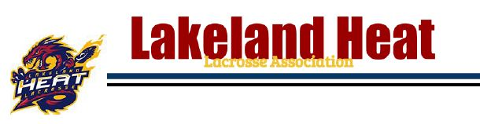

March 1, 2019

To Whom It May Concern:

____________________________(name) is a volunteer for the Lakeland Heat Lacrosse Association as a _________________________ (position).

As part of their volunteering position, they will be working in close contact with youth aged 5-17. Due to this, and in the interests of protecting the youth in our community, all of our volunteers are required to complete a vulnerable sectors record check.

If there are any questions, please contact our Association President at president@lakelandlacrosse.ca

Thank you in advance for your cooperation,

Mike Groves League President 2018-present 780-201-7042
Lakeland Lacrosse Association
4313 50 avenue
Unit 1007
Bonnyville, Alberta T9N 0B4

