Lakeland Lacrosse Association Board of Directors
Meeting Highlights
Wednesday February 22, 2023 – 7:00 pm

- Registrations –Latest registration numbers: 93 registrations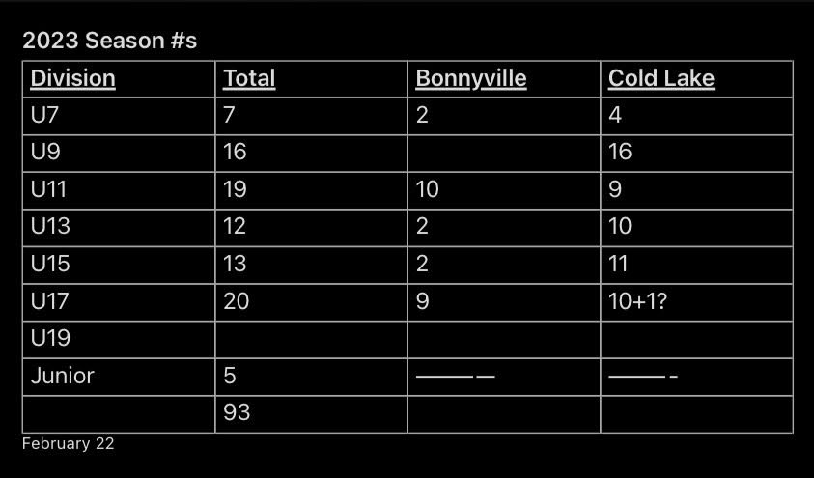
Wheatland plans to book 14U (bantam) & 16U (midget) games on the same nights and location whenever possible to maximize ref availability and save on travel costs.
Practice and game schedule to come soon.
League play is expected to start week of April 16th.

- Apparel – We are getting prices and options for Lakeland Heat apparel and swag.

- Ice Melter – Daryl will try to schedule a Jr game for the same weekend as the Ice Melter
- Set up a committee with at least one member per team.
- Currently booking floor times in Bonnyville (C2) and Cold Lake (EC, JJ Parr, North rink).

- Girls’ lacrosse – Roz Klassen attended our meeting to express interest in creating a U11 & U13 girls’ team. Many of the Jaguars hockey team in interested in trying lacrosse. We will support this initiative as best we can. The week of 21-25 of August, the Jaguars are holding a local hockey camp. They asked if we could offer a dryland/intro to lacrosse session. We will work out the details in the coming months.

- Emergency preparedness discussion – Inspired from the C2 active shooter incident at the end of January. Eric will contact the C2 and EC to see what their emergency protocols are so we can share with the coaching staff. We will share this at our coaches and managers meeting.

Next Meeting Date: March 15, 2023 in Cold Lake at 7:00 pm

