Lakeland Lacrosse Association Board of Directors
Meeting Highlights
Wednesday March 15, 2023 – 7:00 pm

- Registrations –Latest registration numbers as of March 12:
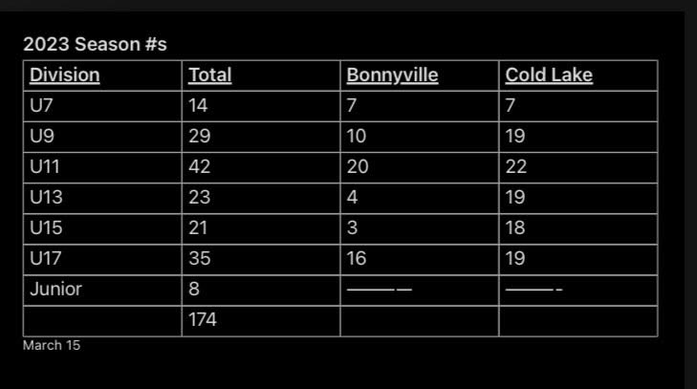

- Jersey bags – A motion was made to replace damaged jersey bags as needed.

- Apparel finalization – Order forms are ready to go. They will be sent out soon. Options include sublimated hoodie (personalization included in the price), jackets, shorts, socks, long sleeve warm up shirt and polo shirt

- Square payments –A motion was made a motion to purchase a Square Payment Reader to offer additional payment options to parents and guardians,

- Office space – We will no longer have the office space in the energy Centre in Cold Lake. We will rent a storage space for jerseys, goalie equipment, etc.

- Reffing clinics – 2 clinics coming up –
Cold Lake on March 26 level 1, 2 & 3
Vermillion on April 2
We invite second year bantam players and all Midget players to attend a special event on April 1 in Vermilion with a scrimmage and ‘see the game through the eyes of a ref’ experience with an invitation for last minute registrations for the ref clinic.

- Coaching clinics –
April 21-22 - ALA Development Camp in Lloyd U13, $25/player, coaches are free
Coaching Community Development Clinic on Sunday in Lloyd, pre-clinic online course needed before registration then post course to be done by Dec. $80 or 100
Competitive Intro Clinic April 15-16 Cold Lake (Bantam Midget or Junior) $80/coach
The Association will be invoiced, coaches do not need to pay this fee

**April 16 there will be a mandatory ZOOM meeting for all Wheatland coaches and managers.

- Finalize practice schedule –
U14, U16 games will be on Wednesday nights
Mon./Wed. U7/U9 5:30-6:30, U15 6:30-7:30, U17 7:30-8:30

Tues./Thurs. U11 6:00-7:00, U13 7:00-8:00, Jr. 8:00-9:30

- Tournament Director -
Tournament meeting on Monday March 20 at 7:00 pm in the evening in Cold Lake in the upstairs lobby near the Game Day Grill.

Date: April 2, 2023 at 8:00 ZOOM Special meeting

