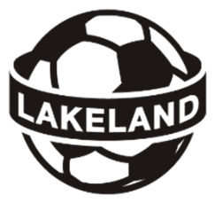
Combined Community Teams

United and Lakeland Teams Information
This form is to be filled out when a team is formed with players registered in multiple communities/associations.
It is not required if a team is formed with players residing in multiple communities, while registrations are retained by one association.
Season:
Team Name: | (Note: “Lakeland FC” name is reserved for the Lakeland Tier 2/3 teams)
Communities Involved: | ☐ Cold Lake Minor Soccer Association  ☐ Bonnyville Soccer Association  ☐ Lac La Biche FC  ☐ St. Paul Soccer Association  ☐ Vegreville Minor Soccer Association  ☐ Vermilion Soccer Association  ☐ Other: ___________________________________________
Host community will be the main community for the team for any required invoicing and declarations. (Lakeland Cup fees, Provincial fees, Travel Permit fees, etc.) LDSA will not be responsible for splitting costs between communities, one community will be invoiced for all team associated costs.
Main Host Community:
Team Contacts
Head Coach Name:
Head Coach Phone:
Head Coach Email:
Manager Name:
Manager Phone:
Manager Email:

Team/Community Plan:
Team Jerseys:
Enter the plan for purchasing jerseys. Which community is ordering, paying? What is the plan to collect funds from other communities? Plus any other relevant details.

Tournaments:
Enter the plan for tournaments. Who will be registering the team for out of district tournaments? What is the plan to collect funds from other communities/players? Plus any other relevant details.

Name: | Position: | Club: | Signature:

