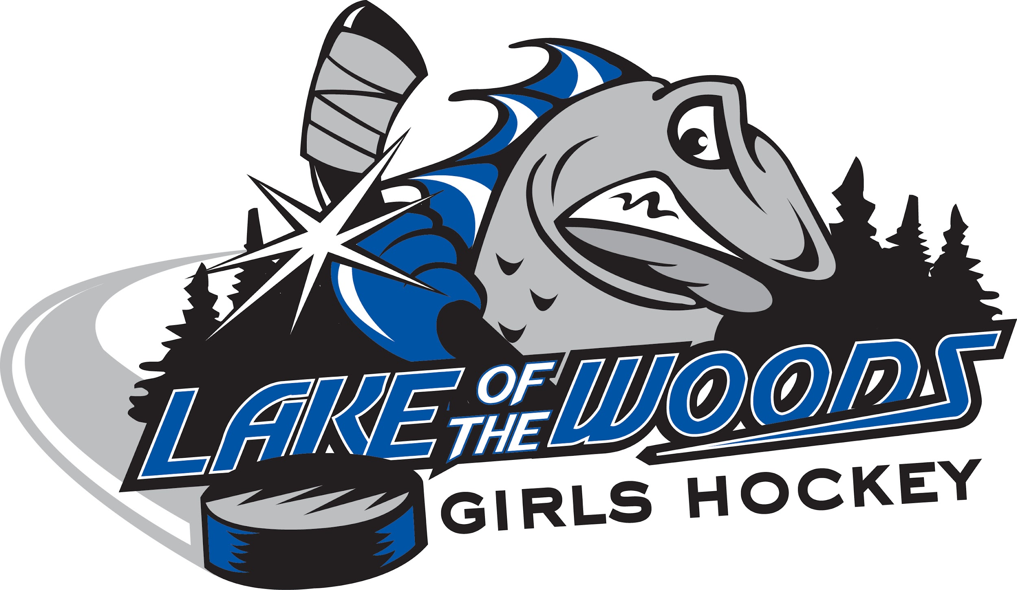

Lake of the Woods Girls Hockey
Larry Bowen 28th Annual Memorial Tournament

U15/U18 Divisions Entry Form

U15 ______ U18 ______

Team Name: ____________________________________________ OWHA#: _______________

Information required for tournament weekend:

HEAD COACH:
Name: ________________________________ Email: ___________________________________

Phone:_________________________________ Cell: ____________________________________

TEAM CONTACT/MANAGER:
Name: ________________________________ Email: ___________________________________

Phone:_________________________________ Cell: ____________________________________

Assistant Coach Name: ______________________________________________________________

Assistant Coach Name: ______________________________________________________________

Jersey Colours:_____________________________________________________________________
(please indicate if you have two sets and the colours)

If you are a team from Manitoba, please note that we only accept house leagues teams which is the equivalent of A2 from Manitoba.

$750.00 entry fee with a guarantee of 4 games.*

Mailing address:
Lake of the Woods Girls Hockey
Box 12
Kenora, ON P9N 3X1
Please make your cheque out to: LOW Girls Hockey. Or EMT to lowsgirlshockey@gmail.com

*Your entry in the tournament will not be confirmed until payment is received in full.

Questions? Please email amyhoutz1980@gmail.com

