

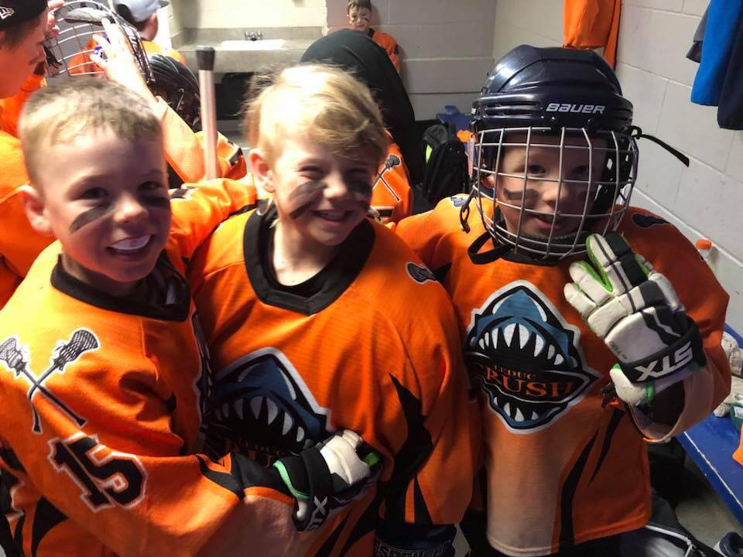

Manager Handbook

2024

# Leduc Crush Lacrosse Club

**Purpose of this Manual**

The purpose of this manual is to provide coaches and team managers with guidelines to assist them in creating an enjoyable sporting experience for everyone involved in Crush Lacrosse, including themselves.

This is simply a guideline which may be followed to help your year be a success. Any information in this manual is subservient to the Constitution and Operating Policies of Leduc Crush Lacrosse Club as well as policies laid down by its governing Lacrosse bodies, including the Greater Edmonton Lacrosse Council (GELC) and the Alberta Lacrosse Association (ALA) and its directorates.

**Code of Conduct**

As a club, the Leduc Crush consider the following as important elements for a minor league coach to provide for his/her players:

* Respect for the game, its rules, officials, opponents, teammates and oneself.   
  • Personal safety, fun, positive reinforcement.   
  • Organized, patient, player centered teaching in all aspects of lacrosse.   
  • A fair amount of playing time, based on the specific level and circumstances, with the best interests of each individual and the team as a whole.

As a player, some specific conduct is required for everyone involved to get as much as possible out of the lacrosse experience:

• A respect for officials and a realization that they are there to protect the game and the players themselves.   
• A positive and constructive relationship with their teammates.   
• A certain level of commitment, recognizing that lacrosse is a team game, and as a player, they will only get as much from the game as they are willing to put in.

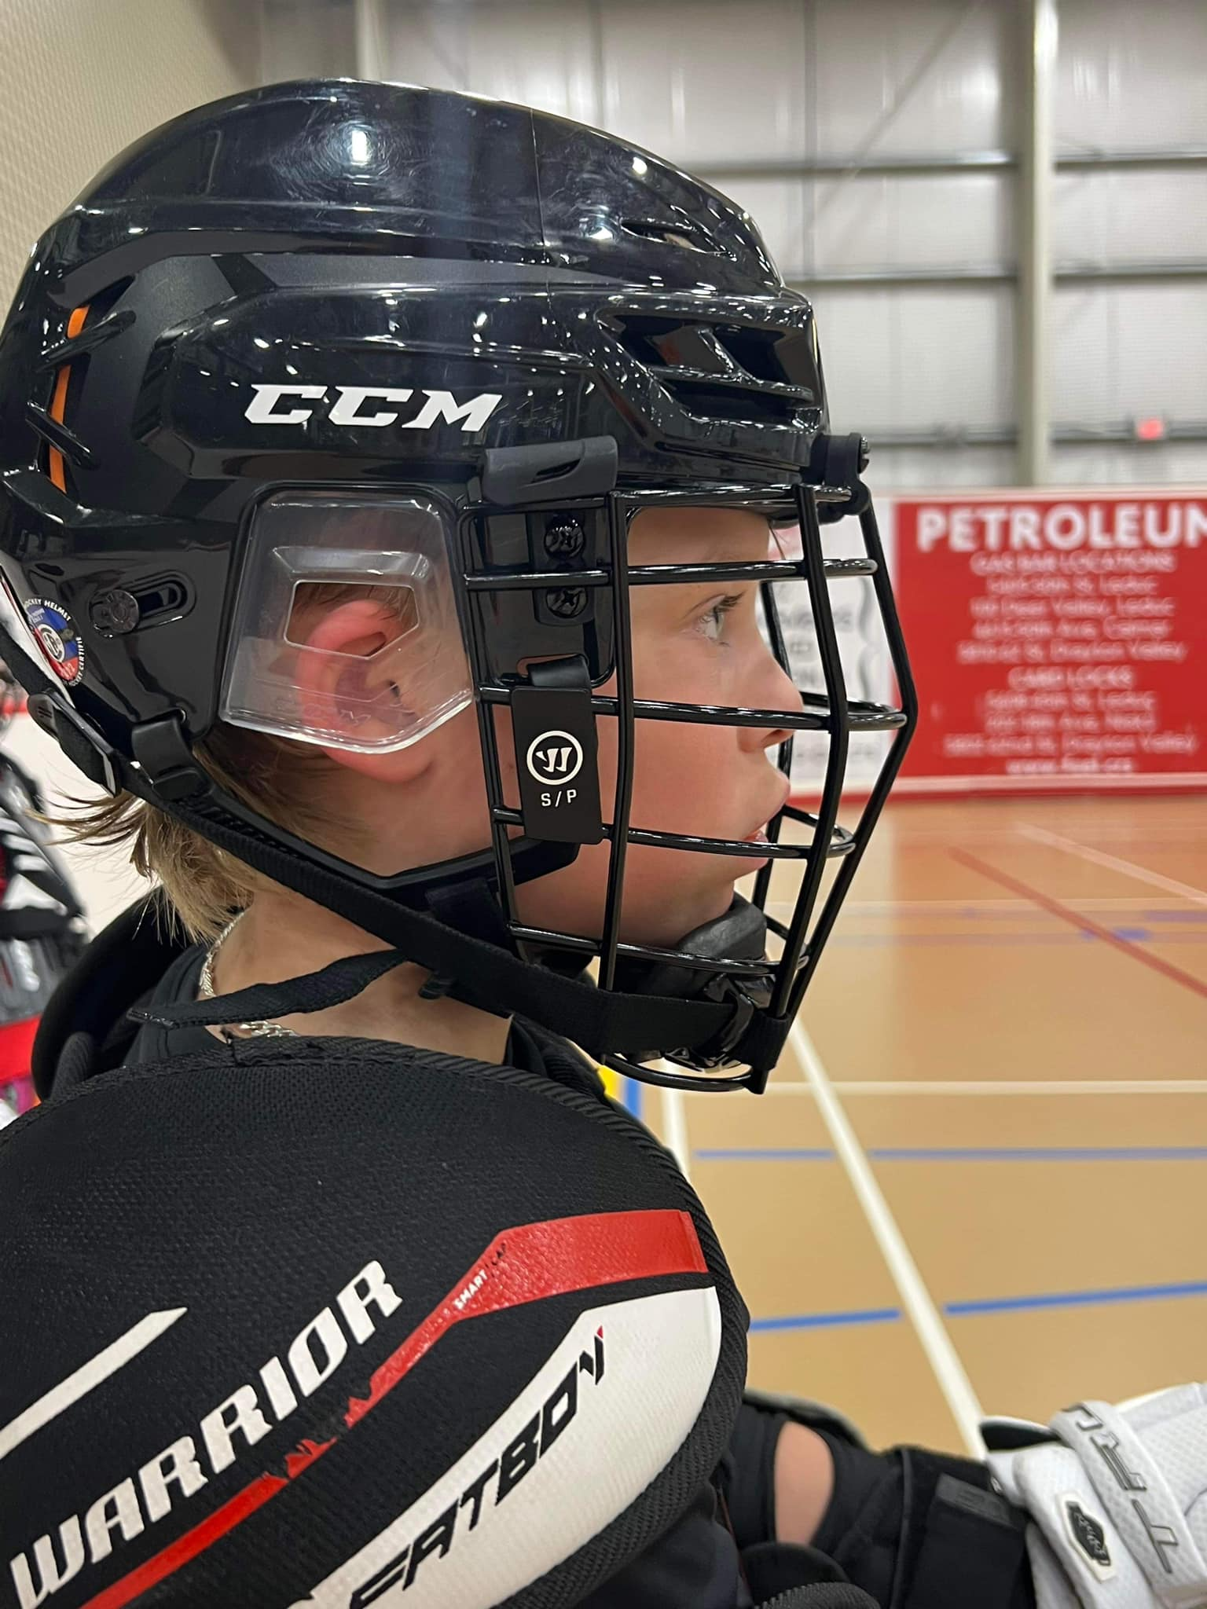

As parents we must remember why our children play minor league sports and appreciate the responsibility we have as examples and teachers.   
  
Both parents and other spectators should encourage the players and foster an environment conducive to athletic and personal growth:

• Establish healthy communication with the coaches.   
• Be a positive role model when relating to coaches, officials, other players or others involved in the game.  
 • Exhibit a respect for the rules of the game.   
• Emphasize athletic and personal growth that results from full commitment to the sport.

The Leduc Crush Lacrosse Association has a tremendous respect for the game of lacrosse. As such, the Board of Directors is working to improve the experience for everyone in our community. The Code of Conduct is an initial expression of the expectations for all Leduc Crush members. We trust that all involved will do everything they can to make this a reality.

Respect, responsibility, sportsmanship, fairness, commitment, and the spirit of friendly competition are foundational for lacrosse. Those involved at all levels should strive to uphold these principals.

For Leduc Crush players, we believe these qualities are essential for success, enjoyment and athletic growth. When we look back on the time, we were part of the Leduc Crush community, whether as a player or in a supporting role, we want to remember an environment of enjoyment and encouragement, conducive to growth both as an athlete and as a person.



**Discipline**

It is necessary to maintain order on your team. It is important to establish rules at the beginning of the season and make sure all players and parents are aware of the rules as well as the consequences of breaking the rules.

A player, coach, manager, and parent code of conduct has been created and needs to be signed by all members of your team and kept with the manager.

The Leduc Crush have implemented a Discipline Committee that will be the governing body over all written complaints/concerns received by parents/spectators/coaches or officials. If you have a complaint, please reach out to your manager or directly to the Vice President at vicepresident.leduccrush@gmail.com  
  
A formal complaint received will be taken to the Leduc Crush Discipline Committee for review. If the Leduc Crush Discipline Committee considers the matter a violation of our club policies, there will be a hearing in which the offender will be mandated to attend. All decisions by the Leduc Crush Discipline Committee are final and will be enforced during the 2024 season. Any discipline that is issued that cannot be enforced during the 2024 season will be carried forward to the 2024 season.

**Complaints**

Complaints which you receive about any aspect of our association should be referred to the Leduc Crush Board of Directors. The Board of Directors Contact List is contained in the Leduc Crush Lacrosse web site at <http://www.leduclacrosse.com/content/executive-contact-list>. The complaints must be submitted via email to the President and Vice President after a 24 hour waiting period as per “Respect In Sport” guidelines.

**Organizing your team once you are assigned Team Manager:**

As the team manager you need to do the following as soon as possible:

* Plan a parent meeting to discuss coaching philosophy, tournaments and volunteer positions.
* Set up a team online scheduling system (Ex. Team Snap)
* Discuss the volunteer opportunities for the parents on your team to ensure you have individuals willing to help where needed. (Time keepers, shot clock, jersey parents, etc.)
* Discuss a cash call option and address what the cash call would be for (Ex. Tournaments) – Team Budget
* Discuss fundraising for the team, options include bottle drives, chocolate almond sales etc.
* Goal jar is also a great way to raise team funds. A container is brought to each game, when your team scores it is passed around and parents put in $0.25 (or an amount of their choosing)
* Complete medical emergency forms for all children and keep on hand for each game. (Recommend keeping a binder with pertinent information)
* Create team labels with your team listed on them. This will be most convenient for game sheets; you will need 3 labels per game. The players will be listed in numerical order. Clear labels are recommended.
* Assigning a Parent Liaison (PL) – This is an important role that should be assigned to someone who can be a calm representative of the team. This person needs to be a strong communicator who can address both parents on your team who are perhaps getting overly passionate about the game, or parents from the other team who may come over to express concerns. This parent needs to be addressed in a parent meeting and given the respect/authority from the parents and coach that he is the liaison and represents the best interest of the team and staff. The coach and PL need to be able to communicate with each other over any areas of concern on the team.
* Picking a Jersey Parent – This parent(s) needs to ensure they will be at every game, and if they cannot make a game, they must make arrangements to get the jerseys to another parent. You could have 2 jersey parents, one for away and one for home games.
* Tournaments – both in and out of town tournaments fill up very quickly so I would suggest that you register for the tournaments you want ASAP. Please see the list of Alberta tournaments attached.

Please note that a Tournament Travel Permit is required for ALL tournaments whether in the city or not. Any team that does not get a Travel Permit for a tournament from the GELC will face disciplinary action which may result in the suspension of the head coach.

The Tournament Travel Permit Approval Form can be found at:

<https://cloud.rampinteractive.com/gelc/files/Forms/Tournament%20Permitupdated2019.pdf>

A sample is also available at the back of this book.

* Entering game sheets – you will require a GELC log in to access the manager page of the website. Here you will find all of your games listed. It is your responsibility to enter your game sheet information within 24 hours of your game along with a scanned copy of the white game sheet.

Please ensure you follow the ALA tournament guidelines for all tournaments you enter. These guidelines can be found at:

<https://cloud.rampinteractive.com/ablax/files/Administration/Alberta%20Lacrosse%20%20Tournament%20Guidelines%202019.pdf>

* Season wrap-up party – It is the Team Manager’s responsibility to oversee team financials. You do have the option of assigning a Treasurer. We would encourage the team manager to handle funds as they see fit in a transparent manner reflecting the financial requirements of the team. Should your team be participating in fundraising, it must be one that does not require a license. Ex. No 50/50 or silent auction unless a gaming license is obtained.
* The Leduc Crush Lacrosse Association can request an accounting of team expenditures at the end of the season. This will be signed off by the team treasurer and another parent and submitted to the Leduc Crush Lacrosse Association Treasurer [–treasurer.leduccrush@gmail.com](mailto:–treasurer.leduccrush@gmail.com) as well as the parents on the team.

**Communication**

Communication is essential to the smooth operation of your team. At the parent information meeting:

* Explain the goals you have for the team.
* Explain the rules that you have established and what actions will be taken if the rules are broken.
* Hand out parent/player contracts and explain that no child will be allowed on the floor until both are returned to the manager signed.
* Explain how ongoing communication will be conducted (e-mail, telephone, or TeamSnap)
* Describe the team emergency plan and hand-out Participant Medical History Forms (found under resources on the website)
* Explain what volunteer positions need to be filled and why.
* Discuss financials – how many tournaments would the team like to participate in? Cash call vs fundraising? Getting these issues out of the way should avoid any confusion during the season.

Have all parents fill out a contact information sheet, complete with names of parents, home address(es), home phone number(s), cell phone number(s) and e-mail address(es), as the information contained in the registration form may not contain all necessary contacts.

**Team Spectator Liaison**:

This volunteer role is mandated by the GELC and is a very important role on your team. The parent who volunteers for this role must understand what is required of them by GELC guidelines.

Before assigning this role, ensure the parent has read the policy guidelines below:

|  |  |
| --- | --- |
|  |  |
| **Policy** | **Team Spectator Liaison** |
| Reason | To improve the player experience, to assist the officials and coaches at games with spectator management. |
| Position Requirements | All GELC teams are required to have an adult volunteer be the team Spectator Liaison.  Duties of the Liaison   * Uphold the code of conduct of the GELC. * Introduce yourself to the officials and other teams Spectator Liaison at the start of the game as the Name of the Team, spectator Liaison. * At all games monitor the actions of the spectators who have come to the game to watch. * Speak with spectators as to appropriate behaviors. * Assist the coaching staff with crowd/and or remove of offensive individuals. * When team is requested to supply offending individuals’ names be the person responsible to providing to the head coach and referee. * If matters escalate please walk away and call the police. |
| Inappropriate Behaviors | **Inappropriate behaviors include the following:**   * Banging on the glass, or boards. * Making abusive comments to the officials. * Verbally abusing players on either team. * Getting into verbal sparring matches with opposing spectators. * Using profanity or making inappropriate gestures. * Engaging coaching staffs. * Going to areas of the arena that are not spectator seating. * Throwing objects. * Not leaving when asked to leave the facility. |

**Bench Personnel**

Bench personnel include the coaches and trainer. The Head Coach (and Assistant Coach if assigned) run all practices and manage the bench during games.

In all games (including regular league, playoffs, tournaments), teams are required to have all bench personnel who are on the bench meet the CLA Minimum Standards. In practices, teams are required to have at least one of the supervising coaches trained as per CLA Minimum Standards.

Trainers must have the appropriate certification. Appropriate certification is defined as one of the following:

a) Any St. John Ambulance Emergency First Aid course of 8 hours (or more) or equivalent   
b) Canadian Red Cross Standard First Aid & First Responder   
c) Canadian Red Cross Sport First Responder and Sport Aid course   
d) Hockey Canada Safety Program (HCSP)   
e) An appropriate designation (examples: MD; RN; Physiotherapist, Police Officer; Firefighter, Chiropractor; Registered Massage Therapist).

From the above, please be clear CPR (as a stand-alone certification) is NOT an equivalency.

Note that the maximum number of bench personnel permitted on the player’s bench is five (5), excluding the trainer. As these people need to be registered and trained with ALA for insurance purposes, you should try to make sure you have the same bench volunteers for each game.

**Team Manager**The person in this position is responsible for coordinating team functions and acting as liaison between the coach(es) and players’ parents. This allows the coach(es) to devote their volunteer time to the functions of coaching.

Duties which may be allocated to the Team Manager include, but are not limited to:

* Distributing information – provide a team roster and schedule.
* Fundraising and tracking expenditures
* Scheduling for timekeepers, scorekeepers and shot clock.
* Submitting Significant Incident Reports and tracking discipline – please see our website.
* Enter scoresheets into the online reporting system.

**Timekeepers and Scorekeepers**

* The home team is responsible for providing two adults for the timing bench during games, one to run the electronic scoreboard and one to complete the score sheet. A third official may be provided by your team to run the 30-second clock.
* Home team keeps the white copy of the game sheet.

**Home Games**

The following are the home team’s responsibility for all home games:

* Supply the score sheet (make sure you complete it and hand it to the visiting team no less than 15 minutes prior to game start) Make sure the game sheet is signed prior to giving to the away team.
* Supply the game balls (minimum of 3)
* Arrange for volunteers to be the scorekeeper and timekeeper.

**Equipment**

Equipment provided by Wizards:

* **Balls for Games and Practices** –Leduc Crush will supply enough balls for use during the season. Should your team require additional balls, contact the Leduc Crush Equipment Director at equipment.leduccrush@gmail.com
* **Team Jerseys** are very expensive and should be well cared for. Please impress upon the jersey parents the importance of washing (inside out) and drying (hang dry) the jersey and making repairs as necessary (mend tears, stain removal, affixing “Stop Signs”, etc.) Any major repairs should be reported to the Leduc Crush Equipment Director.
* **Team jerseys** are not to be worn to practice under any circumstances. Please return jerseys cleaned and repaired and in numerical order. If a jersey is missing, stained or damaged, please let our equipment director know.
* **Team Shorts** – are provided to the players at the beginning of the season and must be worn for all games.
* **Goalie Equipment** – The goalie gear typically consists of leg guards, body armor, pants, throat guard and stick. Please air the equipment out after every game and either repair or report minor repairs which may be required to the Equipment Director, before they become major problems.

**Equipment provided by Team**

* + It is recommended that the team obtain a small cooler for ice packs (could be borrowed from a parent or purchased out of team funds).
  + Each player should bring his or her Crush shorts to practices and games.
  + The team should have a small toolkit containing the necessary screws, nuts, screwdrivers, tape, leather strips, cords, etc. to perform minor equipment repairs.

All games and indoor practice times are scheduled and posted by the GELC.

If your team is entering a tournament, it is your responsibility to ensure you have submitted a travel permit request to the GELC to have your game rescheduled if there is a conflict.

**Player Movement and Affiliation**

Registered and paid players may participate in Leduc Crush team games and practices. Athletes not yet registered are not allowed on the floor until officially registered by the Leduc Crush Registrar.

Coaches and other team officials cannot accept registrations.

**Affiliating Players**

The coach of a player must be contacted for permission prior to contacting the player to play for another team. With the permission of their coach or manager, players are allowed to play up in their own division as per affiliation policy.

You will find the Player Affiliation Form attached to this booklet. As of 2023, please note that teams can affiliate players for any tournaments within Alberta.

**Social Media**

Leduc Crush’ social media is coordinated at a club level, with one volunteer who posts Facebook, Instagram and Twitter pages. Please stay connected! Teams will be encouraged to send game results, scores, interesting news and photos to the Social Media Director at socialmediaassistant.leduccrush@gmail.com. Before you send anything or post anything on your team, please ensure every player signs the Photo and Video Consent Form in this book.

**Forms**

The GELC website has many forms available to you including:

* Team Medical Form
* Request Game Chance Form
* League Incident Form
* CLA Head Injury Incident Report
* Tournament Permit Form

These can be found at <http://gelc.ab.ca/content/manager-resources>

**Policies**

Please see provided policy manual. Many policies can also be found on the GELC website at <http://gelc.ab.ca/> under the policy tab.

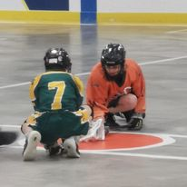

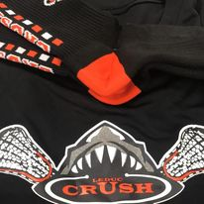

**2024 Team Fundraising Information**

**Team Fundraising**:

If your team would like to participate in fundraising, the following is a non-exhaustive list of options. Please note, the AGLC requires licenses for gaming events such as, casinos, raffles, bingos and pull tickets. It is each team’s responsibility to ensure any AGLC requirements are met. For more information, please visit their website at:

<https://aglc.ca/gaming/licences>

**Additional Fundraising Ideas:**

* Bottle Drives
* Team Garage Sale
* Car Wash
* Goal Jar
* Little Caesar’s Pizza Kits <https://www.pizzakit.ca/fundraising-products>
* Krispy Kreme Donuts <http://www.krispykreme.ca/fundraising-community/>
* Jack Link’s Jerky <https://www.fundraising.com/canada/beef-jerky>
* World’s Finest Chocolates <https://www.canadafundraising.ca/>
* The Mixing Spoon <http://www.themixingspoon.ca/fundraising>
* Scoops Fundraising <http://futurefundraising.com/>
* Cineplex Fundraising <https://www.cineplex.com/CorporateSales/Fundraising>
* Kernels Popcorn <https://www.kernelspopcorn.com/pages/footer/links/fundraising>

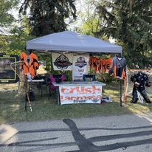

**Tournament Permit Approval Form**

# Contact Information

|  |  |
| --- | --- |
| Team |  |
| Name |  |
| Home Phone |  |
| Cell Phone |  |
| E-Mail Address |  |

**Tournament**

Provide the name of the Tournament or Tournaments the team is wishing to attend

|  |  |
| --- | --- |
| Tournament Name | Tournament Times |
|  |  |
|  |  |
|  |  |

**Coaches/Trainers**

Name all coaches and trainers, please indicate level of coaches training achieved

|  |  |  |
| --- | --- | --- |
| Name | Position on Team,  Head Coach/ Asst Coach, Trainer | Coaches Training and Level Achieved |
|  |  |  |
|  |  |  |
|  |  |  |
|  |  |  |
|  |  |  |
|  |  |  |

**League Games**

Does this team have league games, pre, post or during the tournament that would be affected by the team attending this tournament.

**Out of Province Tournaments**

Has the team applied to the ALA for a Travel Permit to attend an out of town Tournament

**Acknowledgement of the Head coach of Regulation 20 as below**

|  |  |
| --- | --- |
| Name |  |
| Signature |  |
| E-Mail Address |  |

**Approval**

For GELC office use only:

|  |  |
| --- | --- |
| Coaches appropriately trained |  |
| 2 members who attended Coaching event |  |
| Name |  |
| Signature |  |
| Date |  |

**GELC Regulation**

**Regulation 20 - GELC Tournament Permit**

All GELC teams wishing to participate in tournaments inside and outside of Alberta must have a league Tournament permit issued.

* 1. In order to have a Tournament permit issued the team must conform to the following:
     1. Minimum of 2 team officials from each teams coaching, management and training staff must have attended any mandatory Coaches training event as declared by the GELC for the current playing season.
     2. Tournament permits will only be issued by the GELC office.(The club presidents will receive a copy of the signed permit as well as the team
     3. Additionally, teams with 45 penalty minutes or more in a single game, for two or more games, may not be granted a tournament permit or have their permit revoked by the GELC Board. This may be done within 48 hours via email.

d. Exceptions to this regulation and or appeals may be made to the GELC Executive and their decision on the matter shall be final.

* 1. Teams entering tournaments without the GELC tournament permit.

The head coach shall be suspended for the number of games that were played

by their team in the non- permitted tournament. A second occurrence will result in the head coach being required to attend the GELC discipline committee meeting.

* 1. Teams must email copies of all tournament games sheets to the GELC office within 48 hours of the completion of the tournament.

.

# Submission of Application

Please note this application must be scanned and submitted to the GELC office [[executivedirector@gelc.ab.ca](mailto:executivedirector@gelc.ab.ca),](mailto:edmlax@telus.net) no later than 8 days prior to the tournament the team is intending to attend. It will be signed off and returned by the GELC office. Please ensure you return your tournament game sheets

# **Tournament Approval Request Form**

#### **Tournament Approval Request Form - Online**

All teams that enter Tournaments (Alberta and Out of Province) are required to submit a Tournament Approval Request Form.  Submissions must be approved by the GELC Executive and Office.  Please ensure that all of the Bench Staff Credentials (NCCP/Coach Level/Trainer Certification) are filled out accordingly.  All Bench Staff must be included. Incomplete Submissions will not be approved.

**Please note, if your team is entering a tournament outside of Alberta, they must fill out an ALA Travel Authorization Request form.   A copy of this request form must be submitted to the GELC office: [executivedirector@gelc.ab.ca](mailto:executivedirector@gelc.ab.ca) **

* [ALA Travel Authorization Request](https://cloud.rampinteractive.com/ablax/files/Form-ALARequestforTravelAuthorization-March2023-v2.pdf)

Please read below for detailed information on Bench Personnel Certifications:

#### **REGULATION 13 - BENCH PERSONNEL CERTIFICATIONS**

13.01 Bench Personnel are considered Coaches and Trainers.

13.02 In all games (including regular league, playoffs, exhibition, tournaments), teams are required to have all bench personnel who meet the LC Minimum Standards. 13.03 All Female-only teams must have one registered female bench personnel registered to the team in RAMP and on the bench as per the ALA Registration System and correlating to the game sheet.

13.04 Bench personnel are determined as per ALA Registration System for each team. Only coaches with the required qualifications and certified trainers are permitted on the bench. To be eligible to coach, all coaches must meet the requirements of the LC Minimum Standards as applicable to each discipline of lacrosse.

13.05 Trainers must have the appropriate certification.

Appropriate certification is defined as one of the following:

* Any St. John Ambulance Emergency First Aid course of 8 hours (or more) or equivalent
* Canadian Red Cross Standard First Aid & First Responder
* Canadian Red Cross Sport First Responder and Sport Aid course
* Hockey Canada Safety Program (HCSP)
* An appropriate designation (examples: MD; RN; Physiotherapist, Police Officer; Firefighter, Chiropractor; Registered Massage Therapist).

From the above, please be clear CPR (as a stand-alone certification) is not an equivalency.

13.06 The ALA recognizes only one trainer per team on the bench to address those specific activities (activities which would not include coaching athletes).

13.07 All coaches must be 16 years of age in the year he/she wishes to attend a coaching clinic and coach an ALA sanctioned team.

Medical History Card

Name: Birth date:

Address:   
  
 Phone:

Alberta Health Care Number:

Parent/Guardian Name:

Address (If different than above):

Alberta Health Care Number:

Phone (Home): Phone (Work):

Contact Person

(if Parent is unavailable): Phone:

Family Physician: Phone:

Please state illnesses or conditions, past or present, that may affect or be affected by performance.

Asthma Heart Disease Diabetes Seizures

Other:

(Specify) Other problems, previous injuries or surgery

Headaches Blackouts Chest Pain Fractures

# of Concussions: Other:

Are corrective lenses required: No Yes

Immunization: Year of last tetanus shot:

List allergies and/or medications taken regularly:

Signature of Parent/Guardian: Date: