Leduc Ringette Association
Minutes
June 16, 2022, Time 7:00PM
Google Meets (Online)
Regrets:
In Attendance: Chelsea Cameron, Crystal Kardelis, Natasha Hancharuk, Shauna Paul, Joanne Stempien, Kerri McKinnon, Amy Shipley, Mike Baker, Nicole Liddle

- Call to Order : 7pm
- Additions to Agenda None
- Approval April Minutes Crystal approves, Kerri seconds, All in favor
- Reports/Updates – Read prior to meeting:

- President's Report – Chelsea Cameron

- Vice President – Crystal Kardelis
-Still waiting to hear from the bingo hall but will reach out to him sometime this month to see where it’s going. Will also get in touch with the photographer.

- Treasurer's Report –Kristine Gullickson

- Secretary – Natasha Hancharuk

- Ice Allocator's Report – Shauna Paul
-Will be looking at rotating all current Open ice through each team, as we look at adding Open A to LRA. This would mean we will have Open A, B, and C in the association.
-Regular season ice starts Sept 10.
-UAA’s will have to be run on the second skate of the season.
-Camps and paid preseason skates do not count towards that second skate
-The Woods tournament is in Leduc in December, same as last season.

- Referee-In-Chief's Report – Kennedy Horn

- Equipment Manager's Report – Joanne Stempien
-Needs to get set up with the equipment manager email
-the code needs to be changed on the equipment locker

- Registrar's Report – Kerri McKinnon
- See attached report.
Numbers are looking solid but it’s too early to tell what teams will look like

RAMP is being utilized for all registrations this year (Players, Team Staff, Board Members) If you not yet registered, please do.
Please note: registering does not confirm placement.
Player registrations opened following our AGM on April 26th.
Preliminary numbers are below. Please note that number comparisons are based of July last year.
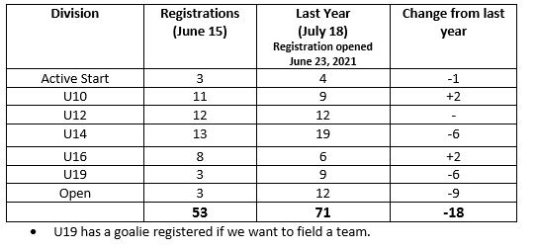

Releases:
Withdrawals:
Move ups Requests:
_____________________________________________________________________________________
Recruitment
• LRA registered floats in both the Leduc Rodeo Parade and Devon Days Parade.
Thank you to the Dupont and Baker families for taking lead on getting us ready on short notice!
• Looking for a come try in late August/Early September
• Flyers were sent to a number of families to be included in school newsletters.
• Waiting on dates for registration events (usually late August/Early Sept).

- Safety Office (Appointed Interim – Non-Voting) – Kerri McKinnon
Leave this position until RAB decides if we still need it and will remove in September

- Zone 5 Rep. Report – Amy Shipley
Needs to get set up with the Zone 5 rep email
BGL AGM – there were a lot of new faces at the AGM and a lot of the discussion was on parent conduct and what the chain of command is.
At the start up meeting for BGL in August they will be talking about third session, there will be some updates on some policies and procedures

- Fundraising & Bingo Report – Open

- Coach Coordinator – Mike Baker
-Sent out emails about coaching clinics to previous coaches and will work on hosting a clinic in the fall.
-The parades went well in both Leduc and Devon.

- Manager Coordinator – Nicole Liddle
Needs to get set up with the manager coordinator email

- Player Dev. Report – Open

- Social Media Director – Open

- Tournament Coordinator's Report – Open

- Webmaster Report – Amy Lackie

- PR & Marketing – Open
Looking for people who are into representing the sport

- Unfinished Business:
  - Twin Arena box

- New Business
  - Summer Camp
  - UAA Schedule / First Skate
We will talk about this further into the summer
  - Criminal record checks
Letters will be sent out in the next few weeks for people to have them done sometime this summer. Email them to Crystal when they’re complete.

- Next Meeting: Week of July 20 online
- Adjournment: 7:46pm

