CATCHING (RECEIVING THE THROW) PROGRESSION & TECHNIQUE
https://www.youtube.com/watch?v=uOwC9wmhd0Y
- Stand in ready position. Feet apart. Knees slightly bent. Hands open for target. Glove open wide. Elbows bent and down.
- Always use 2 hands to catch. The glove hand squeezes the ball while the throwing hand helps to keep the glove closed while being closed to throw the ball right away.
- You may have to reposition your body by taking a step or 2 to the side to catch straight on. But sometimes you need to just move your glove. Use the face of a clock for older kids or up, down, left, right for younger ones.
- 12:00 or “up” position for anything above your head. Still using the other hand to be right beside it too.
- 9:00 or “left” position for anything to your left. Still using the other hand to be right beside it too.
- 6:00 or “down” position for anything below your waist. Still using the other hand to be right beside it too.
- 3:00 or “right” position for anything to your right. Still using the other hand to be right beside it too.

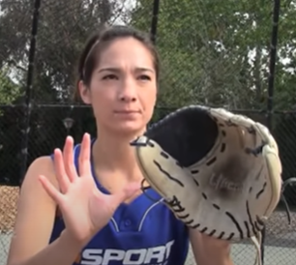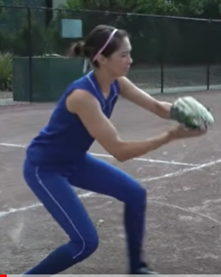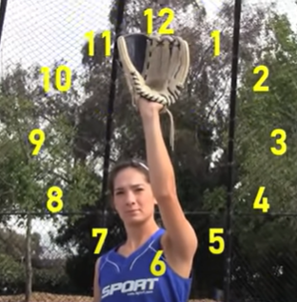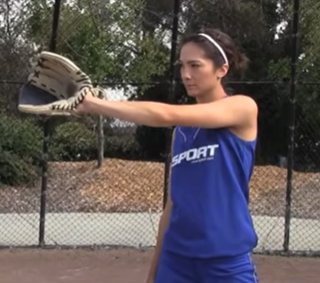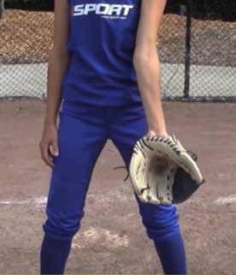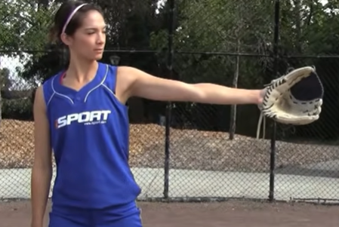

Mechanics
- Stand in an athletic and balanced position to receive a throw:
◼ Weight on the balls of the feet
◼ Knees slightly bent
◼ Feet staggered with the non-throwing foot slightly forward
◼ Glove and throwing hand out in front of body
- Give a target to the thrower in centre of the body
- Use two hands to receive the throw
- Hands and glove work like the face of a clock (pinkies and thumbs)
◼ When the ball is below the belly button, the pinkies should be together
◼ When the ball is above the belly button, the thumbs should be together
- Move body so that the ball is caught on the throwing hand side to aid in a quick transfer to the throw
- When ball contacts the glove, the hands and elbows should give (Soft Hands)
- As you absorb the catch, bring the ball and glove to the throwing shoulder

