CATCHING TECHNIQUES
https://www.youtube.com/watch?v=VSSurPu2bGw
- The feet are slightly more than shoulder-width apart, squared to the front of the plate and slightly turned out. Weight is on the inside balls of feet.
- The throwing hand is either behind the back or at the side with the thumb tucked under the fingers.
- When having to move to the right, move your right leg over while keeping your left leg in position.
- The same for moving to your left. Move your left leg over keeping your right leg in position
- After the ball is caught move the body into a throwing position where the glove goes back to meet the throwing hand.
- This is the position if the ball is going low or bouncing.
- Knees on ground but still on balls of feet.
- Shoulders over knees
- Chin to chest to protect throat
- Glove blocking gap
- Throwing hand behind glove to protect.
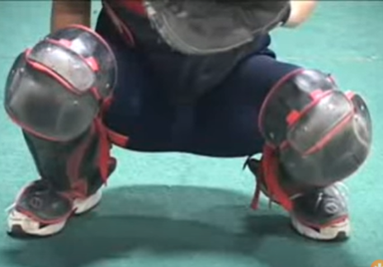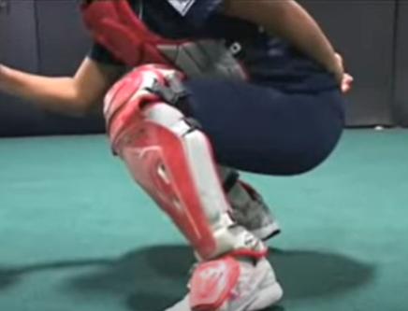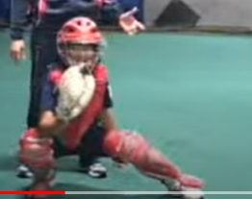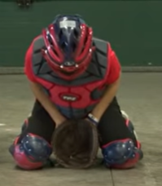
Position in the Catcher’s Box
- Wait for batter to get set
- Take note of their swing
- Position about one bat length behind back foot of batter
- Do not reach out to catch the ball. Let the ball come to you.

Giving the Signal
- Squat with heels off ground
- Hide signal from opposition using glove below knee of same side
- Align knees with edges of home plate
- Give the signal deep and against thigh

Giving the Target (no runners)
- Same as when giving signal except:
◼ Feet staggered with more forward lean of trunk
◼ Glove to side of leg to hide signal from opposing coach
◼ Throwing hand hidden behind back or lower leg

Giving the Target (with runners on base or two strike count)
- Receiving position changes to allow for a quicker throw
◼ Feet more spread apart
◼ Heels on ground
◼ Feet staggered with pivot foot farther back
◼ Knees bent according to height of target
◼ Throwing hand hidden behind back or lower leg

