Emergency Action Plan (EAP):

Attach allergy/medical and emergency contact information for team members and coaching staff.

Emergency Numbers: | 9-1-1 (if available in your community)
Coach Information: | Head Coach:  Cell: | Assistant Coach: _________________  Cell: ___________________________  Assistant Coach: _________________  Cell: ___________________________
Facility Details: | Tel: N/A  Address: 1901 - 15th Avenue North Lethbridge Alberta  George Vaselenak Field (AKA Miners Field)  Nearest Major Intersection:  15th Ave North and 23rd Street North | 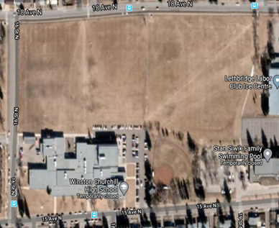
Nearest Hospital: | Tel: 403-388-6111  Address: 960 19 St S, Lethbridge, AB T1J 1W5 | 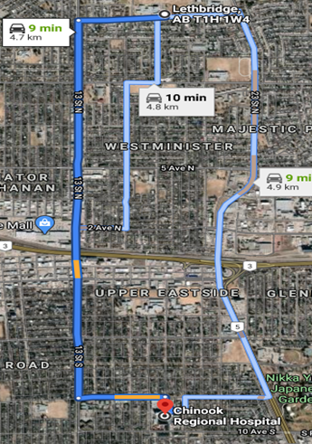
On-site Charge Person(s)  - Clear the risk of further harm to the injured person by securing the area and shelter the injured person from the elements  - Designate who is in charge of the other participants  - Protect yourself (wears gloves if he/she is in contact with body fluids such as blood)  - Assess ABC’s (checks that airway is clear, breathing is present, a pulse is present, and there is no major bleeding)  - Wait by the injured person until EMS arrives and the injured person is transported  - Fill in an accident report form  FIRST AID KIT WILL BE KEPT: In Storage Room at Miners Field  __________________________________________________________ FIRST AID KIT WILL HAVE PPE AVAILABLE. |  | Option 1:  DESIGNATED FIRST AIDER  PHONE #: _______________________  Option 2:  TEAM SANITIZATION VOLUNTEER – PRIMARY PHONE #: _______________________  Option 3:  TEAM SANITIZATION VOLUNTEER – OTHER PHONE #: _______________________  Option 4: _______________________  TEAM SANITIZATION VOLUNTEER – OTHER  PHONE #: _______________________
On-site Call Person(s)  - Call for emergency help  - Provide all necessary information to dispatch (e.g. facility location, nature of injury, what, if any, first aid has been done)  - Clear any traffic from the entrance/access road before ambulance arrives  - Wait by the driveway entrance to the facility to direct the ambulance when it arrives  - Call the emergency contact person listed on the injured person’s medical profile |  | Option 1:  HEAD COACH  Option 2:  ASSISTANT COACH  Option 3:  ASSISSTANT COACH

RAPID RESPONSE PLAN (RRP)
Rapid Response to Symptomatic Individuals
Facilities & organizers are required to have a rapid response plan in place to manage symptomatic participants, spectators and staff. A rapid response plan sets out a fast-action plan for operators when an attendee shows symptoms of COVID-19.

During Pre-assessment by the sanitization volunteer, if a participant answers YES to any of the questions:
1. Team sanitization volunteer puts on PPE and gives PPE to the symptomatic participant.
2. Team sanitization volunteer isolates symptomatic participant
3. Team sanitization volunteer contacts parent/guardian to remove participant, ensuring no public transit. In the event that the participant drove themselves and is a minor, the volunteer or coach will contact parent/guardian regarding the situation.
4. Team sanitization volunteer or coaching staff will advise the participant to pursue testing and report back to the designated team sanitization volunteer regarding testing and any clearance for activity.
5. Team sanitation volunteer will then contact the President to inform that the RRP was enacted.
6. Clean and disinfect of all surfaces that may have come into contact with the symptomatic participant.
7. Performance of hand hygiene by remaining participants.
8. Return to Play Committee member will contact Softball Alberta immediately if there is reason DURING a practice or game to enact the RRP. For symptomatic individuals the above plan would be used, however, an immediate suspension/cancellation of the event will take place.

EMERGENCY RESPONSE PLAN REGARDING WEATHER:
- Suggest for all teams to check local weather radar before attending practice. Come prepared: bug spray, sun screen, extra water, umbrellas – all individual NO SHARING.
- In the event of poor weather, sudden storms: no huddling is permitted – take cover under umbrellas, under concession overhang or go to individual vehicles – spread out.

"If you can see it, flee it; If you can hear it, clear it"
The 30/30 rule (rule 1 and 2) says to shut down when lightning is 10 km's away. Use a "flash to bang" (lightning to thunder) count of five seconds equals 1.2 km's. Keep an eye on the sky. Note when skies darken or gusty winds develop. Have a place of shelter in mind, and a plan to get there.

Rule 1: When you can count less than 30 seconds between the lightning strike and the thunder, the storm is less than 10 km away. There is an 80% chance the next strike will happen within that 10 km. It is time to take cover. But, often, it's hard to remember to count off seconds, or how many, and keep tally of the score too, and pay attention to the game, and watch the sky, and so on. Too confusing! So, here's the trick. Sound can carry great distances when the atmosphere is stable and quiet, like early mornings. But sound doesn't travel nearly as far during a stormy afternoon. Essentially, if you can hear the thunder, you're in the strike zone. Take cover!

Rule 2: Wait 30 minutes after the last clap of thunder before resuming your activity. Naturally, watch for broken tree limbs, fallen power lines or flooding that may have been caused by the storm.

Move to a safe location: A large permanent building or vehicle is best. Unsafe places are near metal or water; under trees; on hills, near electrical/electronic equipment. Lightning likes power lines, metal, electrical conductors, high places, prominent or tall objects. It looks for the easiest or shortest path to the ground. Safe places are homes and buildings. Close windows and doors then stay away from them. Lightning can go through both. It can strike through walls too, so stay away from outside walls if you can. Most cars and trucks are safe too. The metal body shields the interior (the tires have no affect). If you're caught in the open, try a valley or ravine. Get low. If you're in a wooded area, hide near a small tree or shrub.

If no shelter is available, crouch down, feet close together with head tucked down. Don't lie flat. If you're in a group, spread out, so that individuals are several meters apart. Don't be the tallest object around. Stay away from the tallest objects too. Don't carry softball bats, or an umbrella. Don't wear metal cleats. Don't go under a tree or by a metal fence. Don't take cover in a stand-alone shed.

