Field Positions
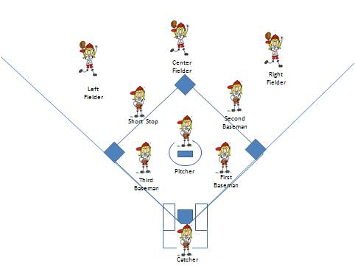
Infielders
Pitcher: Pitches the ball from the pitcher’s mound to the catcher.
Catcher: Crouches behind home plate and receives pitches thrown by the pitcher. Also receives throws from fielders attempting to make outs at home plate.
First baseman: “Fields,” or defends, balls hit near the 1st base line. Receives throws from fielders attempting to make outs at 1st base.
Second baseman: Fields balls hit near 2nd base. Receives throws from fielders attempting to make outs at 2nd base. Often involved in a double-play.
Third baseman: Fields balls hit near the 3rd base line. Receives throws from other fielders attempting to make outs at 3rd base.
Shortstop: Fields balls hit between the second baseman and third baseman. Covers 2nd base when the ball is hit to the second baseman.
Outfielders
Three outfielders — left fielder, center fielderand right fielder— attempt to catch balls hit into their portion of the outfield. Balls hit to the outfield are generally ground balls or fly balls hit past the infield.

