FIELDING PROGRESSION AND TECHNIQUE
https://www.youtube.com/watch?v=ccta-HWnXis
- Get into ready position. Feet apart, knees bent, facing the target, glove low.
- Glove on ground, throwing hand on top, eyes on the ball all the way. If ball is coming slow they can approach it instead of waiting for it to come to them.
- DO NOT LET THEM TRAP THE BALL.
- Bring throwing hand on ball in glove into stomach to create soft hands.
- Look at target, Step and throw.
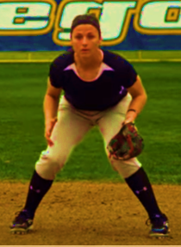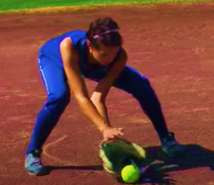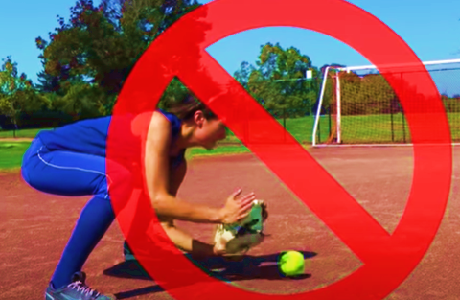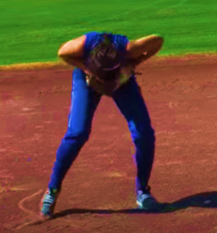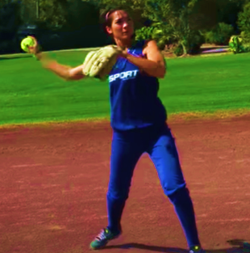
MECHANICS
Ready Position
- Taken on every pitch by fielders
- Infielder
◼ Feet are wider than shoulder width apart with parallel or slightly staggered
◼ Knees well bent, butt low
◼ Back is straight with head up, eyes on the batter
◼ Most of the weight is on the inside of both feet to allow for quick movements in any direction
◼ Both hand and glove hand are out front of the body
◼ Elbows out in front of knees

- Outfielder
◼ Feet shoulder width apart with weight evenly distributed
◼ Stride foot slightly ahead
◼ Knees bent with slight bend at hip
◼ Head up, eyes on batter
◼ Body relaxed ready to move in any direction
◼ Hands and glove about belt height

Footwork
- Side Shuffle Step
◼ Used to cover short distances
◼ Feet do not cross
◼ Body kept low during side shuffle step (body does not rise up)
◼ Move ball side foot first then bring feet together
◼ Repeat if necessary to get body centred behind ball

- Cross-Over Step
◼ Used to cover long distances
◼ Weight is shifted to the foot closest to the ball
◼ Pivot on foot closest to the ball as you cross-over with foot furthest away from the ball
◼ Turn shoulders and hips to the direction on is moving
◼ Body kept low during cross-over step (body does not rise up)
Fielding Technique
Ground Balls
- Infielders
◼ Hands well out in front of body (past the toes) and the touching ground,
◼ Glove wide open facing ball
◼ Feet wider than shoulder width apart
◼ Stride foot slightly ahead
◼ Ball fielded from ground up
◼ Absorb ball (soft hand) by giving with elbows into the body
◼ Use both hands

- Outfielders
◼ Regular Ground Ball
- Move around the ball so coming into the ball on a straight line towards target
- Hands well out in front of body (past the toes) and the touching
- ground,
- Glove wide open facing ball
- Drop to one knee (throwing side) and square upper body to the ball
- Stride foot slightly ahead
- Absorb ball (soft hands) by giving with elbows into the body
- Use both hands
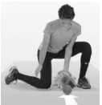

◼ Do or Die Throw Ground Ball
- Move around the ball so coming into the ball on a straight line
- towards target
- Catch ball on glove hand side with stride foot beside glove
- Push glove out to ball to catch it
- Bring glove/ball up to throwing shoulder as player hops and
- plants pivot foot to make throw (crop hop)
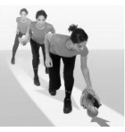
Fly Balls:
- Get to ball as quickly as possible. Do not run with glove arm extended and do not back pedal (run
- backwards)
- Set up under ball and stride into ball to catch
- Catch ball above the head over the throwing shoulder with shoulders in line with target.
- Catch ball with two hands watching it into the glove the entire way
- Soften the impact of the ball with the giving of the elbows and hands

