HOW IS T-BALL PLAYED?
Playing Field:
Fielding positions are as follows:
The Pitcher: The pitcher does not pitch the ball but is tasked with fielding the diamond area in which most balls are hit
The Catcher: This role, unlike their baseball equivalent is to place the ball on the tee, catch the ball and to tag runners running for home base.
Bases: First Base, Second Base and Third Base positions field in and around their base area and attempt to run out players running for their base.
Others: If playing with larger numbers, other fielders are placed around the playing area and are tasked with fielding the ball, catching and trying to run players out.
Field Set-Up
Like a regular ball diamond, from the Tee pace off 30 feet to first base. Bases are 30 feet apart. This will establish your fair/foul lines. Anything hit outside of the diamond is foul.
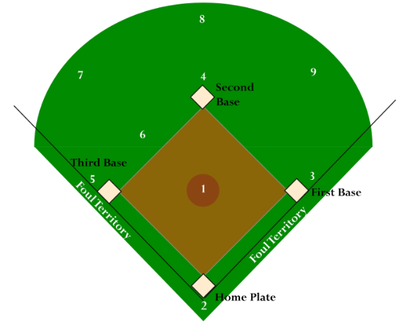
Equipment:
All players should wear suitable training shoes.
When batting, each player is required to wear a batting helmet with a face mask.

The bats used should be between 25 and 26 inches long and the balls are special Tee-Ball ones, very similar to baseballs but made to be softer to help minimize the risk of injuries.
Gloves are to be worn when on defence.
Parents are responsible for their children’s belongings and marking each equipment piece with child name is recommended.
Games:
- Games shall last 30 minutes, with the first 25 minutes (of 60 mins) being dedicated to skill building, review and warmups.
- No score or win/loss records will be kept.
- Home team will be determined by the schedule and each home team will be in the field first with the away team batting first. Home team will be responsible for setting up the bases.

Rules:
Tee-Ball is played by two teams of between five and seven players, but can be played with more if the team sizes are equal.
All players bat. The hitting order will rotate each inning enabling each player to have the chance to lead off an innings.
The players should also rotate each inning when playing defence positions.
Each team should have coaches/adults on the field of play at all times.
--> Batting team: 3 adults – 1 at first base 1 at the tee and 1 at 3rd base
--> Defensive team: 3 adults – 2 on the field and 1 to the side of the tee for defensive players to throw the ball back to home.
No intentional bunting.
Batter is to only advance 1 base at a time, even if the ball is hit into the outfield.
No advancement on an overthrow.
No lead offs or stealing.
Sliding is allowed.
Score and standings will not be kept as the emphasis is on player and team skill development not on winning.
An innings is complete when each player on the team that is batting has had a turn to bat.
Batting
When batting, the ball shall not be pitched but shall be placed on a tee from which the batter shall hit it.
The batter (aka hitter) is entitled to have as many swings as they need to hit the ball.
A runner may only advance to the base they were going for.
A player is declared as being out when:
The ball is hit and then caught without hitting the ground.
A player who has the ball stands on the base before the runner makes it to the base.
A fielder with the glove or hand that is holding the ball tags a runner between the bases.

