HITTING PROGESSION AND TECHNIQUES
https://www.youtube.com/watch?v=HFXlONfyjek
- To measure how far away from the plate the player should be is the players bat should be able to touch the closest corner. NOT the Farthest. You can also measure by holding the bat over the plate and putting the meat of the bat square over the plate.
- The grip should be in the pads of the hands and the “knocking knuckles” are in line.
- This is the “relax” position to start. Feet slightly wider than shoulders. Arms should be making an “A”. Weight is balanced but more on the balls of the feet.
- This is the “Load” position. And should be in when the pitcher puts her hands together. Knees slightly bent with more weight on the back leg. Back foot is slightly inwards along with the back knee. Front foot is lifted slightly. The bat just comes off the shoulder. Notice that there is still an “A” but that the shoulder is not up.
- This is the contact position or “Stack” position. This is the form you want to take when you hit the ball. You can see that her back hip has turned in but her front is not. Her back foot has pivoted with this but her front has not.
- This is the Follow Through position. Hips rotate and bat comes back over other shoulder. No leaning forward.
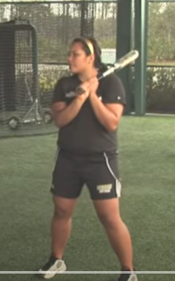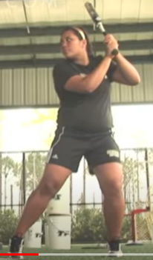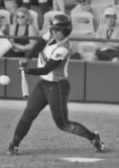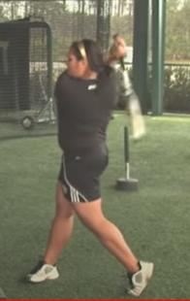
Grip
- Hold the bat in the fingers not the palms
- Align the middle knuckles (door knocking knuckles) of both hands to prevent locking wrists
- Types of grip:
◼ Long Grip
- Hands together near at end of bat
- Less control, more power
◼ Choke Grip
- Hands together about 3-5 inches from end of bat
- More control, less power
Stance
- Parallel
◼ Both feet equidistant from plate
◼ Compact swing, with power

- Closed
◼ Front foot closer to plate
◼ More power potential, harder to hit fast pitching
◼ Easier to hit to opposite field

- Open
◼ Back foot closer to plate
◼ Better vision of ball
◼ More control, less power

Location in Batter’s Box
- Deep in the batter’s box (further from the pitcher)
◼ More time to react to the pitch
- Front of batter’s box
◼ Easier to hit breaking pitches
- Even with the plate
◼ A neutral approach
- Crowding the plate
◼ Easier to hit outside pitches
- Away from the plate
◼ Easier to hit inside pitches
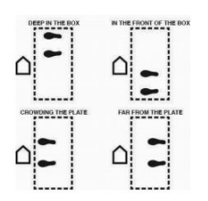

Ready Position
- Lower body
◼ Both feet point towards the plate
◼ Feet are outside the shoulders to a maximum of 1.5 shoulder width
◼ Knees slightly bent
- Upper body
◼ Bent slightly forward at hips
◼ Shoulders and arms relaxed
◼ Top hand at height between back shoulder and ear
◼ Head level and both eyes facing the pitcher
◼ End of the bat pointing at a 30 to 60 degree angle

Swing
- Load (Pre-Stride)
◼ Weight shift to the back foot
◼ Front shoulder & hip rotate inward toward catcher

- Launch (Stride phase)
◼ Short (5-10 cm) stride towards the pitcher
◼ Should be short, controlled (compact)
◼ Front foot planted at no more than 45° open
◼ Head & eyes remain steady
- Swing
◼ Initiated with front heel planting
◼ After hard push from back foot,
◼ Back hip turns in, followed by shoulders and arms
◼ weight transferred to front side (foot)

- Contact
◼ The top hand will be facing up and the bottom hand will be facing down
◼ Arms slightly flexed at contact

- Follow Through
◼ Arm extend through and after contact
◼ Hands should finish between the shoulder and the ear and the conclusion of the follow through

