Lethbridge Minor Softball Coach Resource Book
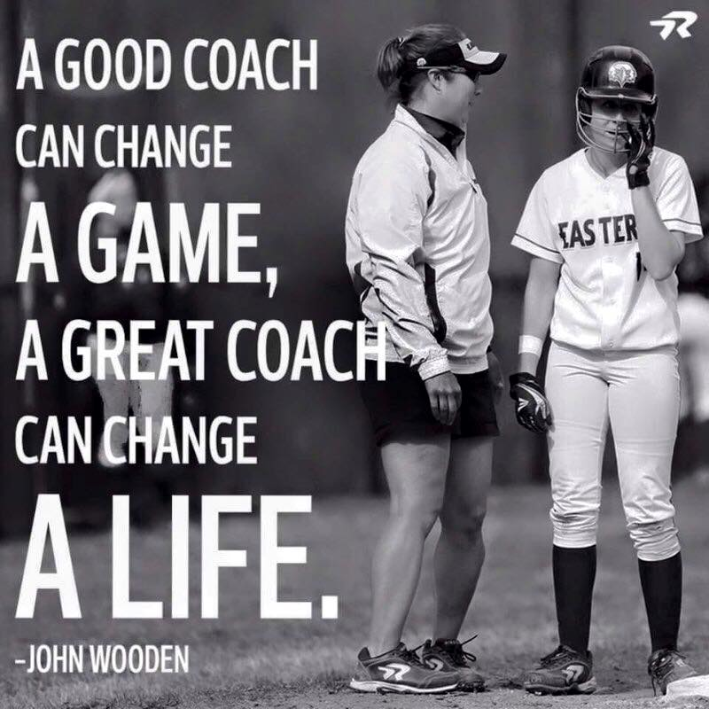
Kids First…Athletes Second
Fun always= Success

Kids will be kids. . .Because they are kids!
Updated April 2021

CONTACT INFORMATION
Jennifer Drader – President
Website: www.Lethbridgeminorsoftball.com
Email: drader.2@hotmail.com
Phone: 403-360-7806

Score Sheet Hand In email – admin@lethbridgeminorsoftball.com

RESOURCES
PLEASE REFERENCE OUR LMSA HANDBOOK FOR SEASON STRUCTURE, DATES, RULES AND MUCH MORE!
- Lethbridge Minor Softball – Under Coaches www.Lethbridgeminorsoftball.com
- Canadian Sport for Life www.canadiansportforlife.ca
- CS4L Physical Literacy www.physicalliteracy.ca
- Active for Life www.activeforlife.com
- Respect in Sport www.respectinsport.com
- Coaching Association of Canada www.coach.ca
- Softball Alberta www.softballalberta.ca
- Softball Canada www.softball.ca
- Positive Coaching Alliance www.positivecoach.org
- Sportskool www.sportskool.com/sports/softball
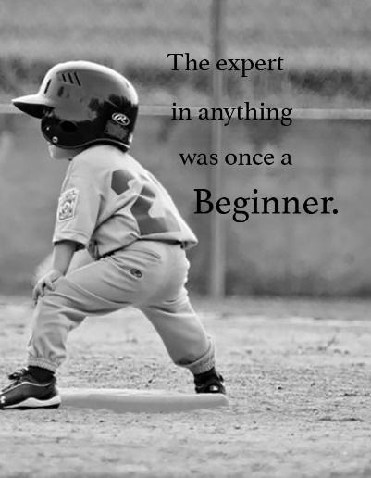

You may not have planned on being the coach of a softball team, but here you are. It is your job to somehow organize a group of enthusiastic but inexperienced kids into a team. You may be wondering what you have gotten yourself into and whether it is too late to get out of it. If you are feeling overwhelmed, underprepared, or maybe a little panicked, that is okay. Most coaches have shared your experience and lived to discover the joys of coaching youth sports.
Taken from “Survival Guide for Coaching Youth Softball” Robert B. Benson

Objective
The objective of Lethbridge Minor Softball Associations Coaches Orientation is to:
- Provide information to assist coaches in preparing for their season of coaching.
- Set expectations of Lethbridge Minor Softball.
- Promote a safe environment for the kids.
- Promote Sport for Life ideas.
- Common rules discussed.
- Provide access to resources for coaching.

Our Softball Family
Your team is part of a larger softball family including other teams within our zone. Lethbridge Minor Softball Association are members of Softball Alberta and affiliated with Softball Canada.

“You won’t know if you were a good coach for 20 years or more.”
Bob Bigelow – retired MBA player and author – Just Let the Kids Play (2001)

You can't expect people to do what they haven't been trained and developed to do. People enjoy doing things they know how to do well. Lethbridge Minor Softball is committed to making sure our coaches have all the tools to coach well and be successful!

Lethbridge Minor Softball Board of Directors will communicate with coaches and give assistance where required. The Board of Directors will attend and assist practices when possible or requested.

Assistant Coach
Ideally, every team will have at least two coaches. Having an assistant coach can take the pressure off the head coach in a number of ways. If he or she must miss a game or practice because of family or business emergencies, the assistant can be prepared to cover. It also allows for better practices; athletes can be taught in smaller groups, which is difficult for a lone coach to manage.

Role of the Coach
- The role of the coach is not just coaching! A study on Olympians stated that their coach was the number one factor for them achieving success. Coaching is a crucial role that we must accept with compassion, commitment, and honor.
Your role includes:
- Motivator
- Teach Ethics
- Teach Respect
- Show Love of the Sport
- Teach Team Play
- Teach Individual Skills
- Play Ball – Learn Life

Coach Expectations

You, “the Coach”, are the most important person in our organization. You determine the kind of experience our athletes have with sports. We are committed to the principles of Positive Coaching. We expect our coaches to 1. Provide a fun and positive experience 2. More importantly help players learn "life lessons" and positive character traits from sports. The following is what we expect from you during the coming the season.

1. Model and teach your players to Honor the Game. Teach the elements of ROOTS:
- Respect for: Rules, Opponents, Officials, Teammates, and one's Self.
- Share with your players' parents your desire for them to Honor the Game.
- Seize teachable moments to talk with players

2. Help players Redefine what it means to be a "Winner" in terms of Mastery, not just the Scoreboard:
- Teach players the ELM Tree of Mastery (Effort, Learning, and bouncing back from Mistakes).
- Use a "Team Mistake Ritual" (like Flushing Mistakes) to help players quickly rebound from mistakes.
- Reward effort, not just good outcomes. Look to recognize players for unsuccessful effort.
- Encourage players to set "Effort Goals" that are tied to how hard they try.
- Use Targeted Symbolic Rewards to reinforce effort and team play.

3. Fill your players' Emotional Tanks:
- Use encouragement and positive reinforcement as your primary method of motivating.
- Strive to achieve the 5:1 "Magic Ratio" of 5 positive reinforcements to each criticism/correction.
- Schedule "fun activities" for practices, so players will enjoy the practice and have fun.
- Use the "Buddy System" to teach players to fill each other's Emotional Tanks.
- Develop "player coaches" by asking for player input & asking rather than telling them what to do
- Learn to give "Kid-Friendly Criticism" so players will be able to hear it. Criticize in private, (have your manager or assistant coach with you)

4. Have Conversations during Team Meetings with your players at every practice and every game:
- Review Honoring the Game, the ELM Tree and the Emotional Tank throughout the season.
- Remind players about these three concepts before and after every game.
- Ask questions and encourage players to speak and contribute during team meetings.
- Use the Winner's Circle after a game to reinforce the positive things players did.

COACHES CODE OF CONDUCT

- I will remember that all the players are playing for their enjoyment, not for mine.
- I will place the emotional and physical well being of my players ahead of a personal desire or external pressure to win.
- I will do my best to provide a safe playing environment for all players.

- I will not have unrealistic expectations. I will remember that the amateur athletes are not professionals and cannot be judged by professional standards.

- I will respect the official’s decisions and communicate with them in an appropriate manner, and I will encourage my players to do the same.

- I will encourage all players to play by the rules and to resolve conflicts without resorting to hostility or violence.

- I will teach my players good sportsmanship.

- I will never ridicule or yell at the players, coaches, or officials for making a mistake.

- I will applaud good players’ performances on both teams.

- I will never question the official’s judgment or honesty in public.

- I will support all efforts to remove verbal and physical abuse from sporting activities.

- I will not consume alcohol or smoke on, or near the vicinity of the players’ benches.

- I will not use bad language, nor will I harass athletes, coaches, officials, or other spectators.

- I will be knowledgeable of the league rules and regulations and teach these rules to the players on my team.

- I will encourage my players to respect the rights of other players, coaches, fans, & officials.

- I will be responsible for my own behavior and also the behavior of my team members, their parents & fans.

- I will have respect for all the facilities and equipment used in the sport.

Coaches Philosophy

What is a coaching philosophy?

A coaching philosophy is a statement of what you value and how you will approach your coaching role. It covers your purpose as a coach and how you will approach player development and winning. Your coaching philosophy guides how you behave as a coach and how you interact with your athletes.

The three major objectives of coaching are, to help young people have fun, and to help young people to develop both physical sports skills and physiological learning to control emotion, socially interact and for the athletes to learn how to win and lose.

As well as promoting consistency, a clear coaching philosophy will remove uncertainty around areas such as team rules, style of play, player discipline, competition, and our long-term objectives. Each of these should be based on your coaching philosophy and you should be consistent in applying them.

A good coach is positive, enthusiastic, supportive, trusting, focused, goal-oriented, knowledgeable, observant, respectful, patient and a clear communicator.
For many athletes, a coach will serve as a mentor, teacher, friend and counselor. The coach gives individuals endless opportunities to influence, empower and inspire others. One coach can impact more young people in a year than most people are afforded in a lifetime.

How to develop your coaching philosophy

- Identify your values.
  - List 3 or more specific values – example mutual respect, organization, integrity.
- Develop a personal belief system by developing actions for each value.
  - Mutual respect – always approach athletes with unconditional positive regard.
  - Organization – always be organized with practice plans, line ups, administration completed.
  - Integrity – always honor the trust and confidents of your players.
- Build a philosophy statement from your answers.
  - Set an expectation with your coaching philosophy.
  - Be aware of the physical and emotional maturity level of the athletes you are coaching.
  - Parents, as well as players, will often follow the standard set by the coach – example if you are a coach that is always yelling, your players and parents may believe that is acceptable behaviour.
  - Consider how you will address fair play.

Lethbridge Minor Softball Fair Play Philosophy

Lethbridge Minor Softball considers fair play to be the opportunity for athletes and coaches to have equal opportunities in the game of softball. This principle applies to practice time, playing time, offensive position, and defensive position throughout the season.

WORKING WITH YOUR PARENTS
As the coach you should always hold a Parent Meeting, that should be done at your first practice. Give your parents jobs; keep them involved with the team. With a parent setting up your diamond this leaves your time to warm up the team. Having regular scorekeepers will ensure that you have consistency with your scorekeeping.
The Parent Meeting
Before you meet your parents for the first time send an email introducing yourself as well as how they can get a hold of you to let you know if they can not make it.
Suggested topics for the meeting could be as follows:
- Introduce yourself and your coaching philosophy
- Introduce the families to one another.
- Assigning Team rolls (Team Manager, Equipment Manager, Score Keeper)

Running the Practice
Practice does not make perfect it just makes permanent!
Practice time is precious, so you will want to make the most of it. Here are some tips for running efficient and successful practices:
- Get to practice early and insist that your players arrive on time.
- Share responsibilities with another coach (and other helpers if necessary). This will give players more individual attention and help keep them active and involved.
- Keep drills and other activities brief (i.e., 5 – 10 minutes each)
- Provide as many contacts with the ball as possible – throwing, receiving, fielding, and hitting. In a game, players may only get four or five chances at bat or to field a ball. They must get many more contacts in practice to improve.
- Do the more demanding skills and drills early in the practice.
- Continually challenge players by increasing the difficulty of the drills once they have mastered easier ones.
- Treat all players equally and emphasize positive feedback. Try to talk to every player individually at every practice.
Include the following elements in every practice:
Warm Up
- Easy run or warm up activity followed by slow stretching will prepare players for the more demanding activities that follow.

Throwing and Receiving
- Spend some time each session on developing throwing form and accuracy as well as arm strength.

Defensive Skills
- Practise all defensive skills used in a game on a regular basis. These included moving to the ball, fielding ground balls, and catching pop-ups.

Batting Practice
- To run this part of practice efficiently, have players rotate through a series of stations. These could include hitting off a batting tee, soft toss, and “live” batting practice (with the coach pitching from 8 – 9 metres from the batter)

Base Running
- Use races and relays to improve running technique. Players should practise running from home to first, and from base to base. Strategies like tagging up and advancing can also be practised. Some elements of base running can also be included in batting practice.

Cool Down
- Conclude the practice with stretching and easy running to bring the player’s heart rate body temperature back toward normal resting levels.

CONTENT OF A GOOD PRACTICE PLAN

A good practice plan:
- helps in adhering to effective practice plan principles
- results in less discipline problems
- wastes very little time
- results in a quality practice that produces better individual and team achievement

A good practice plan has the following elements:
- Written Down
- not just in the coach’s head or made up on the way to the field or the coach asks players on arrival at field what they want to do today.

- Objectives are stated
- the purpose the key segments of the practice

- Equipment required
- considering the number of players to be kept active; space available; helpers in attendance

- WHAT SKILLS to be taught are shown
- specific individual or team skills ie: overhand throw

- HOW the skills will be taught is shown
- progressions that will be used

- WHAT SPECIFIC ACTIVITIES
- what drills, mini-games will be used to practice the skills ie: “Leap Frog Tag” for warm-up or “Bulls Eye” for accuracy game
- Indicates Time allowed for each activity

Coaching points
Cue words or teaching cues

See Appendix for sample plans.

Warming Up

As with any sport, it is important to prepare your body by warming up. Always have your team warm up for at least 10 minutes to prevent injuries.
It can be as simple as a short jog (after moving continuously for a few minutes, your muscles should be ready to stretch) followed by jumping jacks or a game of tag – make it fun but be sure to warm up all muscles. Do not let your pitchers begin to pitch without first warming up.
Coach’s Clipboard
- Put together a plan before your first practice – Have a practice plan for every practice.
- For each practice, be sure to have a goal & objectives and activities (keep the kids moving)
- Make sure your practices are FUN! Your main goal as coach is to make sure the kids have fun while teaching them fundamental skills and that they get better after each practice.
- At the younger age groups rotate your players so that they players get a good understanding of each position. This also gives you a chance to see who performs best at each position.
- The simpler you can make your offensive and defensive strategies, the more successful your players will be.
- A simple offensive plan can consist of having a good at bat and running the bases aggressively. (A good at bat means the batter sees five or more pitches)
- The pitching routine includes five basic steps: the approach to the rubber and the presentation, the loading phase, the stride, the arm circle and release and the finish.
- Use tennis balls, sponge balls, or softie balls when young players are first learning to throw and catch.
- Proper catching mechanics include moving to the ball with the glove-side foot and having the fingers pointed to the sky when receiving the ball above the waist or having the fingers pointed to the ground when receiving the ball below the waist.
Batting Safety
The number one priority for batting practices is player safety. Before you even begin batting explain to the players how you expect them to handle a bat! DO THIS BEFORE YOU PASS OUT THE BATS!
The Primary Rule is that when any player has a bat in hand, the barrel of the bat should be pointed down. When moving from station to station in practice, players should drag the barrel on the ground. Bats should only be swung when a player is at a designated batting station with adult supervision. To ensure the safety of your players, you must enforce these rules.

LINEUP SHEET
It is recommended that prior to your game you sit and think about the batting order you will have and where the
Players will play each inning. By doing this before the game it will help reduce the stress during innings making sure
Everyone is getting opportunity to play both infield and outfield. It is imperative at an early age everyone learns to
Play all the positions.
Remember when filling in the line up you must put the players first and last name, uniform number and number that
To the position they are playing.

BATTING ORDER |  |  |  | POSITIONS BY INNING
 |  |  |  | 1 | 2 | 3 | 4 | 5 | 6 | 7
 | # | First Name | Last Name
1
2
3
4
5
6
7
8
9
10
11
12
13
14
15
16

Position Tracker
This document is used to track the number of times in games that your players get to play the different positions. It is not uncommon for you as the coach to be approached by a player’s parents about the amount of time they are getting to play a position or the number of innings played. By taking the time to document this after the games you will have the data to have those conversations with those parents. This is also a job that you could possibly assign to your team manager.
Players Name | Pitcher  (1) |  |  | Catcher  (2) |  |  | 1st Base  (3) |  |  |  | 2nd Base  (4) |  |  | 3rd Base  (5) |  |  | Shortstop  (6) |  |  | Left Field  (7) |  |  |  | Centre Field  (8) |  |  | Right Field  (9)
After each game, enter the # of innings played at each position, using "ticks". This accumulates throughout the season.

Innings Played
Players
1.
2.
3.
4.
5.
6.
7.
8.
9.
10.
11.
12.
13.
14.
15.
Enter the number of innings each player played in each game. Average = # innings played/# innings present (Do not include missed games)

STRATEGIES FOR A STRONG BATTING ORDER
After finalizing your defensive starters, you need to figure how to put them in the batter order that maximizes your scoring opportunities. Listed below are some basics about the batting order that you can use to start making decisions.
- 1st (leadoff) – ability to get on base often, speed, high on base percentage, has a good eye and is selective with pitches.

- 2nd – bat control and good bunting ability, speed, as well as strengths like those of the leadoff hitter. Allow the first batter the opportunity to steal. May be a sacrifice hitter/bunter.

- 3rd – power hitter, left-handed preferably, generally your most consistent hitter, the best all around hitter on the team.

- 4th – Same as number 3 batter, cleanup batter, strong RBI hitter, more of a power hitter.

- 5th – generally the next highest RBI player, someone who can protect the plate & other base runners.

- 6th – The sixth-place hitter is something like a second leadoff hitter. If the team has a second player with leadoff-type skills, they will often bat 6th can be another power hitter.

- 7th – Ability to execute hit and run, strongest hitter remaining amount the last three, a patient hitter.

- 8th – weak hitter – should posses the best speed – can act as lead off if they get on base.

- 9th – good to great speed, good on base percentage (7th, 8th and 9th are generally the weakest hitters).

Giving Signals
Yes, you can give signals to every age level!
The main duty of the third base coach is giving signs to the batter. The coach must know what their players are capable of handling. For young players signs may be simple and few in number, but the older and more knowledgeable players, additional plays and situations can be covered. Whatever the system, every player should know and understand it perfectly.
Most signs are missed because the players do not look at the right time. Hitters should look at the coach just before they enter the box. Base runners must look at the same time as the hitter so that they are aware of what is going to happen. To avoid being picked off, base runners must be on the bag when they are looking signals.
The most common system of signs involves a key or indicator. A complete routine can be signaled in this method, but nothing is valid until the indicator/key is touched. Most often, the first sign given after the indicator is the one indicating the tactic. The following set of signals is an example of this system:
  - Key or Indicator touching the face with the right hand
  - Sacrifice/bung right hand to baseball cap
  - Steal right hand to ear
  - Take a pitch right hand to left arm
  - Hit and run right hand to chest
  - Swing away (batters choice) left hand to right arm
Example of a signal routine: Right hand to ear / left hand to right arm / right hand to chest / touch face with right hand / right hand to ear / right hand to baseball cap
The steal is on! Although several signs were given, the only valid sign is the one appearing after the key or indicator sign.

Coaching the Bases
The main duties of first and third base coaches are giving signals and assisting runners.
First Base Coach
- Encourage and help the batter get to first base.
- Alert the runners to fielding errors, overthrows, or the ball through the infield.
- Position them at the front of the box and tell the runner to “run hard” “take your turn” “go for two” etc.
- Runner on first – be aware of the inning, number of outs, count on the batter, the score, the ability of the hitter, the pickoff moves the positions and throwing abilities of the defensive players, any offensive play that has been signaled, when the runner should tag up or go halfway, what the runner should do on a ground ball or line drive and the speed of the runner.
Third Base Coach
- Give signs to batter.
- Once runner leaves first base, they become the responsibility of third base coach.
- Visual arm signals and voice commands may be used.
- To stop runners or not to slide – hold both hands high with palms facing outwards.
- To indicate a slide, lower the arms with the palms facing downward.
- Position themselves near the bag for all close plays at third.
- If play is not close the coach moves toward home plate to get a better view of the developing play while maintaining contact with the runner.
- If the runner should continue towards home the coach points to home plate with one arm while waving with the other.
- Best way to instruct the runner is with arm signals.
- Keep the runner informed of the game situation or give signs to the batter.

Safety
Protective equipment, safe playing environments and playing by the rules help to prevent injuries from occurring while coaching your team in safe ways to have fun. Review the following safety recommendations with your team and teach them how to have fun and be safe on the softball fields.

Player Safety Equipment
Offensive Players are required to wear a correctly fitted, protective batting helmet with dual ear flaps and face guard, and properly fastened with a chin strap, at all time while batting, running the bases or while on the playing field. An approved facemask/guard is required as part of the protective batting helmet for all players.
Encourage children to wear rubber cleats to reduce slips and falls. No metal cleats are permitted.
- Adults or minors warming up a pitcher, or umpiring at the plate, must wear a protective face mask or catcher’s protective helmet and mask.

Proper Playing
- Teach young players how to play correctly, especially when batting and pitching.
- Have children play with other children of the same skill level, physical maturity.
- Educate players on appropriate techniques for stretching and strengthening.
- Make sure your child learns proper throwing techniques such as: releasing the ball out in front of the body after the arm passes the head, use a smooth throwing motion and keeping his/her eyes on the target.
- A child should not play if experiencing persistent pain, loss of motion or X-ray abnormalities.

Number Reason Why Kids say “We” Play Sports – TO HAVE FUN!
CHILD CENTERED COMPETITION

FUN IS DEVELOPMENT!
- Only 10% of Kids are active – The Goal is “ACTIVE FOR LIFE”
- The 7 Stages of LTAD is from CRADLE to GRAVE
- 0 – 12 Years old is the PHYSICAL LITERACY YEARS
- This Generation is the first generation expected not to outlive their parents

Athlete First – Player Second
- Master Skills before Tactics
- Development Over Winning
- Plan the Season
- Quality Coaching
- Be the Student of your Childs Sport

Physical Literacy
Skills + Confidence = Fun = Active for Life
- Time on Task is one of the most important factors in sport

**ARE YOUR PLAYERS SMILING, LAUGHING & HAVING FUN!!!!**
“Failing to plan is planning to fail”
Fundamental Movement Skills

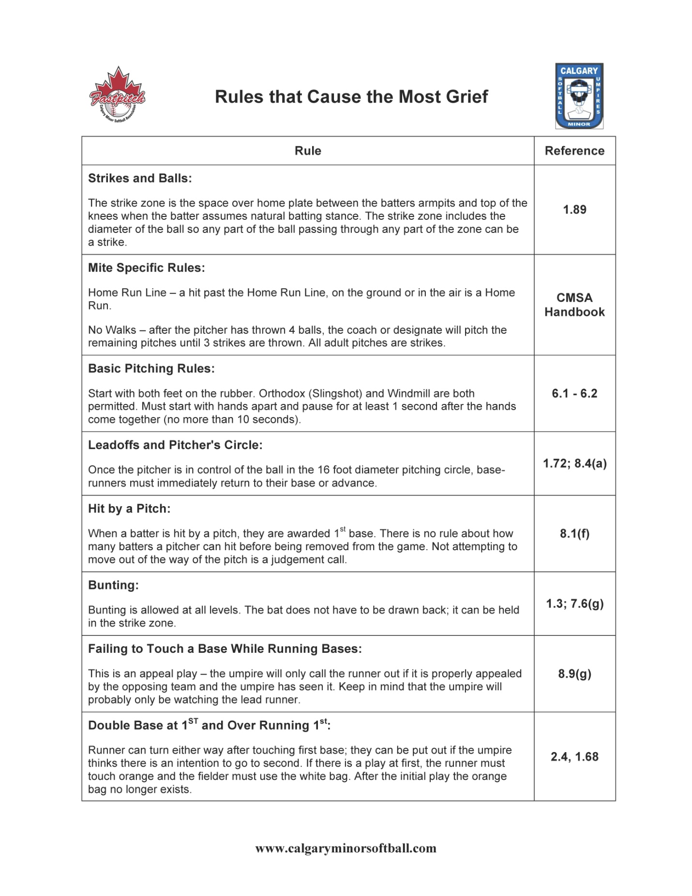

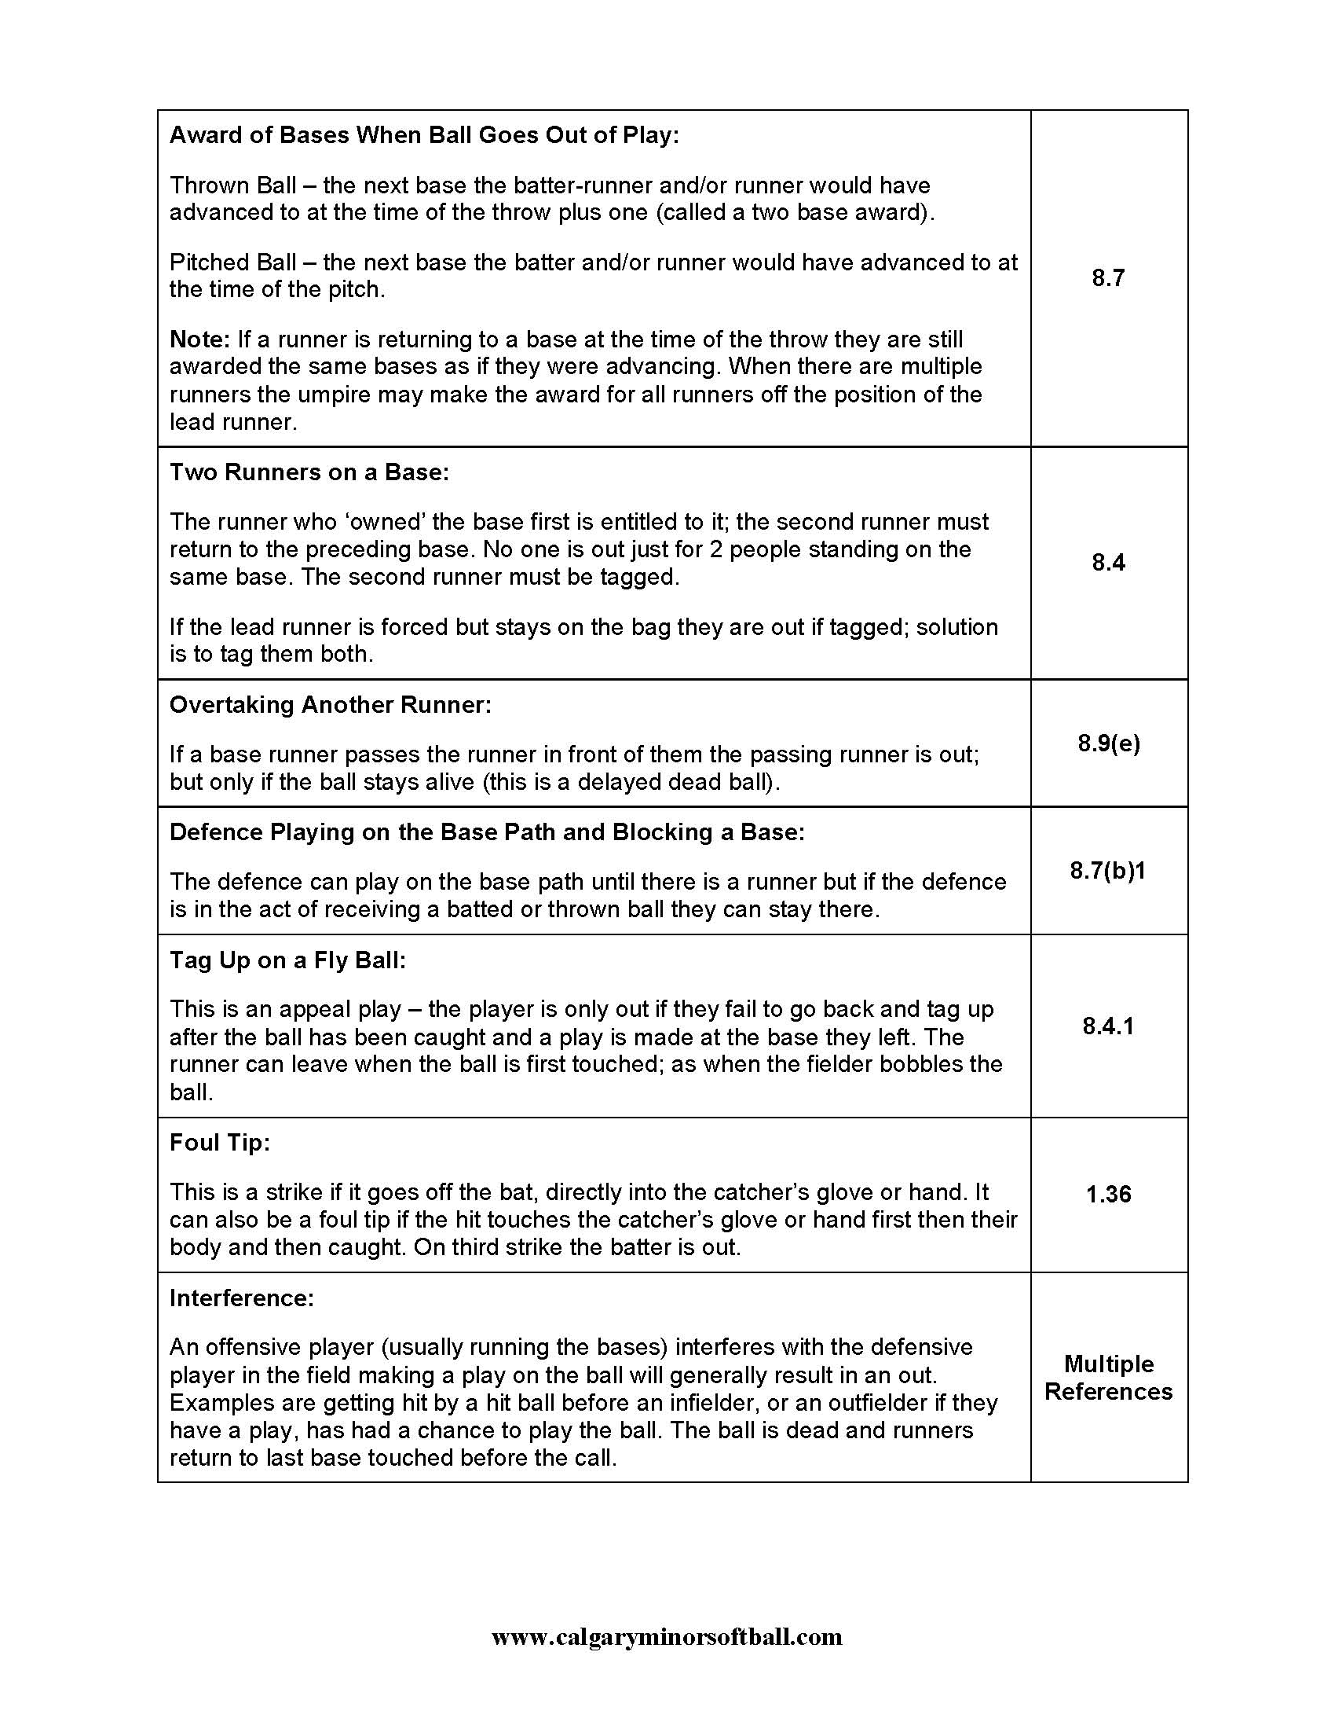

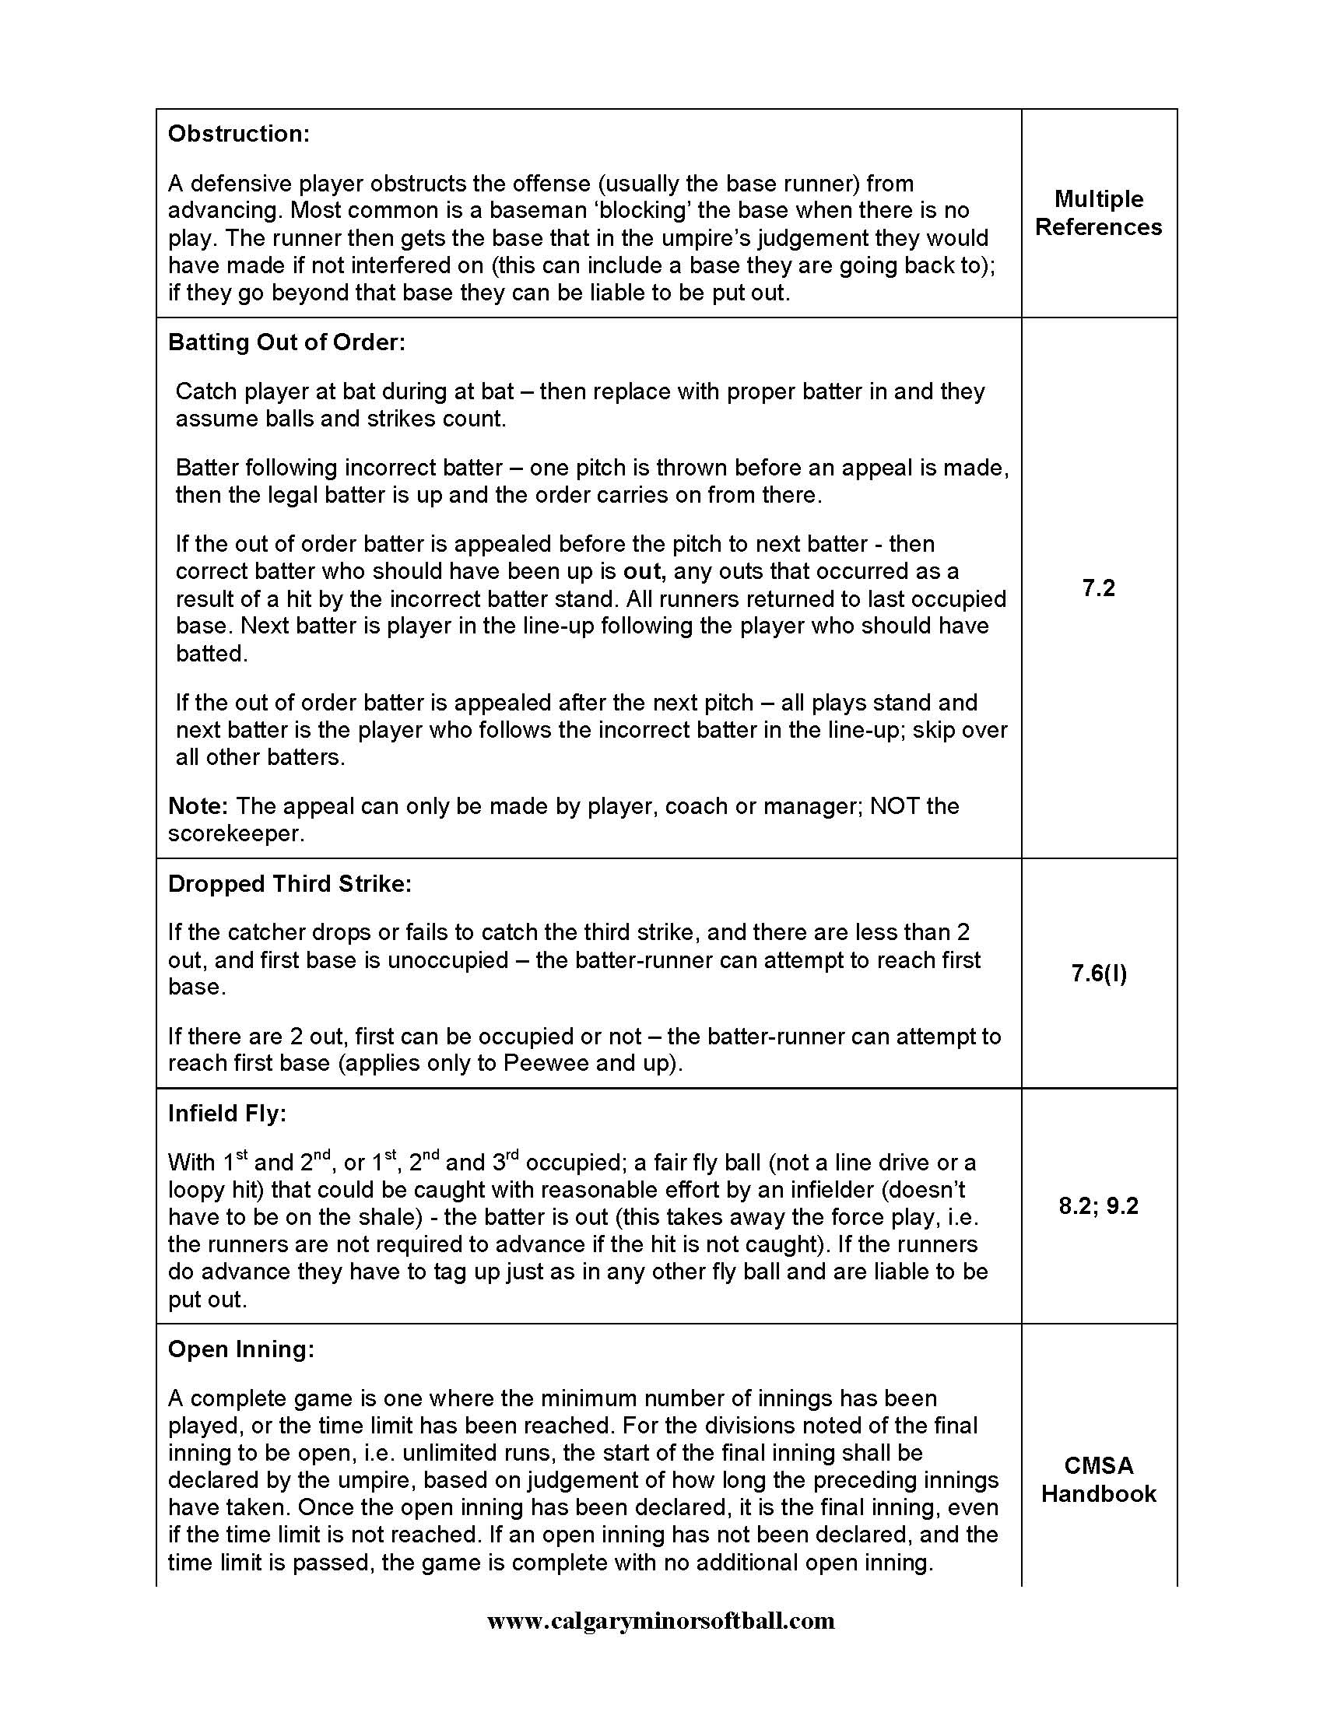

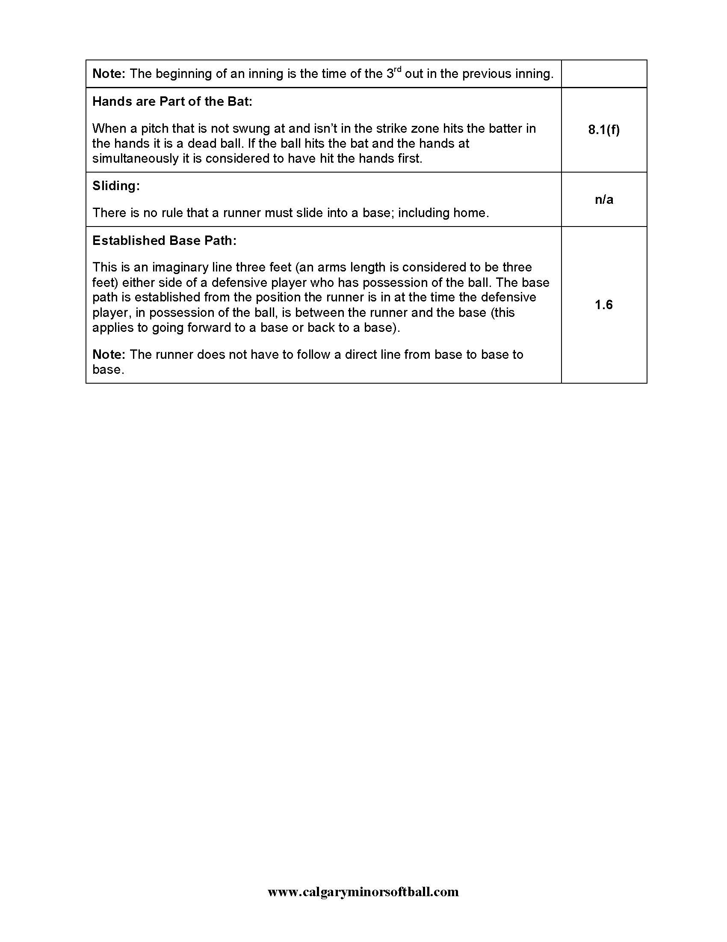

WHO CAN YOU COACH?

Lethbridge Minor Softball ‘Coaches Orientation
This course is a Lethbridge Minor Softball Course and does not certify you!
You can coach any level within Lethbridge Minor Softball:
- Head Coach and Assistant Coach(s) must take the Coaches Orientation or be a NCCP Certified Softball coach (Community Sport)
- May bring your team to sanctioned tournaments (unless otherwise specified)
- Does not certify you to coach at Provincial Level Play {Exception-U10 (Mites)}
National Coaching Certification Program (NCCP)
- Must be certified in Softball (no other sport certification accepted by Lethbridge Minor or Softball Alberta or Softball Canada)
- You can coach any level within Lethbridge Minor Softball
- You may coach your team at the Softball Alberta Provincials
- Proof of certification required (NCCP number)

WHAT IS NCCP?
The NCCP is Canada’s recognized National Coaching Certification Program. It was developed in 1974 to provide quality training and certification to Canada's coaches in more than 60 sports. The NCCP has moved towards a competency-based approach where coaches are:
► trained in NCCP outcomes relevant to the participants that they are coaching
► evaluated by demonstrating coaching outcomes to a specified standard
The core competencies of coaching are valuing, interacting, leading, problem-solving, and critical thinking. These competencies will be woven throughout all NCCP training and evaluation activities.
How does the new program help me to become a better coach?
The new NCCP has been specifically designed to train coaches to be able to meet the needs of the specific participants/athletes they are working with. Coaches will participate in training opportunities that will enable them to return to their coaching environment with specific skills that can be implemented immediately. Coaches will learn to plan safe and effective practices, design meaningful season plans, teach appropriate sport skills to athletes, and many other important aspects of coaching. The true beneficiaries of the changes to the NCCP will ultimately be the participants, when their coaches are trained and certified based on the things, they need to be able to do to best support those they coach.

NOTE: All coaches who are attending Provincials are required to be Certified with at least their Community Sport or better. Exception: U10

Things to Remember.

- Always start with your parent meeting, even before your first practice!

- Work with your parents; determine what additional help you will need during the season. This may include, assistant coaches, team manager, team treasurer, equipment manager, scorekeepers, and umpires (umpires if required for your age level).

- Go to a practice with a well laid out practice plan. Do not have your players standing around, but rather have several different stations and keep your players moving. Standing around is boring and your players will quickly lose interest!

- Teams should meet at least ½ hour before game time to warm up. Always warm your teams up before you begin a game or practice – start with stretching, jumping jacks, etc, then a run. It is imperative that you warm up your team’s muscles before any game or practice begins. This prevents injuries! After your warmup, each practice should begin with soft toss and move into full throwing. Your pitchers need to warm up too!!

- Teams should try their best to practice at least once a week. Practices are time for learning and fun - games are NOT practices. Coaches teach at practices NOT games.

SAMPLE PRACTICE PLAN - #1

Objectives:

Equipment:
Skill | Activities | Coaching points cues/progressions | Time
Warm UP

Review Skills

New Skills

Game Like Activities
Cool Down
Messages
Evaluate

SAMPLE PRACTICE PLAN - #2
Goals:
Equipment:
Time | Practice Part | Key Contents and Tips
 | Introduction
 | Warm Up
 | Skills
 | Game Application
 | Cool Down

Position Location Numbers

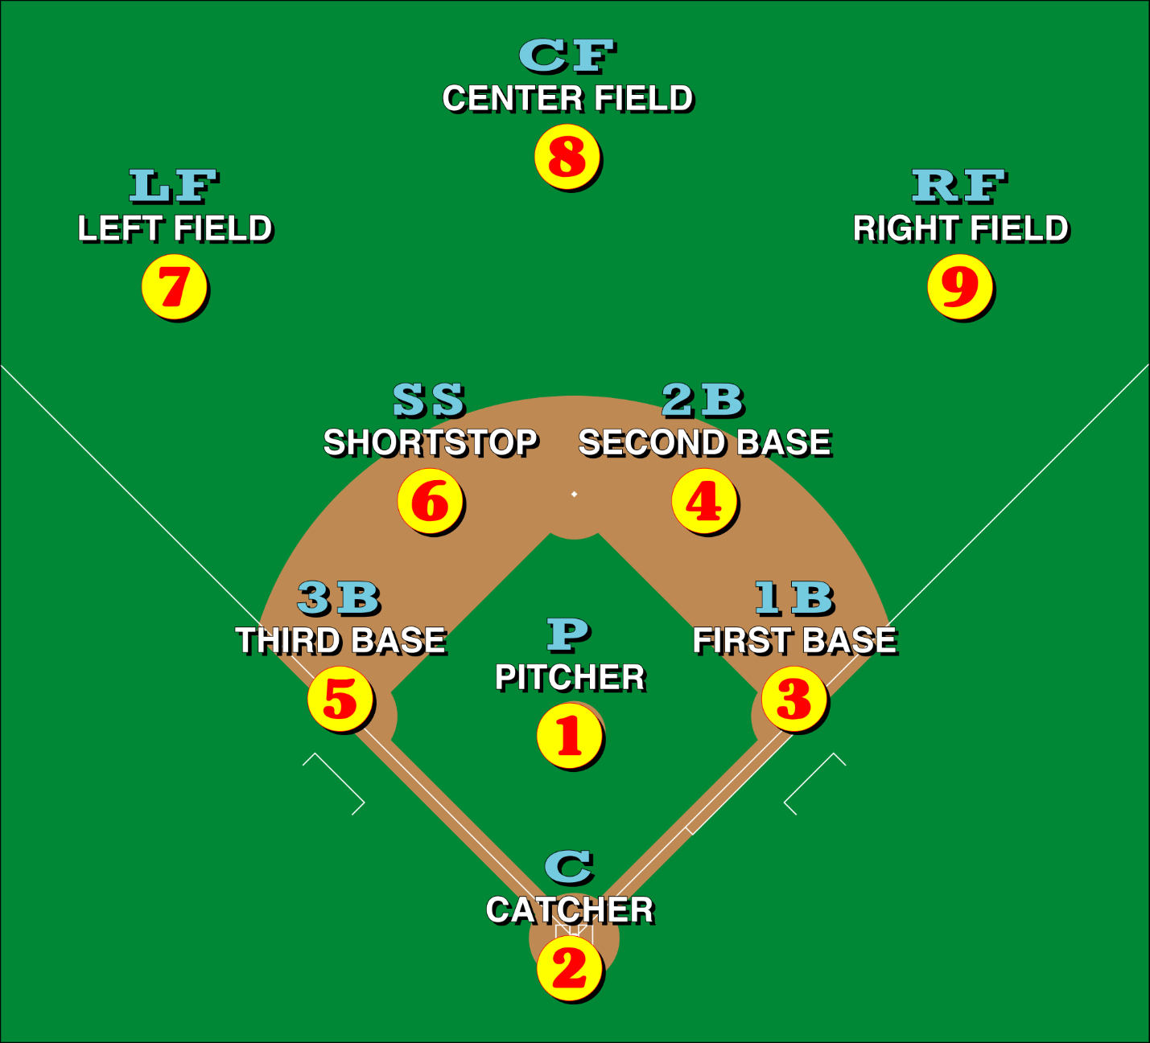
It is important that you get to know the positions by their numbers and record those numbers on the line up cards and scoresheets. This will be extremely important when stats are starting to be kept. When completing your line up card always use the players last name, first name, uniform number and position number.

The Coaching Code of Ethics

(Developed and Endorsed by the Coaching Association of Canada and the Canadian Association of National Coaches)
Integrity
The coach must act with integrity in performing all duties owed to athletes, the sport, other members of the coaching profession, and the public.
Competence
The coach must strive to be well prepared and current in order that all duties in the respective discipline are fulfilled with competence.
Athlete’s Interest
The coach must act in the best interest of the athlete’s development as a whole person.
Respect for the Rules
The coach must accept both the letter and the spirit of the rules that define and govern sport.
Respect for Officials
The coach must accept the role of officials in providing judgment to ensure that competitions are conducted fairly and according to the established rules.
Responsibility to Other Coaches
The coach’s conduct toward other coaches must be characterized by courtesy, good faith, and respect.
Personal Conduct
The coach must maintain the highest standards of personal conduct and support the principles of fair play.

