PITCHING PROGRESSION AND TECHNIQUES
https://www.youtube.com/watch?v=yhDvuDBGZSU
https://www.youtube.com/watch?v=dxAa5K1wki4
- For younger age groups there is only 1 type of pitch – the “Fast Pitch”. The grip for this is 4 finders all on the seam with the thumb below.
- The way the ball should come off is like if you have money in your hand and someone goes to grab it you close your hand. This is the motion of how the ball is released.
- Spin practice. Start feet apart. Throwing hand is just snapping the ball to focus on the spin and release. Do 20 reps
- Follow through of hand should show snap with fingers closed and wrist up.
- Next start with the throwing arm at shoulder height and glove arm pointing at catcher. Practice the snap release. Notice that ball is facing away and out. Do 20 reps.
- Next start with the throwing arm above head and glove arm pointing at catcher. Practice the snap release. Notice that the ball is facing away. Do 20 reps.
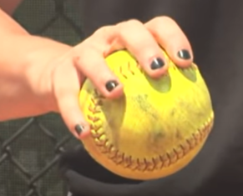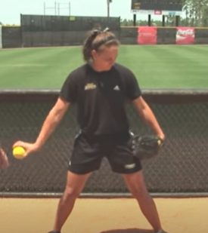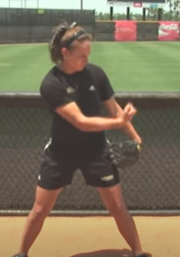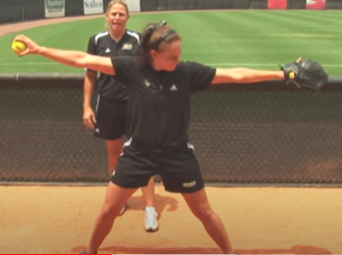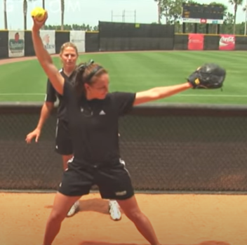

- Next is to practice all motions together. Both feet must be on the pitcher’s mound to start. Throwing side foot should be at the front of the mound with the heal touching and the ball of the foot on the shale. The glove side foot should be on the back of the mound with the heal on the shale and the ball on the mound.
Weight is either equal or on the back leg to start.
When the pitcher comes to the mound the ball must either be in the glove or in the throwing hand. BUT HANDS MUST be separated.
- When you put your hands together you must start your sequence.
- First motion is to come off the mound in a “superman” position. This drives your arms out and then up. In this position the weight has transferred to the front leg beginning to push off the mound facing the catcher.
- Second motion is to “kick the bad guy” Notice that the body has turned, weight has shifted to the back leg and ball is facing out and away. Glove arm is pointing towards catcher
- Third motion is to get in a “K” position. Notice that the body is now in the same position we were in when practicing (above). Weight is still on back leg but other foot is coming down and ball is still facing out and away. Glove arm is pointed at catcher.
- Fourth motion is to get in a “Scarecrow” position. Notice that the body is now in the same position we were in when practicing (above). Weight is balanced and ball is still facing out and away and coming around. Glove arm is pointed at catcher.
- Fifth motion is to get in a “I” position. Weight has shifted to front foot and the back foot has made a “c” in the shale by dragging to back of front foot. Notice that the body is still facing out with the pitch is made and front foot is at a 45 degree angle. The wrist is snapped and comes up to the opposite shoulder.
- Practice full motions 20 times. If not getting “near” the strike zone, go back to beginning and repeat.
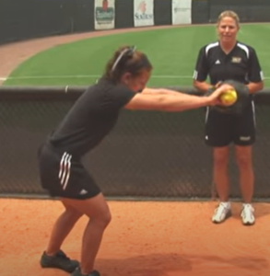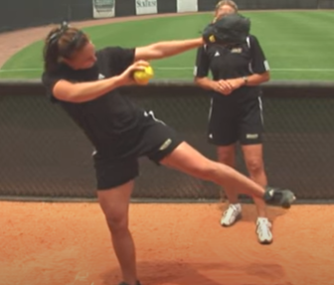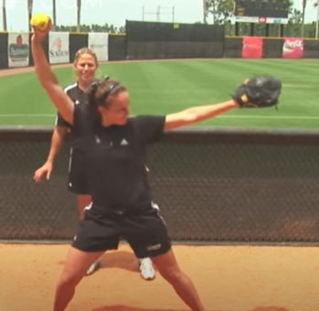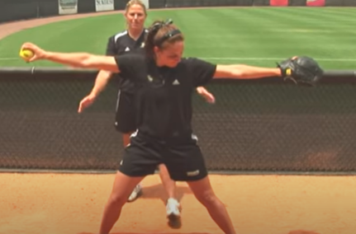

Pitching Sequence
- Receive ball in circle
- Move to a position 2-3 feet (1 m.) behind the pitcher’s plate
- Step onto pitcher’s plate with hands apart
- Both feet must be touching the pitcher’s plate and be within its 24” width
- Bring hands together in pitching position:
◼ Hips should be in line with first and third bases
◼ Ball in both hands in front or side of body
◼ Must remain motionless at least one second and no more than 10 seconds
- Deliver legal pitch

Legal Pitch
- Must use underhand motion
- Must pitch directly from the pitching position
- Only one step permitted and must be forward towards the catcher within the 24” width of pitching plate
- Wrist below hip at release
- Wrist no farther from body than elbow at release
- Release of ball and follow through of the hand and wrist must be forward and past the straight-line
- position of the body

Pitching Mechanics
- Grip (basic fastball grip is similar to that used for overhand throw)
◼ Hold ball in fingers and thumb
◼ Use three or four fingers (depends on size of pitcher’s hand)
◼ Place fingers across seams; thumb directly across ball from middle finger
◼ Grip should be comfortable (firm but relaxed)
- The Pre-Motion and Start
◼ Pitching Stance
- Comfortable stance with both feet touching pitcher’s plate with feet staggered:
◆ Narrow stance for easier rotation
◆ Wide stance for more stability
- Instep of pivot foot across front edge of pitcher’s plate
- Weight resting largely on the stride foot with hands apart
◼ After receiving the signal from the catcher, shift weight to pivot foot and pause when the
hands are brought together.
◼ Slightly turn pivot foot outward and point the stride foot towards the catcher
◼ Two ways to start the pitching motion:
- Break hands apart and swing the pitching arm down and back to generate forward momentum towards the catcher. The backswing does not cross behind the body. If it does, the arm circle moves outside the body, causing the pitch to be off-target at the point of release. As the arm swings back, keep weight on the back foot, preparing the legs to generate maximum momentum to the catcher.
or
- Keep hands together as pitcher prepares to drive off the mound.
- The Push-Off
◼ Get into an athletic position by bending the knees, engaging the core and driving off the mound in a coordinated motion towards the catcher.
◼ Drive off from the mound using the pivot foot to push against and away from the mound while at the same time lifting and extending the stride foot and leg, glove arm, and pitching arm in a coordinated effort maintaining a straight line to the catcher.
◼ The stride length should be an extended walking step.
◼ Pivot foot rotates outward to allow hips to turn sideways to catcher and pushes away from the mound on a straight line to the catcher.
◼ Stride foot and leg should be kicked high to allow a longer push off the mound towards the
plate and time to allow the pitching arm to get to the back of the down swing.
◼ It is at the onset of push-off that the three components of the pitching arm and arm circle become important. The pitching arm should:
- Be straight but with the elbow slightly bent (12°)
- Pass close to the ear at the top of the downswing and brush by the back hip before ball
release. Arm must remain in line with direction of desired force.
- Be fast with the arm circle picking up speed as it moves up and into the down swing
producing a smooth motion
◼ Glove hand needs to come up (no higher than shoulder height) and point at the target to
allow the pitcher to stay on the power line.

- The Landing
◼ Land the stride foot at a 45° angle on a straight line to the catcher (power line).
◼ At the touch down of the stride foot, the pitching arm should be in the 10 o'clock position.
◼ The stride leg needs to be put down hard and the knee should be slightly flexed but strong and firmly planted so the pivot leg can come up to meet it.
◼ At landing, the pitcher’s weight shifts into a firm front side (stride leg and torso) in a movement referred to as “stacking” and the pivot knee is brought under the back hip.
◼ Pull the pivot leg into the stride leg and bring the legs together allowing the pitcher to use the force generated from the lower body at push-off in the delivery of the ball to the plate. Therefore, it is extremely important that the stride leg is firm after landing and the torso is upright and strong to allow the pivot knee to stack under the back hip. If the stride leg or torso collapses at any time after landing, the pitcher’s balance, accuracy, and velocity will be
greatly affected.
◼ Hips and shoulders should be rotated 90° away from the catcher (glove arm shoulder pointing at catcher) when the stride foot lands.

- The Release
◼ Once the pitching arm begins the down swing, the glove arm bends and is pulled toward the waist in a straight line for additional power as the pitcher’s legs are brought forcefully together with the inside of the back knee visible to the catcher.
◼ The pitcher’s weight is over their stacked legs.
◼ From touch down of the stride foot (where the arm is roughly parallel to the ground) to release (at the bottom of the circle), the upper arm should be brought close to the pitcher’s side with the elbow leading
the wrist into release.
◼ Lastly, the wrist snap should be sharp at the bottom of the pitcher’s arm circle and finishes at the middle of the thigh of throwing arm side.
◼ At release, the pitcher’s body must be upright and balanced over the stacking of the legs. Any
deviation in the angle of the shoulders will cause accuracy problems both up and down in the strike zone and in and out through the strike zone.
◼ The hips and shoulders should be rotated 45° away from the catcher at the point of ball release.
◼ Release point is at mid-thigh of the back leg.

- The Follow Through:
◼ Finish with the back of the pitching hand facing the catcher and the pitching arm in the middle of the chest toward the glove hand shoulder.
◼ Allow back foot to come forward naturally
◼ Finish in balanced position and ready to move any direction

